Lab 1 Report

For this assignment we create a program that will read in a line of text, search for a substring, and replace that substring with another substring specified using the command line.

In order to do this we will need two functions: find(char * substr, char * str) and replace(char * str, int pos, char * substr). The find function will loop through the string provided and look for the substring within it, it will then return the index of the beginning of the chosen substring. The replace function will take an index and replace the letters after the index with the chosen substring.

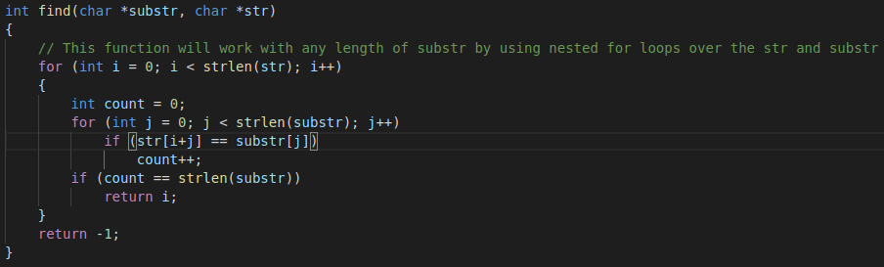
The way I chose to implement the find() function was to use a nested for loop. This allows me to loop over the whole string based on its length, and then do the same with the substring. Doing this will allow for any length of substring to be used. I used an integer variable, count, to keep track of the number of times that the character in the substring matched the character in the string itself. After this I checked to see if count was equal to the length of substr and if true, it would return the current index of the string. If the count is not equal to the length of substr, then the function would return -1.

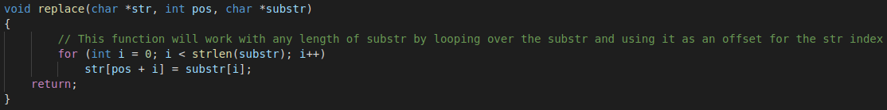
For the replace() function I did something similar to the find() function. The function uses a for loop to go through the substring, it then uses the pos argument to go to where the index of the found substring. After this it uses the value of i as an offset to make sure it only goes as far as the substring is long while replacing that character with the character in the equivalent index of substr.

In order to test that my functions would work well with any length substrings I used the commands:
`./lab1 "st" "xx" < data.txt`,
`./lab1 “string” “strung” < data.txt`,
`./lab1 “a”, “b” < data.txt`,
`./lab1 “st” “x” < data.txt`, and
`./lab1 “foo” “fee” < data.txt`
The results of these commands are shown in the following screenshot
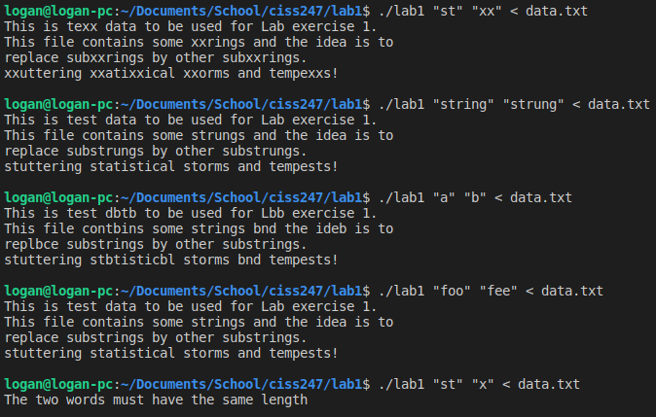
In conclusion, this lab went well. The first four test commands passed as expected, while the last test command failed. The fourth test command was different than the others because the string to find did not exist in the data.txt file, so nothing would be replaced. The fifth test failed because the two substrings had different length, this error was handled in the main function and produced an error message.

