Logan Lipke
11/24/20
CISS 247
Assignment 3

Introduction:
In this lab we are making a program to output digits based on a seven segment display.
Process:
To begin I mapped out what all the numbers should look like as a seven segment display.

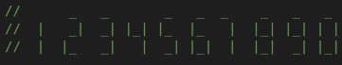

Once I had this done I was able to go through each number and separate it into sections. This made it much easier to see the similarities between the numbers which allowed me to easily create the correct output.

With all that done I began on the code for the top section of the numbers. This was the simplest to do because the top only consisted of either a space or ‘_’ character. Since 1 and seven were the only characters with the space I used a switch case to fall through on 1 and 7 to output a space and defaulted to every other character outputting a ‘_’ between two spaces.

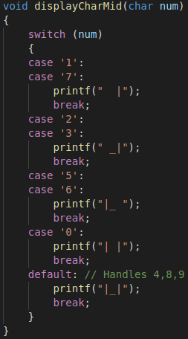
For the middle I had a similar process, except the characters were split into larger groups. I grouped 1 and 7, 2 and 3, 5 and 6 together. Zero had its own case and the rest fell into the default group of the switch case statement.

For the bottom segment I did the same thing as the middle, but with different groups. 1,7, and 4, 6, 8, and 0, 3, 5, and 9 were all grouped together with 2 being a special case as the default.

I decided to add negative number representation to the program as well. This is taken care of in the function that prints the full string of numbers. Each function to do this is the same except they call their respective character print functions. If it sees that the number is supposed to be negative, it adds a ‘_’ to the middle section and an extra space to all the others.
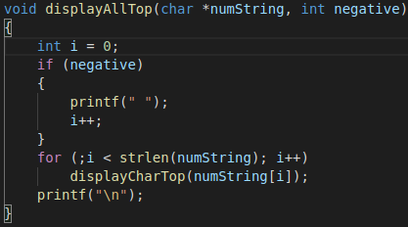
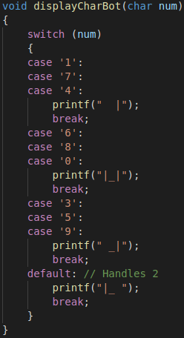

Testing:
To test this functions correctly I used a multiple numbers of varying lengths with some being positive and others being negative.

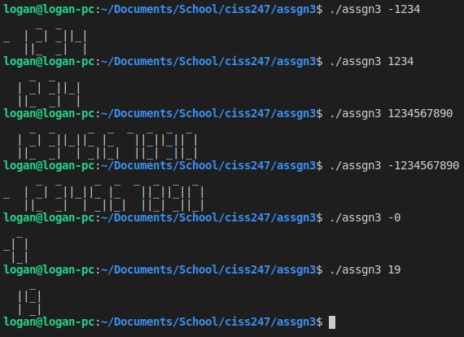
Results:
This program works well to output multiple numbers in a seven segment form, both positive and negative.
Conclusions:
Overall this program and its functionalities were fairly simple to implement. I didn’t run into any trouble anywhere and was able to come up with and implement all the functions very quickly.

