Logan Lipke
11/7/20
CISS 247
Asssignment 2 report

Introduction:
The purpose of this assignment is to create a program for spell checking using Hamming Distance. This accomplished by comparing each letter of one word to each word of another word. Each different character adds one to Hamming Distance.
Process:
In order to do this correctly I will need a few functions. All words need to be in lower case, so that will be one function. Another useful function is one that can take two words as arguments and find their Hamming Distance. For some of the extra credit options I will also create one other function as well as modify my Hamming Distance function.

Converting to lower case is a very simple thing to do. In ASCII, uppercase letters are valued at 32 less than their lowercase counterparts. All my function needs to do is check that each letter is between A and Z and if it is, add 32 to the char value. It will also check for a nextline character and convert that to a null terminator.

Since every word I’ll be passing into the Hamming Distance function is going to be the same length, I can loop using the length of one of them. I will then compare each letter of one word to the other word. At this point I decided to add something extra and change the weight of the type of character in the word. If both characters are vowels or consonants, only 1 will be added to the Hamming Distance, otherwise I add 2. This was done with a function called isVowel. This function will return true or false depending on if the letter was found in the list of vowels in the function. Another criteria I added to the Hamming Distance function was checking if the words started with the same letter. This being false added more to the Hamming Distance than other checks. The final criteria I added to the function was the alphabetical difference between the two characters. If char1 – char2 was greater than 10 or char2 – char1 was greater than 10, 3 was added to the Hamming Distance. This will hopefully keep the words more similar to each other.

There are two other extra things I added to my program. First was keeping track of the smallest Hamming Distance that was found. Since we were only supposed to return the first five words in alphabetical order, sometimes the correct word might not be found. Keeping track of the word with the lowest Hamming Distance would allow us to suggest the best possible alternative that was found in the entire wordlist.
Second was a function that could check if the chosen word appeared in any other words. This would allow us to suggest things like resting, forest, or crest from the word rest. Since there are so many words in the wordlist however, you still have to worry about a bias towards the front of the alphabet.

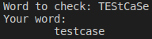
Testing:
To test that our case conversion function is working correctly we can use a little bit of output to see the results. Included to the right is an example of that:

The next test we will do is the Hamming Distance function. It should return 5 words with the score displayed next to them, we should also see that the scores are relatively low. If we were keeping track of the lowest scores found rather than the first five alphabetically we could probably see even lower scores. The screenshot below shows the differences in Hamming Distance with 5 words. You can see that words with letters in the same position had lower scores than those that did not. There is another screenshot with a misspelled word. I was hoping to see the word computer show up, however since there were words fitting within the threshold I set (less than the word’s length) we don’t quite get down to that point in the wordlist. One problem that could be found here is finding an appropriate threshold for the Hamming Distance. The lower the threshold, the more strict the spellcheck. This could be useful for common words or words that aren’t horribly misspelled, but words that are shorter or have more mistakes may have a hard time finding any reasonable suggestions for words. I have included a few more screenshots of the difference that can be made when lowering the Hamming Distance threshold. My tests from here on will use a Hamming Distance threshold of less than or equal to four.
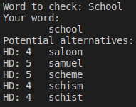
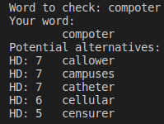
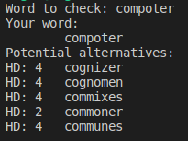

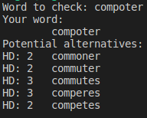
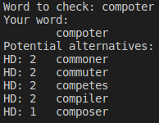

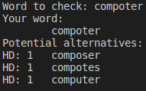

The next function I will test is the substring function. This works best when the word given is spelled correctly, but could be improved by using the word with the lowest Hamming Distance. My tests will compare the results of these two ideas. The first screenshot shown below demonstrates the first five words found containing the word eat. For the next test I changed the substring search from using the chosen word to using the best word found. I misspelled the word rest as rost to see what it would find and I saw that it correctly gave me the word and offered alternatives as well as the correct substrings. I also tried it with a longer word with more misspellings. I misspelled the word controller as conturller and was given the correct word back.

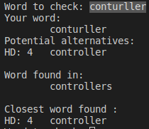
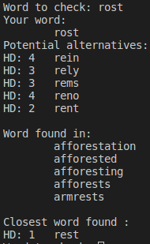
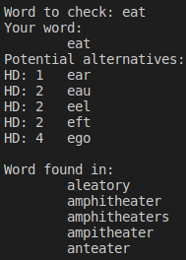

Results:
My testing has indicated much of the program works as intended. During testing I also found it best to have my main function split into multiple loops. The first being a loop to read the wordlist file contents into an array. After this I loop through every word in the array checking the Hamming Distance to get the lowest Hamming Distance as well as find possible alternatives to the provided word. Finally I loop through the list one last time and check the wordlist for occurrences of my chosen word within other words.
Conclusions:
In conclusion, this lab went well. It was interesting to see how simple something like this can be to create, but I can only imagine what can be done to properly optimize spellcheck functions within things we use. If I were to make any large improvements to this program, the first would be to have a list ranked by Hamming Distance rather than alphabetical order. This would allow for greater accuracy in suggested words. I would also like to include something to check for more common misspellings or scrambled letters within words.

