Assignment 2
CISS 360
Logan Lipke
2/19/21

Introduction:
For this lab we are creating a bash script that monitors processes in some way. My script allows for all processes currently running to be watched or specific processes can be watched using the pid or name of the process.
Process:
I started by creating the function to list and refresh all running processes. To do this I created a list of all running processes by using ‘ls’ on the /proc directory. This output was then processes by grep looking for strings containing only digits. Finally, it was sorted so that the list appears in numerical order. When the script is run with the option --displayProcs this is part of the output that is shown:

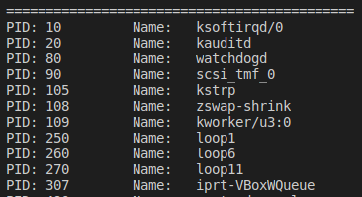

Every ten seconds it will refresh the list of processes and will run until a key is pressed.

If the option --pname or --pid is given, a name or process id can be specified after the option. --pid allows for more exact process watching while --pname will only watch the first process with that name it encounters. This is what the output will look like for each option.

If ‘--pname soffice.bin‘ or ‘--pid 8038’ is used we will see this as well as some extra info below:

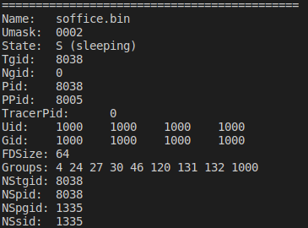

This function is called by the parseOptions function that determines how the command line input is interpreted. If --pid is used then it will call the function watchProcess straight away using the pid as the argument. If the --pname function is given however, it will get a list of the processes, loop through them, and access their status file. From this it is able to find the process name and will use the process number of the first match it finds as the argument for watchProcess.

The final function in the script is parseOptions which is called by the script, passing all command line arguments to it. It looks at only the first argument given to determine which function to run. If --help is used it will display the help output, --pid will call the watchProcess function and --pname will call watchProcess shortly after determining which process to use. If an unknown option is used it will output an error message and the help output.

Testing:
To determine that everything is working correctly, we will test all the options for the script as well as give it bad input to check error handling.

Input: ./assgn2 --help
Output:
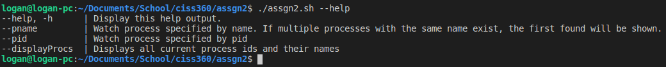
Input: ./assgn2 --displayProcs
Output: Some output omitted to save space
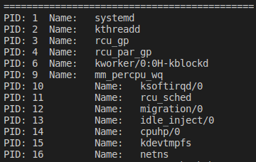

Input: ./assgn2 --pname systemd
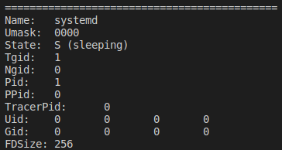
Output: Some output omitted to save space

Input: ./assgn2 --pid 10
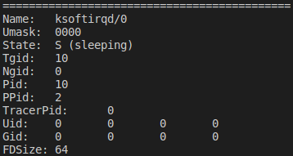
Output: Some output omitted to save space

Input: ./assgn2 --badOption
Output:

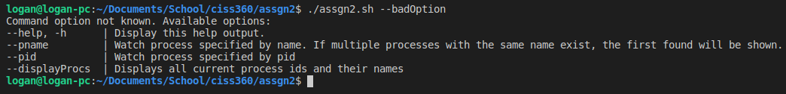
Input: ./assgn2.sh --pid 567892
Output:

Results:
The functions in this script run properly and are capable of handling errors related to incorrect input or missing processes.

Conclusion:
In conclusion, this script was simple but could prove to be useful when monitoring a system. Being able to look at all the currently running processes and their names could be valuable to an infosec professional. This is because you would be able to see quickly when a new process is spawned which could be the result of an intrusion or a possible malware infection. Being able to watch a specific process could be useful as well because an attacker could fake the name of the process while doing other things with it. This could be seen in more detail when watching the specific process. To improve on a script like this, I think that implementing some form of comparison between two processes or logging one process and comparing results to real-time could be used to see differences or changes in a process.

