Logan Lipke
11/3/20
CISS 247
Lab 6 Report

Introduction:
In this lab we are doing bitwise manipulation on floating-point numbers. To do this we will be using 5 different functions. These functions will negate, get the absolute value, double, halve, and get the class of float (normalized, denormalized, or special)
Process:
In order to accomplish these functions an understanding of floating-point number is essential. I used the Wikipedia page on single precision floating point format to see how floats are represented in binary.
I chose to start with the negate and absval functions as they are the simplest. Since there is one bit that determines the sign of a floating point number, I could just change that bit and the function would be finished. To negate a number I would just need to OR the 32nd bit of the number with a 1. Getting the absolute value of a number is to make it positive, so the 32nd bit would need to be a 0. I accomplished this by ANDing the number with a mask of 31 1s. This has the effect of keeping the number but changing the 32nd bit to a 0.
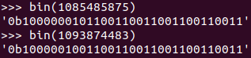
After these were finished I moved onto the doubling and halving functions. My initial thought with these functions was to double the number in the fraction portion of the bits. This did not have the effect I was hoping for and would often only increase or decrease the float by a fraction of its full value rather than the whole thing. I decided that the best way to find out how a number and its double would look would be to look at the binary. I used python to convert a the unsigned integer version of the user input to binary to look closer.

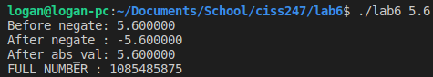
The current output is shown below and the python results are to the right. The numbers on the right are 5.6 and 11.2 in integer format.

After looking at these numbers I was able to see that they were the same in the fraction portion, but the exponent was one higher in 11.2. This means that rather than double the fraction, I needed to add or subtract one to/from the exponent to double or halve. Since we can’t use the – operator in our functions I used a ~1 >> 1 to add a negative one to the exponent.

The last function that needed to be done was the float_class function. This function should return an integer depending on the class of the float. -1 for special (NaN or infinite), 0 for denormalized, and 1 for normalized. For a float to fit into the special class it needs to have the exponent field set to 255 or 8 bits set to 1. To get this I shifted f 23 bits to the right and XORed the result. If this field was all 1s it would return a 0. I then added that result to f right shifted by 22 and ANDed with 1. This will let me see if the most significant bit in the fraction is a 1 or 0. The result of that is NOTed and added to the first check. I had a lot of trouble with this function and it doesn’t work quite right. It can detect special numbers just fine but labels everything else as normalized. I will expand on this in the testing section.

Testing:
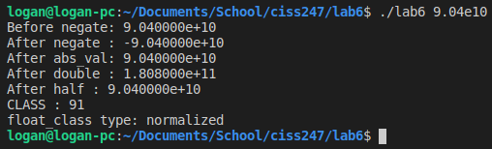
Testing for this was fairly straightforward, mostly just trying different numbers to see the results. Below are some screenshots of the output for all the functions with different numbers.

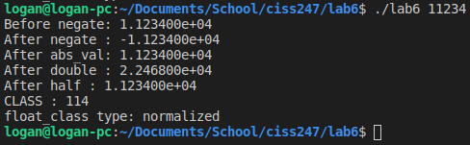

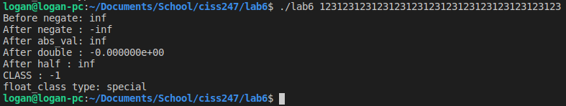

To further explain my issues with the class_float function I added the CLASS : lines to my output. This is the output after the float_class function was called. As you can see it correctly used this to find the infinite value with a large number, but other numbers did not work correctly. This is because of the XOR done on the exponent field. When all 8 bits are set the XOR causes it to be 0 then when it is added to the NOTed result of the next operation it becomes -1. However, because of this same system, the number after the XOR ends up much larger than the number its being added to so there is almost no possibility of it being 0.

Results:
Although the float_class function doesn’t work as intended, everything else works as it should as far as my testing went. Numbers that are normalized, like 9.04e10 were able to be accurately manipulated to be negated, had their absolute value found, doubled, and halved. I wasn’t able to find a way to get the float_class function to fully work properly though.
Conclusions:
In conclusion, this lab was mostly successful. Float numbers are a bit more complicated to manipulate when compared to regular integers and overall I learned a lot about their format and how to use them.
References:
https://en.wikipedia.org/wiki/Single-precision_floating-point_format
https://electronics.stackexchange.com/questions/226320/normalized-and-denormalized-floating-point-numbers

