Assignment 1
CISS 360
Logan Lipke
2/1/21

Introduction:
For this assignment we needed to create a script that would read a log file and give useful information based on what was found inside it. I decided to create a script in Python that would read each line, break it into parts, and look for user defined information within those parts.

Process:
After looking through some log files I determined that a lot of files had the common format of timestamp, user, log message. Using this I broke the sections down using regular expressions and assigned them to variables for each piece of information. To use regex I needed to create the expression that would be used to match each section so I used "(\w+ \d+ \d+:\d+:\d+) (\S+) (.+)". The expressions are grouped using parentheses. The first group looks for a timestamp in format Month Day Hour:Minute:Second. The second looks for a username by looking for any non-whitespace characters, and finally the last group will match anything else on the line.

With the regex groups done, the program will look for user defined substrings within the matched groups based on what mode is specified. Mode 1 will look at the timestamp, mode 2 will look at the user, mode 3 will look at the log message, and mode 4 will look at all of them at the same time.
If the user defined string is within the regex match then the relevant count variable will be incremented.
At the end of the program it will display the number of matches found for the specified criteria. If the verbose cli option is used it will display the information as it checks each line as well.

Testing:
To test this script I mainly used /var/log/syslog as it had a good amount of information in it. Since it uses command line options for input a help option is very useful. The argparse module for python helped a lot with this part of the script. Here is the help function I ended up with:
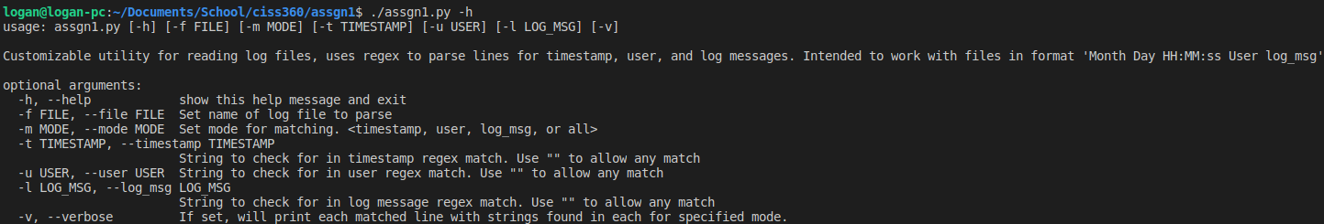
I found after some testing that the original regex I used has some problems with the timestamp. On days that are two digits, the date would look like this: Jan 29. However, days with only one digit use a space to fill the missing first digit like this: Feb 1. This wouldn’t match the original regex, so it had to be changed to "(\w+ .\d \d+:\d+:\d+) (\S+) (.+)". This change allowed the script to work correctly again and we can get results like this:
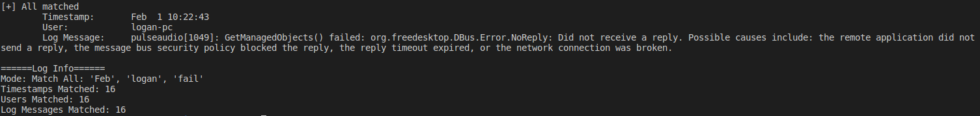
This is the final match found and the total matches that are displayed at the end of the script.

Results:
Below are screenshot for each mode tested on /var/log/syslog:

Using the timestamp option would allow searching for events that happened on a certain day or timestamp

Using the user option would allow you to find events originated from a specific username
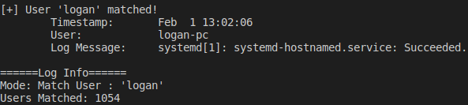
Finally the log message option would allow you to search the contents of the log messages for something like failures.

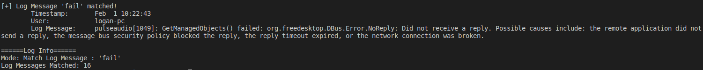

Conclusion:
In conclusion, this lab was fairly straight forward to complete. I didn’t run into any issues in making the script. I believe something like this could be useful to a security professional because it provides a simple way to parse potentially very large files quickly. Something like this could be useful for finding actions done by a specific user done in a certain time range. If I were to add more features to this script I would want some way to specify custom regex and possibly a way to search for multiple substrings rather than just one at a time.

