Logan Lipke
10/17/20
Lab 3 Report
CISS 247

In this lab I created four functions to complete some basic bit manipulation tasks. These functions could only use bitwise manipulation and were restricted to 8 bit integers.

I wrote four functions to test this. Function one required me to create the equivalent of bitwise AND using only NOT and OR. This was the function I created to do this:
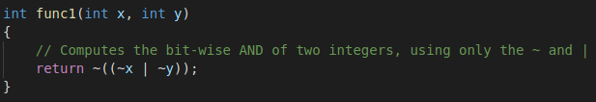
This function will return the NOT of NOT x OR NOT y. This works because if x is 1 and y is 0 or vice versa, the result of the OR will be 1. When this is negated the result is 0. When they are both 0 it becomes 1 OR 1 due to the negations and the result of 1 is negated ending with 0. Finally when they are both 1, they are negated to both be equal to 0, the result of the OR, 0, is negated to be 1.

The second function required me to create a logical XOR using only the NOT and AND bitwise operations. This is how I did it:
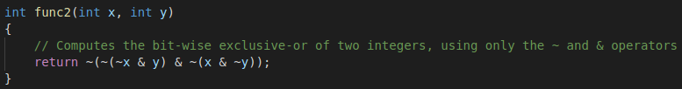
This function negates then ANDs the negated x AND y operation with an x AND negated y operation. It then negates the result to get an xor operation. If x is 1 and y is 0 then the result of NOT x AND y is 0, the result of x AND NOT y is 1. These are both negated which still leaves us with a 1 AND 0, this results in 0 which is negated one last time leaving us with a result of 1. This follows the XOR truth table of returning 1 only when one input is 1.

The third function will return 1 if any odd-numbered bits in an integer are set to 1 and will return 0 otherwise. We weren’t given a range for the integers to expect for this function but the test functions gave 8 byte integers so I assumed that it should work with 8 bytes. This is my function:
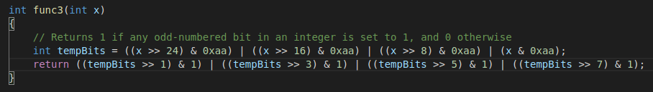
For this function I created a variable to hold the result of four shifts that are ANDed with 0xaa (the odd bits in 2 bytes) and then ORed with each other. This has the result of checking all 8 bytes for odd bits set. They are then shifted again four times by a number incremented by two each shift. This has the effect of checking all the odd bits in 2 bytes. Once they are compared to 1 and ORed with each other we can know if any of the odd bits were set.

The fourth and final function was similar to the third. For this one we are asked to return 1 if all the odd bits set to 1. This is my function:
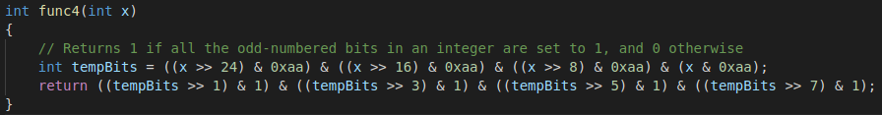
I used the same method here as I did in function 3 except I replace any ORs with ANDs. This allows the function to check every odd bit and if one is set to 0 it will return 0.

Overall I don’t think this assignment was too difficult. I learned a bit about boolean algebra designing the functions for the XOR and AND replacements, and was able to further improve my bit manipulation skills.

