Logan Lipke
11/10/20
CISS 247
Lab 8 Report
Introduction:
In this lab we are tasked with reverse engineering three executable files with gdb.
Process:
For Example1 I started by loading it into gdb and setting a breakpoint on main. After this I decided to look at the disassembly of main to see what was going on.

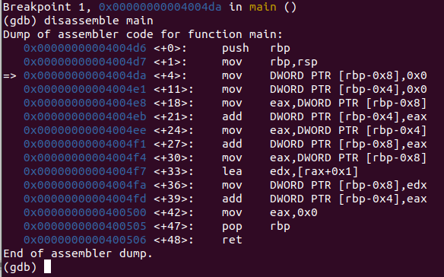
To the right is the disassembly output. The mov DWORD PTR [rbp -0x8],0x0 shows a variable being initialized to 0. This happens twice so there are two variables in this program. Looking at 0x400500 tells us that 0x0 is moved into eax, then rbp is popped off the stack, and finally we return. This program consists of a main function that returns 0.

Example2 had a little more going on with it. Similar to Example1 I loaded it into gdb, stepped through, and immediately noticed, again, that it was exiting after one step through. Looking into the disassembly revealed that it had a little more going on this time though.
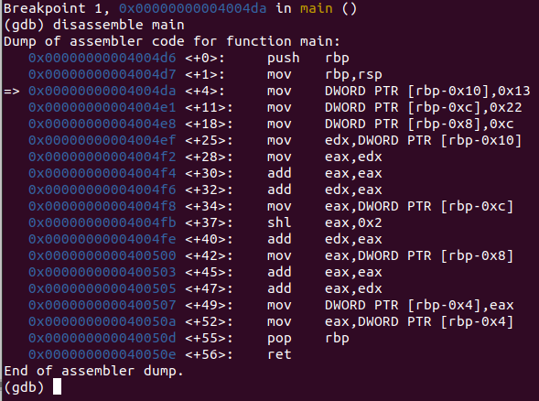

This program starts with three integer variables; 0x13, 0x22, 0xc. 0x13 is moved into eax and edx. Eax is then added to itself and again to edx. Edx is now equal to 0x13 * 3 or 57
After this 0x22 is moved into eax then shifted left by 2 and finally added to edx. Edx is now equal to 193.
Finally 0xc is moved to eax, added to itself, and the sum is added to edx. At the end of the program edx holds the value 217 or 0xd9. This is the value that is returned. We can see this by looking at the registers after stepping.

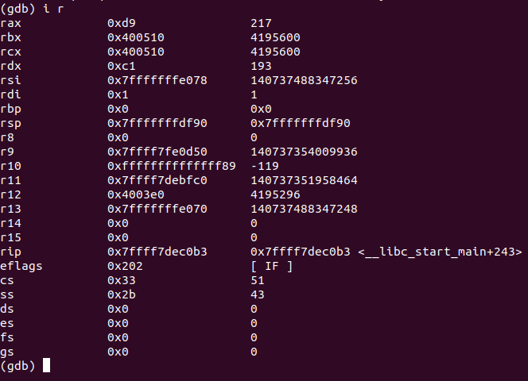

The first register rax (64 bit eax) can be seen with the value of 0xd9 or 217.

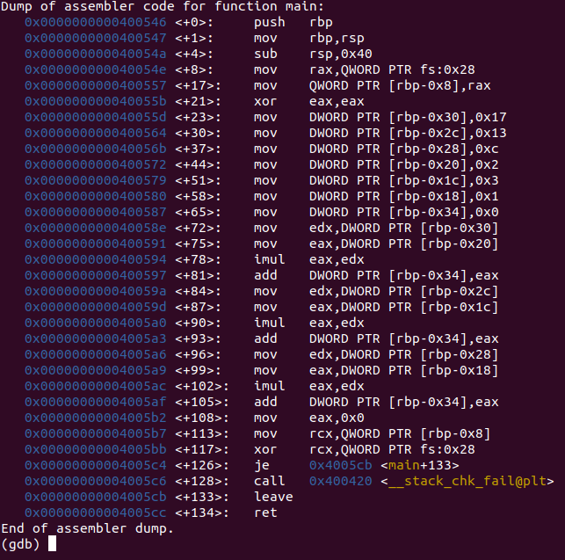
Example3 was the longest of the three programs. It starts by allocating space on the stack by moving rsp to rbp and subtracting rsp by 0x40. It then zeroes out eax and puts 7 numbers into an array; 0x0, 0x1, 0x2, 0x3, 0xc, 0x13, and 0x17. The spot on the stack storing 0x0 is a it different than the others because it is being used to store the sums of the products of other numbers. Continuing on, we start out by multiplying 0x17 and 0x2 and adding it to the total. Total now equals 0x2e. We then add the product of 0x13 and 0x3 to the total bringing it to 0x67. Finally we add the last product of 0xc and 0x1 to the total to get 0x73.

To check that we got the right number we can find the value at rsp before the program starts, subtract 0x34, and use that as an address for our result.

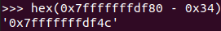

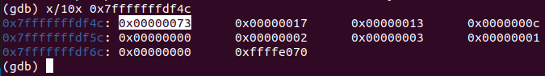
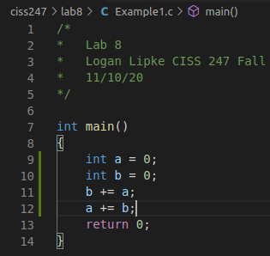
This shows the result in memory that we got from the program, which matches our calculations from earlier.

Testing:
The code for Example1.c is very simple since it’s just two ints equal to zero being added together.

Example2 had a bit more code but not much.
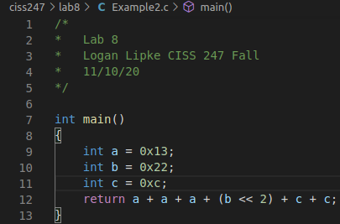

To see the result of this output I added a printf statement and got this:

Finally for Example3, the function was a bit longer since it created variables:
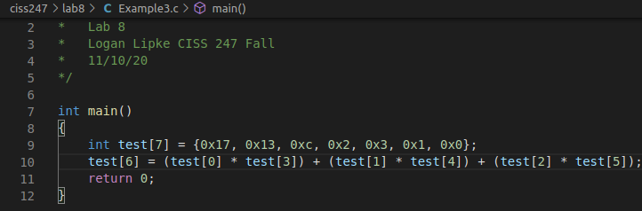
Adding output will show us that the value we found in memory earlier is correct.

Results:
To compare the result I will show the disassembly of each example program and the programs I wrote.

Example1: On the left is the example program and the right is the one I wrote

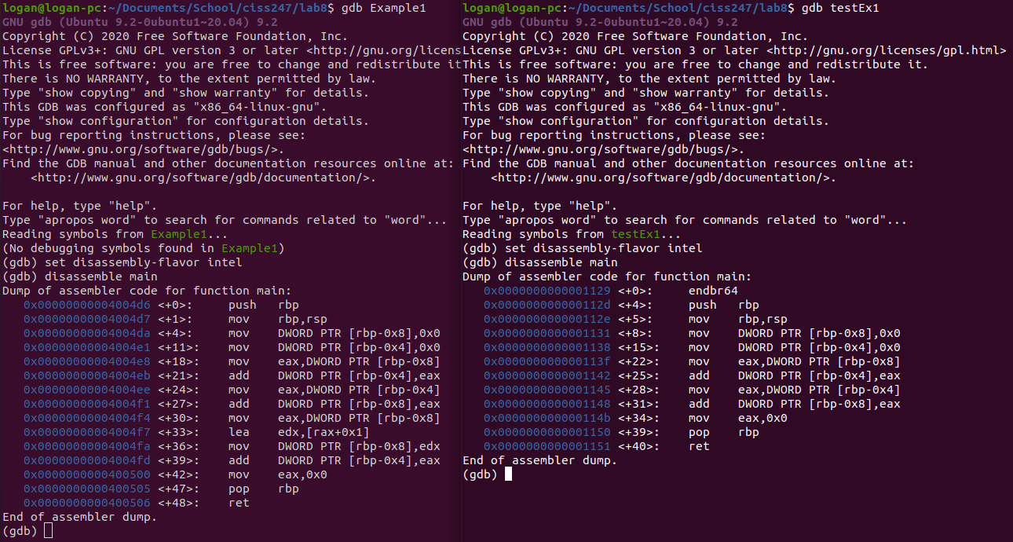
They’re similar aside from a couple lines at the bottom. I wasn’t too sure how to replicate those and with disassembling a program there’s always a chance of the compiler making optimizations that don’t always make sense.

Example2:
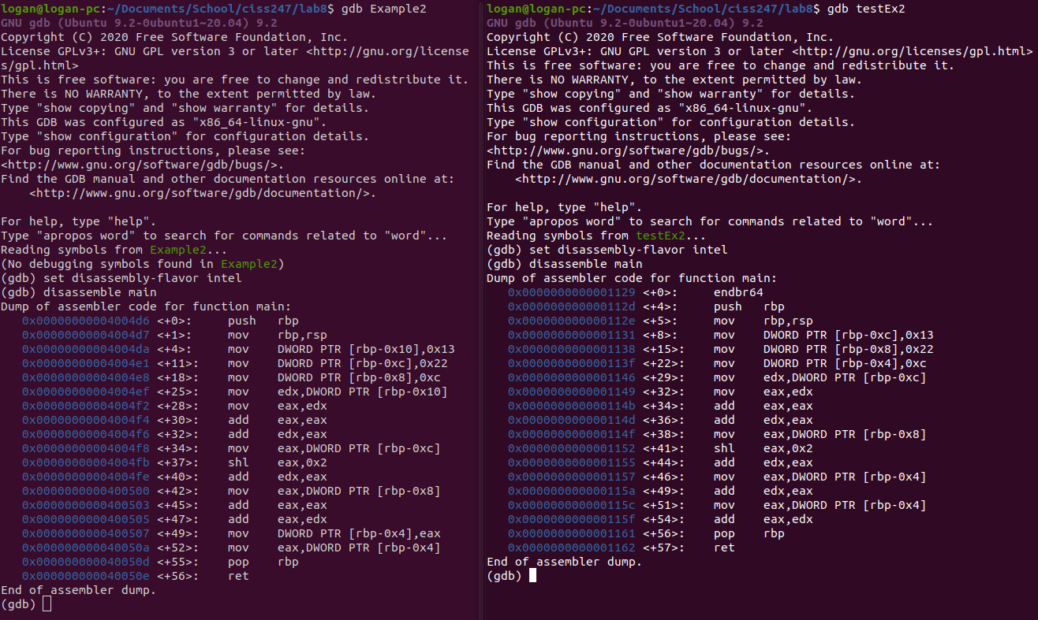
The disassembly for these two programs is identical aside from the offsets in memory being a bit different.
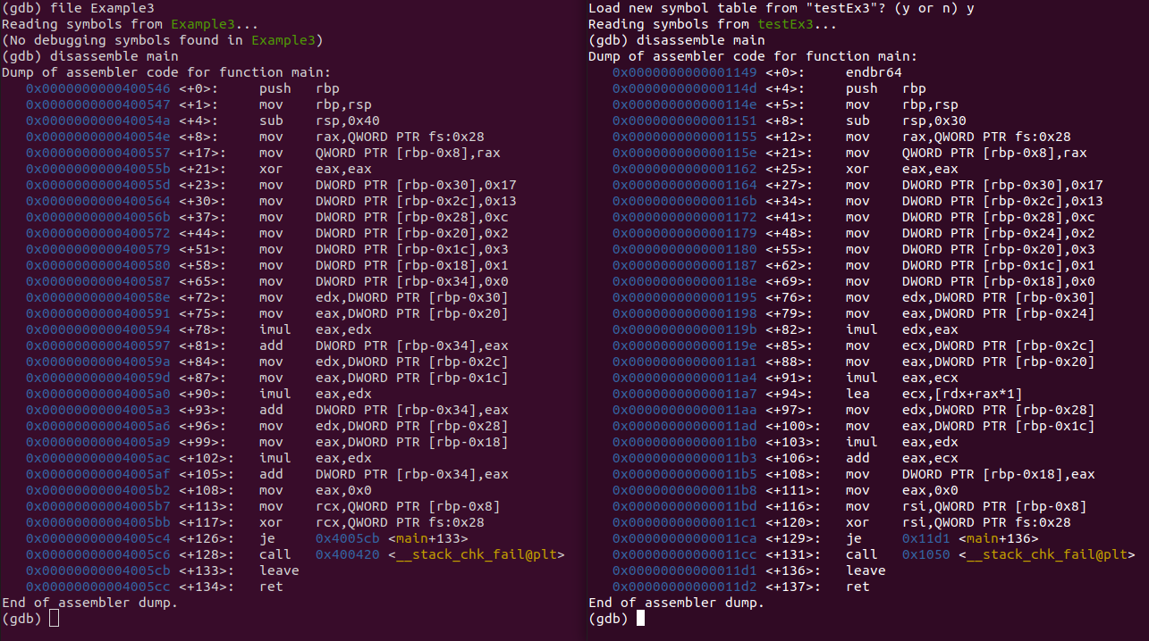
Example3:
These are, again, identical apart from some most likely compiler related additions or differences such as offsets or comparisons.

Conclusions:
In conclusion, this was a fun lab. It was interesting to see the different code that can be created because of compiler optimization or other factors. It was also fun getting to reverse engineer assembly code. This is a skill I hope to grow and potentially use in a career someday so getting more experience with these sorts of things is always welcome.

