# Introduction to the Web - A3 - HTML CSS and DESIGN

WebEdu

Logan McInerney - 11789145

Table of Contents:

* Concept Map
* CSS Design
* Structure Chart
* Storyboard
* index.html
* lm_A3_resume.html
* lm_A3_about.html
* lm_A3_web_skills.html
* style.css
* Validations
* Folder Structure
* Testing plan
* Personal Reflection / A2 to A3 Changes
* References

## Concept Map

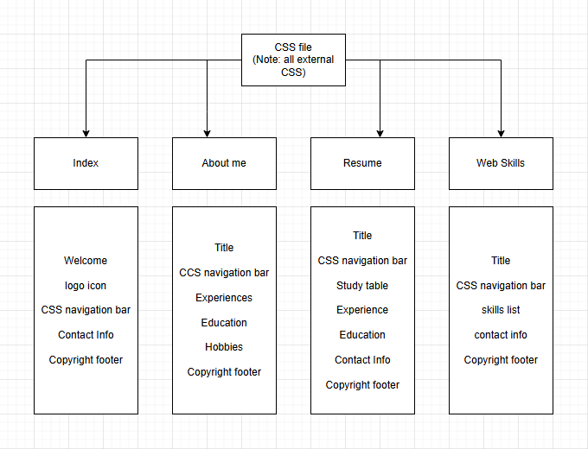

## CSS Design

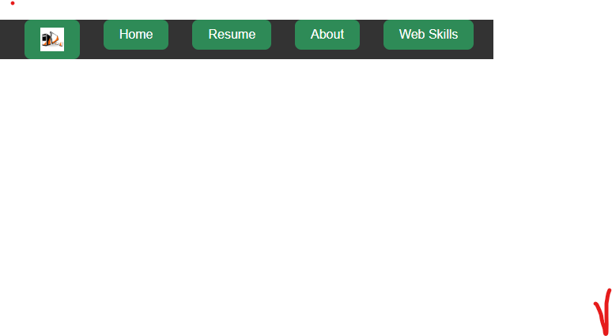CSS navigation buttons

The buttons in the navigation bar are styled using CSS to give them a border, padding, background colour and colour the buttons

Text

The text throughout the documents uses CSS to change it’s font family, font style, colour,and size

## Structure Chart

## 

## Storyboard

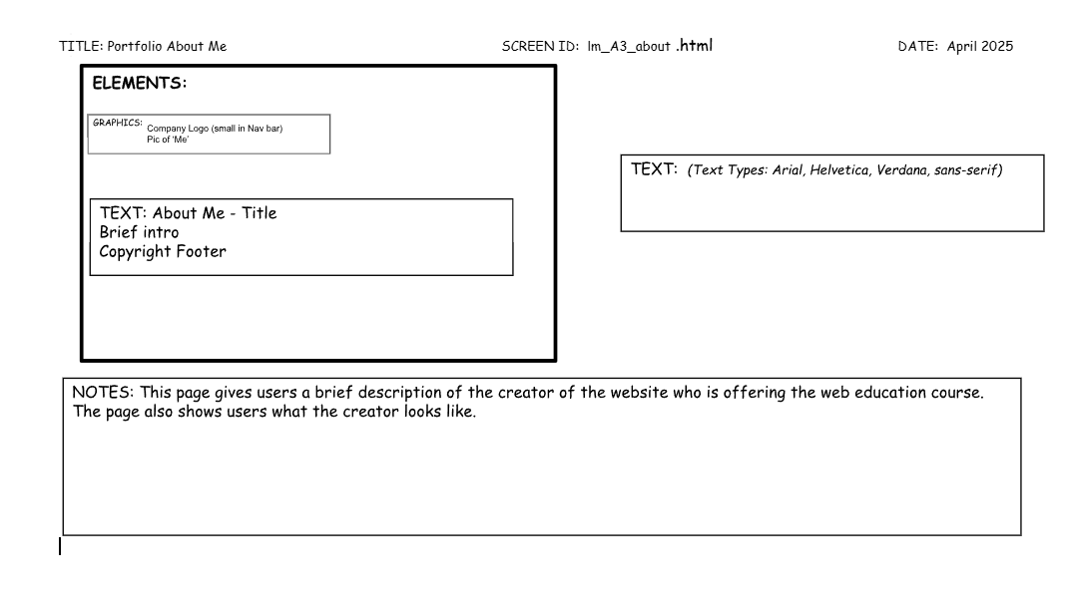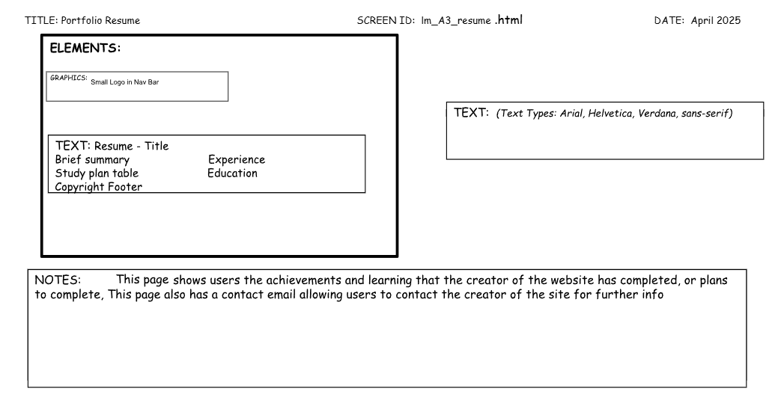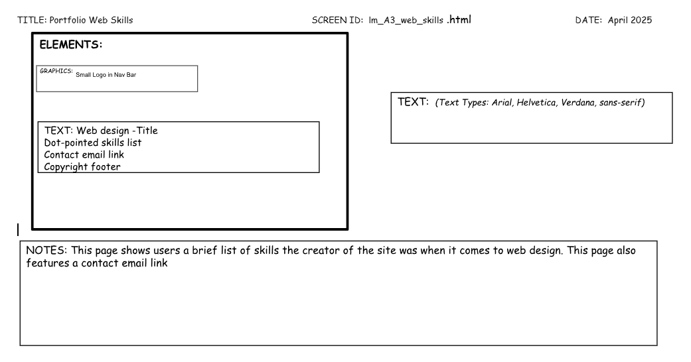

## 

## index.html

## 

## 

## 

## 

## 

## 

## 

## 

## 

## lm_A3_resume.html

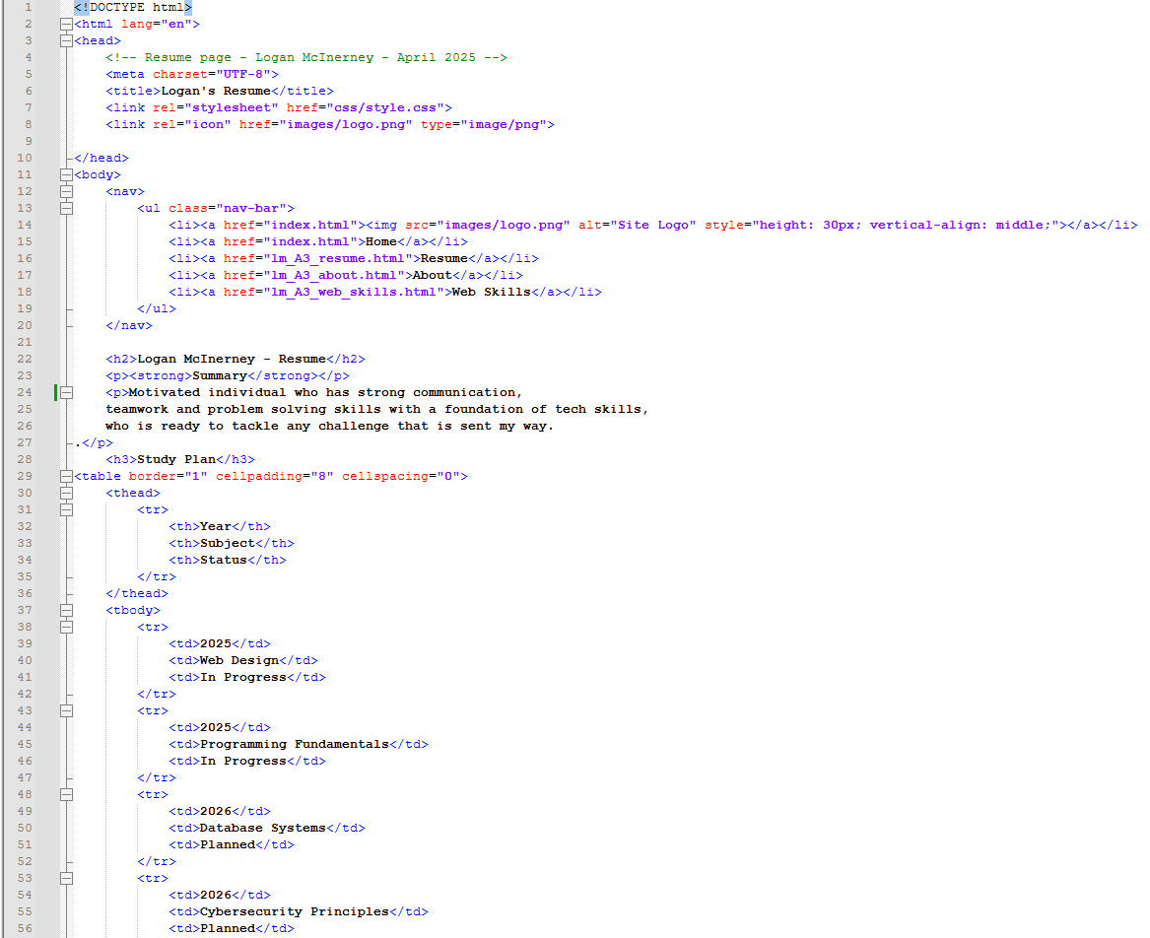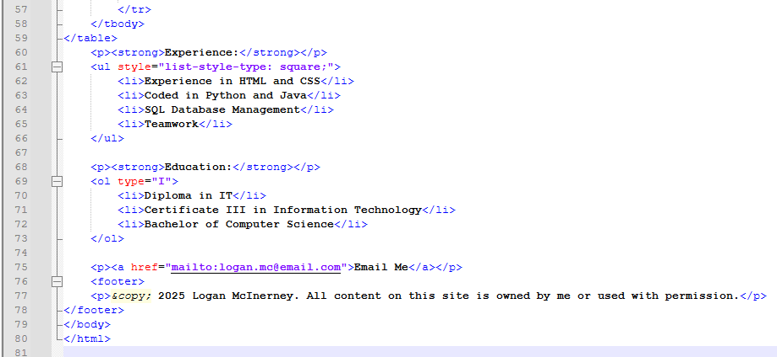

## lm_A3_about.html

## lm_A3_web_skills.html

## 

## style.css

Validations  
Index.html

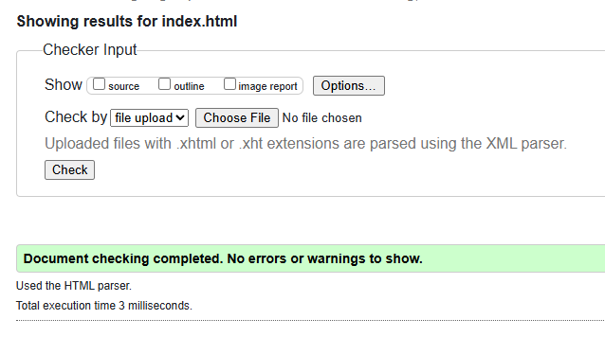

lm_A3_about.html

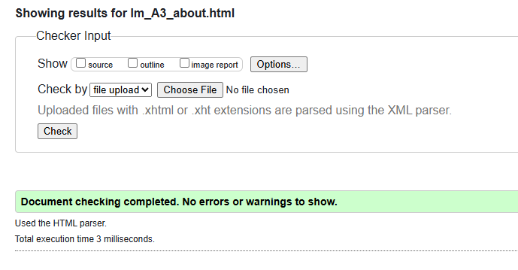

lm_A3_resume.html

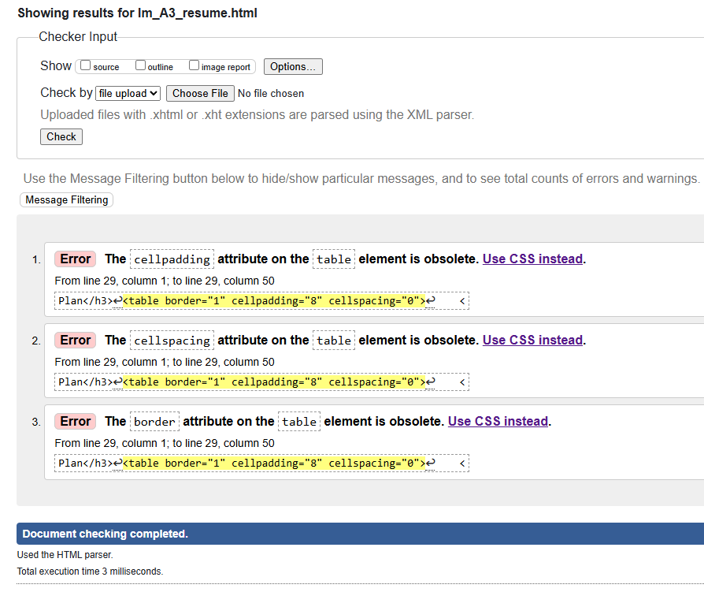

lm_A3_web_skills.htm

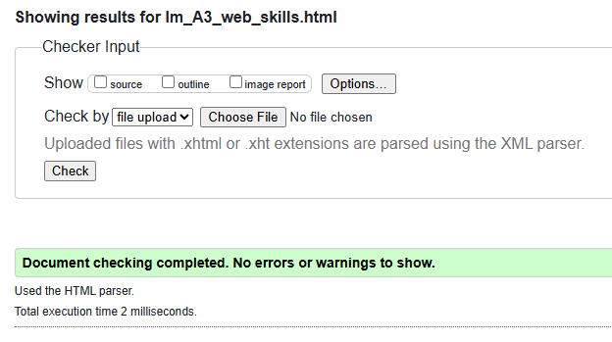l

## Folder Structure

## Testing Plan

| What is Being Checked | Expected Result | Actual Result |
| --- | --- | --- |
| Navigation Buttons | All buttons link to another page of the website | All navigation buttons worked as expected |
| Logo | Logo appears on all pages | Logo appears where expected |
| Print styling | Removes nav bar buttons and footer | Print styling works as expected |

## 

## Personal Reflection / A2 to A3 Changes

After completing Assessment 2, the WebEdu portfolio website has been improved in a number of ways for Assessment 3. The main change to the website was the consistency of colours and fonts between each web page, and having the CSS all done externally. These changes made the web pages feel unified, with a consistent theme from page to page, so it still felt like you were on the same website throughout. Where assessment 2’s main focus was to show that the different HTML processes could be complete, assessment 3 focuses on making the website that reflects a real website, having a ‘brand’ such as the logo in the tab bar at the top of every page.

Another improvement from A2 to A3 was the implementation of the copyright not on the footer of every webpage, it gave the pages a more professional look.

## References

Moonlight Creative. (2021,03, 08). Sitemaps vs Navigation: What’s the Difference? Moonlight Creative. <https://moonlightcreative.com/insights/sitemaps-vs-navigation-whats-the-difference/>

MDN Web Docs. (2025, 03, 22). CSS: Cascading Style Sheets. Mozilla Foundation. <https://developer.mozilla.org/en-US/docs/Web/CSS>

MDN Web Docs. (2025, 04, 11). *HTML: HyperText Markup Language*. Mozilla Foundation.<https://developer.mozilla.org/en-US/docs/Web/HTML>

W3Schools. (2025). HTML Element Reference. <https://www.w3schools.com/tags/default.asp>