# Introduction to the Web - A4 - HTML CSS DESIGN and Java Script

WebEdu

Logan McInerney - 11789145

**Website Link :** <https://loganmci.github.io/Assessment4/>

Table of Contents:

* Concept Map
* CSS Design
* Structure Chart
* Storyboard
* index.html
* lm_A4_resume.html
* lm_A4_about.html
* lm_A4_web_skills.html
* lm_A4_Communication.html
* lm_A4_Digital_Literacy.html
* lm_A4_Design.html
* lm_A4_Web_Developing_skills.html
* cssForm.css
* Style.css
* newsLetterForm.html
* Validations
* Folder Structure
* Testing plan
* Personal Reflection / Changes as the assignment progressed
* References

## Concept Map

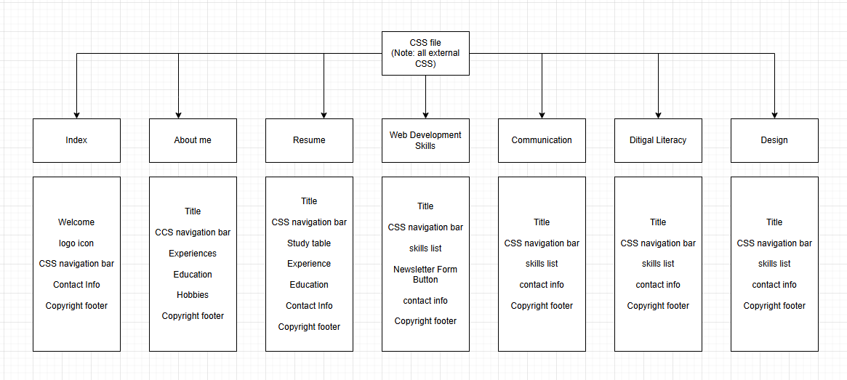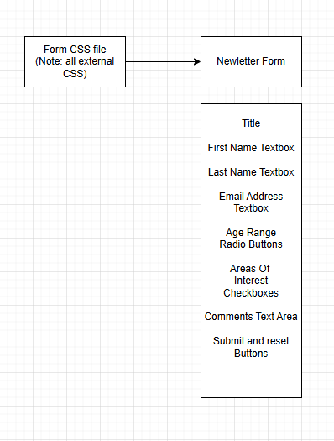

## CSS Design



CSS navigation buttons

The buttons in the navigation bar are styled using CSS to give them a border, padding, background colour and colour the buttons

Text

The text throughout the documents uses CSS to change it’s font family, font style, colour,and size

## Structure Chart

## 

## Storyboard

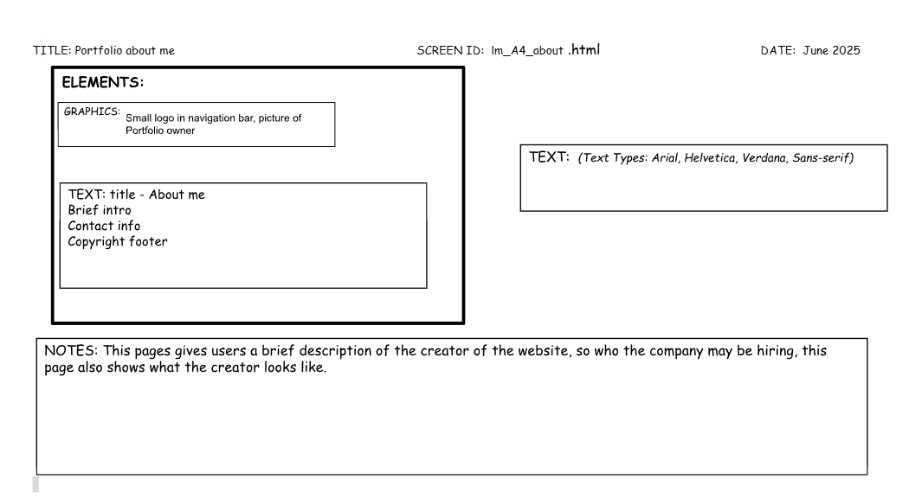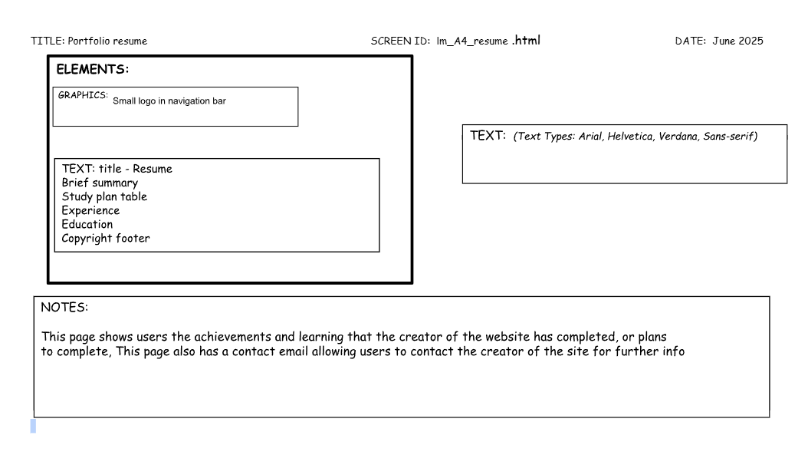

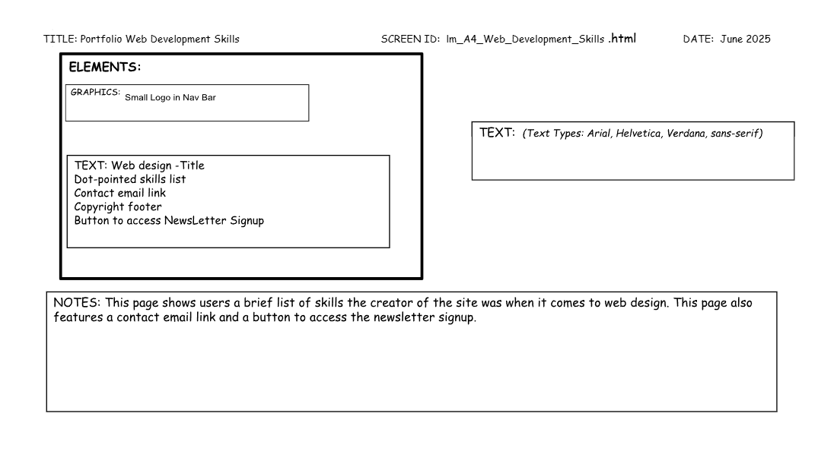

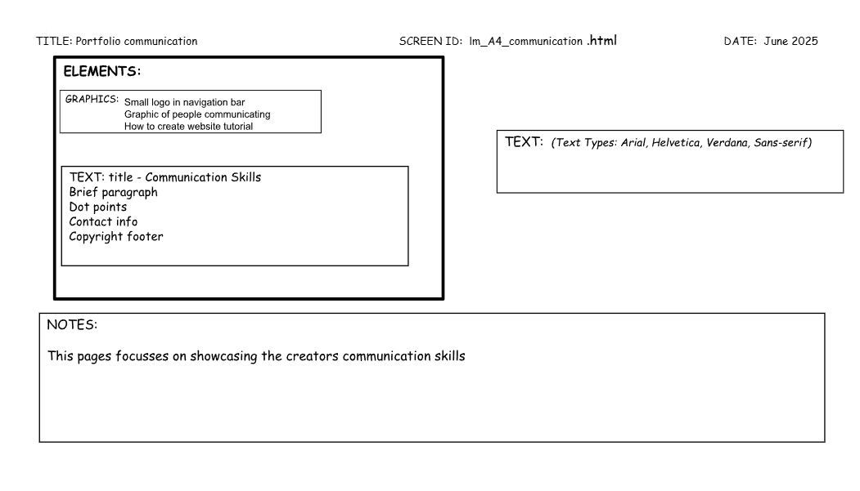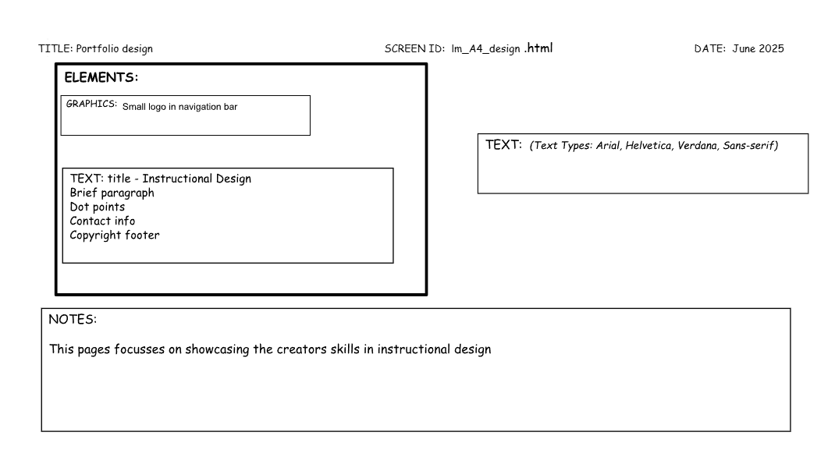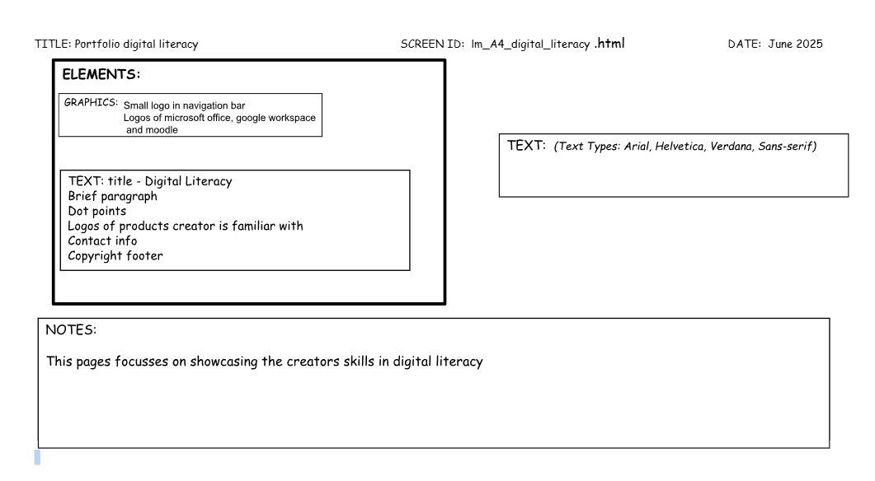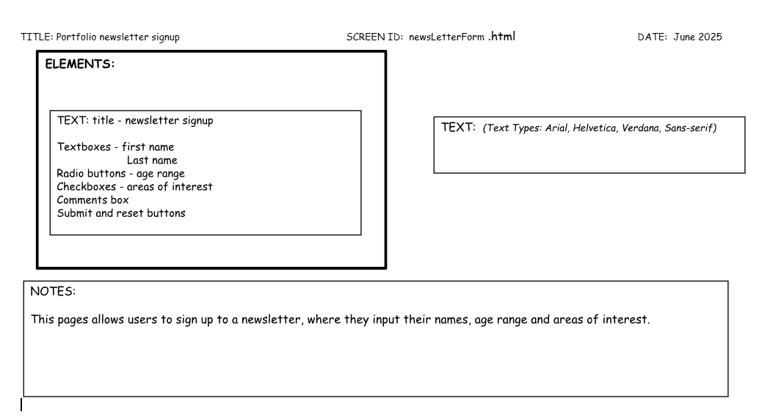

## 

## index.html

## 

## 

## 

## 

## 

## 

## 

## 

## 

## lm_A4_resume.html

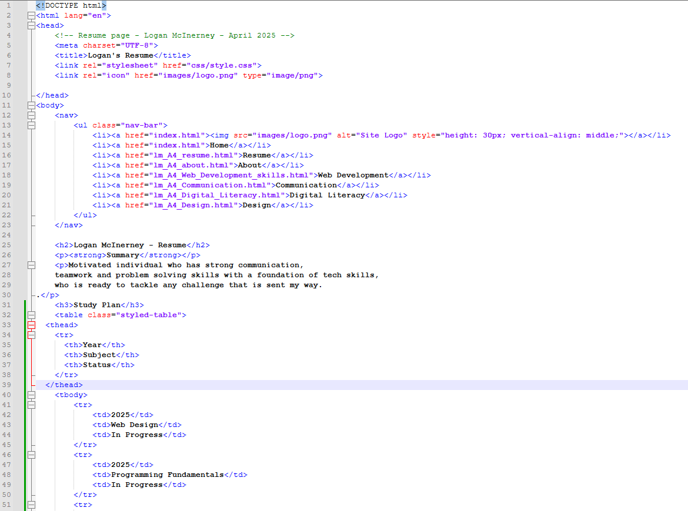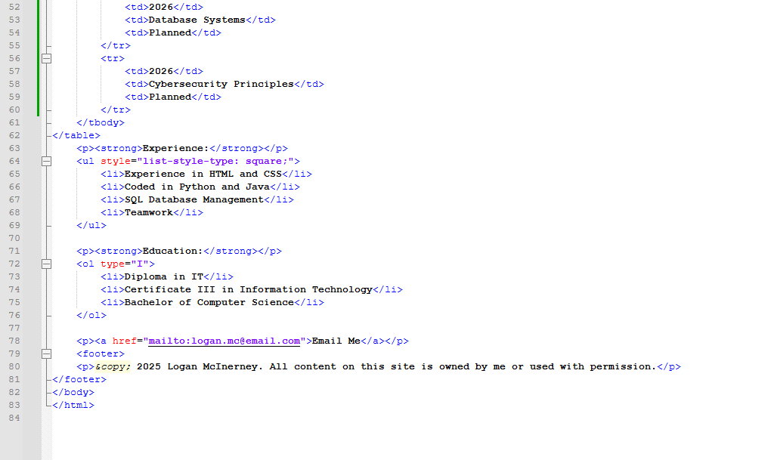

## lm_A4_about.html

## lm_A4_web_development_skills.html

## 

## lm_A4_Communication.html

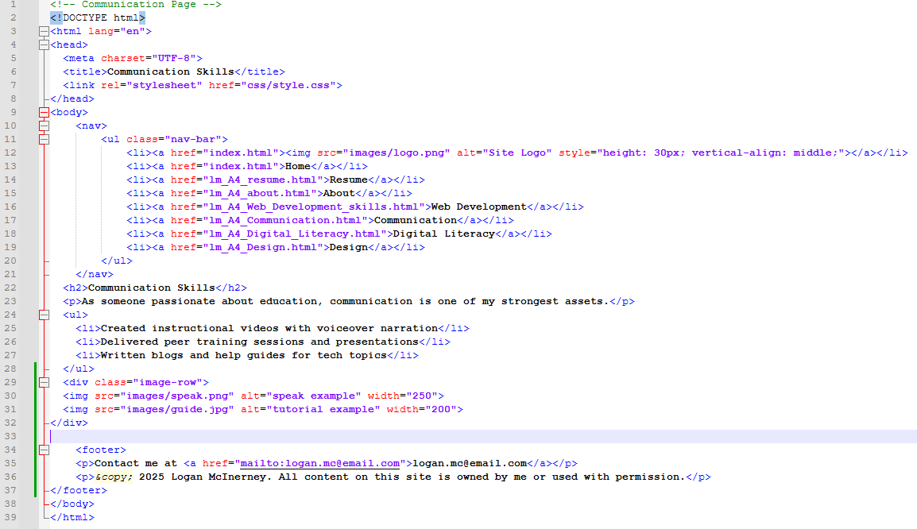

## lm_A4_Digital_Literacy.html

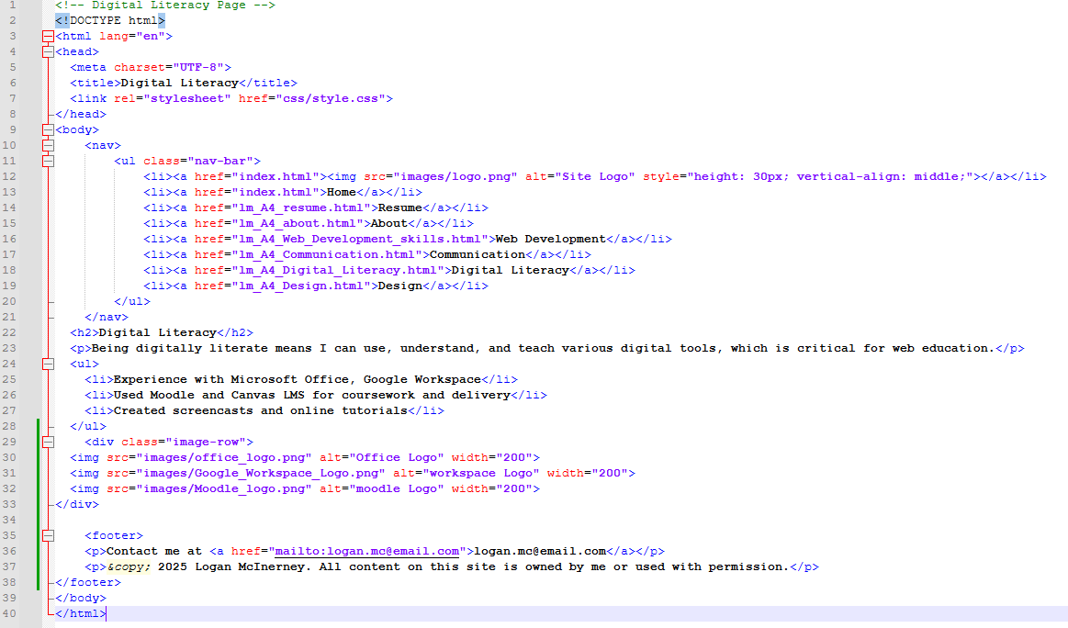

## lm_A4_Design.html

## 

## newsLetterForm.html

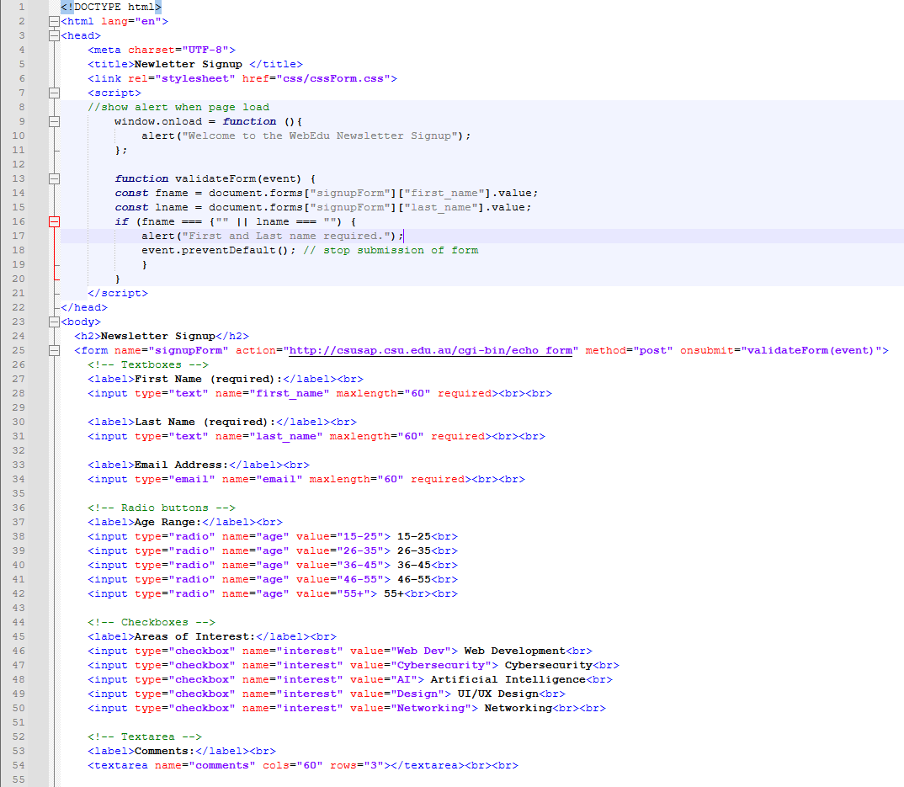

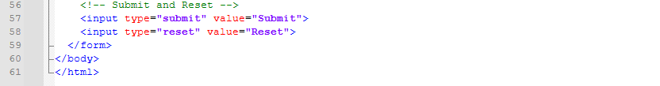

## cssForm.css

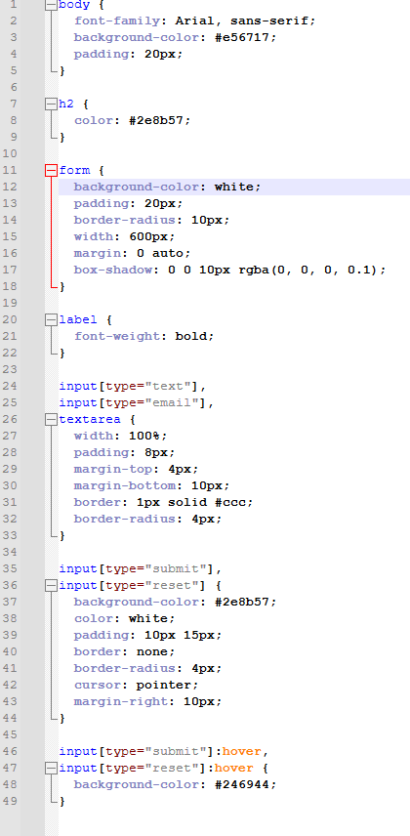

## style.css

Validations  
Index.html

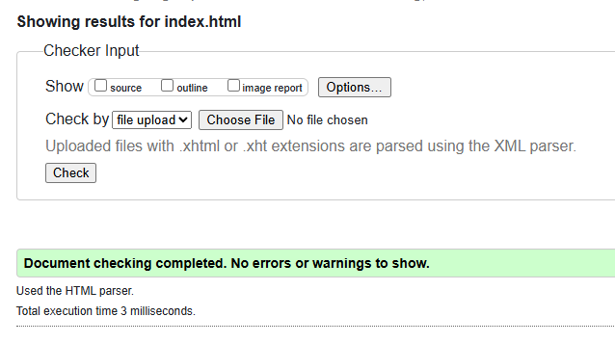

lm_A4_about.html

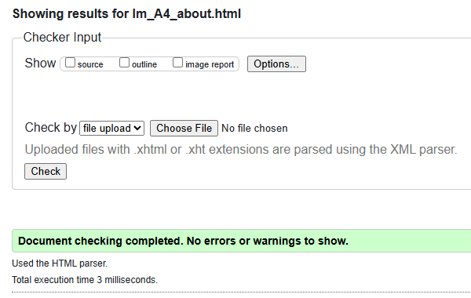

lm_A4_resume.html

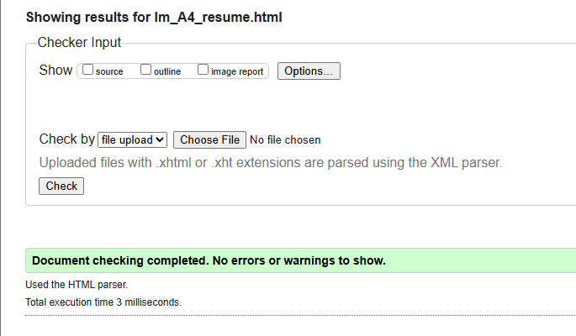

lm_A4_Web_Development_Skills.html

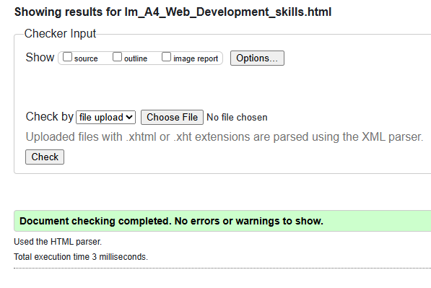

lm_A4_Communication.html

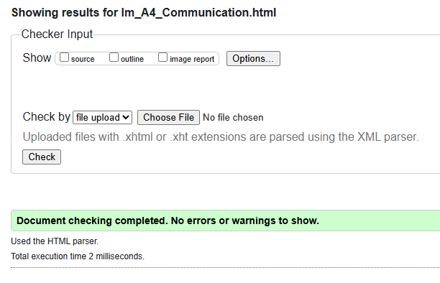

lm_A4_Digital_literacy.html

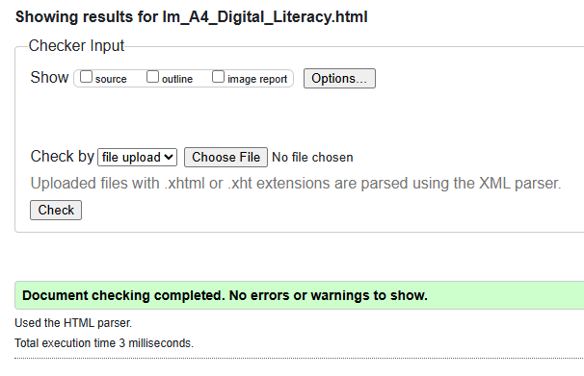

lm_A4_Design.html

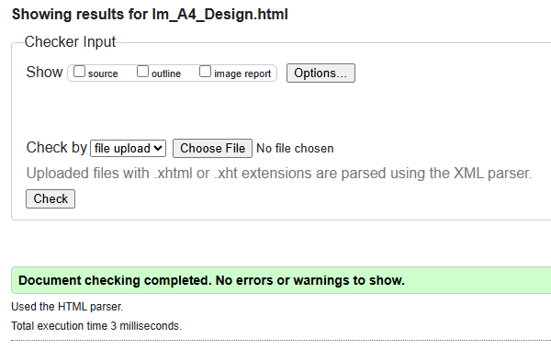

newsLetterForm.html

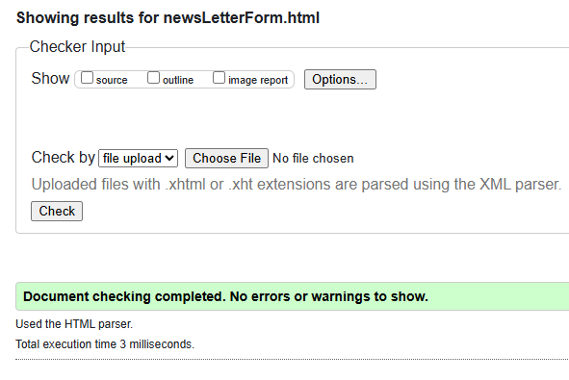

## Folder Structure

## Testing Plan

| What is Being Checked | Expected Result | Actual Result |
| --- | --- | --- |
| Navigation Buttons | All buttons link to another page of the website | All navigation buttons worked as expected |
| Logo | Logo appears on all pages | Logo appears where expected |
| Print styling | Removes nav bar buttons and footer | Print styling works as expected |
| Newsletter form | Newsletter form opens in new tab | Newsletter form works as intended |
| Newsletter radio buttons | Test is radio buttons are functional | Radio buttons are functional |
| Newsletter checkboxes | Check if checkboxes are functional | Checkboxes are functional |
| Newsletter Text boxes | Check is text boxes are functional | Text boxes are operational |
| Newsletter submit and reset buttons | Check if reset and submit work as intended | Reset and submit buttons work |
| External CSS | All CSS is to be external from the html files | No CSS was found in the html files |

## 

## Personal Reflection / Changes for A4

After completing assessments 2, 3, and now 4 the webedu website that I have slowly constructed and upgraded has gone through a few different iterations. The biggest change that occurred coming into assessment 4 was the implementation of javascript in the form of the newsletter signup. Implementing the javascript elements to the website gave it a more realistic feel, even though the website is for a purely fictitious company. Furthermore, having to set up the hosting for the website on github now means that the website can actually be accessed online, like a real website, which also adds to the authentic feel.

Additional pages were also added during this edition of the assessment, with each of the new web [ages showcasing a particular skill that would be desirable for a company looking for new hires in the ‘web education industry’.

On the submission of assessment 3, there were still some issues when I validated code, in particular with the table used on the resume web page. This issue has now been resolved.

## References

Moonlight Creative. (2021,03, 08). Sitemaps vs Navigation: What’s the Difference? Moonlight Creative. <https://moonlightcreative.com/insights/sitemaps-vs-navigation-whats-the-difference/>

MDN Web Docs. (2025, 03, 22). CSS: Cascading Style Sheets. Mozilla Foundation. <https://developer.mozilla.org/en-US/docs/Web/CSS>

MDN Web Docs. (2025, 04, 11). *HTML: HyperText Markup Language*. Mozilla Foundation.<https://developer.mozilla.org/en-US/docs/Web/HTML>

W3Schools. (2025). HTML Element Reference. <https://www.w3schools.com/tags/default.asp>