Raytracer Writeup

The raycasting engine provides a simple interface for seeing how different input parameters are reflected in the output images. One of the first things I had to resolve was my mental model of the scene as it relates to the coordinate plane. I was invisoning a scene with the positive x axis to the right, positive y axis up, and positive z axis forward. This does not work in a right handed system. This confusion made the images appear reflected about the YZ plane from my expectations as I experimented with changing the parameters. Once I resolved this confusion, I was able to dig into how changing other parameters affected the output.

1. Direction of the up vector

I used the following base image to review modifications to the up vector:



Of relevance, the viewdir is [0,0,-1].

Rotating the up vector in the Z direction resulted in no change due to it being used to disambiguate changes in the angle in the x direction:

Similarly, changes in the Y direction didn’t result in a change until it’s sign changed which reflected the image across the ZY plane



Finally, rotating in the X direction, both in the negative and positive directions resulted in the image rotated in the opposite direction by the same amount

Positive X



Negative X



1. Vertical Fov

I used the same base image for the vertical fov analysis. By changing the fov, more of the space around the spheres was visible. The base image had an vertical fov of 45 degrees

Vfov: 90 degrees

The spheres take up less of the image and more distortion is visible on the blue sphere in the horizontal direction with a larger fov.



Vfov: 15 degrees

The spheres that are visible are larger and the blue sphere is completely cut from view. In addition less distortion is visible



1. Distortion

To better visualize distortion I used a grid of spheres:

The vertical and horizontal fov is 90 degrees and some distortion is already visible along the edges.

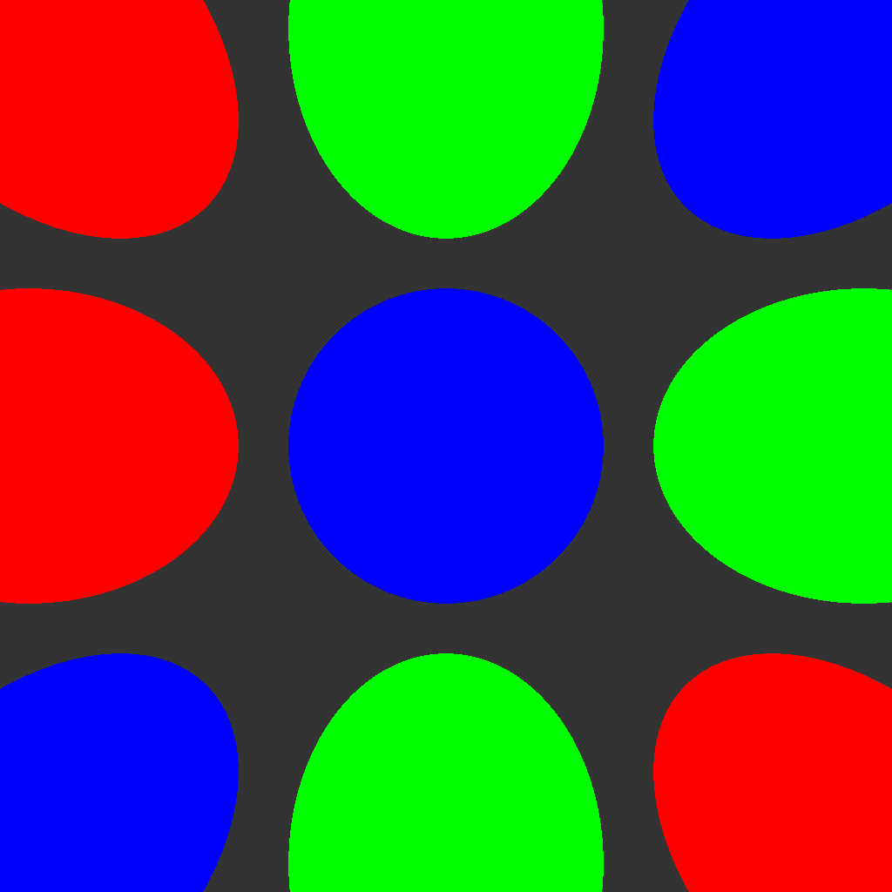

Increasing the fov results in more distortion (and more of the spheres visible)

Using a wider image resulted in a higher horizontal fov and more distortion.

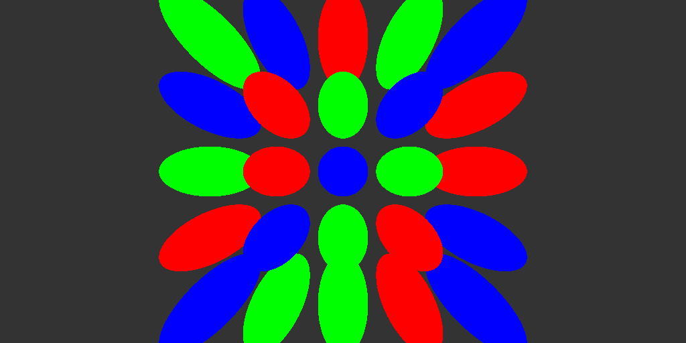

Shifting the initial camera position causes the center of distortion to shift with it

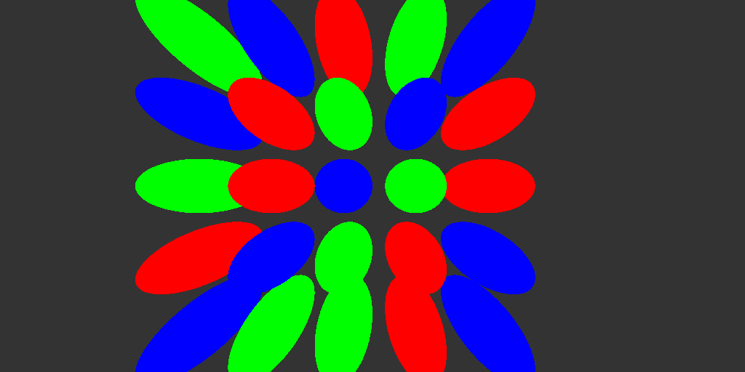

As pointed out in the fov section, smaller fov results in less distortion.