***Summative2***

***Accommodation***

***Web Proposal***

***11th November 2020 - 4th December 2020***

**Client-**Tourism New Zealand

**Designer : Logan Robb**

Table of Contents

Strategy phase 3

Research 4

Questionnaire 4

Questionnaire summary 4

Survey 4

Use Case Diagram 7

Algorithm 8

Competitors 8

SWOT 8

Target Audience 9

Secondary TA 10

Personas 10

Timeline 12

# Strategy phase

Proposal    
Tourism New Zealand has approached me to create a website to hit the market of people only coming to New Zealand for a short while.

Response

I will create a single page application that allows users to easily book their stay in a hotel with calculated costs and an option to add meal options.

Business Requirements

To attract people to come travel to New Zealand.

User Requirements

To find the right place for them to stay on their journey in New Zealand.

Assumptions

* Could take up more horizontal space on the page
* They should add a filter for how many people

# Research

## Questionnaire

1. Book a hotel in Wellington
2. Find the cheapest hotel option in Wellington
3. Find a Motel
4. Find a place to stay between $100 - $150

## Questionnaire summary

1. Was very easy, no problems.
2. Was a little bit harder. 1 of the people couldn't find the lowest to highest button.
3. Was hard to tell the difference between different types of accommodation
4. This was easy as for all users

## Survey

* Which age range suits you?
* How many times per year do you book a holiday online?
* How many people usually go with you?
* How many days do you usually go for?
* How do you usually find a place to stay?
* What is the most important information when booking accommodation?
* Do you usually go for the meal deals when booking a place to stay?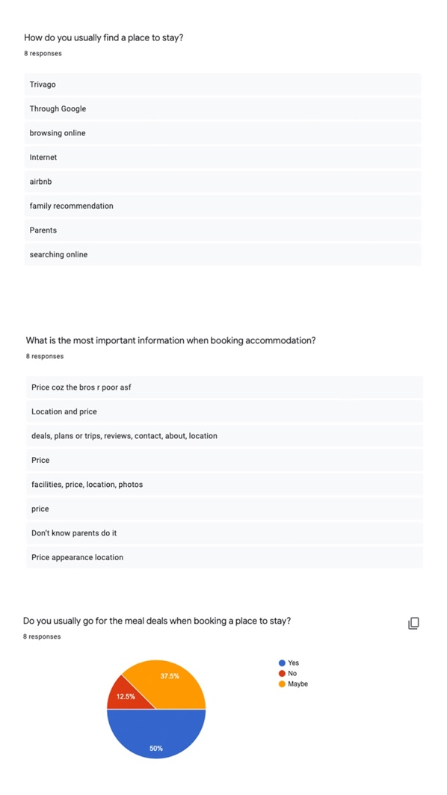

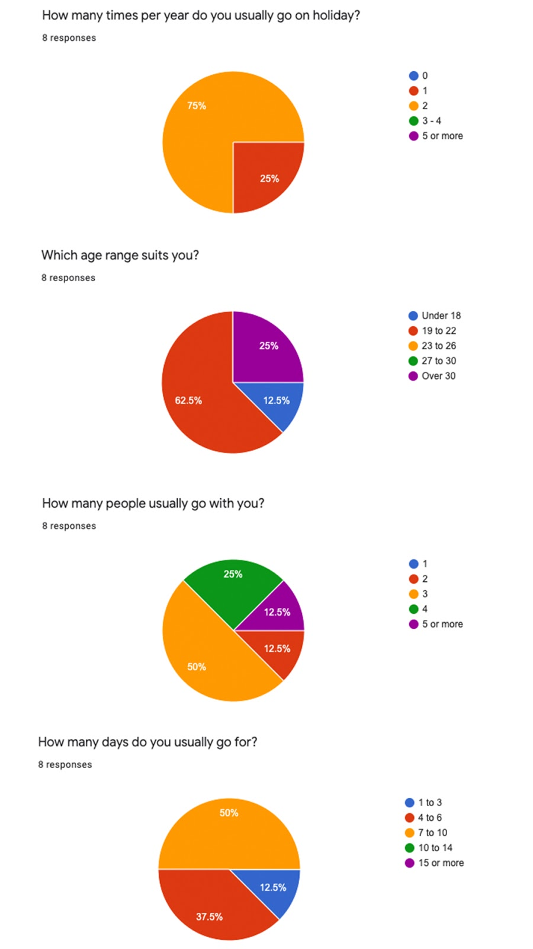

Accommodation

* Hotel 1-2 people – $157/night – min 1 night, max 5 nights
* Hostel 1 person – $30/night – min 1 night, max 10 nights
* Motel 2-4 people $90/night – min 3 nights, max 10 nights
* House 1-4 people $240/night – min 2 nights, max 15 nights

Interviews

* What do you think works with this webpage?
* Thoughts on the colours used?
* Are the filters relevant to the inputs you need to book a hotel
* What is missing from the filters/webpage

Interview summary

* Colours and font suit the page, easy to follow and navigate site
* Simple and suiting
* Yes
* Nothing

<https://www.tourismnewzealand.com/>

# Use Case Diagram

*User*

1. Filter input asking for days, number of guests and if they want to add breakfast.
2. Look at the map and look through the filtered accommodation to suit their needs.
3. See total price and proceed to relative website

Admin/Developer

1. Change list of accommodation
2. Update design
3. Update costs

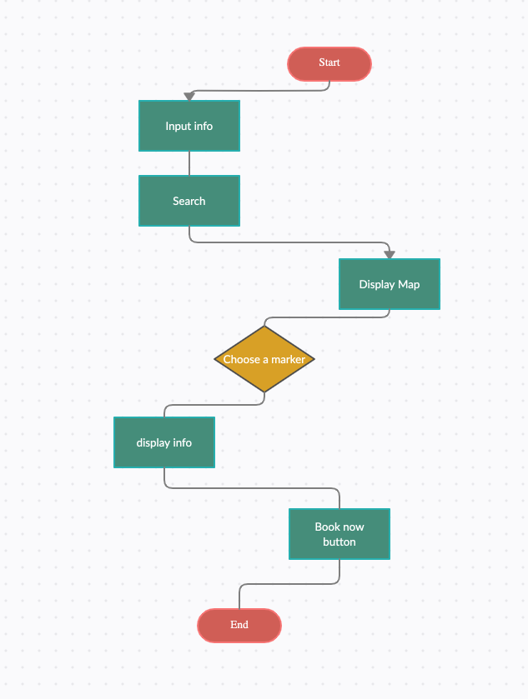

## Algorithm

1 - User input

2 - Click search button

3 - Modal of map comes up with markers with hotels that fit their input.

4 - Once marker is clicked it will open a modal like window showing the accommodation with a photo and description

5 - Click book now

## Competitors

[www.booking.com](http://www.booking.com)

www.trivago.co.nz

## SWOT

Booking.com

*Strengths*

* Simple trusting colours
* Eyes go straight to important parts of the page
* Has offers on the main page

*Weaknesses*

* Doesn't look that exciting
* Looks like its missing information on the main page
* All the info is crammed into a tiny space

*Opportunities*

* With the style of the website it would be cool to see more green to make it look more like New Zealand to tourists.
* Having a map on the main page.
* Have more options on booking on the main page.

*Threats*

* People not seeing the good deals
* People being unsure because there are no prices on the main page
* Doesn't have anything about covid stuff.

SWOT

Trivago.co.nz

*Strengths*

* Well known
* Saves recent activity
* Good marketing

*Weaknesses*

* Has almost nothing on the main page
* Quite hard to find information

*Opportunities*

* Could add some different colours onto the website
* Add some indication about scrolling down on main page
* Make the nav a bit more obvious

*Threats*

* Other sites are easier to use.

## Target Audience

Primary TA

* 27 - 40 year olds
* Work in the city in an office job
* Travels in from the suburbs
* Has spare money around
* Is good at saving/not spending money
* Don’t mind spending the bit extra for quality or a better experience.
* Look for the best deals
* Organised
* Plans ahead

## Secondary TA

* 18-25 year olds
* Want to go somewhere that looks cool on social media.
* Want to spend everything they have to make it the best holiday/trip possible.
* Do lots of things with their friends
* Working in the suburbs
* Plan things ahead of time to do while on holiday
* Wants to stay in a place of luxury.

## Personas

Tell a story!



*Amy*

* 32 years old
* Mother of 2
* Wants a getaway with her husband for the weekend
* Works in a local pharmacy
* Has extra money that she saves for holiday and special events.
* Extroverted
* Has a big group of friends.
* Uses social media a lot to update her friends on what she's been up to.
* Like to try different brands out to find the best one.
* Lives in New Zealand
* Likes booking holidays but it always takes way longer than she wants it to. She would like a solution to make booking faster.
* Ideally would like to be able to book everything on the same website
* Good with technology



*Adam*

* 21 years old
* Owns his own fencing business
* Single
* Enjoys spending time with his group of mates
* Does not go on holidays very often
* Extroverted
* Not the best with technology
* Wants a boys trip
* Has extra money to spend
* Loyal to brands
* Doesn't care about labels
* Lives out on a farm/lifestyle block
* Organised
* Like doing new things
* Will usually plan a holiday like a week or 2 before he goes.

Tools used

* Atom (javascript, html, css)
* Koala
* Bootstrap
* Popper
* Photoshop
* Google

# Timeline

Wed 11th Nov

* Create timeline

Thurs 12th Nov

* Look at competitors
* Competitor Analysis
* SWOT
* Start on target audience
* Write survey and interview questions
* Conduct survey

Friday 13rd Nov

* Finish Target Audience
* Conduct interviews
* Persona’s
* Got all the results from interviews and surveys
* Research done (milestone)

Weekend 14th - 15th Nov

* Finalise design choices(milestone)(deliverable)
* Start figma

Mon 16th Nov

* Work on prototype
* (Over the weekend and monday something came up that meant I could not work.)

Tues 17th Nov

* Work on prototype
* (ended up starting prototype on this day)

Wed 18th Nov

* Finish hi fi prototype(milestone)

Thurs 19th Nov

* Style Guide (deliverable)
* (ended up finishing my figma on this day)

Friday 20th Nov

* User testing

Weekend 21st - 22nd Nov

Mon 23rd Nov

* File setup
* Start coding(milestone)

Tues 24th Nov

* Working on mainpage

Wed 25th Nov

* Finish input

Thurs 26th Nov

* Coding

Friday 27th Nov

* Coding

Weekend 28th - 29th Nov

* Coding

Mon 30th Nov

* Coding

Tues 1st Dec

* Coding

Wed 2nd Dec

* Wrap up coding
* Debug

Thurs 3rd Dec

* Finish coding(milestone)

Friday 4th Dec

* HAND IN(deliverable)

Timeline summary

I actually stuck to what I planned bother than one weekend when something came up