Regional and Temporal Variation in Coal Power's Emission Intensity:
A Global Analysis (2000–2024)

Logan Rosell
School of Computing & Information Sciences, Willamette University
Data501: Data Science With R
Dr. Zechariah Meunier
December 10, 2025
Contents
Introduction 2
Methods 4
Data 4
Tests 5
Models 5
Linear Regression Assumption Tests 6
R Packages Used 8
Results 9
Testing Difference in CO2 Intensity Between Regions 9
Modeling Intensity Over Time By Region 10
Global Model 10
European Model 12
Latin American Model 13
Asian Model 13
Oceanian Model 14
Discussion 14
Question 1: Differences Between Regions 14
Question 2: Differences Over Time 15
Limitations 16
Conclusion 17
References 18
Appendix 19

Introduction
Climate change is perhaps the defining issue of our time. A significant portion of the greenhouse gases we continue to emit, worsening the health of the global climate, come from the production of electricity. Cleaning the means by which we create our power is the key to unlocking many other climate solutions, including electric vehicles, home heating, and the impact that the growth of AI datacenters will have on our future. Without a clean source of electricity, even our best-intentioned interventions will merely shift the point of emissions as in the case of transportation from the tailpipe of a car to the exhaust stack of a power plant.
There are many ways that electricity is currently generated, largely split into clean sources (solar, hydro, wind, and nuclear) and dirty sources (oil, coal, and natural gas). Clean forms of power generation emit either zero or negligible amounts of greenhouse gases, so it is natural to focus on the so-called dirty forms of power. Among the common fossil-fuel power sources, coal produces by far the highest amounts of air pollutants for a given unit of electricity generated (National Renewable Energy Laboratory [NREL], 2021). It should be noted that the combustion of coal releases multiple forms of air pollutants, several of which are greenhouse gases and some of which are harmful to human health but do not directly contribute to human-caused climate change. CO2 is the primary pollutant of concern when discussing climate, and thus for the sake of simplicity and to limit the scope of this analysis, I will focus on the CO2 emitted by coal-fired power plants, given their outsized contributions to air pollution worldwide and thus to climate change.
Given that coal is the dirtiest way to generate electricity (Xu et al., 2024), one might assume that the best way to reduce emissions in the power generation sector would be to stop burning coal. This is the fastest way to reduce emissions, but the choice of which fuel to use to create power depends not only on emissions, but also on cost, technological know-how, politics, existing infrastructure, geography, and the needs of electrical grids. Therefore, other emission reduction solutions have been proposed and implemented for coal power plants to fill the gaps where greener power may not yet be feasible. The amount of CO2 produced by a coal-power plant depends on the grade of coal used (Quick & Glick, 2000), the efficiency of the plant (Yue et al., 2024), and flue gas scrubbers (Baloyi, Okonye, & Ren, 2024). Given the granularity of emissions limited only to total CO2 output by fuel source and country, this analysis will not be able to disaggregate the relative impacts of the methods used to reduce per-generation CO2 emissions and will instead focus on the split between the impact of coal-power capacity reduction and efficiency efforts in aggregate between global regions.
Research Question: Does coal power’s CO2 emission intensity vary across global regions and time between 2000 and 2024?
Null Hypothesis A: Coal power CO2 emission intensity does NOT vary between global regions.
Alternative Hypothesis A: Coal power CO2 emission intensity DOES vary between global regions.
Null Hypothesis B: Coal power CO2 emission intensity does NOT vary over time between global regions.
Alternative Hypothesis B: Coal power CO2 emission intensity DOES vary over time between global regions.

Methods

Data
These data were published by Ember, an Energy Think Tank (Ember, 2024). This dataset contains the production (TWh), demand (TWh), and resulting CO2 emissions (mtCO2) split out by the fuel sources used to produce that power for 215 countries or economies from the year 2000 to 2024.
Table 1
Explanation of Variables
Variable | Explanation
Area | Represents seven areas of the world:  Asia  Africa  Europe  Latin America and Caribbean  Middle East  Oceania  North America
TWh | Terawatt hours of electricity generated from coal fired power plants in a given year
mtCO2 | Million metric tons of carbon dioxide produced from coal fired power plants in a given year
mtCO2_per_TWh | The CO2 intensity or how many million metric tons of CO2 are emitted by coal fired power plants to produce one terawatt of electricity.

The response variable, mtCO2_per_TWh was calculated by dividing the mtCO2 by the TWh columns, which were already provided in the original dataset. The global regions used for the analysis were aggregated within the original dataset.

Tests
Testing for normal distribution, starting with a histogram, we can see that these data appear to be right skewed (Figure 1). 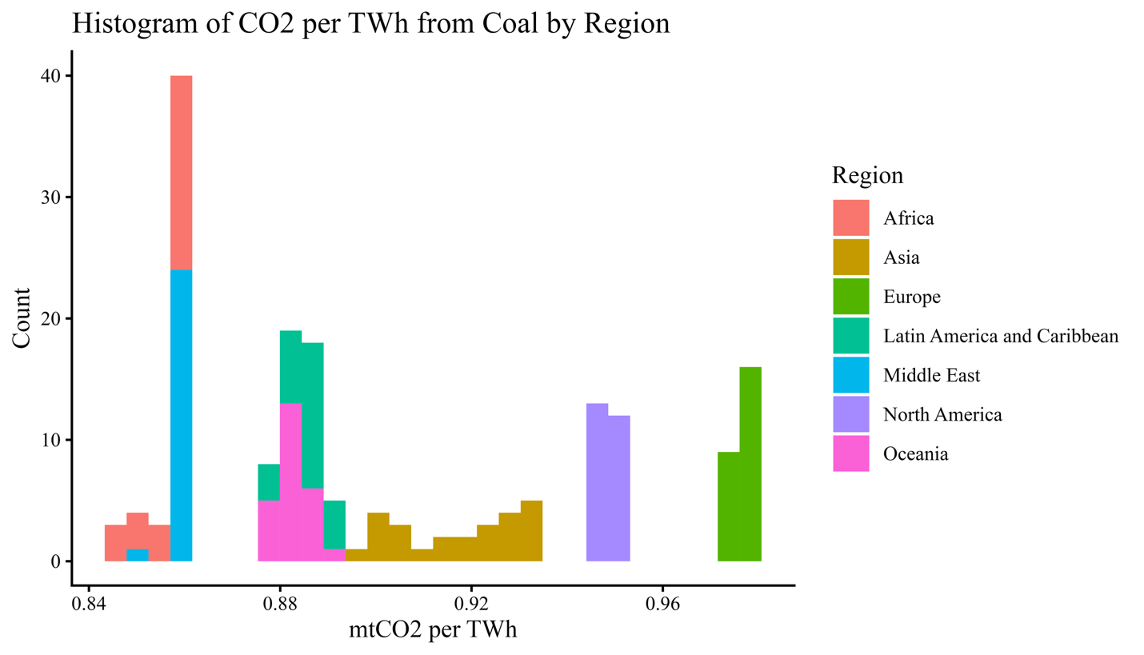
Figure 1
Running a Shapiro-Wilk test on the data yielded W = 0.87914, p-value = 1.117 x 10⁻¹⁰, allowing me to reject the null of normality.
Because the data is not normally distributed, I ran a Brown-Forsythe test for equal variance which is robust to departures from normality. With a Test Statistic = 36.197 and a p-value < 2. x 10⁻¹⁶, we reject the null of equal variance.
Lacking both normality and equal variance, I used the Kruskal-Wallis test which is robust to both issues. Since the Kruskal-Wallis test can only tell us if there is a statistically significant difference in medians between any of the groups, I also performed a the Wilcoxon rank sum exact test (Table 4) to check the differences between each pair-wise combination in the dataset.

Models
Linear regression models were used to estimate the impact of region (Area) and time (Year) on CO2 intensity (mtCO2_per_TWh). The standard tests for linear modeling were performed as follows. Linearity was check with a scatter plot of the model’s fitted values plotted against residuals. Normality was tested with both a Q-Q plot and the Shapiro-Wilk test. Equal variance was checked with a scatter plot of the model’s fitted values plotted against residuals. For models with more than one predictor, multicollinearity of predictor the variables was checked by computing the Generalized Variance Inflation Factor (VIF).
Table 2
Shapiro-Wilk Test for Normality
Region | w value | p value
Asia | 0.90794 | 0.02743
Africa | 0.67129 | 3.066 x 10⁻⁶
Europe | 0.959 | 0.395
Latin America and Caribbean | 0.95898 | 0.3945
Middle East | 0.5853 | 2.913 x 10⁻⁷
Oceania | 0.90222 | 0.02051
North America | 0.88603 | 0.009224

Running a Shapiro-Wilk test for normality individually for each region only two, Europe and Latin American and Caribbean, have large enough p-values for us to fail to reject the null of normality (Table 2). Asia and Oceania are near normal and thus worth investigating as well (Table 2).
Five linear models were computed with carbon intensity (mtCO2_per_TWh) as the dependent variable in every model. The Global Model used region (Area), time (Year), and an interaction terms region by time (Area:Year) as independent variables. The European, Latin American, Asian, and Oceanian model all used time (Year) alone as the independent variables.

Linear Regression Assumption Tests
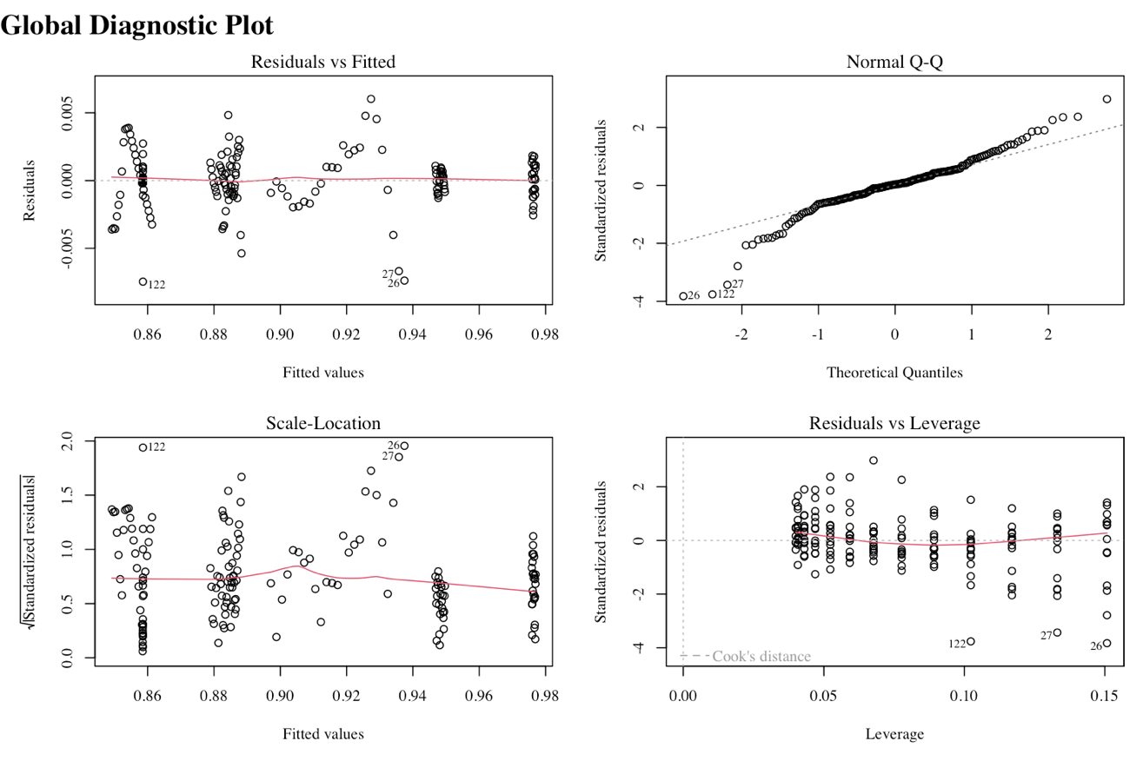
Figure 2
This model is not linear as evidenced by the patterns in the Residuals vs Fitted plot (Figure 2). We also see large deviations from normality in the Q-Q plot (Figure 2)) and non-equal variance in the Residuals vs Fitted plot (Figure 2)).
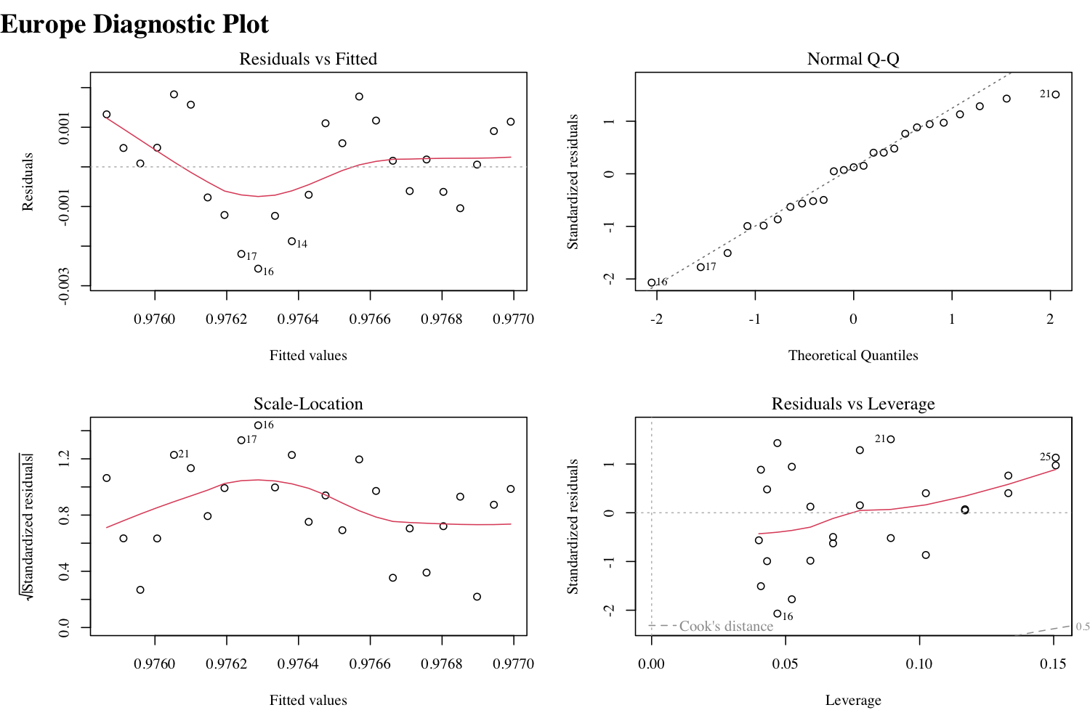
Figure 3
The data is normally distributed (Table 2) (Figure 3), but not particularly linear or equally varied (Figure 3).
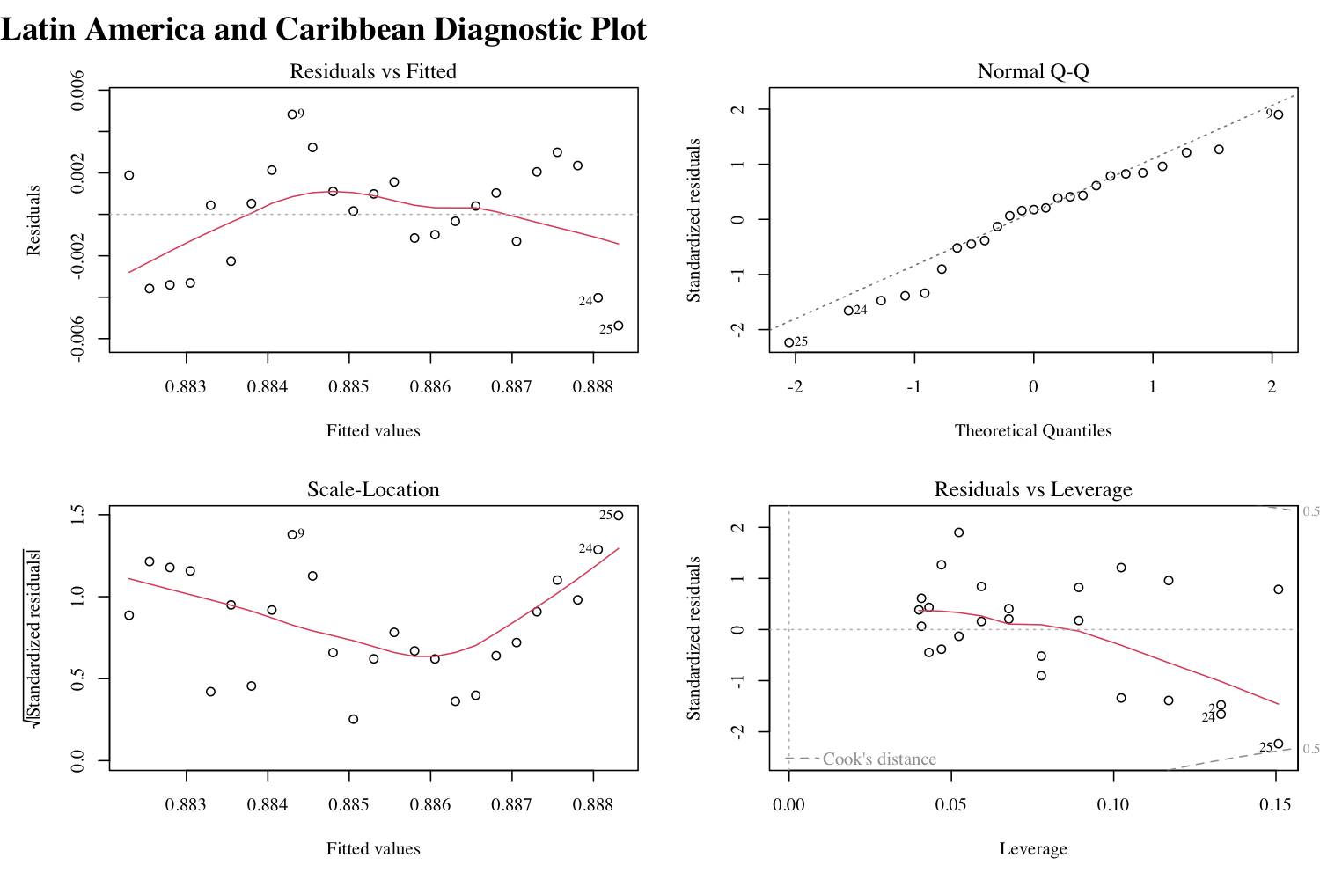
Figure 4
The data is close to normally distributed (Table 2) (Figure 4) and suffers from moderate departures from linearity and equal variance (Figure 4).
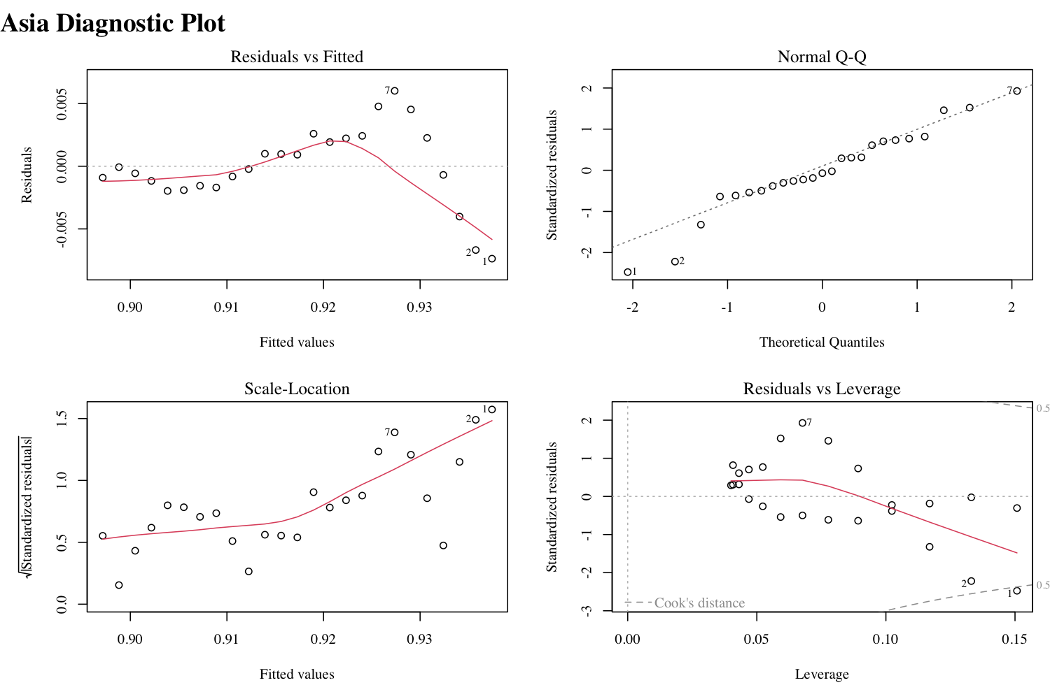Figure 5
The data is nearly normally distributed (Table 2) (Figure 5), linear with small exceptions prior to 2007, and roughly equally variant, again with higher deviations prior to 2007 (Figure 5).
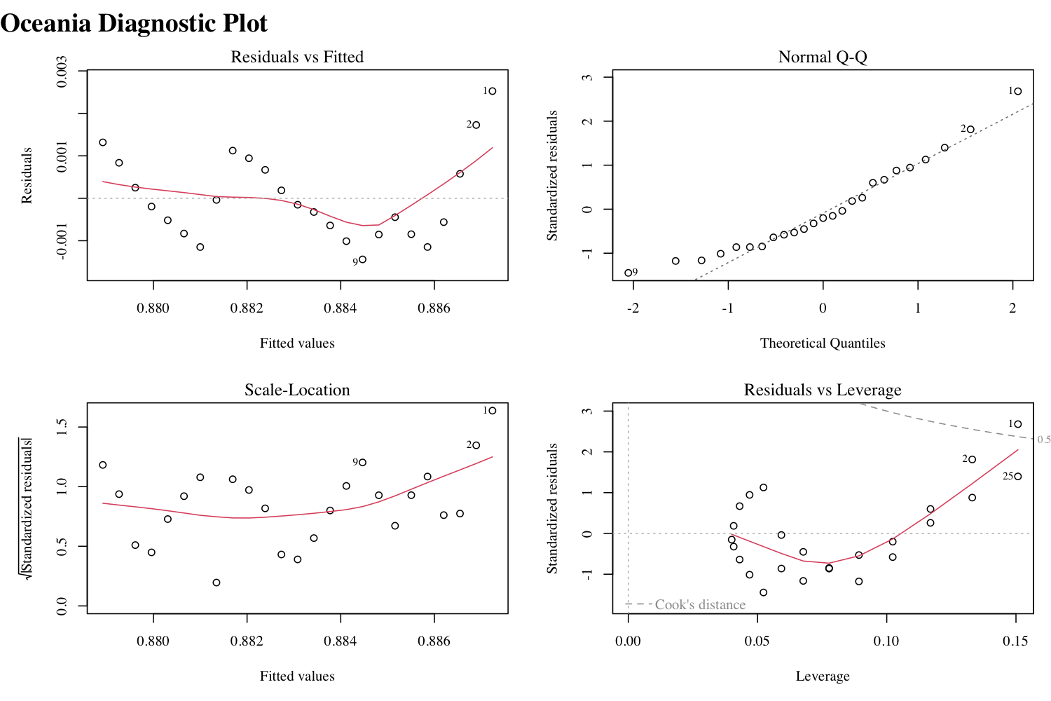Figure 6
The data is normally distributed (Table 2) (Figure 6), not linear, and not equally variant (Figure 6).

R Packages Used

- ggplot2
- tidyverse
- skimr
- car
- gtsummary
- gt
- lawstat
- sf
- rnaturalearth

Results

Testing Difference in CO2 Intensity Between Regions
To investigate whether coal power CO2 emission intensity varies between global regions, I started by visualizing the data with box plots.
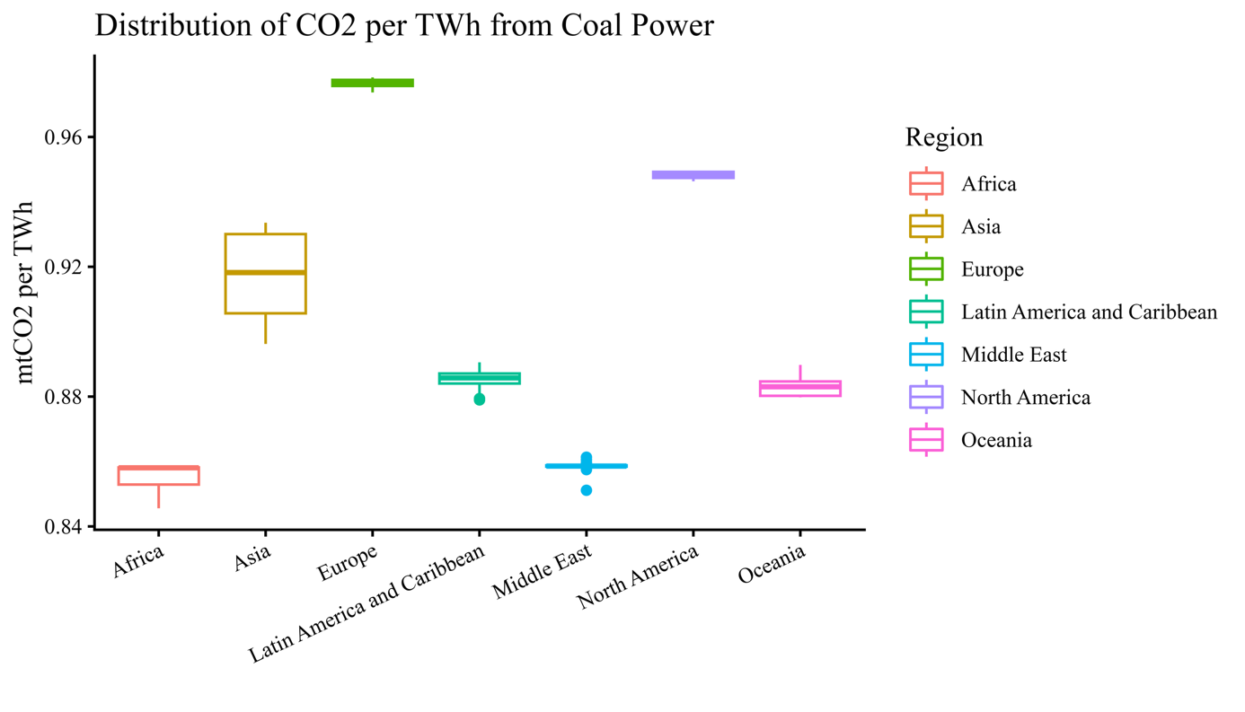Figure 7
Table 3
Summary Statistics by Region
Area | N | Mean | Median | SD | Min | Max
Africa | 25 | 0.855 | 0.858 | 0.005 | 0.846 | 0.858
Asia | 25 | 0.917 | 0.918 | 0.013 | 0.896 | 0.934
Europe | 25 | 0.976 | 0.976 | 0.001 | 0.974 | 0.978
Latin America and Caribbean | 25 | 0.885 | 0.886 | 0.003 | 0.879 | 0.891
Middle East | 25 | 0.859 | 0.859 | 0.002 | 0.851 | 0.861
North America | 25 | 0.948 | 0.949 | 0.001 | 0.946 | 0.950
Oceania | 25 | 0.883 | 0.883 | 0.003 | 0.880 | 0.890
Significance codes: 0 ‘***’ 0.001 ‘**’ 0.01 ‘*’ 0.05 ‘.’ 0.1 ‘ ’ 1
We can see there appears to be a substantial difference in the median values of CO2 intensity between regions, but to be sure we will need to conduct some statistical tests. Although the absolute difference between median values in each region is small, the standard deviation is also very small telling us that our data is very tightly clustered together (Table 3). Therefore, even apparently small differences in median values could be significant.
Running a Kruskal-Wallis test produced the following results: chi-squared = 167.33, df = 6, p-value < 2.2 x 10⁻¹⁶ allowing us to reject the null that the distributions and medians are the same across global regions.
Testing each pair-wise combination with the Wilcoxon rank sum exact test produced the following:
Table 4
p-Values for Wilcoxon Rank Sum Test
 | Africa | Asia | Europe | Latin America | Middle East | North America
Asia | 3.3 x 10⁻¹³ | - | - | - | - | -
Europe | 3.3 x 10⁻¹³ | 3.3 x 10⁻¹³ | - | - | - | -
Latin America and Caribbean | 3.3 x 10⁻¹³ | 3.3 x 10⁻¹³ | 3.3 x 10⁻¹³ | - | - | -
Middle East | 2.6 x 10⁻¹³ | 3.3 x 10⁻¹³ | 3.3 x 10⁻¹³ | 3.3 x 10⁻¹³ | - | -
North America | 3.3 x 10⁻¹³ | 3.3 x 10⁻¹³ | 3.3 x 10⁻¹³ | 3.3 x 10⁻¹³ | 3.3 x 10⁻¹³ | -
Oceania | 3.3 x 10⁻¹³ | 3.3 x 10⁻¹³ | 3.3 x 10⁻¹³ | 0.0085 | 3.3 x 10⁻¹³ | 3.3 x 10⁻¹³
All Pairs of regions are statistically significantly different from each other (Table 4).

Modeling Intensity Over Time By Region

Global Model
Running a linear regression to estimate CO2 intensity as a function of year and area where year and area have an interaction term yields the following coefficients:
Equation 1
$$\hat{{mtCO2 per TWh}_{i}}=1.87-0.505\left({Year}_{i}\right)+ \sum_{j=1}^{6}{α_{j}}{Area}_{ji}+\sum_{j=1}^{6}{γ_{j}}{({Year}_{i} × Area}_{ji})$$

Table 5
Results of the Multiple Linear Regression Model
Predictor | Estimate | S.E. | t value | p-value | Significance
(Intercept) | 1.87 x 10⁰ | 1.17 x 10⁻¹ | 16.026 | < 2 x 10⁻¹⁶ | ***
Year | -5.05 x 10⁻¹ | 5.80 x 10⁻⁵ | -8.700 | 3.71 x 10⁻¹⁵ | ***
Area
Asia | 2.43 x 10⁰ | 1.65 x 10⁻¹ | 14.689 | < 2 x 10⁻¹⁶ | ***
Europe | -8.00 x 10⁻¹ | 1.65 x 10⁻¹ | -4.846 | 2.95 x 10⁻⁶ | ***
Latin America | -1.49 x 10⁰ | 1.65 x 10⁻¹ | -9.022 | 5.31 x 10⁻¹⁶ | ***
Middle East | -1.02 x 10⁰ | 1.65 x 10⁻¹ | -6.189 | 4.82 x 10⁻⁹ | ***
North America | -6.83 x 10⁻¹ | 1.65 x 10⁻¹ | -4.136 | 5.67 x 10⁻⁵ | ***
Oceania | -2.90 x 10⁻¹ | 1.65 x 10⁻¹ | -1.758 | 0.0807 | .
Year x Area
Year x Asia | -1.17 x 10⁻³ | 8.21 x 10⁻⁵ | -14.314 | < 2 x 10⁻¹⁶ | ***
Year x Europe | 4.58 x 10⁻⁴ | 8.21 x 10⁻⁵ | 5.580 | 9.99 x 10⁻⁸ | ***
Year x Latin America | 7.55 x 10⁻⁴ | 8.21 x 10⁻⁵ | 9.204 | < 2 x 10⁻¹⁶ | ***
Year x Middle East | 5.10 x 10⁻⁴ | 8.21 x 10⁻⁵ | 6.209 | 4.35 x 10⁻⁹ | ***
Year x North America | 3.86 x 10⁻⁴ | 8.21 x 10⁻⁵ | 4.699 | 5.57 x 10⁻⁶ | ***
Year x Oceania | 1.58 x 10⁻⁴ | 8.21 x 10⁻⁵ | 1.927 | 0.0558 | .
Significance codes: 0 ‘***’ 0.001 ‘**’ 0.01 ‘*’ 0.05 ‘.’ 0.1 ‘ ’ 1
All model coefficients are statistically significant (Table 5) and the adjusted R-Squared is 0.998. 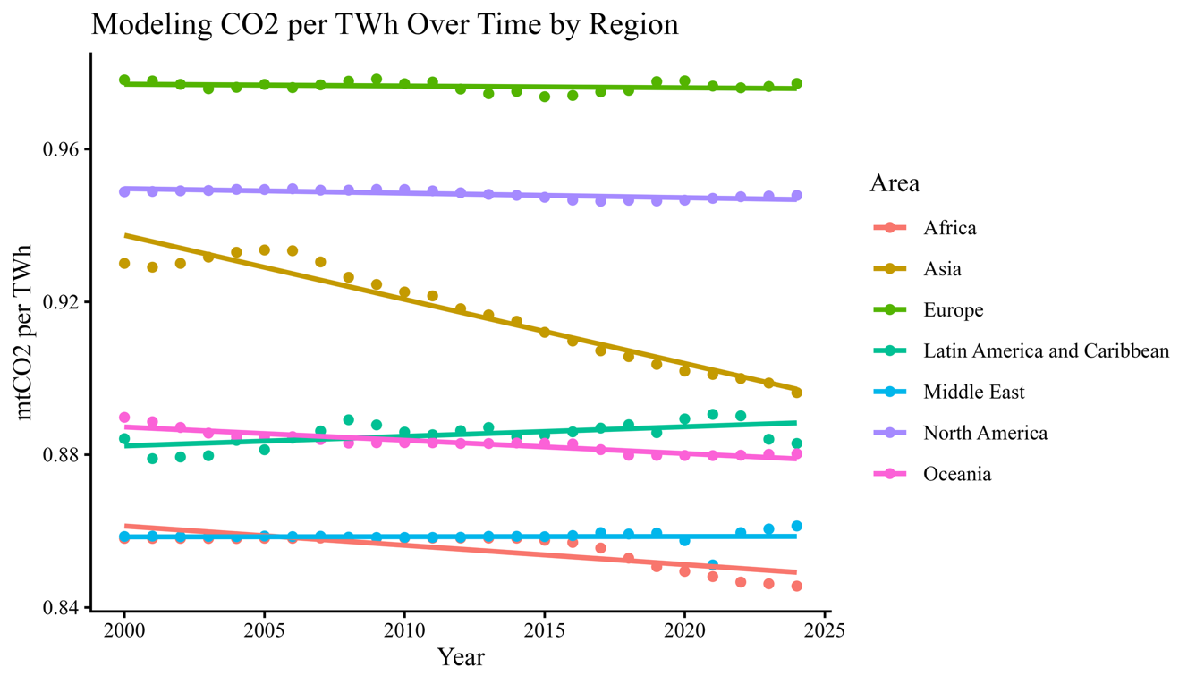
Figure 8
Each region’s line of best fit appears to match closely to the data points (Figure 8). Asia is the standout region with a strong downward trend (negative slope), but Africa and Oceania also exhibit a slight decline over time. The Middle East and Latin America appear to generally increase, while Europe and North America present flat lines (Figure 8).
Table 6
Generalized Variance Inflation Factor
 | GVIF | Df | GVIF^(1/(2*Df))
Year | 7.00 | 1 | 2.65
Area | 2.23 x 10²⁹ | 6 | 2.79 x 10²
Year:Area | 2.23 x 10²⁹ | 6 | 2.79 x 10²

The model suffers from multicollinearity between explanatory terms, provided the Generalized Variance Inflation Factor (GVIF) scores above 10 (Table 6).
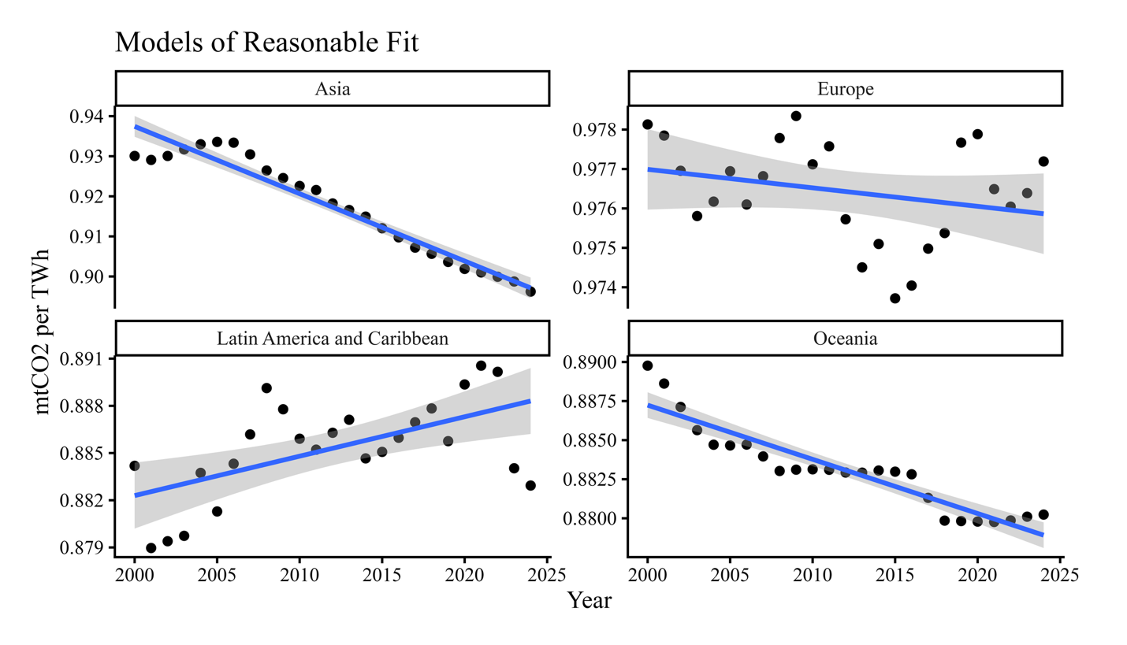Figure 9
The Asian and Oceanian models appear to fit well with the training data and both exhibit a clear negative slope (Figure 9). The European and Latin American models display non-linear trends over smaller time scales explaining their larger grey uncertainty bars (Figure 9) indicating poor model fit.

European Model
Table 7
Linear Model Coefficients
 | Estimate | S.E. | T value | Pr(>|t|) | Significance
(Intercept) | 1.07 | 7.10 x 10⁻² | 15.09 | 2.02 x 10⁻¹³ | ***
Year | -4.69 x 10⁻⁵ | 3.53 x 10⁻⁵ | -1.33 | 0.197
Significance codes: 0 ‘***’ 0.001 ‘**’ 0.01 ‘*’ 0.05 ‘.’ 0.1 ‘ ’ 1
Equation 2
$$\hat{{mtCO2 per TWh}_{i}}=1.07-0.0000469({Year}_{i})$$
Residual standard error: 0.001272 on 23 degrees of freedom
R-squared: 0.031
F-statistic: 1.769 on 1 and 23 DF, p-value: 0.1965
The coefficient on Year is incredibly small and not statistically significant (Table 7). The R-Squared value of 0.03 is very low.

Latin American Model
Table 8
Linear Model Coefficients
 | Estimate | Std. Error | t-value | Pr(>|t|) | Significance
(Intercept) | 3.81 x 10⁻¹ | 1.46 x 10⁻¹ | 2.619 | 1.53 x 10⁻² | *
Year | 2.51 x 10⁻⁴ | 7.24 x 10⁻⁵ | 3.46 | 0.00212 | **
Significance codes: 0 ‘***’ 0.001 ‘**’ 0.01 ‘*’ 0.05 ‘.’ 0.1 ‘ ’ 1
Equation 3
$$\hat{{mtCO2 per TWh}_{i}}=0.381+0.000251({Year}_{i})$$
Residual standard error: 0.00261 on 23 degrees of freedom
R-squared: 0.3138
F-statistic: 11.97 on 1 and 23 DF, p-value: 0.002123
The coefficient on Year is small in magnitude, statistically significant, and positive (Table 8). The R-Squared value of 0.31 indicates that this model explains about one-third of the variation in the data. The Latin American model is the only of the 4 reasonable fit models to show a clear, if small, positive slope.

Asian Model
Table 9
Linear Model Coefficients
 | Estimate | Std. Error | T value |  | Pr(>|t|) | Significance
(Intercept) | 4.30 | 1.80 x 10⁻¹ |  | 23.81 | < 2 x 10⁻¹⁶ | ***
Year | -1.68 x 10⁻³ | 8.97 x 10⁻⁵ |  | -18.73 | 2.02 x 10⁻¹⁵ | ***
Significance codes: 0 ‘***’ 0.001 ‘**’ 0.01 ‘*’ 0.05 ‘.’ 0.1 ‘ ’ 1
Equation 4
$$\hat{{mtCO2 per TWh}_{i}}=4.30-0.00168({Year}_{i})$$
Residual standard error: 0.003233 on 23 degrees of freedom
R-squared: 0.9358
F-statistic: 350.6 on 1 and 23 DF, p-value: 2.022 x 10⁻¹⁵
The Year coefficient is modest in magnitude, highly statistically significant, and negative (Table 9). The Asian Model has a high R-Squared value at 0.94 suggesting strong model fit. This model has the highest F-statistic of the 4 reasonable fit models lending further credence to fit of this model.

Oceanian Model
Table 10
Linear Model Coefficients
 | Estimate | Std. Error | t-value | Pr(>|t|) | Significance
(Intercept) | 1.58 | 5.71 x 10⁻² | 27.7 | < 2 x 10⁻¹⁶ | ***
Year | -3.47 x 10⁻⁴ | 2.84 x 10⁻⁵ | -12.23 | 1.52 x 10⁻¹¹ | ***
Significance codes: 0 ‘***’ 0.001 ‘**’ 0.01 ‘*’ 0.05 ‘.’ 0.1 ‘ ’ 1
Equation 5
$$\hat{{mtCO2 per TWh}_{i}}=1.58-0.000347({Year}_{i})$$
Residual standard error: 0.001022 on 23 degrees of freedom
R-squared: 0.861
F-statistic: 149.5 on 1 and 23 DF, p-value: 1.522 x 10⁻¹¹
The Year coefficient is small in magnitude, highly statistically significant, and negative (Table 10). The R-Squared value is high at 0.86.

Discussion

Question 1: Differences Between Regions
Null Hypothesis A: Coal power CO2 emission intensity does not vary between global regions.
Alternative Hypothesis A: Coal power CO2 emission intensity does vary between global regions.
Provided the results of the Kruskal-Wallis, we can say that the CO2 intensity of coal power plants have statistically significantly different medians, and thus it does vary between global regions. Thus, we can reject our null hypothesis A and accept our alternative hypothesis A allowing us to conclude that there is a meaningful difference between the CO2 intensities of major global regions.
Coal usage in power generation is not uniform across regions, and thus we can reason that there may be more incentive to improve the CO2 intensity in areas of the world which more heavily rely on coal for power. This question would be an excellent candidate for an extension of this analysis in the future. Additionally, it would be interesting to, provided the data can be sourced, to test whether the mechanisms responsible for different CO2 intensity (fuel quality, combustion efficacy, or exhaust scrubbers) differ between regions. Assuming that global demand for electricity generation continues to rise in the future and the coal will not be instantaneously phased out as a power source, how many terawatt hours of power can be squeezed out of a given unit of carbon dioxide emissions (the inverse of mtCO2/TWh) will become all the more impactful. This leads nicely to our second question about the relationship between CO2 intensity and time.

Question 2: Differences Over Time
Null Hypothesis B: Coal power CO2 emission intensity does not vary over time between global regions.
Alternative Hypothesis B: Coal power CO2 emission intensity does vary over time between global regions.
Determining a statistically significant trend over time proves more difficult than finding a difference between the regions. The Global Model (Table 5), initially appears to match the data for each region (Figure 8), but fails key assumptions for linear regression (Figure 2) (Table 6) meaning this model cannot well describe the data. Only 2 regions (Europe and Latin America) fail to reject the null of normality at the 5% level and only 2 additional regions (Asia and Oceania) fail to reject the null of normality at the 1% level (Table 2). Interestingly, Asia and Oceania turn out to have better fit models with adjusted R squared values of 0.93 and 0.86 respectively compared to Europe and Latin Americas respective 0.20 and 0.31. Europe and Latin America have far more variation in their data and thus present less clear of a trend matching their comparatively weaker model performance (Figure 9).
Given the in ability to construct meaningful linear models for Africa, the Middle East, and North America as well as the poor model fit for Europe and Oceania, we cannot conclude that there is a consistent, statistically significant linear trend between CO2 intensity and Year.
However, we can say more about Asia and Oceania. Asia’s linear model has a clear negative relationship between CO2 intensity and year meaning that as time progresses, we tend to see an improvement (lower emissions per unit of generation) in CO2 intensity on average.
$$\hat{{mtCO2 per TWh}_{i}}=4.30-0.00168({Year}_{i})$$
Specifically, each year into the future we expect an average reduction of CO2 intensity of 0.00168 million metric tons of CO2 per TWh of electricity generated. In 2024, Asia produced 8738 terawatt hours of power from coal meaning the expected reduction in CO2 emitted compared to the intensity of the previous year was $8738TWh *0.00168\frac{mtCO2}{TWh}=14.68mtCO2$. Put another way, without shutting down any coal power plants (the most carbon-intensive way to generate power) Asia didn’t put 14.68 million metric tons of CO2 into the atmosphere that would have otherwise been there without changes to the fuel or facilities used to create that power.

A similar calculation can be done for Oceania which has the following linear model.
$$\hat{{mtCO2 per TWh}_{i}}=1.58-0.000347({Year}_{i})$$
This region produced 130TWh of power from coal in 2024, meaning that due to an improvement in carbon intensity from the previous year, we would expect $130TWh *0.000347\frac{mtCO2}{TWh}=0.045mtCO2$ or about 45 thousand metric tons of CO2 to not have been emitted.
To get a sense of the scale of emissions, a typical American is estimated to produce around 15 metric tons of CO2 a year (Tso, 2023). This would mean that coal power’s CO2 intensity improvements in Asia in 2024 prevented the CO2 emissions equivalent to about 978,666 Americans, and Oceania stopped about 3,000 Americans’ worth of emissions. It is worth noting that while these emissions reductions may seem large, they only represent 0.18% and 0.039% of Asia and Oceania’s CO2 emissions from coal power in 2024, respectively.

Limitations
These data only represent 24 years, meaning that the sample size for each region is rather small. This also means that we don’t have much variation, as seen in some of the linear models, which can produce poor model estimation. The accuracy of both the power generation and CO2 emissions may not be equal across regions, depending on Ember’s data collection methods and the reporting standards between countries. CO2 emissions have become a politically charged topic, meaning there may be pressure from governments to misrepresent their pollution statistics.
Linear models may not be well suited for the more volatile trends seen in some of the region data. For example, Europe saw strong improvement in CO2 intensity in their coal power plants between 2010 and 2015 and then an equally rapid backslide between 2015 and 2020.
It should also be noted that improving emission intensity for coal power plants does not mean that total CO2 emissions from coal will decline in a region or country. Coal produces large amounts of CO2 for every unit of power it generates meaning the relatively incremental gains in intensity reviewed in this paper are unlikely to outweigh the increased CO2 emissions of even a modest increase in the usage of coal as a power source.

Conclusion
We can conclude that there is a real, statistical difference between the median CO2 intensity of coal power between global regions. We cannot say that there is a clear trend in CO2 intensity over time for all global regions. There is a statistically significant negative correlation between CO2 per terawatt hour and year between 2000 and 2024 for Asia and Oceania. The actual positive impact of the theoretical reduction in CO2 emissions attributable to improvements in CO2 intensity is minuscule compared to the emissions from coal power as a whole, even within Asia and Oceania. Without considering the political and economic complexities of power generation, this analysis would indicate that reducing coal power is a far more effective method of lowering power generation’s CO2 footprint as compared with even those parts of the world with the most consistent improvements in CO2 intensity over the last 24 years.

References
Baloyi, H. I., Okonye, L. U., & Ren, J. (2024). Design of retrofit flue gas (CO2) scrubber for dependable clean energy at the Duvha Coal Power Plant. Scientific Reports, 14(1). https://doi.org/10.1038/s41598-024-72104-9
car: Fox, J., & Weisberg, S. (2019). An R Companion to Applied Regression (3rd ed.). Sage. https://socialsciences.mcmaster.ca/jfox/Books/Companion/
Ember. (2024, December 9). Yearly Electricity Data. Ember. https://ember-energy.org/data/yearly-electricity-data/
ggplot2: Wickham, H. (2024). ggplot2: Elegant Graphics for Data Analysis. R package. https://CRAN.R-project.org/package=ggplot2
gt: Iannone, R., Cheng, J., Schloerke, D., Atkins, A., & Russell, K. (2024). gt: Easily Create Presentation-Ready Display Tables . R package. https://CRAN.R-project.org/package=gt
gtsummary: Sjoberg, D. D., Whiting, K., Curry, M., Lavery, J. A., & Larmarange, J. (2021). Reproducible summary tables with the gtsummary package. The R Journal, 13(1), 570–580. https://doi.org/10.32614/RJ-2021-053
lawstat: Huo, Y., Kim, J., Kim, K., Leemis, L., Lu, R., Priebe, C., Sheskin, D., & Zhang, Y. (2024). lawstat: Tools for the Analysis of Non-Standard Data and Procedures . R package. https://CRAN.R-project.org/package=lawstat
National Renewable Energy Laboratory. (2021, September 1). Life cycle greenhouse gas emissions from electricity generation: Update. National Renewable Energy Laboratory. https://research-hub.nrel.gov/en/publications/life-cycle-greenhouse-gas-emissions-from-electricity-generation-u/
rnaturalearth: Decere, L., & Schimoler, C. (2024). rnaturalearth: World Map Data from Natural Earth . R package. https://CRAN.R-project.org/package=rnaturalearth
sf: Pebesma, E. (2018). Simple Features for R: Standardized Spatial Vector Data for R. The R Journal, 10(1), 439–446. https://doi.org/10.32614/RJ-2018-009
skimr: Rudis, R., & Fullmer, B. (2024). skimr: Compact and Flexible Summaries of Data . R package. https://CRAN.R-project.org/package=skimr
tidyverse: Wickham, H., Averick, M., Bryan, J., Chang, W., McGowan, L. D., François, R., Grolemund, G., Hayes, A., Henry, L., Hester, J., Kalibera, T., Klinke, S., Pedersen, T. L., Schloerke, D., Schubert, I., Selzer, M., Smith, K., Spinu, V., Takahashi, K., Tanner, G., Taylor, M., Yutani, H. (2019). Welcome to the tidyverse. Journal of Open Source Software, 4(43), 1686. https://doi.org/10.21105/joss.01686
Tso, K. (2023, December 21). How much is a ton of carbon dioxide?. MIT Climate Portal. https://climate.mit.edu/ask-mit/how-much-ton-carbon-dioxide
Quick, J., & Glick, D. (2000). Carbon dioxide from coal combustion: variation with rank of US coal. Fuel, 79(7), 803–812. https://doi.org/10.1016/s0016-2361(99)00197-0
Xu, H., Zhang, W., Ren, Y., Zhang, Y., Li, J., Zheng, S., Dai, R., Hu, J., Cheng, H., Shen, G., Shen, H., Ma, J., & Tao, S. (2024). Role of primary drivers leading to emission reduction of major air pollutants and CO2 from global power plants. Environment International, 190(190), 108936–108936. https://doi.org/10.1016/j.envint.2024.108936
Yue, T., Liu, Q., Tong, Y., Gao, J., Zheng, Y., Li, G., & Li, R. (2024). Analysis of emission evolution and synergistic reduction effect of air pollutants and CO2 from Chinese coal-fired power plants. Atmospheric Pollution Research, 15(2), 102001. https://doi.org/10.1016/j.apr.2023.102001

Appendix
--- title: "Global Coal Power & Emissions R Project" author: "Logan Rosell" format: pdf editor: visual ---
{r} library(ggplot2) library(tidyverse) library(skimr) library(car) library(gtsummary) library(gt) library(lawstat) library(sf) library(rnaturalearth) library(extrafont) #font_import() #loadfonts(device = "pdf") theme_set(theme_classic()) theme_update(text = element_text(family = "Times New Roman")) setwd("~/Desktop/WU R Class/R Project Files")
Data Source: https://ember-energy.org/data/yearly-electricity-data/
Question: Does coal power's CO2 emission intensity vary across global regions and time between 2000 and 2024?

Cleaning Data
{r} global_power_data <- read_csv("yearly_full_release_long_format.csv")
{r} global_coal <- global_power_data %>% filter(Variable == 'Coal') %>% filter(Category != "Capacity") %>% dplyr::select(-c(`YoY absolute change`, `YoY % change`, Category, Subcategory, Variable)) %>% pivot_wider(names_from = Unit, values_from = Value) %>% mutate(mtCO2_per_TWh = mtCO2/TWh, mtCO2_per_TWh = ifelse(is.na(mtCO2_per_TWh), 0, mtCO2_per_TWh))

Overview of Data
{r} skim(global_power_data) summary(global_power_data)
{r} countries <- global_power_data %>% filter(`Area type`=="Country or economy") %>% dplyr::select(Area) unique(countries)

Region Analysis
{r} global_coal %>% filter(TWh != 0) %>% filter(`Area type` == "Country or economy") %>% ggplot(aes(x=Year, y=mtCO2_per_TWh)) + geom_point(size=0.5) + facet_wrap(~Continent) + theme( axis.text.x = element_text( angle = 45, vjust = 1, hjust = 1 ) ) + labs(title="CO2 Intensity Variation Within Region Over Time") ggsave("CO2 Intensity Variation Within Region Over Time.png", width = 6, height=4, units = "in", dpi = 1500)
{r} region_data <- global_coal %>% filter(`Area type` == 'Region') %>% filter(Area %in% c("Africa", "Asia", "Europe", "Latin America and Caribbean", "Middle East", "North America", "Oceania")) %>% dplyr::select(-c(`ISO 3 code`, Continent, `Ember region`, EU, OECD, G20, G7, ASEAN)) %>% mutate(percent_100 = `%` / 100)
{r} table_1 <- region_data %>% tbl_summary(by = Area, include = c(`%`, TWh, mtCO2, mtCO2_per_TWh), statistic = all_continuous() ~ "{mean} ({median})") %>% as_gt() gtsave(data = table_1, filename = "summary_stats_table_by_region.png") table_2 <- region_data %>% tbl_summary(by = Year, include = c(`%`, TWh, mtCO2, mtCO2_per_TWh), statistic = all_continuous() ~ "{mean} ({median})") %>% as_gt() gtsave(data = table_2, filename = "summary_stats_table_by_year.png")
{r} ggplot(region_data, aes(x=Year, y=mtCO2_per_TWh, color=Area)) + geom_line() + labs(title="CO2 Intensity Over Time by World Region", y= "mtCO2 per TWh") ggsave("CO2 Intensity Over Time by World Region.png", width = 6, height=4, units = "in", dpi = 1500)

Summarizing Region Data
{r} skim(region_data) summary(region_data)
{r} ggplot(region_data, aes(x=Area, y=mtCO2_per_TWh, color=Area)) + geom_boxplot() + theme(axis.text.x = element_text(angle = 25, vjust = 1, hjust=1)) + labs(x="", title="Distribution of CO2 per TWh from Coal Power", color = "Region", y= "mtCO2 per TWh") ggsave("Distribution of CO2 per TWh from Coal Power.png", width = 7, height=4, units = "in", dpi = 1500)

Summary Stats by Region
{r} region_data %>% group_by(Area) %>% summarize( N = n(), Mean = mean(mtCO2_per_TWh), Median = median(mtCO2_per_TWh), SD = sd(mtCO2_per_TWh), Min = min(mtCO2_per_TWh), Max = max(mtCO2_per_TWh) ) %>% mutate(across(where(is.numeric), round, 3)) %>% gt()
{r} ggplot(region_data, aes(y=mtCO2_per_TWh)) + geom_boxplot() + theme(axis.text.x = element_text(angle = 30, vjust = 1, hjust=1)) + labs(x="Region", title="Distribution of CO2 per TWh from Coal Power--Separate Scales", color = "Region", y= "mtCO2 per TWh") + facet_wrap(~ Area, nrow = 2, scales = "free_y") ggsave("Distribution of CO2 per TWh from Coal Power--Separate Scales.png", width = 7, height=4, units = "in", dpi = 1500)
{r} ggplot(region_data, aes(x=mtCO2_per_TWh, fill=Area)) + geom_histogram() + labs(title="Histogram of CO2 per TWh from Coal by Region", fill="Region", y="Count", x="mtCO2 per TWh") ggsave("Histogram of CO2 per TWh from Coal by Region.png", width = 7, height=4, units = "in", dpi = 1500)

Testing the difference in CO2 Intensity between regions
Null Hypothesis B: Coal power CO2 emission intensity does NOT vary between global regions.
Alternative Hypothesis B: Coal power CO2 emission intensity DOES vary between global regions.
{r} shapiro.test(region_data$mtCO2_per_TWh)
A small p-value from our Shaprio-Wilks test tells use we should reject the null that our CO2_per_TWh data is normally distributed.
{r} levene.test(region_data$mtCO2_per_TWh, group=region_data$Area)
Small P-value for Brown-Forsythe means we reject the null of equal variance.
{r} kruskal.test(mtCO2_per_TWh ~ Area, data=region_data)
Because we don't have normally distributed data or equal variance I used the Kruskal-Wallis test (robust to both issues) and got a small p-value allowing us to reject the null that the distributions and medians are the same across global regions.
{r} pairwise.wilcox.test(region_data$mtCO2_per_TWh, g = region_data$Area)
All Pairs of regions are statically significantly different from each other.

Mapping the data (2024)
{r} only_2024 <- global_coal %>% filter(Year == "2024") %>% filter(`Area type` == "Country or economy") %>% mutate(iso_3 = toupper(trimws(`ISO 3 code`))) %>% mutate(log_intensity = log((mtCO2_per_TWh * 100)))
{r} world_map <- ne_countries(scale = "medium", returnclass = "sf") map_data_2024 <- world_map %>% left_join(only_2024, by = c("iso_a3" = "iso_3"))
{r} ggplot(data = map_data_2024) + geom_sf(aes(fill = log_intensity), color = "gray80", size = 0.1) + scale_fill_viridis_c( option = "viridis", direction = -1, name = "mtCO2 per TWh", na.value = "lightgray", guide = guide_colorbar( title.position = "top", title.hjust = 0.5, barwidth = 10, barheight = 0.5, direction = "horizontal") ) + theme_void() + theme( legend.position = "bottom", legend.title = element_text(vjust = 0.5)) + labs( title = "Global Coal Carbon Intensity by Country (2024)") + # No Antarctica coord_sf(ylim = c(-55, 85)) ggsave("Global Coal Carbon Intensity by Country (2024).png", width = 6, height=4, units = "in", dpi = 1500)

Modeling Intensity Over Time By Region
{r} intensity_time_region_model <- lm(formula = mtCO2_per_TWh ~ Year * Area, data=region_data) summary(intensity_time_region_model) shapiro.test(region_data$mtCO2_per_TWh) old_par <- par(no.readonly = TRUE) diagnostic_plot_title = "Global Diagnostic Plot" plot_file_name = paste0(diagnostic_plot_title, ".png") png(filename = plot_file_name, width = 1500, height = 1000, units = "px", res = 150) par(mfrow = c(2, 2), family = "serif", oma = c(0, 0, 2, 0), mar = c(5, 5, 2, 1)) plot(intensity_time_region_model, sub=" ") mtext(text = diagnostic_plot_title, outer = TRUE, cex = 1.5, font = 2, line = 0, adj = 0) dev.off() par(old_par)
{r} vif(intensity_time_region_model)
{r} ggplot(region_data, aes(x=Year, y=mtCO2_per_TWh, color=Area)) + geom_point() + geom_smooth(method="lm", se=FALSE) + labs(title="Modeling CO2 per TWh Over Time by Region", y= "mtCO2 per TWh") ggsave("Modeling CO2 per TWh Over Time by Region.png", width = 7, height=4, units = "in", dpi = 1500)
{r} region_model_maker_2 <- function(region) { df <- region_data %>% filter(Area == region) old_par <- par(no.readonly = TRUE) diagnostic_plot_title = paste(region, "Diagnostic Plot") plot_file_name = paste0(diagnostic_plot_title, ".png") model <- lm(formula = mtCO2_per_TWh ~ Year, data=df) print(summary(model)) png(filename = plot_file_name, width = 1500, height = 1000, units = "px", res = 150) par(mfrow = c(2, 2), family = "serif", oma = c(0, 0, 2, 0), mar = c(5, 5, 2, 1)) plot(model, sub=" ") mtext(text = diagnostic_plot_title, outer = TRUE, cex = 1.5, font = 2, line = 0, adj = 0) dev.off() par(old_par) plot(ggplot(df, aes(x=Year, y=mtCO2_per_TWh)) + geom_point()) plot(ggplot(df, aes(x=mtCO2_per_TWh))) + geom_histogram() }
{r} regions = c("Asia", "Africa", "Europe", "Latin America and Caribbean", "Middle East", "Oceania", "North America") for (i in regions){ df <- region_data %>% filter(Area == i) print(i) print(shapiro.test(df$mtCO2_per_TWh)) }
{r} region_model_maker_2("Asia")
{r} region_model_maker_2("Africa")
{r} region_model_maker_2("Europe")
{r} region_model_maker_2("Latin America and Caribbean")
{r} region_model_maker_2("Middle East")
{r} region_model_maker_2("Oceania")
{r} region_model_maker_2("North America")
{r} good_models_regions <- c("Europe", "Latin America and Caribbean", "Asia", "Oceania") good_models_data <- region_data %>% filter(Area %in% good_models_regions) ggplot(good_models_data, aes(x=Year, y=mtCO2_per_TWh)) + geom_point() + geom_smooth(method = "lm") + labs(title="Models of Reasonable Fit", y = "mtCO2 per TWh") + facet_wrap(~Area, scales = "free_y") + theme(plot.margin = unit(c(5, 10, 5, 5), "mm")) ggsave("Models of Reasonable Fit.png", width = 7, height=4, units = "in", dpi = 1500)

