**GitHub Desktop**

FOR DUMMIES

**Download GitHub Desktop**

Download Link: <https://desktop.github.com>

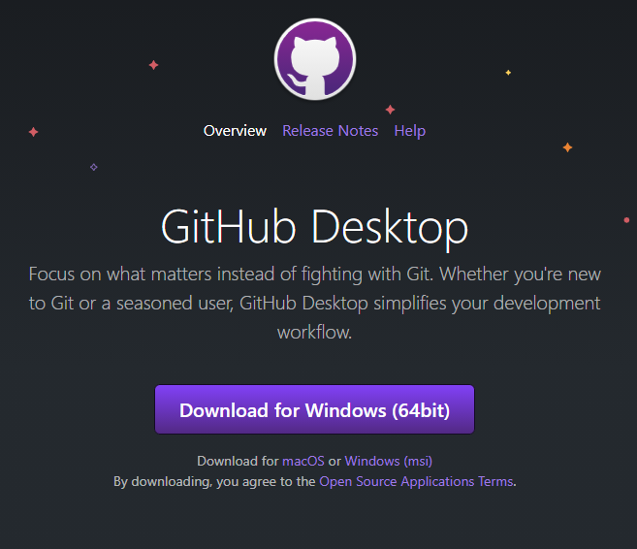

**Linking GitHub Desktop to your GitHub account**

1. Once GitHub desktop is installed, go to File->Options:

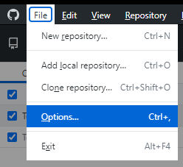

1. Then “Accounts” and follow the prompts to link your GitHub web account to the GitHub desktop app:  
   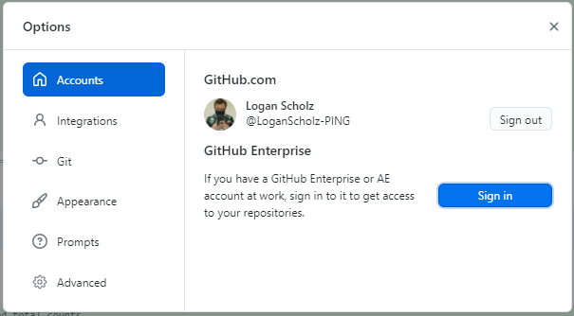

**Creating a NEW GitHub repository with GitHub Desktop**

As our first test of GitHub desktop, we are going to create a repository for tracking modifications to this document, as well as allowing you all to have access to the latest instructions

1. In GitHub Desktop, go to File->New Repository  
   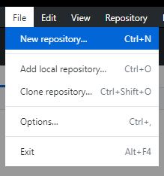
2. Fill out the information for the new repository:  
   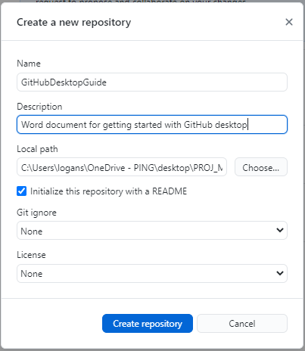
3. Click “Create repository” and allow the process to finish
4. Your repository has been created locally but has not been officially added to your GitHub repositories online yet. To officially check this repository in, click “Publish repository”  
   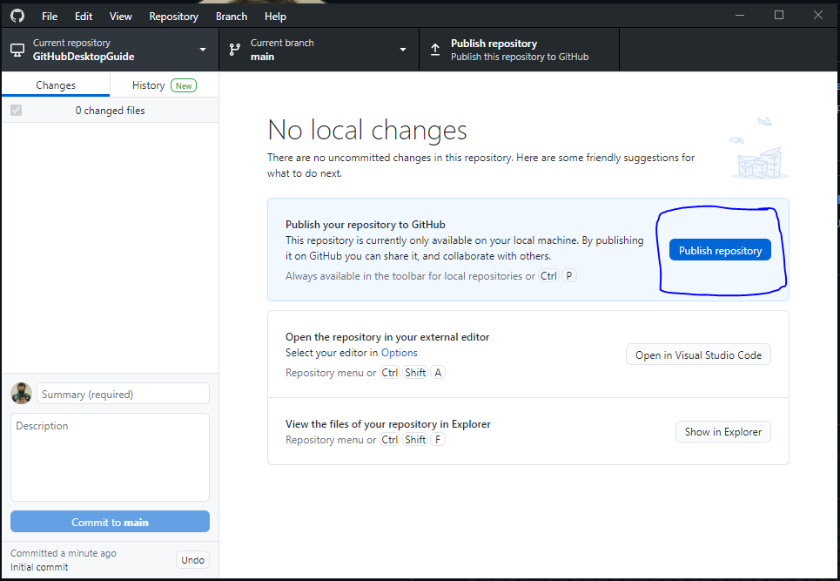
5. The “Publish repository” window will appear, everything will be pre-filled out for you, but un-check the “Keep this code private” checkbox (unless you want to be the only person to see this repository along with anyone else you specifically invite to collaborate)  
   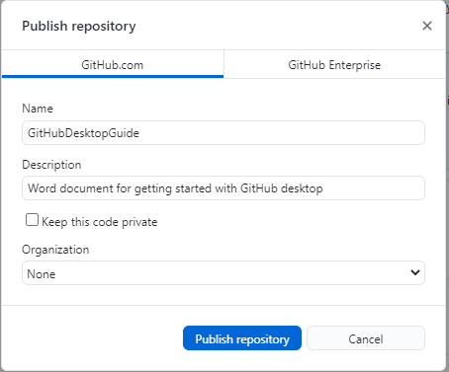  
   Click “Publish repository”
6. Proceed to the repositories list on your GitHub.com account and confirm that the new repository has been added:  
   
7. If we click on our new repository (“GitHubDesktopGuide” in this case), we find that the repository contains no particularly useful files. We will add our files in the next step
8. In step 2 you added a local path to contain this repository on your computer. Navigate to that folder and add the file or start a project:  
   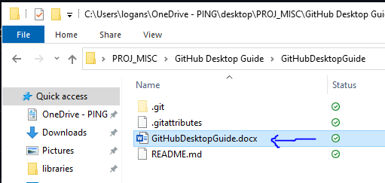
9. Return to the GitHub desktop application and notice that GitHub desktop understands that you have modifications in the local folder:  
   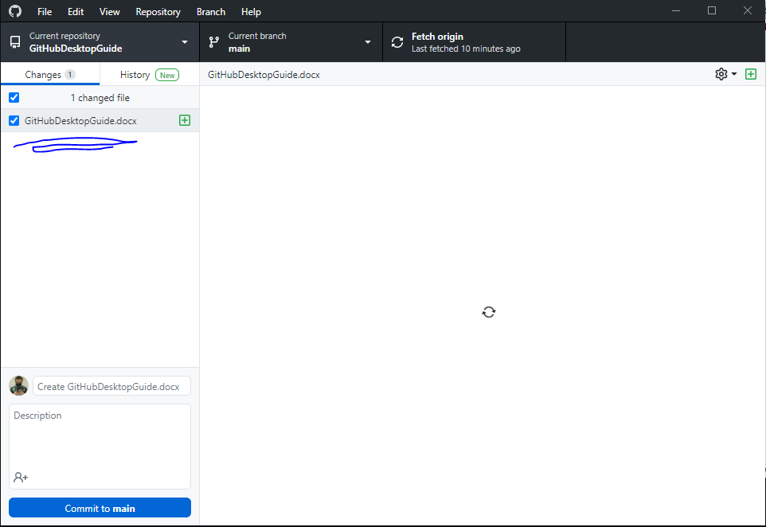
10. Let’s commit these changes to a “Working “ branch (NOT MAIN!!! DON’T COMMIT WORKING FILES TO MAIN!!). To do this, first create a “Working” branch by left clicking “Current branch” in the GitHub Desktop application and typing “Working” into the text box:  
    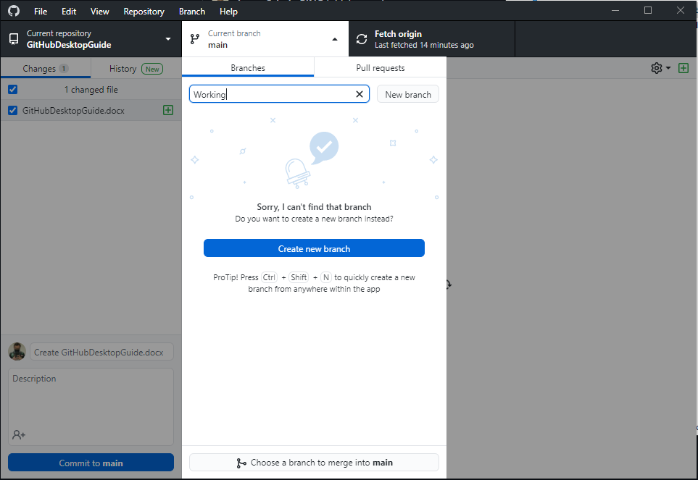
11. Click “Create new branch”, GitHub desktop will double-confirm the name of this new branch:  
    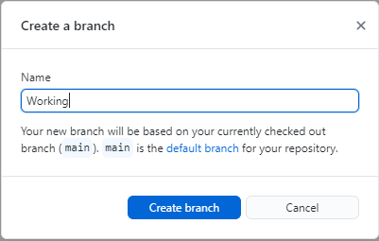  
      
    Click “Create branch”
12. In the “Switch branch” window, I recommend choosing “Bring my changes to Working”:  
    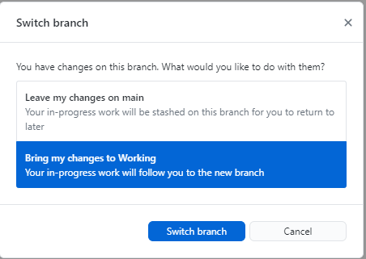  
      
    Click “Switch branch”
13. On GitHub Desktop, confirm that your Current branch is now the “Working” branch:  
    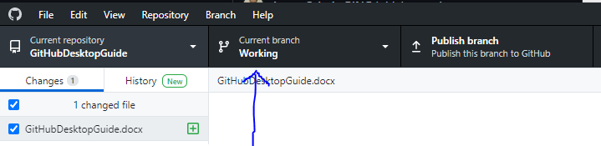
14. We’re ready to commit our document now! To commit your changes on GitHub desktop, you need to make a title for the commit and fill out a description:  
    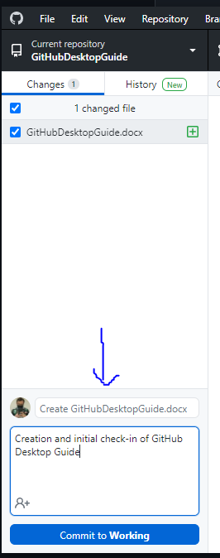
15. Click “Commit to Working” to commit our current changes: