27.03.2022,

Loganathan,

1.Today I have made my page more responsive

2.and learned how to add gif ,videos in my page

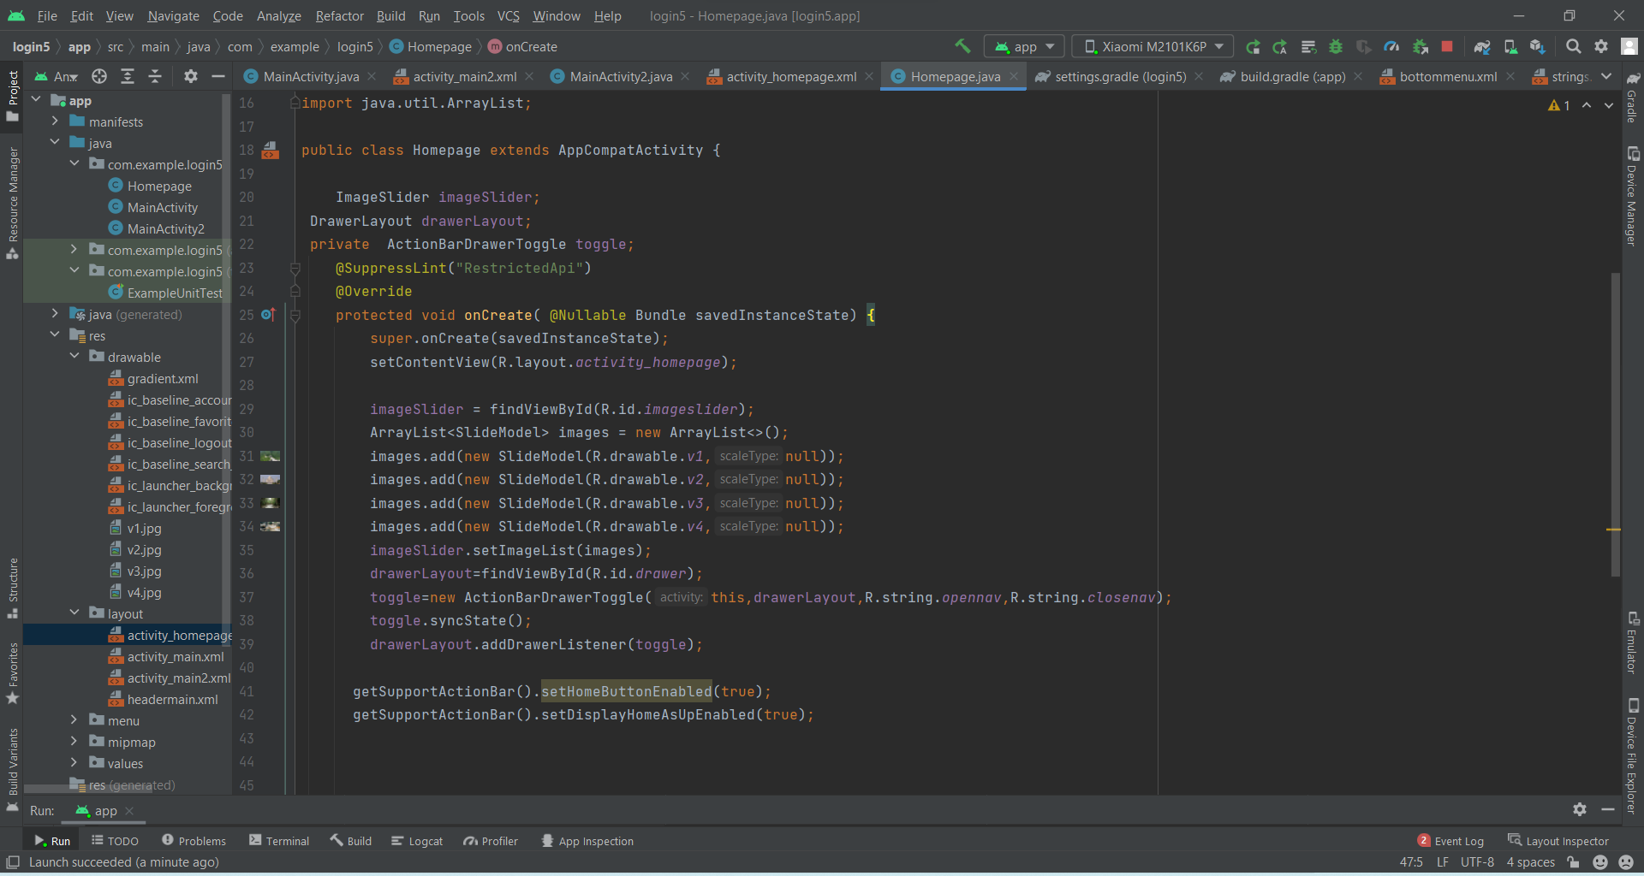

This is my java code page for image slider and navigation bar