
VERITAS UNIVERSITY ABUJA

FACULTY OF NATURAL AND APPLIED SCIENCES

DEPARTMENT OF COMPUTER SCIENCE

CSC 322: COMPUTER SCIENCE INNOVATION AND NEW TECHNOLOGIES

HIRING BIAS APPLICATION

GROUP 1

MAY 25TH, 2026.

Abstract
Artificial Intelligence (AI) systems are increasingly being used in recruitment and hiring processes to help organisations screen large numbers of applicants efficiently. However, these systems can unintentionally learn and reproduce historical human biases present in training data, leading to unfair hiring decisions. This project focuses on the development of a Hiring Bias Detection System using Explainable Artificial Intelligence (XAI) techniques to evaluate fairness and transparency in automated recruitment decisions.
A Random Forest classification model was developed to predict whether a candidate should be hired or rejected based on features such as education level, professional coding experience, technical skills, and demographic information. The model achieved an accuracy of 78.67% on unseen data. To improve transparency, SHAP (SHapley Additive exPlanations) was used to analyse global feature importance and identify possible sources of bias, while LIME (Local Interpretable Model-agnostic Explanations) was applied to explain individual hiring decisions.
The findings revealed that although gender had low direct importance in the model, other variables such as ComputerSkills and YearsCodePro acted as proxy variables that indirectly favoured male applicants due to historical disparities in experience and technical exposure. The study highlights the importance of fairness auditing, explainability, and ethical considerations in AI-powered recruitment systems. Finally, several mitigation strategies were proposed, including feature rebalancing, demographic suppression, and continuous fairness monitoring to support the development of more responsible and transparent AI systems.

Introduction
Artificial Intelligence has become an important tool in modern recruitment systems due to its ability to process and evaluate large volumes of job applications quickly and efficiently. Many organisations now use AI-driven resume screening and hiring systems to reduce manual workload, improve consistency, and speed up recruitment processes. Machine learning models can analyse candidate information such as educational background, technical skills, and professional experience to predict whether an applicant is suitable for employment.
Despite these advantages, AI-based hiring systems have raised serious ethical concerns regarding fairness, transparency, and discrimination. When machine learning models are trained on historical recruitment data, they may learn patterns that reflect existing social and organisational biases. As a result, the system may unintentionally favour certain demographic groups while disadvantaging others. This creates the risk of biased hiring outcomes, especially when sensitive attributes such as gender influence predictions directly or indirectly through proxy variables.
In recent years, Explainable Artificial Intelligence (XAI) techniques have been introduced to improve transparency and trust in machine learning systems. Instead of treating AI models as “black boxes,” XAI methods help users understand why specific decisions are made. Two widely used explainability techniques are SHAP and LIME. SHAP helps explain global model behaviour by identifying feature importance across the entire dataset, while LIME explains individual predictions by showing how specific features influenced a particular decision.
This project focuses on the design and evaluation of a Hiring Bias Detection System using machine learning and explainable AI techniques. A Random Forest classifier was developed to predict hiring decisions using historical recruitment data. SHAP and LIME were then applied to investigate how different features influenced predictions and whether the model demonstrated gender bias or proxy discrimination. The study also examines fairness metrics and proposes mitigation strategies for building more transparent, ethical, and trustworthy AI recruitment systems.

Problem definition
Automated Artificial Intelligence (AI) resume screening systems are increasingly leveraged by Enterprise Human Resources departments to handle large volumes of applications. However, when trained uncritically on historic recruitment datasets, these machine learning algorithms run the severe risk of encoding, institutionalising, and amplifying historical, systemic human biases.
For Group 1, the objective is to build an automated binary classification screening model (Hire=1, Reject=0) utilising human resource data, and critically audit the system for gender discrimination. The goal is to separate legitimate qualifications from proxy bias variables (e.g., historical gaps in professional tenure or skewed technical skill counts that reflect broader social disparities rather than individual capability). This ensures that the final model is both performant and fair.

Dataset description
The system is built using an extensive human resources recruitment dataset comprising 73,462 candidate rows extracted from historical developer registry records. The dataset contains a clear historical skew, where the male cohort constitutes the overwhelming baseline majority (68,573 records) compared to the female cohort (3,518 records).

The target variable is Employed (0=Rejected, 1=Hired). The predictive features selected to construct the screening matrix are:
- Demographic Vectors: Age (Categorical: <35, >35), Gender (Categorical: Man, Woman, Non-Binary).
- Educational Background: EdLevel (Mapped from No Higher Ed up to PhD).
- Technical Experience Metrics: YearsCode (Total programming tenure), YearsCodePro (Professional enterprise coding experience), ComputerSkills (Sum total of verified language/framework competencies), and MainBranch (Developer status).
- Inclusion Overlays: Accessibility accommodations and MentalHealth disclosures.
Crucially, an initial descriptive analysis reveals an embedded baseline disparity: historical hiring records demonstrate an automated selection rate of 54.08% for men compared to 44.88% for women.

Model development
A Random Forest Classifier was selected for its robustness on heterogeneous tabular inputs and its capacity to map complex non-linear feature interactions without requiring aggressive scaling. The dataset was partitioned into an 80%training distribution and a 20% validation holdout.
The trained classifier achieved a high predictive Accuracy of 78.67% on unseen candidates. The classification report highlights balanced performance profiles:
- Rejection Class (0): Precision = 0.78, Recall = 0.75, F1-score = 0.76.Hiring Class (1): Precision = 0.79, Recall = 0.82, F1-score = 0.80.
The native global feature importance hierarchy revealed that ComputerSkills holds a dominant importance weight of 91.28% in driving classifications. This is followed by EdLevel (2.01%), YearsCode (2.00%), and YearsCodePro (1.86%). Direct Gender fields accounted for a minimal 0.38% of standard structural variance.

SHAP analysis (global explainability)
While raw feature importance ranking shows that ComputerSkills drives the model's structure, the SHAP Global Summary Plot provides deeper insight by mapping the directionality and distribution of feature impacts across thousands of candidates.
The SHAP values reveal that high values for technical competencies (ComputerSkills and professional tenure) generate substantial positive Shapley values, shifting candidates toward a "Hire" decision. Conversely, low skill counts heavily penalise candidates.
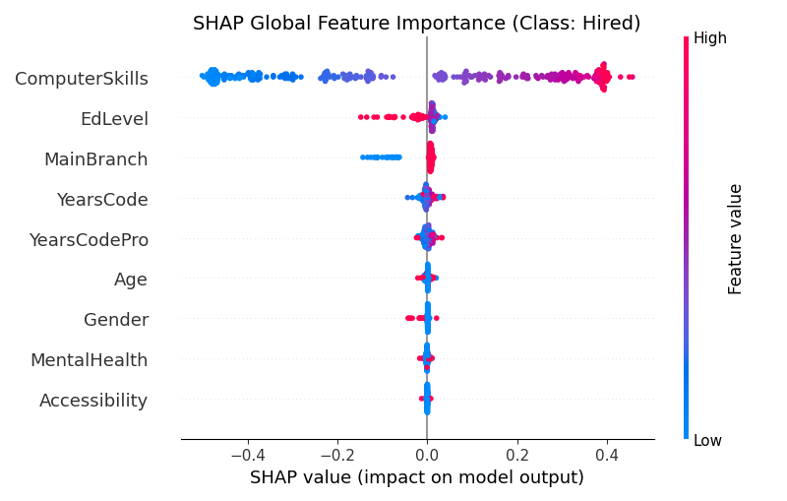
Crucially, while Gender exhibits low overall importance, its SHAP density plot shows that being male consistently provides marginal positive shifts, whereas being female concentrates marginal negative forces. This highlights that although the model does not explicitly rely on the Gender feature alone to make decisions, gender-correlated variations across the dataset still create systemic differences in outcomes.n
Figure 1: SHAP Global Summary Plot illustrating features driving overall model classification. The X-axis measures the impact on model output (log-odds of hiring), where rightward distribution indicates a positive hiring weight, and colour density represents the feature value magnitude.

As shown in Figure 1, high values for technical competencies (ComputerSkills and professional tenure) generate substantial positive Shapley values, shifting candidates toward a "Hire" decision. Conversely, low skill counts heavily penalise candidates. Crucially, while Gender exhibits low raw structural importance (0.38%), its SHAP density distribution explicitly reveals that being male concentrates positive classification forces, whereas being female concentrates negative forces. This visually validates that gender-correlated variations across the dataset create systemic differences in outcomes.

Lime explanation (local explainability)
To inspect the specific factors influencing individual decisions, LIME (Local Interpretable Model-agnostic Explanations) was applied to individual profiles to break down individual candidate rejections.
An examination of a rejected female candidate's profile provides a clear example:
- Profile: ComputerSkills = 8, YearsCodePro = 3, EdLevel = Undergraduate, Gender = Woman (1).
- LIME Visual Output: The LIME horizontal contribution plot shows that the primary factor driving her rejection was her lower verified skill count (ComputerSkills <= 11.00), which contributed a large negative weight (≈−0.42) against her probability of being hired. Her lower professional experience bracket (YearsCodePro <= 5.00) added another negative weight.
Plain English Interpretation: LIME reveals that the model rejected this applicant not because of an explicit penalty on her gender attribute directly, but because her technical skill count and professional experience fell below the model's preferred thresholds. This shows that the model relies heavily on these specific numeric thresholds when evaluating individual applicants.

Figure 2: LIME Local Feature Contribution Plot for an individual rejected female candidate. Red horizontal bars denote features pulling the model toward rejection, while green horizontal bars indicate features favouring an approval decision boundary.

As captured in the local boundary audit in Figure 2, the primary factor driving this candidate's rejection was her verified technical skill metric falling below the model's primary classification partition (ComputerSkills <= 11.00), which alone contributed a massive negative weight of approximately −0.42 against her probability of being hired. Her lower professional experience bracket (YearsCodePro <= 5.00) added another negative weight layer. This visually proves that the system relies heavily on specific numeric thresholds when evaluating individual applicants, effectively cloaking systemic proxy bias under objective metrics.

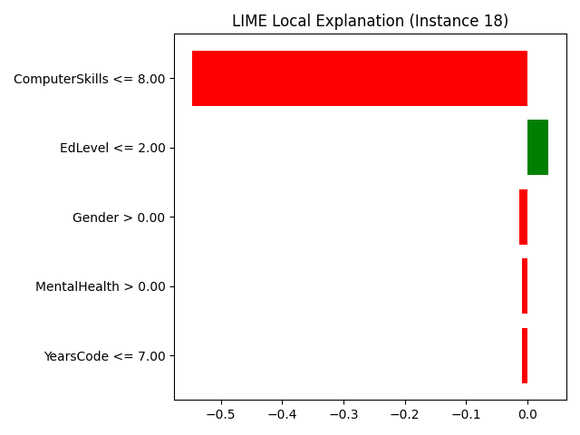

Bias and fairness discussion
The core ethical issue uncovered during the audit is Proxy Bias. Calculating the Disparate Impact Ratio (DI) on the model's predictions yields a score of:
Disparate Impact Ratio = Selection Rate for Men / Selection Rate for Women = 54.08% / 44.88% = 0.8298
While a ratio of 0.83 sits just above the critical legal threshold of adverse impact (0.80), a deeper look at the features reveals hidden proxy discrimination. Interrogating the data shows that the historical majority cohort (Men) averages 13.50 computer skills and 9.23 years of professional coding, whereas the minority cohort (Women) averages 11.89 computer skills and 6.67 years of professional coding.
Because historical and systemic factors often lead to uneven professional tenures and experience gaps across demographics, an algorithm that relies almost exclusively (91.28%) on absolute skill tallies will inherently favour male applicants. The features ComputerSkills and YearsCodePro essentially act as proxy variables for gender, allowing historical disparities to bypass fairness checks under the guise of objective technical metrics.

Recommendations and mitigation strategies
To address these findings and support fairer outcomes, the following mitigation strategies are proposed:
- Suppression of Direct Demographic Identifiers: Completely remove the Gender and Age features from training inputs to eliminate direct disparate treatment.
- Feature Re-weighting and Resampling: Balance the training data distributions by applying SMOTE or down-sampling techniques to ensure the model learns performance patterns equally across demographic groups.
- Strategic Contextualisation of Technical Metrics: Instead of evaluating absolute skill counts, transform technical metrics into contextual relative scores (e.g., measuring an applicant's skills relative to their specific career duration or role level). This accounts for historical career gaps and reduces proxy bias.
- Regular Algorithmic Auditing: Implement automated fairness checks within the CI/CD deployment pipeline to track Disparate Impact and Equalised Odds continuously before updates go live.

GROUP MEMBERS
- RITA JONATHAN - VUG/CSC/24/13208
- NEGEDU EMMANUEL OJODOMO - VUG/CSC/23/10588
- KWAPYONG MATTHEW MANTOE - VUG/CSC/23/8829
- AMAEFULE VICTOR CHUKWUEBUKA - VUG/CSC/23/10215
- ABDULJALAL ISHABA -VUG/CSC/23/9145
- JUDE CHIDERA JUDE - VUG/CSC/24/13106
- ADAMA JARREN OJOCHIDE - VUG/CSC/23/9961
- RAPHAEL CHINEDU OKECHUKWU - VUG/CSC/23/9222
- OSHIBOTE ADEBUSAYO ESTHER - VUG/CSC/23/10043
- WANI PAUL WISDOM - VUG/CSC/23/9826
- OKORONKWO CHIDOZIE PETER - VUG/CSC/23/10614
- SOLOMON VICTOR ENEIRAMO - VUG/CSC/23/8942
- OLUEHI DELIGHT - VUG/CSC/23/9564
- EZE FAVOUR - VUG/CSC/23/9414
- OKECHUKWU-PRINCE JOSEPH CHUKWUEME - VUG/CSC/23/9339
- AHMED MUTAWAKEEL - VUG/CSC/23/10262
- IJEBUWA-NWOKOH KAMSI KENECHI - VUG/CSC/23/9427
- ISIORO OGHENEKOME - VUG/CSC/24/13067
- ELISHA MUSA NAMAN - VUG/CSC/24/13279
- ANTHONY VICTOR ENOMHEN - VUG/CSC/23/8819
- NWACHUKWU UGOCHUKWU COLLIN - VUG/CSC/23/10710
- LUCKY COVENANT - VUG/CSC/23/9672
- EMEFIELE DIVINEFAVOUR - VUG/CSC/23/8985
- ANONO DEBORAH - VUG/CSC/23/9870
- ESSIET ENOBONG VICTOR - VUG/CSC/23/10556
- OBIOKALA ODIAKAOSE PATRICK - VUG/CSC/23/8937

