Linux Programming
Practice Lab
Name: Logarathinam A
Regno: 16MIS1003

Scripts

Script 1:

sudo apt-get install sl
sl

Description:
Displays animations aimed to correct users who accidentally enter sl instead of ls.

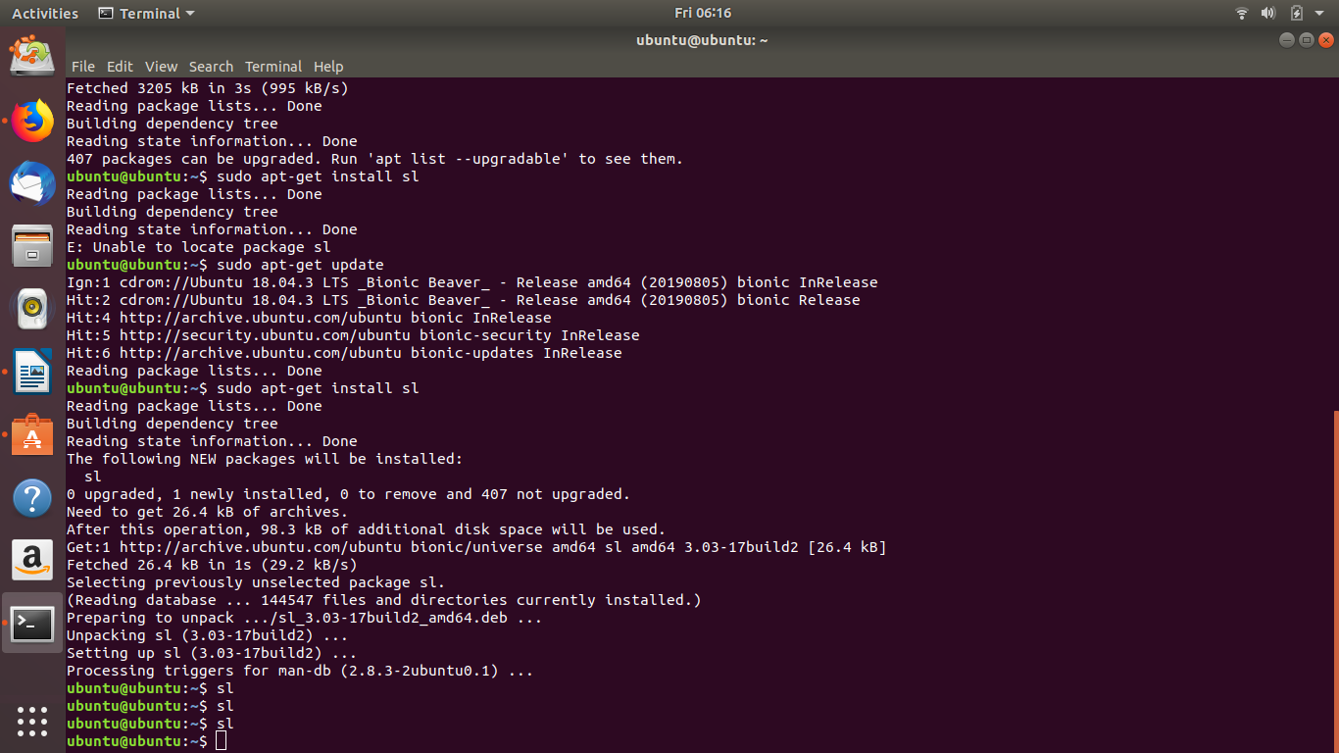

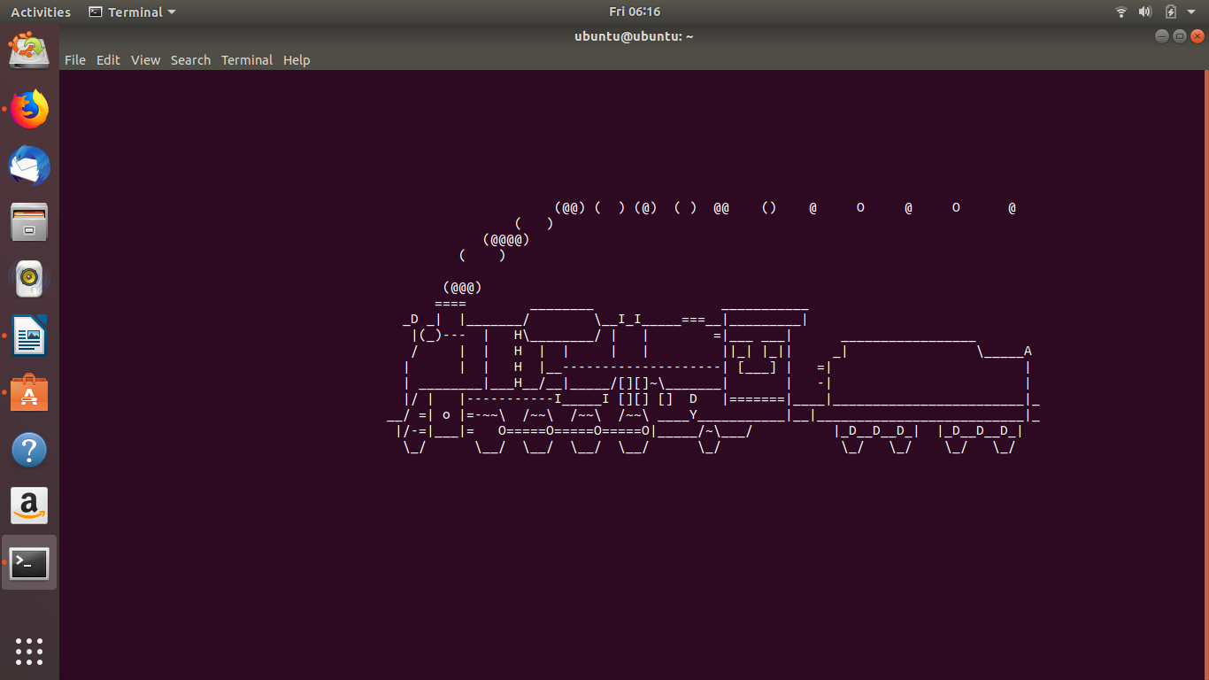

Script 2:

Rev: It Reverse anything that is given as input. It includes String,integer,Special Characters,spaces etc..
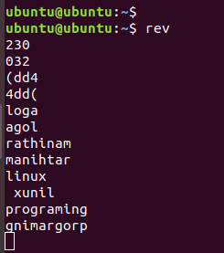

Factor: It finds all the factors of the given positive integer.
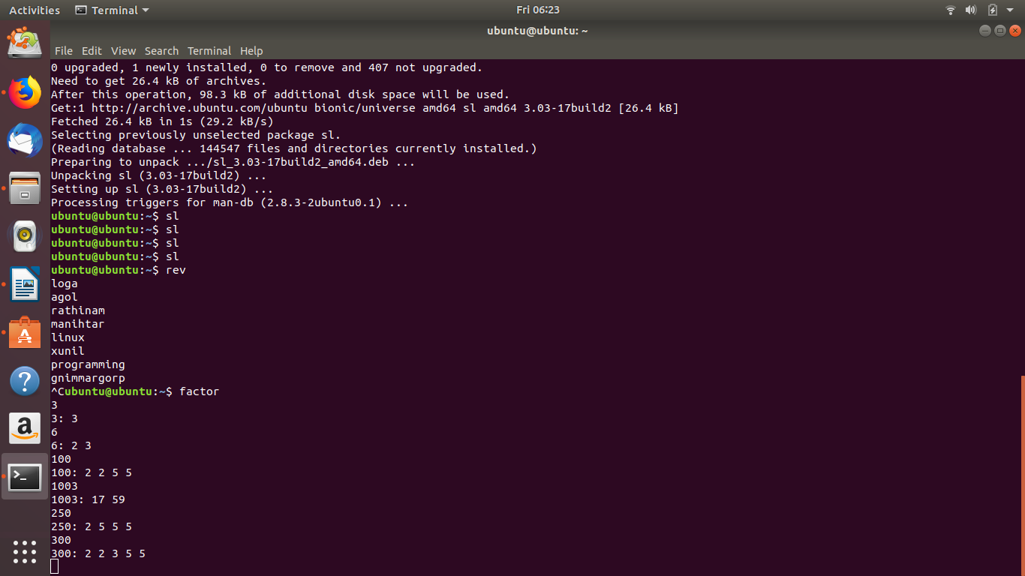

Yes: It Keeps printing Y until it is interrupted by the user

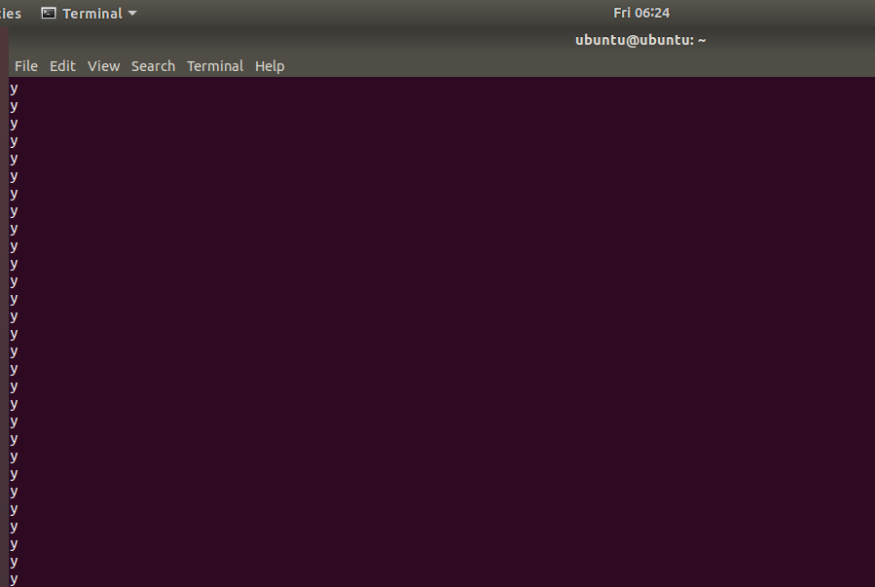

Hot Question

System Health Check

Code:

S="************************************"
D="-------------------------------------"
COLOR="y"

MOUNT=$(mount|egrep -iw "ext4|ext3|xfs|gfs|gfs2|btrfs"|grep -v "loop"|sort -u -t' ' -k1,2)
FS_USAGE=$(df -PTh|egrep -iw "ext4|ext3|xfs|gfs|gfs2|btrfs"|grep -v "loop"|sort -k6n|awk '!seen[$1]++')
IUSAGE=$(df -PThi|egrep -iw "ext4|ext3|xfs|gfs|gfs2|btrfs"|grep -v "loop"|sort -k6n|awk '!seen[$1]++')

if [ $COLOR == y ]; then
{
GCOLOR="\e[47;32m ------ OK/HEALTHY \e[0m"
WCOLOR="\e[43;31m ------ WARNING \e[0m"
CCOLOR="\e[47;31m ------ CRITICAL \e[0m"
}
else
{
GCOLOR=" ------ OK/HEALTHY "
WCOLOR=" ------ WARNING "
CCOLOR=" ------ CRITICAL "
}
fi

echo -e "$S"
echo -e "\tSystem Health Status"
echo -e "$S"

#--------Print Operating System Details--------#
echo -e "\nPrint Operating System Details"
echo -e "$D"

hostname -f &> /dev/null && printf "Hostname : $(hostname -f)" || printf "Hostname : $(hostname -s)"

[ -x /usr/bin/lsb_release ] && echo -e "\nOperating System :" $(lsb_release -d|awk -F: '{print $2}'|sed -e 's/^[ \t]*//') || \
echo -e "\nOperating System :" $(cat /etc/system-release)

echo -e "Kernel Version : " $(uname -r)

printf "OS Architecture : "$(arch | grep x86_64 &> /dev/null) && printf " 64 Bit OS\n" || printf " 32 Bit OS\n"

#--------Print system uptime-------#
UPTIME=$(uptime)
echo $UPTIME|grep day &> /dev/null
if [ $? != 0 ]
then
echo $UPTIME|grep -w min &> /dev/null && echo -e "System Uptime : "$(echo $UPTIME|awk '{print $2" by "$3}'|sed -e 's/,.*//g')" minutes" \
|| echo -e "System Uptime : "$(echo $UPTIME|awk '{print $2" by "$3" "$4}'|sed -e 's/,.*//g')" hours"
else
echo -e "System Uptime : " $(echo $UPTIME|awk '{print $2" by "$3" "$4" "$5" hours"}'|sed -e 's/,//g')
fi
echo -e "Current System Date & Time : "$(date +%c)

#--------Check for any read-only file systems--------#
echo -e "\nChecking For Read-only File System[s]"
echo -e "$D"
echo "$MOUNT"|grep -w \(ro\) && echo -e "\n.....Read Only file system[s] found"|| echo -e ".....No read-only file system[s] found. "

#--------Check for currently mounted file systems--------#
echo -e "\n\nChecking For Currently Mounted File System[s]"
echo -e "$D$D"
echo "$MOUNT"|column -t

#--------Check disk usage on all mounted file systems--------#
echo -e "\n\nChecking For Disk Usage On Mounted File System[s]"
echo -e "$D$D"
echo -e "( 0-90% = OK/HEALTHY, 90-95% = WARNING, 95-100% = CRITICAL )"
echo -e "$D$D"
echo -e "Mounted File System[s] Utilization (Percentage Used):\n"

COL1=$(echo "$FS_USAGE"|awk '{print $1 " "$7}')
COL2=$(echo "$FS_USAGE"|awk '{print $6}'|sed -e 's/%//g')

for i in $(echo "$COL2"); do
{
if [ $i -ge 95 ]; then
COL3="$(echo -e $i"% $CCOLOR\n$COL3")"
elif [[ $i -ge 90 && $i -lt 95 ]]; then
COL3="$(echo -e $i"% $WCOLOR\n$COL3")"
else
COL3="$(echo -e $i"% $GCOLOR\n$COL3")"
fi
}
done
COL3=$(echo "$COL3"|sort -k1n)
paste <(echo "$COL1") <(echo "$COL3") -d' '|column -t

#--------Check for any zombie processes--------#
echo -e "\n\nChecking For Zombie Processes"
echo -e "$D"
ps -eo stat|grep -w Z 1>&2 > /dev/null
if [ $? == 0 ]; then
echo -e "Number of zombie process on the system are :" $(ps -eo stat|grep -w Z|wc -l)
echo -e "\n Details of each zombie processes found "
echo -e " $D"
ZPROC=$(ps -eo stat,pid|grep -w Z|awk '{print $2}')
for i in $(echo "$ZPROC"); do
ps -o pid,ppid,user,stat,args -p $i
done
else
echo -e "No zombie processes found on the system."
fi
#--------Check Inode usage--------#
echo -e "\n\nChecking For INode Usage"
echo -e "$D$D"
echo -e "( 0-90% = OK/HEALTHY, 90-95% = WARNING, 95-100% = CRITICAL )"
echo -e "$D$D"
echo -e "INode Utilization (Percentage Used):\n"

COL11=$(echo "$IUSAGE"|awk '{print $1" "$7}')
COL22=$(echo "$IUSAGE"|awk '{print $6}'|sed -e 's/%//g')

for i in $(echo "$COL22"); do
{
if [[ $i = *[[:digit:]]* ]]; then
{
if [ $i -ge 95 ]; then
COL33="$(echo -e $i"% $CCOLOR\n$COL33")"
elif [[ $i -ge 90 && $i -lt 95 ]]; then
COL33="$(echo -e $i"% $WCOLOR\n$COL33")"
else
COL33="$(echo -e $i"% $GCOLOR\n$COL33")"
fi
}
else
COL33="$(echo -e $i"% (Inode Percentage details not available)\n$COL33")"
fi
}
done

COL33=$(echo "$COL33"|sort -k1n)
paste <(echo "$COL11") <(echo "$COL33") -d' '|column -t

#--------Check for SWAP Utilization--------#
echo -e "\n\nChecking SWAP Details"
echo -e "$D"
echo -e "Total Swap Memory in MiB : "$(grep -w SwapTotal /proc/meminfo|awk '{print $2/1024}')", in GiB : "\
$(grep -w SwapTotal /proc/meminfo|awk '{print $2/1024/1024}')
echo -e "Swap Free Memory in MiB : "$(grep -w SwapFree /proc/meminfo|awk '{print $2/1024}')", in GiB : "\
$(grep -w SwapFree /proc/meminfo|awk '{print $2/1024/1024}')

#--------Check for Processor Utilization (current data)--------#
echo -e "\n\nChecking For Processor Utilization"
echo -e "$D"
echo -e "\nCurrent Processor Utilization Summary :\n"
mpstat|tail -2

#--------Check for load average (current data)--------#
echo -e "\n\nChecking For Load Average"
echo -e "$D"
echo -e "Current Load Average : $(uptime|grep -o "load average.*"|awk '{print $3" " $4" " $5}')"

#------Print most recent 3 reboot events if available----#
echo -e "\n\nMost Recent 3 Reboot Events"
echo -e "$D$D"
last -x 2> /dev/null|grep reboot 1> /dev/null && /usr/bin/last -x 2> /dev/null|grep reboot|head -3 || \
echo -e "No reboot events are recorded."

#------Print most recent 3 shutdown events if available-----#
echo -e "\n\nMost Recent 3 Shutdown Events"
echo -e "$D$D"
last -x 2> /dev/null|grep shutdown 1> /dev/null && /usr/bin/last -x 2> /dev/null|grep shutdown|head -3 || \
echo -e "No shutdown events are recorded."

#--------Print top 5 most memory consuming resources---------#
echo -e "\n\nTop 5 Memory Resource Hog Processes"
echo -e "$D$D"
ps -eo pmem,pcpu,pid,ppid,user,stat,args | sort -k 1 -r | head -6|sed 's/$/\n/'

#--------Print top 5 most CPU consuming resources---------#
echo -e "\n\nTop 5 CPU Resource Hog Processes"
echo -e "$D$D"
ps -eo pcpu,pmem,pid,ppid,user,stat,args | sort -k 1 -r | head -6|sed 's/$/\n/'

Output:
