Software Requirements Specification

for

Yoga Center System,  
Release 1.0

**Version 1.0 approved**

**Prepared by Group 5**

**Process Impact**

**June 23, 2023**

**Table of Contents**

**Revision History ii**

**1.** **Introduction 1**

1.1 Purpose 1

1.2 Document Conventions 1

1.3 Project Scope and Product Features 2

1.4 References 2

**2.** **Overall Description 2**

2.1 Product Perspective 2

2.2 User Classes and Characteristics 3

2.3 Operating Environment 4

2.4 Design and Implementation Constraints 4

2.5 Assumptions and Dependencies 4

**3.** **System Features 5**

3.1 Use Case Diagram 5

3.2 Use Case Specification 6

**4.** **Data Requirements 15**

4.1 Logical Data Model 15

4.2 Data Dictionary 16

**5.** **External Interface Requirements 18**

5.1 User Interfaces 18

5.2 Software Interfaces 18

5.3 Hardware Interfaces 19

5.4 Communications Interfaces 20

**6.** **Quality Attributes 19**

6.1 Usability Requirements 19

6.2 Performance Requirements 19

6.3 Security Requirements 19

6.4 Safety Requirements 19

6.5 Availability Requirements 19

6.6 Robustness Requirements 20

**Appendix A: Analysis Models 21**

**Revision History**

| **Name** | **Date** | **Reason For Changes** | **Version** |
| --- | --- | --- | --- |
| Group 5 | 6/23/23 | baseline following changes after inspection | 1.0 approved |

# Introduction

## Purpose

This SRS describes the functional and non-functional requirements for software release 1.0 of the Yoga Center System (YCS). This document is intended to be used by the members of the project team who will implement and verify the correct functioning of the system. Unless otherwise noted, all requirements specified here are committed for release 1.0.

## Document Conventions

**1.2.1. Document Format:** The SRS shall be written in a clear and concise manner, following a standard document format, such as Microsoft Word or PDF.

**1.2.2. Document Structure:** The SRS shall adhere to a consistent structure, including the following sections:

**a. Introduction:** Provides an overview of the document and its purpose.

**b. Document Conventions:** Describes any specific standards, typographical conventions, or notations used in the document.

**c. Project Scope and Product Features:** Outlines the scope of the project and lists the major product features.

**d. Functional Requirements:** Describes the functional requirements of the software system.

**e. Nonfunctional Requirements:** Describes the nonfunctional requirements, such as performance, reliability, and usability.

**f. System Models:** Presents system models, such as use case diagrams or entity-relationship diagrams, to illustrate the system's behavior and structure.

**g. Other Sections:** Includes any additional sections as required by the project or organization, such as glossary, references, or appendices.

**1.2.3. Text Styles:** To enhance readability and understanding, the SRS shall use the following text styles:

**a. Heading Styles:** Clear and hierarchical headings shall be used to structure the document sections and subsections.

**b. Bold:** Important terms, key concepts, or emphasized information shall be formatted in bold.

**c. Italics:** Titles of books, journals, or other works, as well as technical terms or foreign words, shall be italicized.

**1.2.4. Notations and Symbols:** To aid in understanding and interpretation, the following notations and symbols shall be used:

**a. Requirement ID:** Each requirement shall be assigned a unique identifier for easy referencing and traceability.

**b. Cross-References:** When referring to other sections or requirements within the document, cross-references shall be used, including the appropriate section or requirement ID.

**c. Acronyms and Abbreviations:** A list of acronyms and abbreviations used in the document shall be provided, along with their corresponding definitions.

* + 1. **Version Control:** To track document revisions and changes, a version control system shall be employed. Each document version shall be clearly labeled with a version number and date.
    2. **Review and Approval Process:** The SRS shall undergo a review and approval process involving relevant stakeholders, including project managers, developers, testers, and clients. Feedback and changes from the review process shall be incorporated into the document.

## Project Scope and Product Features

The Yoga Center System (YCS) aims to provide an efficient and convenient platform for managing yoga classes, registrations, and related activities within a yoga center. The system will be accessible to both staff members and clients, offering a range of features to enhance the overall experience and streamline administrative tasks. The scope of the project includes the development and implementation of the YCS, as well as necessary integration with existing systems, such as payment gateways and scheduling tools.

## References

1. Wiegers, Karl. Software Requirements, Third Edition, https://www.dirzon.com/file/telegram/HiLCoE - DRB1802/Microsoft Press Software Requirements 3 3rd Edition Aug 2013.pdf

# Overall Description

## Product Perspective

The Yoga Center System is a new software system that aims to streamline and enhance the overall experience of trainees and trainers at The Yoga Center. It replaces the current manual processes for class registration, scheduling, trainee, trainer management, and payment bringing efficiency and convenience to the center's operations. The system is designed to evolve over multiple releases, incorporating additional features to further enrich the yoga experience for both the center's staff and its members.

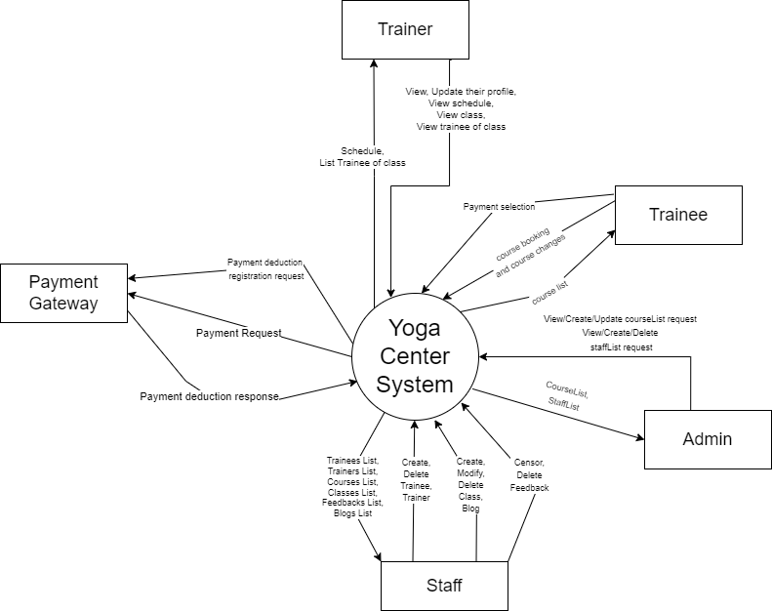

**Figure 1. Context diagram of the Yoga Center System.**

## User Classes and Characteristics

| Trainee | A trainee refers to an individual who enrolls in yoga classes offered by the center. Trainees are motivated to improve their physical and mental well-being through regular yoga practice, and attending classes multiple times per week. There are about 100 potential trainees, of which 60 are expected to use the YCS an average of 3 times per week. Trainees can easily register for classes through the center’s website and they have access to personalized recommendations, progress tracking, and timely notifications about schedule changes and special events. |
| --- | --- |
| Trainer | A trainer is a Yoga Center employee who are highly skilled and knowledgeable professionals who guide and inspire individuals in their yoga journey. They can register the course they want to teach and see all the trainees profile enrolling in the class they guide. Also, they can view their teaching schedule and check attendance of the trainee in the class. |
| Staff | The Process Impact Yoga Center employs about 20 Staffs, who will receive bookings from the YCS, prepare courses, schedule classes, and process payment. Most of the Yoga Staff will need training in the use of the hardware and software for the YCS. |
| Admin | An admin is the one who is responsible for the smooth operation and management of the center. They handle a range of tasks, including course creating, class checking, trainer coordination, and student registration. Also, the admin can see the payment status and check the total revenue in a month of the center. |

## Operating Environment

OE-1: The Yoga Center System shall operate correctly with the following web browsers: Windows Internet Explorer versions 7, 8, and 9; Firefox versions 12 through 26; Google Chrome (all versions); and Apple Safari versions 4.0 through 8.0.

OE-2: The Yoga Center System shall operate on a server running the current corporate-approved versions of Red Hat Linux and Apache HTTP Server.

OE-3: The Yoga Center System shall permit user access from the corporate Intranet, from a VPN Internet connection, and by Android, iOS, and Windows smartphones and tablets.

## Design and Implementation Constraints

CO-1: The system’s design, code, and maintenance documentation shall conform to the *Process Impact Intranet Development Standard, Version 1.3* [2].

CO-2: The system shall use the current corporate standard SQL database engine.

CO-3: All HTML code shall conform to the HTML 5.0 standard.

CO-4: The UI/UX will use ReactJS and The logical threads or the Back-end will use RestfulAPI, C# Programming Language.

## Assumptions and Dependencies

AS-1: The Yoga Center operates classes primarily in the afternoon after the business hours, offering a variety of sessions throughout the day to accommodate trainees' schedules.

DE-1: The operation of the Yoga Center System depends on changes being made in the Membership Management System to integrate trainee information, such as enrollment details, attendance records, and progress tracking.

DE-2: The operation of the Yoga Center System depends on changes being made in the Class Schedule System to update and synchronize class availability, trainers assignments, and any schedule changes as reflected in the Yoga Center System.

# System Features

## Use case diagram

**Figure 2. Use case diagram for release 1.0 of the Yoga Center System.**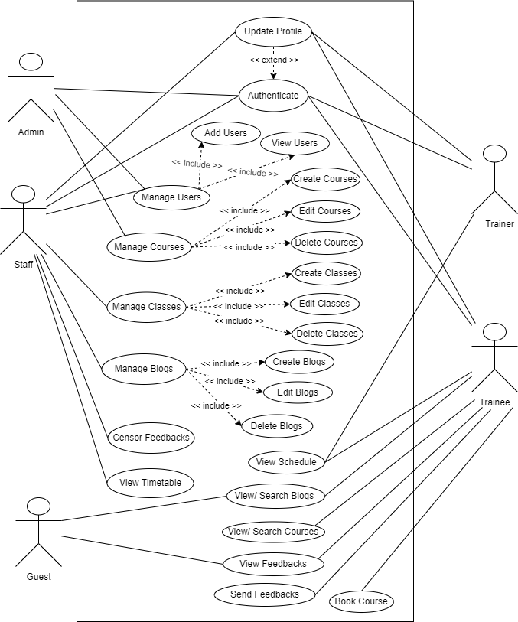

## Use case specification

| ID and Name: | **UC-1 Create new Class** | | |
| --- | --- | --- | --- |
| Created By: | Huynh Minh Thuan | Date Created: | 22/5/23 |
| Primary Actor: | Staff | Secondary Actors: | Courses List |
| Description: | A staff views the list of available courses of the center, and creates new classes for a specific class. | | |
| Trigger: | A staff member indicates that he wants to create new classes for a specific course. | | |
| Preconditions: | PRE-1. Staff is logged into YGC.  PRE-2. The course for which is needed to create new classes is still available. | | |
| Postconditions: | POST-1. The new class is stored in YGC and the notification is viewed for staff if the request is successful or failed.  POST-2. The new class is viewed on the Yoga Center website.  POST-3. Remaining capacity for the available schedule and room is updated. | | |
| Normal Flow: | **1.0 Create a new class for a specific course**   1. Staff asks to view the available courses list. 2. YGC displays a list of available courses. 3. Staff selects the specific course needed to create a new class and clicks the button “Create new class”. 4. The screen for creating a new class has appeared. 5. Staff fills the required information of the new class, including class name, start date, end date, room. (see 1.0.E1) 6. The schedule of the room and input for selecting trainer is selected is displayed (see 1.0.E2) 7. Staff selects the schedule and the trainer for the class. (see 1.0.E3) 8. YGC displays the notification that the request to create is successful or failed. (see 1.2) 9. Staff either confirms the new class (continue normal flow) or requests to modify the class (return to step 5). 10. YGC stores the new class to Yoga Center System 11. The new class is viewed on the Yoga Center website. | | |
| Alternative Flows: | **1.1 Choose multiple schedules for the class**   1. Staff clicks button “Add another Schedule” and choose the schedule 2. Return to step 6 of normal flow.   **1.2 Search for another specific course needed to create new class**   1. Staff searches the name of the course that he wants to create a new class.   2. Return to step 3 of normal flow. | | |
| Exceptions: | **1.0.E1 Start date and end date is before or equal to current date, start date is before or equal to end date**   1. Staff is required to enter start date and end date again.   **1.0.E2 Room, start date and end date are not selected yet**   1. Staff is required to select the room, enter start date and end date to view the schedule.   **1.0.E3 The schedule or trainer is duplicated with another class**  1. Staff is required to choose another schedule or check other classes, and select another trainer | | |
| Priority: | High | | |
| Frequency of Use: | Approximately 2-3 staffs, average of 2-3 usages per month. Peak usage load for this use case is between 8:00 A.M. and 6:00 P.M. local time. | | |
| Business Rules: | BR-1 The class must be displayed on the website, including its start date, end date, trainer’s name and schedule.  BR-2 Any two different classes must not be in the same room at the same time.  BR-3 Any two different classes at the same time must not be trained by one trainer.  BR-4 The maximum number of classes for a course is set by the admin.  BR-5 The class must be displayed on the website, including its name, start date, end date, schedule and trainer.  BR-6 Creating new classes is being implemented by staff only.  BR-7 If an error occurs while creating a class, the system displays an error message.  BR-8 While creating, the information of a class must be filled to be created successfully, including its name, start date, end date, schedule and trainer.  BR-9 The class having been created is displayed on admin and staff’s screen for management and modifying if necessary. | | |
| Other Information: | 1. Staff shall be able to modify the class before it gets started. | | |
| Assumptions: | 1. Assume that 10 percent of classes will be created on daily special with a discount for the course (source: previous 6 months of center data). 2. Assume that all available classes for a specific course have a large number of trainees, then a new class needs to be created (source: previous 3 months of center data). | | |

| ID and Name: | **UC-2 Book Course** | | |
| --- | --- | --- | --- |
| Created By: | Bui Nguyen Kim Long | Date Created: | 22/5/23 |
| Primary Actor: | Trainee | Secondary Actors: | Course list |
| Description: | A Trainee accessed the Yoga Center System from the Internet, viewed the courses for a specific interest, chose a mentor if desired, selected course items, confirmed their booking, and paid for the course. | | |
| Trigger: | A Trainee indicates that he wants to learn yoga and wants to have a course in the Yoga Center. | | |
| Preconditions: | PRE-1. Trainee is logged into YCS.  PRE-2. Trainees are registered for course payments by VNPay. | | |
| Postconditions: | POST-1. A booking confirmation for the selected course attaching the booking detail is sent to the trainee’s email.  POST-2. The course provider’s seat count for the booked course is updated. | | |
| Normal Flow: | **1.0 Book a specific course**  1. Trainee asks to view a course for a specific interest.  2. YCS displays a list of available courses and some recommended courses based on the trainee’s interest.  3. Trainees select a course from the list.  4. YCS presents detailed information about the selected course, including the course name, description, schedule, and available seats.  5. YCS checks the availability of seats for the selected course. If seats are available, the system proceeds with the booking process.  6. Trainees review the course information and decides to proceed with the booking.  7. YCS displays the course items, individual price, and total price including the taxes.  8. Trainees either confirms their booking (continue normal flow) or requests to modify their course selection or cancel booking. (return to step 2).  9. Trainee specifies payment method.  10. YCS confirms acceptance of the booking.  11. YCS generates a booking confirmation, which includes course details, booking reference number, and any additional instructions and sends to Trainees via email message or display it on the screen.  12. YCS updates the course's seat count, reducing the available seats by the number of booked seats. | | |
| Alternative Flows: | **1.1 Insufficient Seats**  In step 5 of the normal flows, if no seats are available for the selected course:  1. YCS displays an error message indicating the unavailability of seats.  2. Trainee is prompted to select a different course or cancel booking.  3. Return to Step 2 of normal flow.  **1.2 Modify Course Selection**  1. Trainees ask to choose a different course.  2. YCS cancel the current booking process.  3. Return to Step 2 of normal flow.  **1.3 Cancel Booking**  1. YCS cancels the booking process.  2. Any temporary seat hold is released, and the available seat count for the selected course is updated accordingly.  3. Return to Step 2 of normal flow. | | |
| Exceptions: | **1.0. Overbooking Prevention – multiple trainees simultaneously attempt to book the last available seat for a course**  1. YCS employs a concurrency control mechanism to prevent overbooking.  2. Only one trainee is allowed to successfully book the seat, while others are notified that the seat has been filled.  3. The use case continues for the successful trainee, while other trainees may need to select an alternative course or cancel the booking process.  **1.1. All the courses have started or have enough trainees, no courses are available**  1. YCS informs the trainees that there isn’t any courses available to book because of the maximum of trainee’s registrations or the course with the specific interest of the trainee is not opened.  2. The trainee is prompted to check back later or contact the center for more information. | | |
| Priority: | High | | |
| Frequency of Use: | Approximately 200 users, average of one usage per day. Peak usage load for this use case is in prime time between 7:00 P.M. and 8:00 P.M. . | | |
| Business Rules: | BR-1 Trainee must have a valid membership to access yoga classes and services offered by the center. This ensures that only registered members can book classes.  BR-2 Trainee can cancel their class bookings up to a specified time before the class start time without penalty. However, late cancellations or no-shows may incur penalties, such as a deduction from the membership or a limited number of allowed late cancellations per month.  BR-3 Each yoga class has a maximum capacity (about 20 trainees) to ensure a safe and comfortable environment for participants. Once the class reaches its capacity, further bookings are not allowed.  BR-4 Some classes may have specific prerequisites, such as prior experience or skill level. The system should verify the trainee's eligibility for such classes before allowing bookings.  BR-5 The booking must be made within a specified time frame before the class start time. This ensures that trainees cannot book classes too far in advance or at the last minute.  BR-6 If a course is successfully booked, the trainee must pay by their payment selection.  BR-12 Total price of the booking is calculated as the sum of the course’s price plus applicable sales tax, minus the discount percentage if desired.  BR-33 Network transmissions that involve financial information or personally identifiable information require 256-bit encryption. | | |
| Other Information: | 1. Trainees shall be able to cancel the booking process at any time prior to confirming it.  2. Trainee shall be able to view the course progress that he booked within the learning process and must finish the registered course if he/she wants to enroll in a new course.  3. Trainees shall be able to give any special requirements to the course and the trainer as well. | | |
| Assumptions: |  | | |

| ID and Name: | **UC-3 Feedback Censorship** | | |
| --- | --- | --- | --- |
| Created By: | Pham Bui Minh Khang | Date Created: | 22/5/23 |
| Primary Actor: | Staff | Secondary Actors: | Feedback List |
| Description: | A staff access the Yoga Center Management System using the Internet, view the feedback list uploaded by trainees for different courses. He/she can view the feedback title, and if needed, the staff can see detailed content of the feedback in order to decide whether to approve or reject the feedback. Also, staff can change to the status of older feedback, to approve rejected feedback or vice versa. | | |
| Trigger: | The staff logs into the Yoga Center Management System and navigates to the feedback management section to review and moderate trainee-uploaded feedback for different courses. | | |
| Preconditions: | PRE-1. Staff is logged into YCS.  PRE-2. Staff is authorized as staff.  PRE-3. Staff want to censor feedback uploaded by trainees | | |
| Postconditions: | POST-1. Newly uploaded feedbacks are decided to be displayed to everyone or to be rejected.  POST-2. Censored feedbacks are changed their status, approved feedbacks can be hidden(rejected) or rejected feedback can be display(approved)(If needed)  POST-3. Status of feedbacks stored in database are updated | | |
| Normal Flow: | **1.0 Censor a Feedback**   1. Staff requests to view the Feedback List for censorship. 2. The Yoga Center System (YCS) displays a list of available feedback, divided into two main sections:   + Uncensored Feedback.  + Censored Feedback.  Staff can choose to view either section.   1. Staff selects feedback from the list based on its header and overview rating. 2. YCS presents detailed information of the selected feedback, including its header, rating, and content. 3. Staff reviews the feedback details to determine its appropriateness for publication. 4. Staff chooses to approve, reject, or remain undecided regarding the feedback. 5. YCS confirms the staff's decision and updates the status of the feedback accordingly.   8. If changes are recorded, YCS updates the feedback status and reflects the update on the trainee feedback list screen. | | |
| Alternative Flows: | **1.1 Trainees edit their feedbacks:**   1. The feedbacks’ content is updated and their status has not been censored.   2. Return to Step 1 of normal flow. | | |
| Exceptions: | **1. Feedback List Retrieval Failure:**  In cases where the system fails to retrieve the feedback list due to database errors, network issues, or other technical problems, an exception should be handled.  The system can display an error message to the staff, informing them about the issue and suggesting they try again later or contact technical support.  **2. Feedback Detail Retrieval Failure**  If the staff encounters a problem while trying to view the detailed content of a feedback, such as a database error or missing data, an exception should be handled.  The system can display an error message indicating the issue and suggesting the staff try again or report the problem to the system administrator.  **3. Feedback Status Change Failure**  If the staff encounters an error while trying to change the status of a feedback (e.g., from approved to rejected or vice versa), an exception should be handled.  The system can display an error message notifying the staff about the issue and suggesting they try again or contact technical support for assistance.  **4. Concurrent Feedback Access**  In situations where multiple staff members are accessing the system and viewing the same feedback simultaneously, proper concurrency handling should be implemented.  The system should prevent conflicts and ensure that concurrent modifications to the same feedback status are handled appropriately to maintain data integrity. | | |
| Priority: | Medium | | |
| Frequency of Use: | Approximately 1-3 users, average of one usage per day. Peak usage load for this use case is in the early working section: 6 a.m and 5 p.m. | | |
| Business Rules: | BR-1: Feedback Approval Timing (Staff members are required to allocate a minimum of time for the review and decision-making process before approving or rejecting a number of feedbacks consecutively)  BR-2: Completeness of Approved Feedback (Feedback must contain complete information in all fields before it can be approved for publication)  BR-3: Timeframe for Re-checking Edited Feedback (A predefined time limit should be established to guide staff members on when to re-check and make a decision on edited feedback)  BR-4: Content Standards for Feedback Censorship (A comprehensive set of content standards must be in place to govern feedback censorship. Any feedback containing violated content, such as racism, personal attacks, personal information, false information, harassment, spam, advertisements, malicious links, or violations of intellectual property, should be rejected)  BR-5: Re-checking of Edited Feedback (All feedback that has been edited by users must undergo re-checking by staff members)  BR-6: Notification to Users (Trainees who edit their feedback must receive system notifications informing them that their updated feedback requires re-checking)  BR- 7: Word Limit for Feedback (Implementing a word limit for feedback content is necessary to ensure brevity and clarity in the provided feedback) | | |
| Other Information: | 1. Censorship Guidelines: Provide specific guidelines or policies that the staff should follow when reviewing and censoring feedback. These guidelines may include criteria for determining inappropriate or offensive content, guidelines for maintaining a respectful and inclusive environment, and any legal or compliance considerations.  2. Continuous Improvement: Show the importance of continuous improvement in the feedback censorship process. Encourage staff members to provide feedback on the process itself and suggest enhancements to make it more efficient and effective. | | |
| Assumptions: | Assume that 50 percent of staff will check the feedback censorship screen daily | | |

| ID and Name: | **UC-4 View schedule** | | |
| --- | --- | --- | --- |
| Created By: | Chau Thi Ngoc Tram | Date Created: | 22/5/23 |
| Primary Actor: | Trainer | Secondary Actors: | Yoga Center System |
| Description: | Trainer accesses the Yoga Center System to view their teaching schedule, including classes and related information. | | |
| Trigger: | A trainer indicates the desire to view the yoga class timetable. | | |
| Preconditions: | PRE-1. Trainer is logged in to the Yoga Center System. | | |
| Postconditions: | POST-1.The trainer has successfully viewed their teaching schedule, including classes and related information.  POST-2.The trainer can choose to continue viewing the schedule of other classes or return to the main screen of the Yoga Center System.  POST-3.If the trainer has no classes scheduled, the system notifies the trainer accordingly. | | |
| Normal Flow: | **1.0 View Schedule**   1. Trainer accesses the "Timetable" section of the Yoga Center System. 2. The Yoga Center system displays a list of sessions and classes that the trainer is in charge of 3. Trainer selects a session or class from the list. 4. The Yoga Center system displays detailed information about the selected session or class, including time, location and other relevant information. 5. 5. Trainer views information about class times, locations and other details of the session or class. | | |
| Alternative Flows: | **Trainer has no classes in the schedule**   1. If the Trainer has no classes on the schedule, the Yoga Center System notices that the trainer has no classes in charge. 2. The trainer can choose to continue viewing the schedule of other classes or return to the main screen of the Yoga Center System. | | |
| Exceptions: | **Error accessing the system**   1. If the trainer encounters an error when accessing the Yoga Center System, the system notices the problem and cannot display the teaching schedule. 2. The trainer is recommended to try again after a short time. If the problem persists, the Trainer can report the error to Technical Support for help. | | |
| Priority: | High | | |
| Frequency of Use: | Depends on the number of trainers and their teaching schedule. | | |
| Business Rules: | BR-1 Only logged-in Trainers can view schedule.  BR2 Trainers can only view their own teaching schedule and related information.  BR-3 The Yoga Center System displays the timetable in the "Timetable" section.  BR-4 If a Trainer has no classes scheduled, the system notifies the Trainer accordingly.  BR-5 In case of an error accessing the Yoga Center System, the system notifies the Trainer and suggests retrying after a short time.  BR-6 Changes made to the teaching schedule should be reflected in real-time within the Yoga Center System.  BR-7 The Trainer should not have the ability to modify or alter the teaching schedule through this feature. Their access is limited to viewing only. | | |
| Other Information: | None | | |
| Assumptions: | Trainer only has the right to view information related to the sessions and classes for which they are in charge. | | |

| ID and Name: | **UC-5 Create blog** | | |
| --- | --- | --- | --- |
| Created By: | Duong Hong Quan | Date Created: | 22/5/23 |
| Primary Actor: | Staff | Secondary Actors: | Blog |
| Description: | This table describes the blog upload use case. | | |
| Trigger: | A Staff indicates that he wants to create a blog | | |
| Preconditions: | PRE. Staff is logged into the website for admin. | | |
| Postconditions: | POST-1. Blog will be archive with the status “Approved”  POST-2. The homepage will update and display this blog | | |
| Normal Flow: | **1.0 Create a blog**   1. The staff member accesses the Yoga Center Management System. 2. The staff member navigates to the management page. 3. The staff member selects the option to create a blog. 4. The system presents a form to the staff member for filling in the blog information. 5. The staff member fills in the required information, including the blog title, content, and any optional images. 6. The staff member submits the blog for creation. 7. The system archives the blog with the "Approved" status. 8. The system updates the homepage to display the newly created blog. | | |
| Alternative Flows: | **The staff member decides not to create a blog:**   1. The staff member cancels the process. 2. The system returns to the management page without creating a blog.   **Error in submitting the blog:**   1. The system encounters an error while submitting the blog. 2. The system displays an error message to the staff member. 3. The staff member can choose to retry submitting the blog or cancel the process.   **Blog creation not approved:**   1. The system does not approve the created blog. 2. The staff member receives a notification about the blog status. 3. The staff member can choose to edit the blog and resubmit it or cancel the process.   **Homepage update failure:**   1. The system encounters an error while updating the homepage with the new blog. 2. The system logs the error and notifies the technical team for resolution. 3. The staff member can continue using the system, but the blog may not immediately appear on the homepage. | | |
| Exceptions: | None | | |
| Priority: | High | | |
| Frequency of Use: | Approximately 300 staff users with an average of one usage per day. Peak usage occurs between 9:00 A.M. and 10:00 A.M. local time. | | |
| Business Rules: | BR-1: The default date for blog creation is the current date if the staff member is using the system before the cutoff time. Otherwise, the default date is the next available date.  BR-2: The blog must be filled with required information, including the blog title and content.  BR-3: Optional images can be added to the blog.  BR-4: The system automatically archives the created blog with the status "Approved."  BR-5: The system updates the homepage to display the newly created blog.  BR-6: The staff member can cancel the process of creating a blog at any time before submitting it.  BR-7: If an error occurs while submitting the blog, the system displays an error message and allows the staff member to retry or cancel the process. | | |
| Other Information: | 1. The staff member can cancel the process of creating a blog at any time before submitting it.  2. The default date for the blog creation is the current date if the staff member is using the system before the cutoff time. Otherwise, the default date is the next available date. | | |
| Assumptions: | It is assumed that 15 percent of staff members will create a blog using the Yoga Center Management System based on historical data from the previous six months. | | |

# Data Requirements

## Logical Data Model

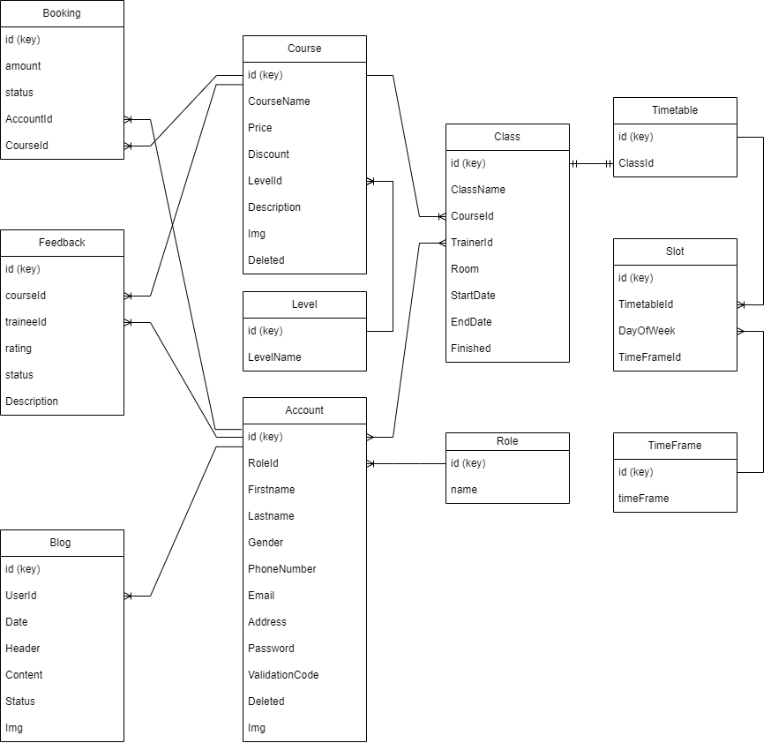

**Figure 3. Entity – Relationship diagram of the Yoga Center System.**

## Data Dictionary

| **Data Element** | **Description** | **Composition or Data Type** | **Length** | **Values** |
| --- | --- | --- | --- | --- |
| blog | details about a blog that staffs could be able to create, view, modify and delete | blog id  + userId  + blog date  + blog header  + blog content  + blog status  + blog img |  |  |
| blog id | unique ID that the system dynamically generates to assign to  each blog after it being created successfully | integer |  | initial value is 1 |
| userId | the unique ID of user used to identify who created the blog | integer |  |  |
| blog date | the date for which a specific blog is created | date, YYYY-MM-DD | 10 |  |
| blog header | the title of the blog | alphabetic | 100 |  |
| blog content | the content of the blog | alphabetic |  |  |
| blog status | the status for which a specific blog is not censored, censored or deleted | integer |  | 0: not censored  1: censored  2: deleted |
| blog img | the image of the blog | text |  | the link of the image being stored |
| Feedback ID | Identifies the unique ID for each feedback | integer |  |  |
| Trainee ID | Identifies the ID of the trainee who provided the feedback | integer |  |  |
| Course ID | Identifies the ID of the course for which the feedback was given | integer |  |  |
| Rating | Represents the rating given by the trainee for the course | integer |  | 1 to 5 |
| Status | Represents the status of the feedback | integer |  | 0: pending 1: approved 2: rejected |
| Description | Provides a textual description or comment given by the trainee | text |  |  |
| classId | System ID number of the class | integer |  |  |
| Class Name | Name of the class, possibly a combination of course name abbreviation and number | alphanumeric | 50 |  |
| Trainer ID | company ID number of the trainer who tutors the class | integer |  |  |
| Course ID | company ID number of the course of the class | integer |  |  |
| Room | The room where the class takes place | alphabetic | 5 |  |
| Start date | the date that class begins | date, MM/DD/YYYY | 10 | default = current date if the current time is before the order cutoff time, else the next day; cannot be prior to current date |
| Start date | the date that class ends | date, MM/DD/YYYY | 10 | default = current date if the current time is before the order cutoff time, else the next day; cannot be prior to current date or Start date |
| Finished | Has the class finished or not | bit |  | Default = true if End date is prior to current Date, else false; |
| courseId | System ID number of the class | integer |  |  |
| Course Name | Name of the course | text | 50 |  |
| Price | price of the course | integer |  |  |
| Discount | percent discount of the code | integer |  |  |
| LevelId | company ID number of the level of the course | integer |  |  |
| Description | provide the description of the course | text |  |  |
| Img | the image of course | text |  | the link of the image being stored |
| Deleted | Has the course deleted or not | bit |  | Default = false if course has not been deleted, else true; |

# External Interface Requirements

## User Interfaces

UI-1: The Yoga Center System screen displays shall conform to the Yoga Center Application User Interface Standard, Version 1.0.

UI-2: The system shall provide a help link from each displayed webpage to explain how to use that page.

UI-3: The webpages shall permit complete navigation and food item selection by using the keyboard alone, in addition to using mouse and keyboard combinations.

## Software Interfaces

SI-1: **VNPAY Integration**

SI-1.1: The Yoga Center System (YCS) shall integrate with VNPAY, a payment gateway, to facilitate course booking and payment transactions.

SI-1.2: The YCS shall communicate with VNPAY to verify the payment status and process successful transactions.

SI-1.3: In case of payment failure or cancellation, the YCS shall handle appropriate error messaging and provide options for users to retry or choose an alternative payment method.

SI-2: **Course Management System**

The YCS shall communicate with the Course Management System through a programmatic interface for the following operations:

SI-2.1: To create, update, and delete courses offered by the yoga center.

SI-2.2: To retrieve information about available courses, including course schedules, descriptions, and pricing.

SI-2.3: To assign trainers to specific courses and manage their availability.

SI-2.4: To manage class capacities and enrollment limits for each course.

SI-2.5: To track and manage trainee registrations and attendance for each course.

SI-2.6: To generate reports and analytics on course enrollments, attendance, and performance.

SI-3: **User Management System**

The YCS shall communicate with the User Management System through a programmatic interface for the following operations:

SI-3.1: To register new trainees and store their information, including contact details, and preferences.

SI-3.2: To authenticate and authorize users, allowing them access to the YCS based on their roles and permissions.

SI-3.3: To manage trainer profiles, including their qualifications, certifications, and availability.

SI-3.4: To provide trainees and trainers with access to their profiles and enable them to update their personal information.

## Hardware Interfaces

No hardware interfaces have been identified.

## Communications Interfaces

CI-1: The YCS shall send email or text message notifications (based on user preferences) to confirm course bookings, payment receipts, and important updates regarding course schedules or cancellations.

# Quality Attributes

## 6.1 Usability Requirements

USE-1: The Yoga Center website shall provide an intuitive and user-friendly interface that allows customers to easily view available courses, book courses, and make payments with a single interaction.

USE-2: 90% of new users shall be able to navigate through the website, book a course, and complete the payment process without encountering any errors on their first try.

## 6.2 Performance Requirements

PER-1: The system shall accommodate a total of 200 customers and a maximum of 70 concurrent users during peak usage times between 7:00 P.M. and 8:00 P.M., with an estimated average session duration of 10 minutes.

PER-2: 95% of web pages generated by the Yoga Center website shall download completely within 3 seconds from the time the user requests the page over a 10Mbps or faster Internet connection.

PER-3: The system shall process and display course availability and payment confirmation messages to users within an average of 2 seconds and a maximum of 5 seconds after the user submits the relevant information.

## 6.3 Security Requirements

SEC-1: Customer personal information, specifically password, shall be encrypted and transmitted securely using BCrypt Library to protect against unauthorized access.

SEC-2: Customers shall be required to log in to the website to access account-specific information, such as course bookings, schedule, payment history.

SEC-3: Only authorized administrators shall have access to the account management features, ensuring the privacy and security of customer data.

## 6.4 Availability Requirements

AVL-1: The Yoga Center website shall be available at least 95% of the time, 24 hours a day, 7 days a week, excluding scheduled maintenance windows, to ensure customers can access course information and make bookings at their convenience.

## 6.5 Robustness Requirements

ROB-1: In the event of an unexpected system failure or connection loss, the Yoga Center website shall have a mechanism in place to enable customers to recover any incomplete bookings and continue the process.

ROB-2: The system shall have adequate backup and recovery mechanisms to prevent data loss and ensure that customer account information, course bookings, payment records and previous constraints are preserved even in the event of system failures or disruptions.

# Appendix A: Analysis Models

**Figure 4: ACTIVITY DIAGRAM**

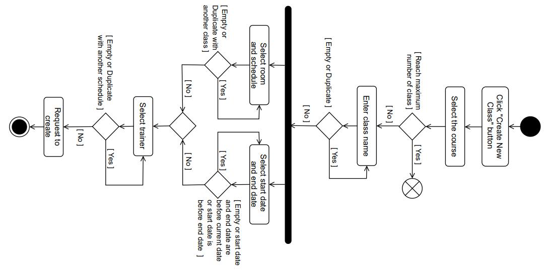

**Figure 4.1: Activity Diagram of the function Create A Class**

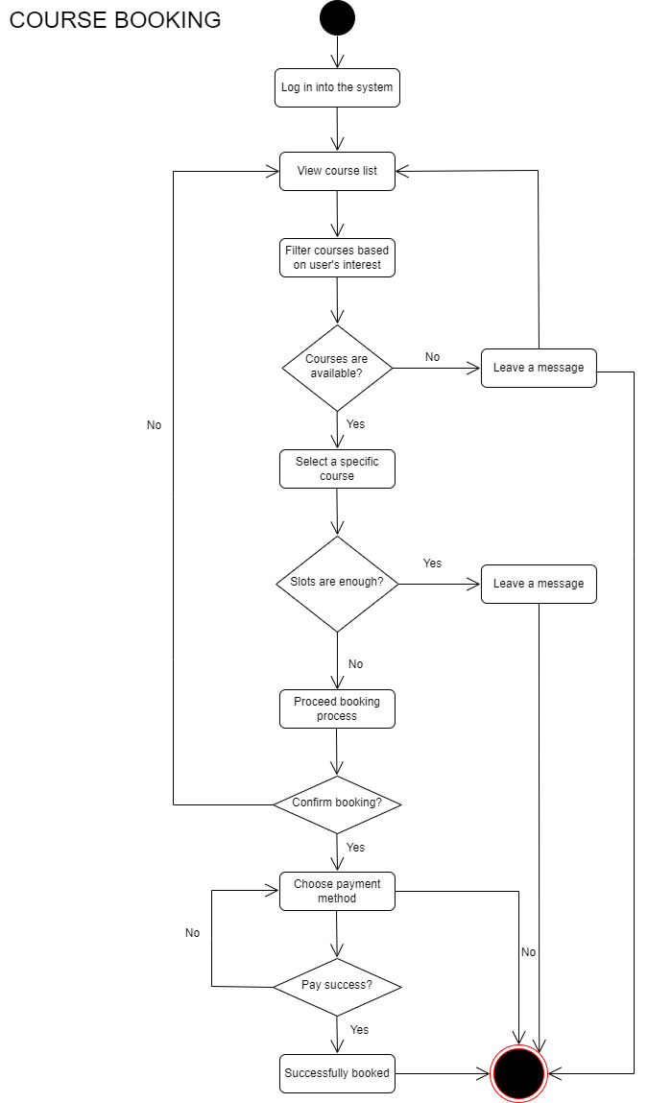

**Figure 4.2: Activity Diagram of the function Book A Course**

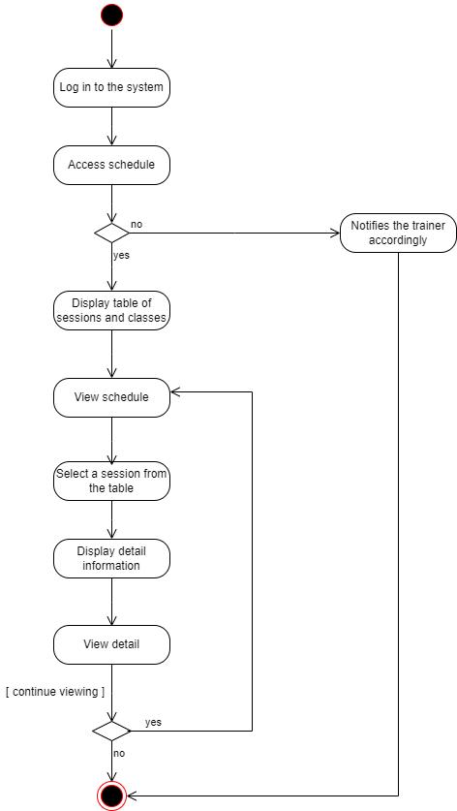

**Figure 4.3: Activity Diagram of the function View A Schedule**

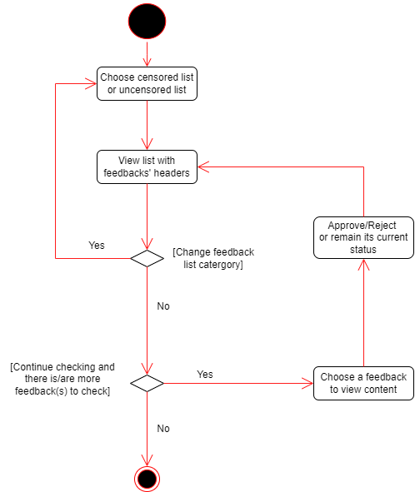

**Figure 4.4: Activity Diagram of the function Censor Feedbacks**

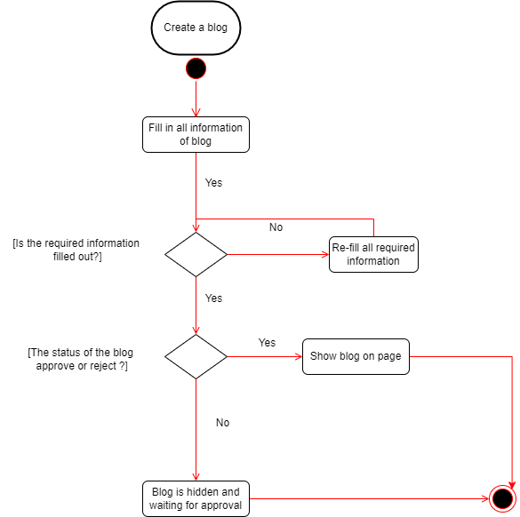

**Figure 4.5: Activity Diagram of the function Create A Blog**

**Figure 5: STATE DIAGRAM**

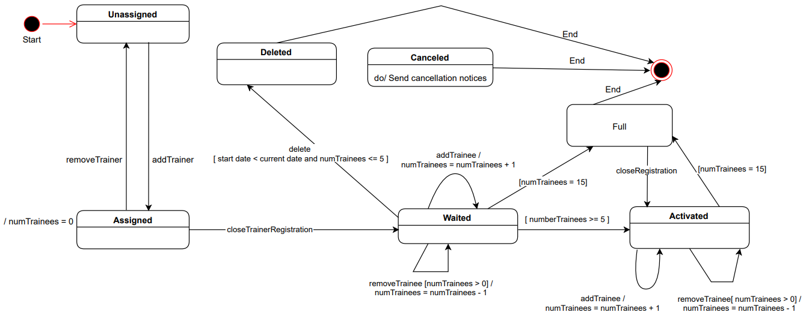

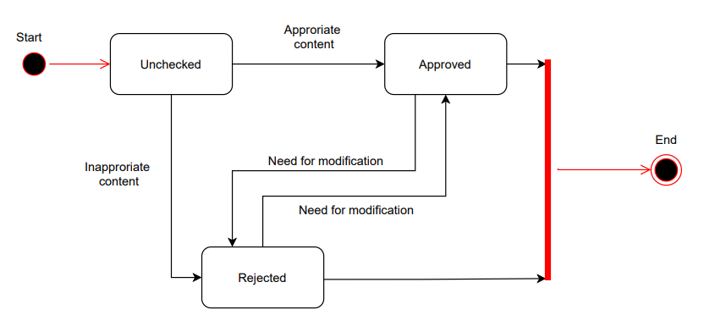

**Figure 5.1: State Diagram of the object Class**

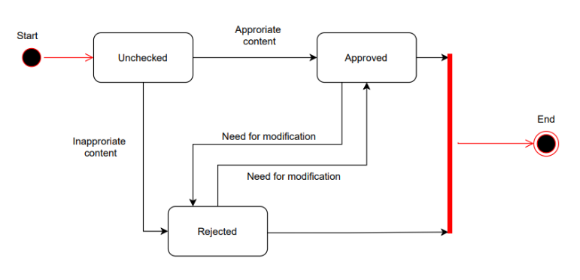

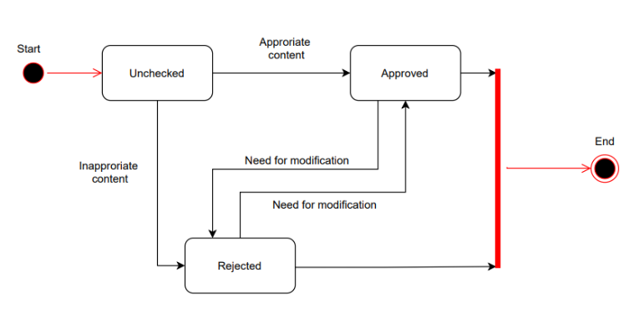

**Figure 5.2: State Diagram of the object Feedback**

**Figure 6: SEQUENCE DIAGRAM**

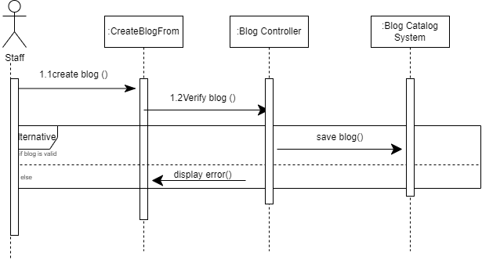

**Figure 6.1: Sequence Diagram of the function Create Blog**

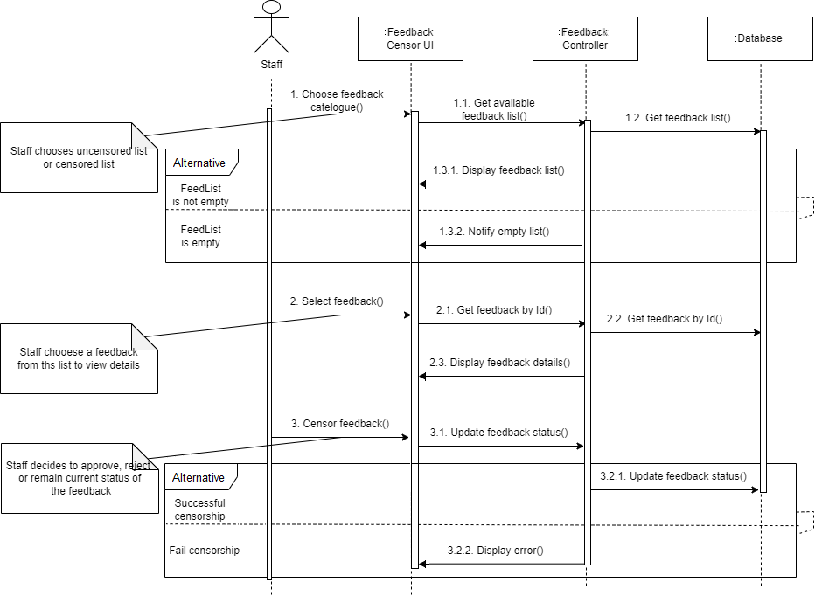

**Figure 6.2: Sequence Diagram of the function Censor Feedback**

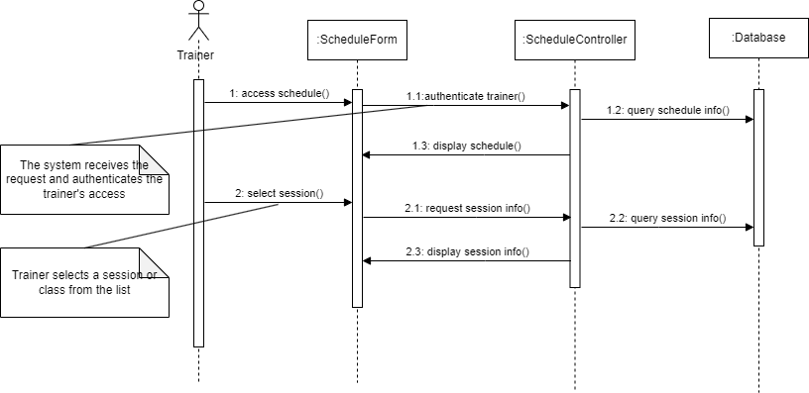

**Figure 6.3: Sequence Diagram of the function View Schedule**

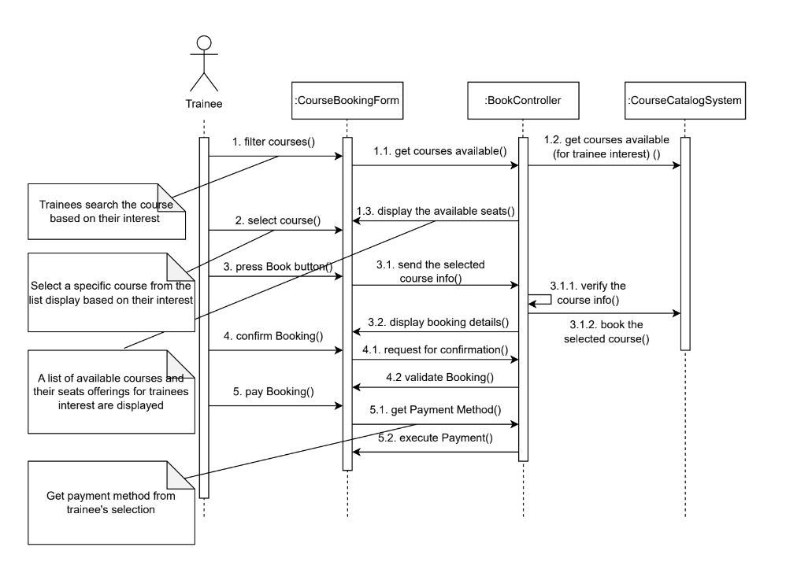

**Figure 6.4: Sequence Diagram of the function Book Course**

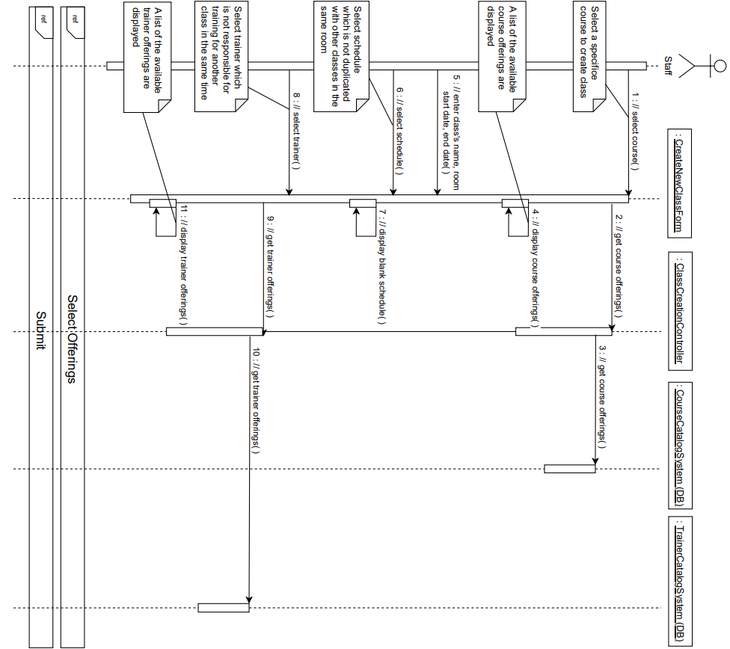

**Figure 6.5: Sequence Diagram of the function Create Class**

**Figure 7: CLASS DIAGRAM**

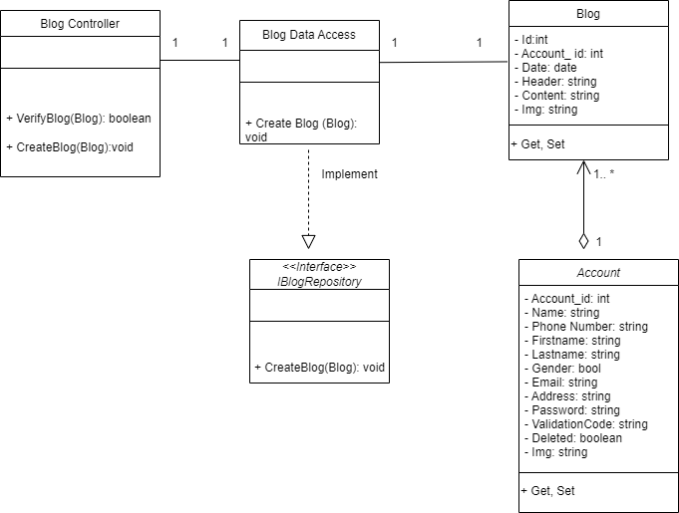

**Figure 7.1: Class Diagram of the function Create Blog**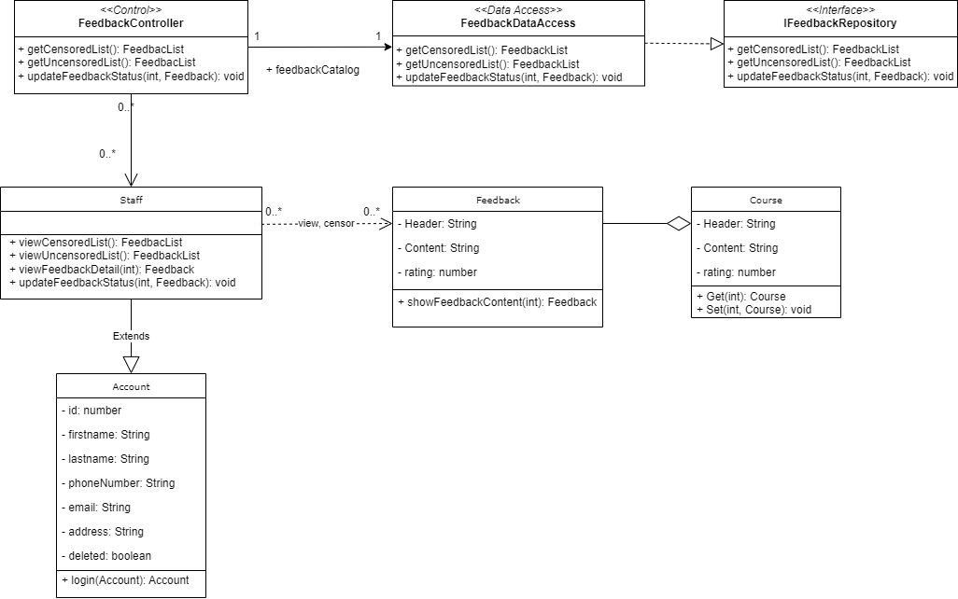

**Figure 7.2: Class Diagram of the function Censor Feedbacks**

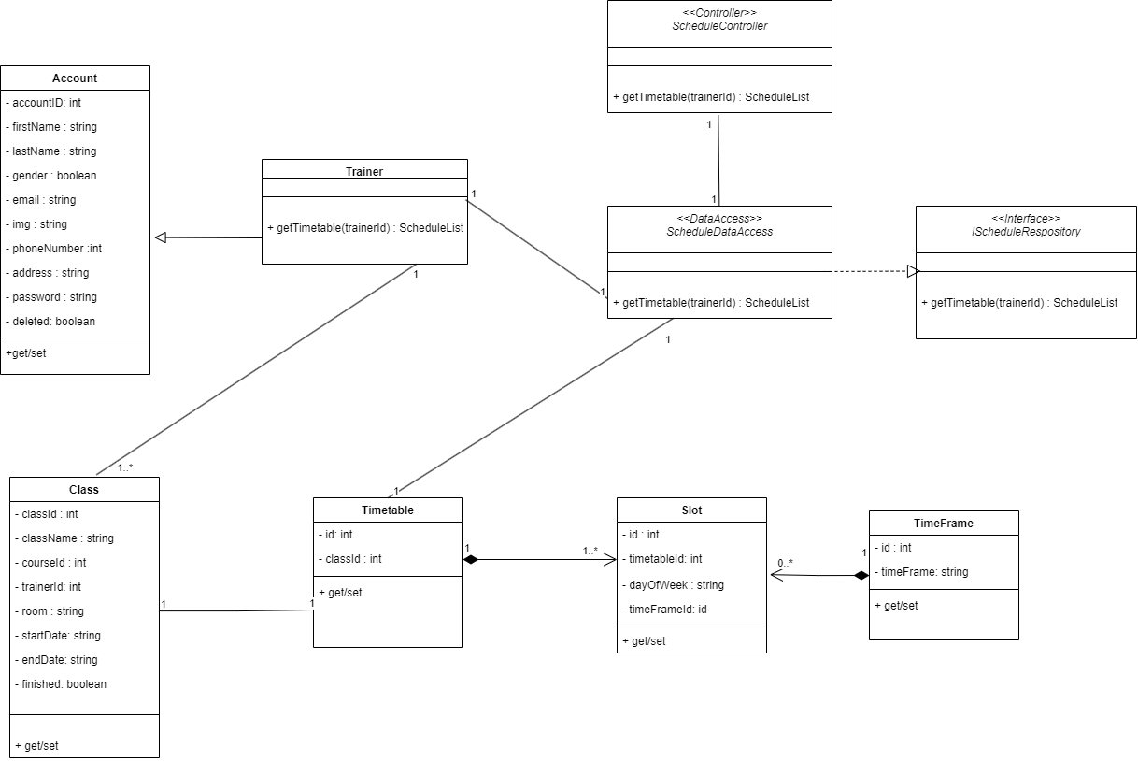

**Figure 7.3: Class Diagram of the function View A Schedule**

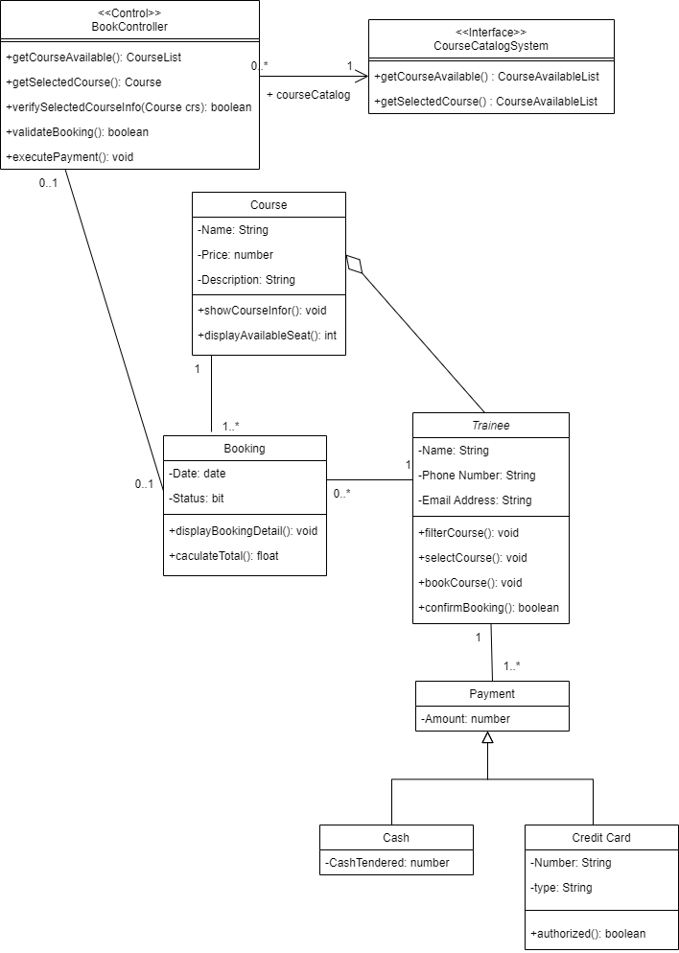

**Figure 7.4: Class Diagram of the function Book A Course**

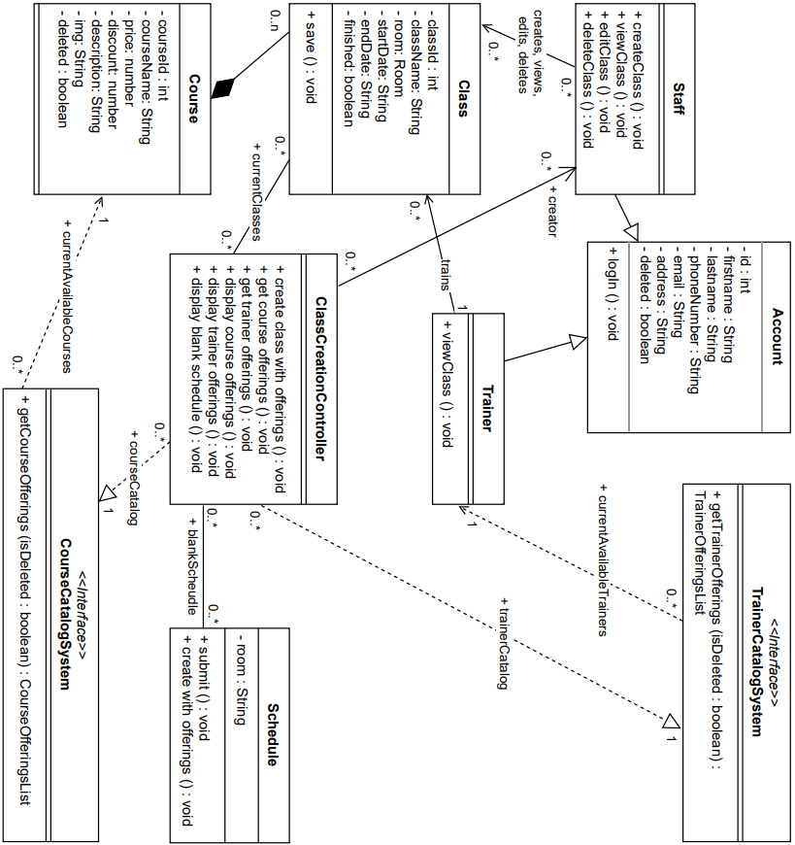

**Figure 7.5: Class Diagram of the function Create A Class**