Week 4: Predictive Modeling and Optimization in Logistics Systems
Project: Logistics Data Analysis
Prediction target: Delivery time in hours
Dataset: Week 3 simulated logistics dataset

1. Objective
The objective is to predict shipment delivery time using shipment distance, shipment volume, transport mode and warehouse. The model results are used to propose data-driven logistics improvements.

2. Dataset and Problem Definition
The dataset contains 200 usable records and 9 columns. The target variable is delivery_time_hours. The input variables are distance_km, shipment_volume_kg, transport_mode and warehouse. Delivery time is a regression target because it is a continuous numerical value.

3. Data Preparation
Rows without a target value were removed. Missing numerical input values are imputed using the median, while missing categorical values are imputed using the most frequent category. One-hot encoding converts categorical values into numerical model inputs. Preprocessing is fitted within the training pipeline to avoid using test data to learn preprocessing parameters.

4. Model Selection
Linear Regression is used as a baseline because it is simple and interpretable. Random Forest Regression is used to capture possible nonlinear relationships and interactions between logistics features. GridSearchCV tests multiple tree counts, maximum depths and minimum leaf sizes using five-fold cross-validation on the training data.

5. Training and Validation
The data is divided into 80% training and 20% testing sets using a fixed random seed. The test set is held out for final evaluation. The selected Random Forest model is also evaluated using five-fold cross-validation on the training set.

6. Performance Evaluation
Mean Absolute Error (MAE) measures average absolute prediction error in hours. Root Mean Squared Error (RMSE) gives greater weight to large errors. R-squared measures the proportion of target variation explained by the model; it can be negative when test predictions are worse than a constant-mean baseline.
Model | MAE (hours) | RMSE (hours) | R-squared
Linear Regression | 3.174 | 4.174 | 0.916
Random Forest | 2.757 | 3.441 | 0.943
Mean five-fold training cross-validation MAE for the tuned Random Forest: 3.218 hours.
The model with lower test MAE has the smaller average absolute error. Consider RMSE and R-squared alongside MAE before selecting a model. Results apply to this simulated dataset and are not a guarantee of real-world delivery performance.

7. Prediction and Feature Analysis
The actual-versus-predicted chart helps identify systematic prediction errors. Feature importance indicates which inputs contribute most to the fitted Random Forest predictions. Importance is not proof of causation and should be interpreted with care.
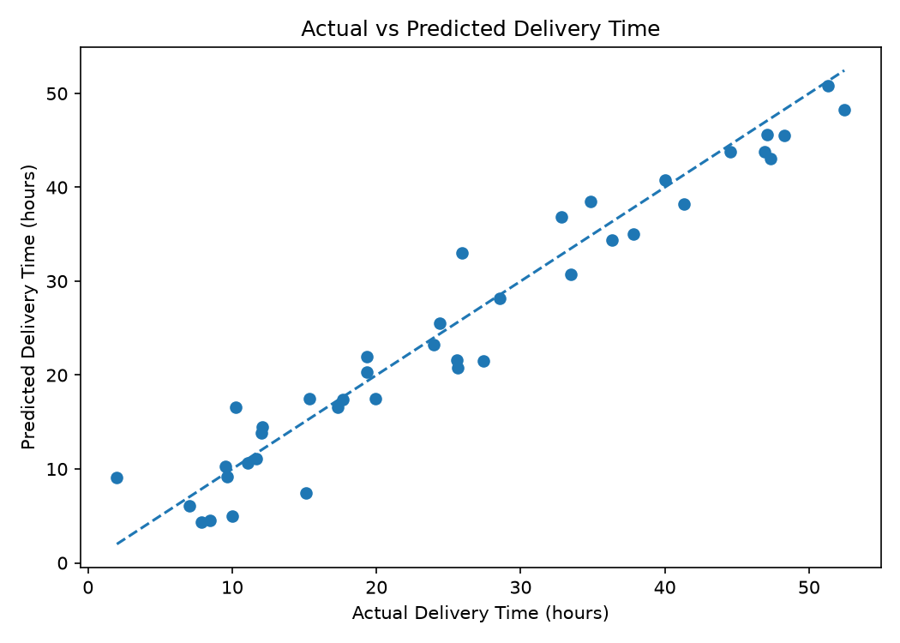
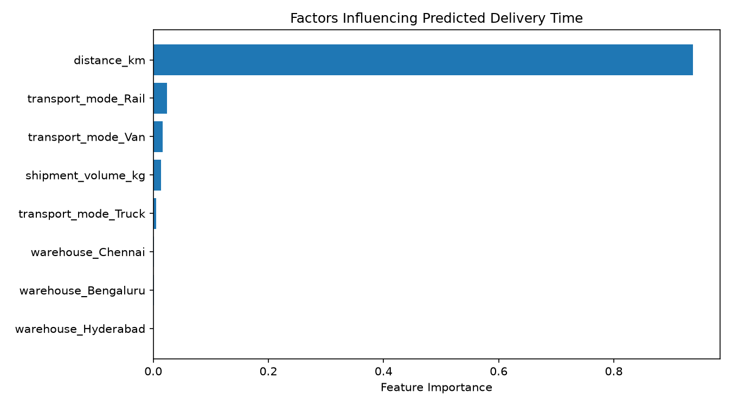

8. Optimization Strategies
1. Use predicted delivery times to flag shipments likely to miss their promised delivery window.
2. Review the mode comparison table when assigning shipments. Treat it as a model-based scenario, not proof that one mode is always faster or cheaper.
3. Prioritize dispatch planning and capacity allocation for high-risk shipments.
4. Group compatible shipments and review route plans to reduce unnecessary distance and delays.
5. Monitor actual delivery times, costs and prediction errors regularly, then retrain the model when new data becomes available.

9. Transport Mode Scenario Analysis
The following table predicts delivery time for the same test shipments while changing the transport mode. This isolates the model's scenario estimates while holding other listed features constant. It does not account for all real-world operational constraints or transport-mode costs.
Transport Mode | Average Predicted Hours
Rail | 21.47
Truck | 24.76
Van | 27.18

10. Python Implementation
The complete implementation is available in scripts/week4_predictive_modeling.py. It loads data, prepares features, trains and tunes models, calculates evaluation metrics, creates charts, compares transport-mode scenarios and writes this report. The main libraries used are pandas, NumPy, scikit-learn, Matplotlib and python-docx.

11. Conclusion
This project demonstrates a complete predictive modeling workflow for logistics delivery-time forecasting. Model evaluation provides a quantitative basis for comparing approaches, while scenario analysis and feature importance help identify opportunities for better dispatch planning, capacity allocation and delivery monitoring. Future work should validate the model on larger real-world data and incorporate traffic, weather, service-level commitments and route constraints.

