Week 3: Advanced Data Analysis and Visualization in Logistics
Project: Logistics Data Analysis
Method: Simulated data, exploratory analysis and visualization

1. Introduction
This report examines a hypothetical logistics operation using Python. It analyzes shipment distance, shipment volume, delivery time, transportation cost, transport mode and delivery status. The purpose is to demonstrate how data analysis supports operational decisions.

2. Dataset Description
The simulated dataset contains 200 shipments and 9 columns. It includes shipment identifiers, distance in kilometres, shipment weight in kilograms, delivery time in hours, transportation cost in illustrative cost units, delay hours, transport mode and warehouse. The data is hypothetical and is not actual company data.

3. Methodology and Tools
NumPy generates reproducible sample data. Pandas performs data manipulation, descriptive statistics and correlation analysis. Matplotlib generates five visualizations. Python-docx creates this report.

4. Data Quality and Cleaning
The dataset contains 0 missing cells. The generated numeric values are constrained to plausible positive ranges. The dataset is checked for missing values and summary statistics. Since the dataset is generated in this script, no real-world records are claimed. In a real dataset, duplicate IDs, invalid values and outliers should be investigated before removal or correction.

5. Exploratory Data Analysis
Summary statistics for the main numeric variables:
Metric | Mean | Std. Dev. | Minimum | Median | Maximum
distance_km | 508.95 | 288.36 | 21.00 | 506.50 | 995.00
shipment_volume_kg | 1107.13 | 552.54 | 51.00 | 1195.00 | 1993.00
delivery_time_hours | 28.25 | 13.71 | 2.00 | 27.91 | 58.58
transportation_cost | 8040.90 | 3778.29 | 1009.64 | 7950.75 | 16807.64
delay_hours | 3.39 | 3.41 | 0.02 | 2.37 | 18.55

6. Key Performance Indicators
- Total shipments analyzed: 200
- On-time delivery rate: 77.50%
- Delayed shipment rate: 22.50%
- Average delivery time: 28.25 hours
- Average transportation cost: 8040.90 cost units
- Average shipment distance: 508.95 km

7. Visualizations and Interpretations

Figure 1: Delivery Time Distribution
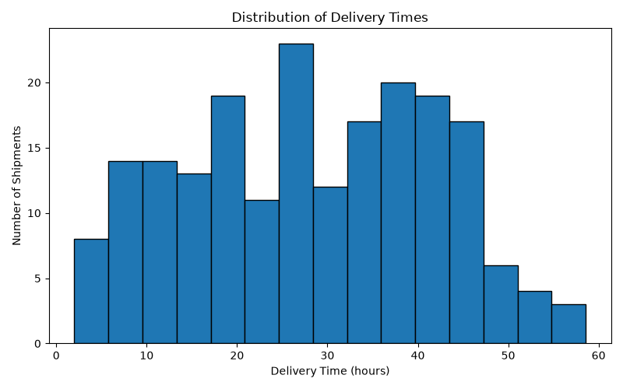
A histogram shows the spread and concentration of delivery times. Longer delivery times may indicate routes or shipments requiring further investigation.

Figure 2: Average Transportation Cost by Mode
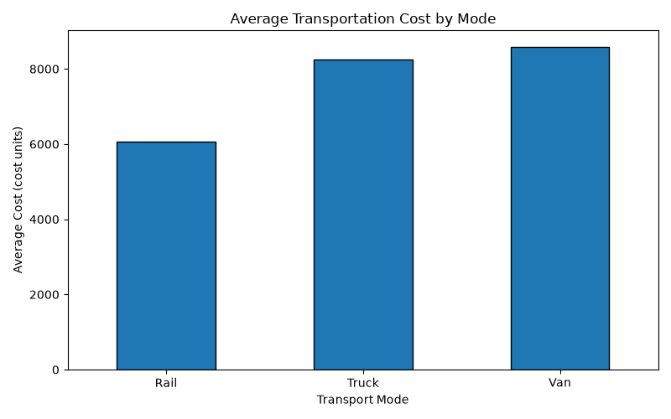
A bar chart compares average cost across trucks, vans and rail. Differences may reflect distance, shipment mix and the simulated cost assumptions; they do not prove that one mode is always cheaper.

Figure 3: On-Time and Delayed Shipments
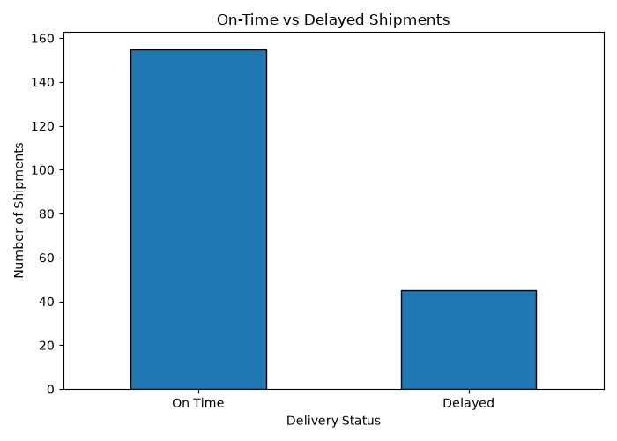
A bar chart compares shipment counts by status. The on-time rate and delay rate help evaluate service reliability.

Figure 4: Shipment Volume vs Transportation Cost
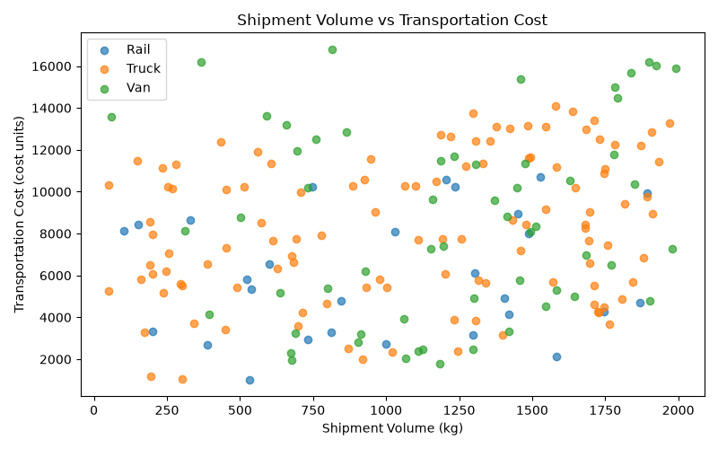
A scatter plot explores the relationship between shipment weight and cost. An upward pattern would suggest that heavier shipments are associated with higher transportation costs.

Figure 5: Correlation Between Logistics Metrics
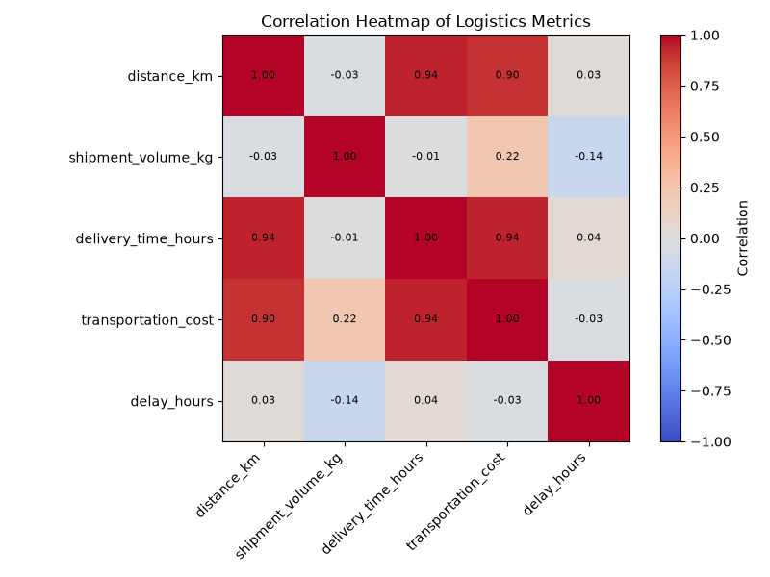
The heatmap summarizes linear relationships between numeric variables. Correlation does not establish causation.

8. Findings and Recommendations
The simulated dataset reports an on-time delivery rate of 77.50% and an average delivery time of 28.25 hours. The average transportation cost is 8040.90 cost units. These figures describe only the generated sample and should not be treated as industry benchmarks.
Recommendations:
1. Review delayed shipments by route, warehouse and transport mode.
2. Compare transport modes using equivalent distances and shipment sizes.
3. Monitor delivery time, cost per shipment and on-time delivery rate.
4. Investigate extreme values before removing them from real data.
5. Use actual historical records to validate findings before making operational changes.

9. Limitations
The dataset is hypothetical, relatively small and generated using assumptions. Its patterns may not match real logistics operations. The results demonstrate analytical methods rather than predict actual business performance.

10. Conclusion
This project demonstrates a complete basic logistics analysis workflow: data simulation, quality checks, descriptive statistics, KPI calculation, correlation analysis, visual exploration and reporting. These techniques can help logistics teams identify questions for further investigation and support evidence-based planning when applied to reliable real data.

