Lets consider we hav ethe following tables

1. Orders
2. Inventory
3. Stock updates

If we don’t have the tables we can crate using

TABLE CREATION:

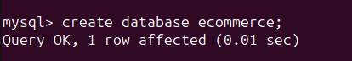

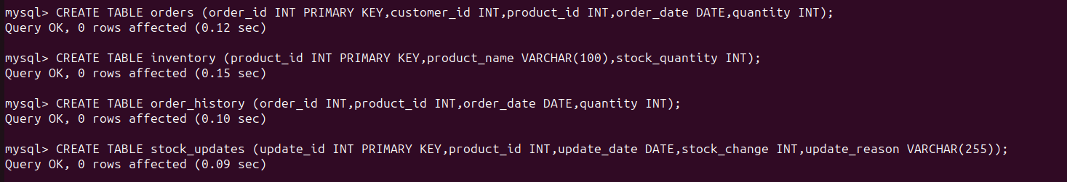





DATA INSERTION:

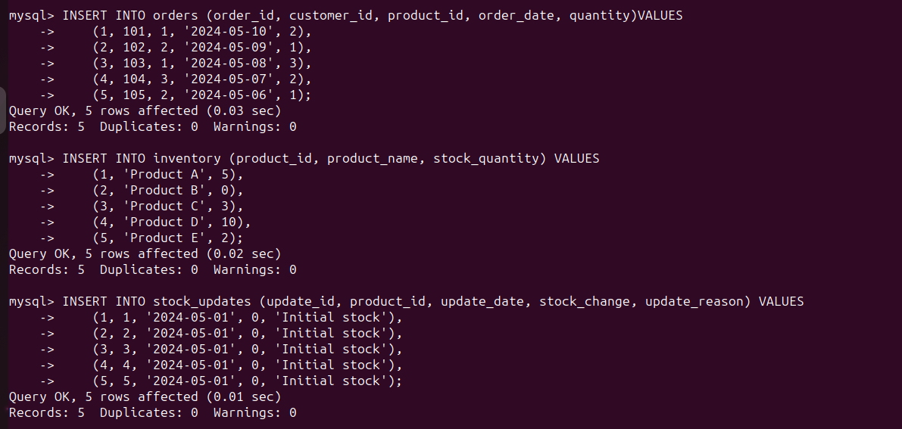



DATA VIEWING:

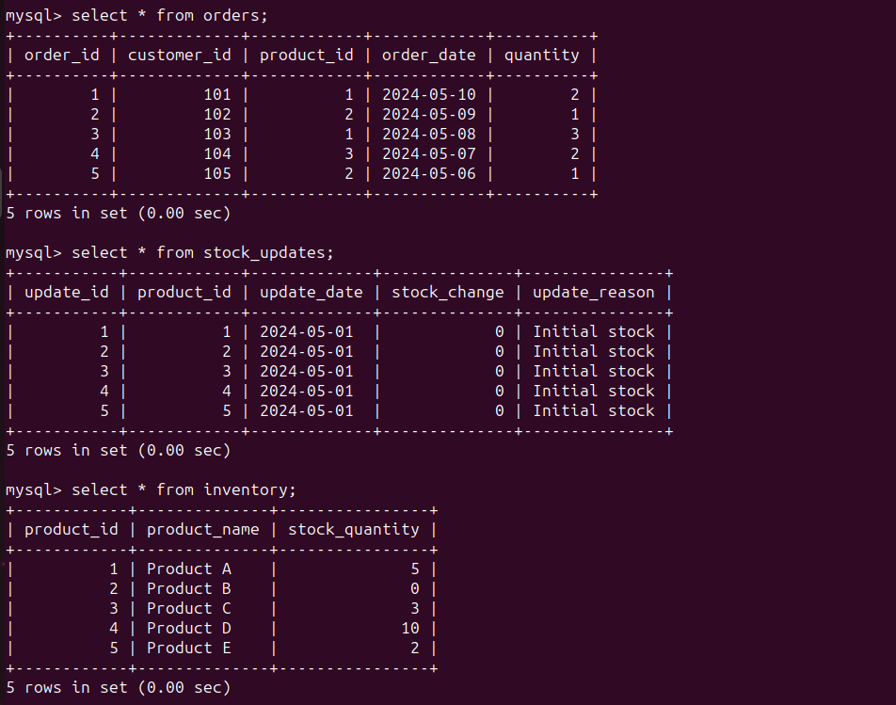

TROUBLESHOOTING:

Verify Customer's Order: First, verify the order placed by the customer. Check if the customer indeed placed an order for the product.

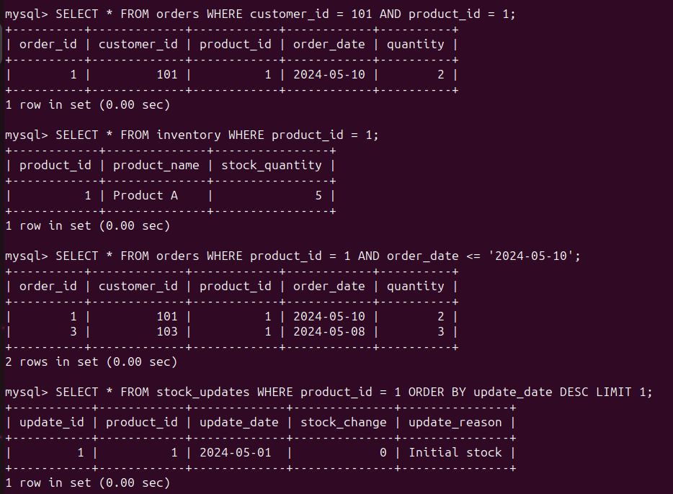

Check Inventory Status: Next, check the current inventory status of the product to ensure it is indeed out of stock.



Review Order History: Review the order history to check if the product was in stock at the time the customer placed the order. This can help determine if the issue occurred due to stock changes after the order was placed.



Check for Recent Stock Updates: Check if there were any recent stock updates or changes that might have caused the product to go out of stock after the order was placed.



The above sql queries can also be performed with the following python code using mysql-python-connector.