Real-Time Object Detection in Retail Stores Using YOLOv8: Inventory DisplayTracking and Pricing Automation

Abstract:
This paper presents a real-time object detection model implemented using YOLOv8, designed for inventory display tracking in retail stores. The system accurately identifies various beverage products (e.g., bottles and cans of brands like Coca-Cola, Pepsi, Sprite, and 7up) to facilitate automated pricing and stock monitoring. The model achieved high accuracy with a mean average precision (mAP) of X% at IoU 0.5 and demonstrated strong real-world performance. This approach is optimized for rapid deployment on edge devices, making it suitable for low-latency applications in smart retail environments.

Keywords:
YOLOv8, object detection, real-time, mean average precision (mAP), retail inventory tracking

Model Information :
YOLO (You Only Look Once)
YOLO (You Only Look Once) is a family of real-time object detection models designed for fast and accurate object localization and classification in images. Unlike traditional object detection approaches that use region proposal networks (like R-CNN), YOLO simplifies the process by treating detection as a single regression problem, predicting bounding boxes and class probabilities directly from the image in one pass.
Key Characteristics of YOLO:
- Real-Time Speed: YOLO is known for its high processing speed, enabling real-time object detection in videos and live streams.
- Single Stage Architecture: YOLO is a single-stage object detector, meaning it predicts bounding boxes and class labels directly without requiring multiple processing stages (unlike two-stage detectors like Faster R-CNN).
- Global Context: YOLO processes the entire image at once, allowing it to incorporate global context, which can reduce false positives compared to methods that focus on local regions.
YOLOv8: The Latest Iteration
YOLOv8 is the latest version in the YOLO series, offering several architectural and functional improvements over previous versions (YOLOv3, YOLOv4, YOLOv5, and YOLOv7). YOLOv8 is designed to further improve both speed and accuracy, making it more suitable for a wide range of object detection tasks, from edge devices to cloud-based systems.
Key Features of YOLOv8:
- Improved Backbone and Neck: YOLOv8 introduces a more efficient backbone network for feature extraction, utilizing advancements in neural network design (such as CSPNet, Path Aggregation Network, or other modern architectures) to better capture both low-level and high-level features. This improves the ability to detect small and occluded objects.
- Anchor-Free Detection: YOLOv8 can operate in an anchor-free mode, which simplifies the detection process by eliminating the need for predefined anchor boxes. This helps reduce the complexity of training and can improve performance, especially on tasks involving irregular or dense objects.
- Better Handling of Small Objects: YOLOv8 improves small object detection by refining its multi-scale feature maps, allowing the model to detect smaller objects more accurately without sacrificing speed.
- Decoupled Head: YOLOv8 employs a decoupled head architecture, where the object classification and bounding box regression are separated into two different streams. This leads to better specialization in each task, improving detection accuracy.
- Loss Function Enhancements: YOLOv8 includes improvements in the loss function, especially for objectness and classification losses, allowing the model to provide more precise object localization and class prediction. Enhanced IoU (Intersection over Union) loss functions such as CIoU or DIoU are also often used for better bounding box optimization.
- Speed-Accuracy Tradeoff: YOLOv8 maintains a strong balance between speed and accuracy, making it suitable for deployment on resource-constrained devices like edge computers, mobile phones, and drones. Depending on the task, the model can be trained to prioritize speed (real-time detection) or accuracy.
- Auto-Anchors: YOLOv8 uses auto-anchor generation, meaning it automatically adapts the anchor box sizes to the dataset being used. This ensures optimal anchor boxes for specific object sizes, improving accuracy during training.
- Pretrained Models and Transfer Learning: YOLOv8 is released with pretrained models, allowing users to apply transfer learning on custom datasets. Pretrained on large datasets like COCO, these models serve as excellent starting points for domain-specific tasks, such as detecting items in retail stores.
YOLOv8 Workflow:
- Input Image: The input image is resized to a fixed size (commonly 416x416 or other dimensions). The model then processes the image in a single forward pass.
- Feature Extraction (Backbone): The backbone extracts features from the input image at multiple scales to capture different levels of detail, from edges and textures to full object shapes.
- Neck: The neck consists of feature pyramid networks (FPN) or path aggregation networks (PAN) to combine feature maps from different stages of the backbone. This helps the model recognize objects of varying sizes.
- Head: The decoupled head then predicts the bounding boxes, objectness scores, and class probabilities. The head is where the final detections are generated, including the position (bounding box) and class of each detected object.
- Non-Maximum Suppression (NMS): To handle overlapping predictions, YOLOv8 applies non-maximum suppression to remove duplicate detections and keep only the best-performing bounding boxes.
- Output: The final output consists of detected objects, along with their class labels, confidence scores, and bounding boxes.
YOLOv8 Performance:
YOLOv8 achieves better mean Average Precision (mAP) across various datasets compared to previous YOLO versions. It can reach up to 60-70% mAP at IoU 0.5, depending on the task, with inference times often less than 10 ms per image on high-end GPUs. The model’s flexibility to adjust for precision or speed makes it an excellent choice for applications ranging from autonomous driving to retail store inventory monitoring.
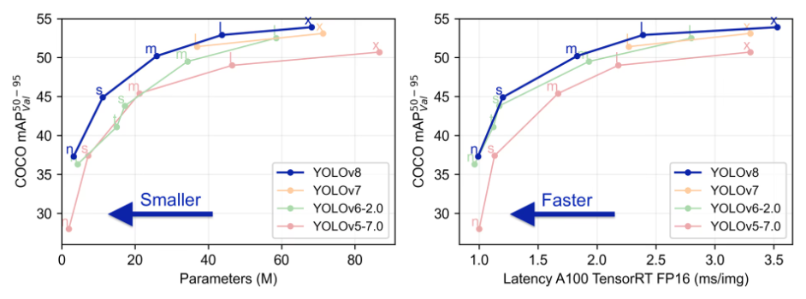

Our model results :

To further analyze the performance of the detection model on a per-class basis, a normalized confusion matrix was generated

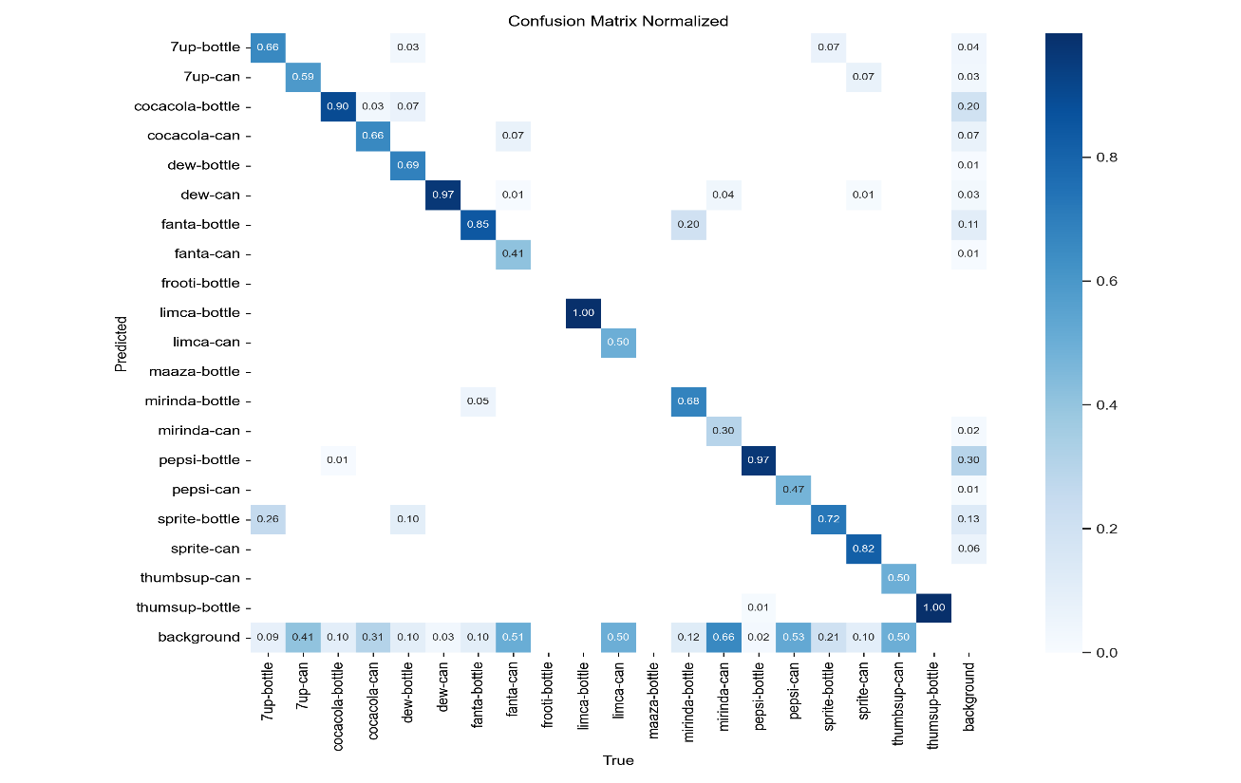
This matrix provides a detailed view of how well the model distinguishes between different object classes by displaying the proportion of correct and incorrect predictions for each class. The diagonal elements represent the proportion of correctly classified instances for each class, while the off-diagonal elements indicate the proportion of misclassifications. For example, the model shows high accuracy in detecting classes such as 'pepsi-bottle' and 'sprite-can', with minimal confusion between these and other classes. However, some misclassifications are observed between visually similar objects, such as between '7up-can' and 'sprite-can'. This insight allows us to identify specific areas where the model's performance could be further optimized, especially in improving the detection of similar or overlapping object features. The normalized confusion matrix serves as a useful tool to gauge the model’s performance beyond overall accuracy, offering a class-wise evaluation that highlights both strengths and areas for improvement.

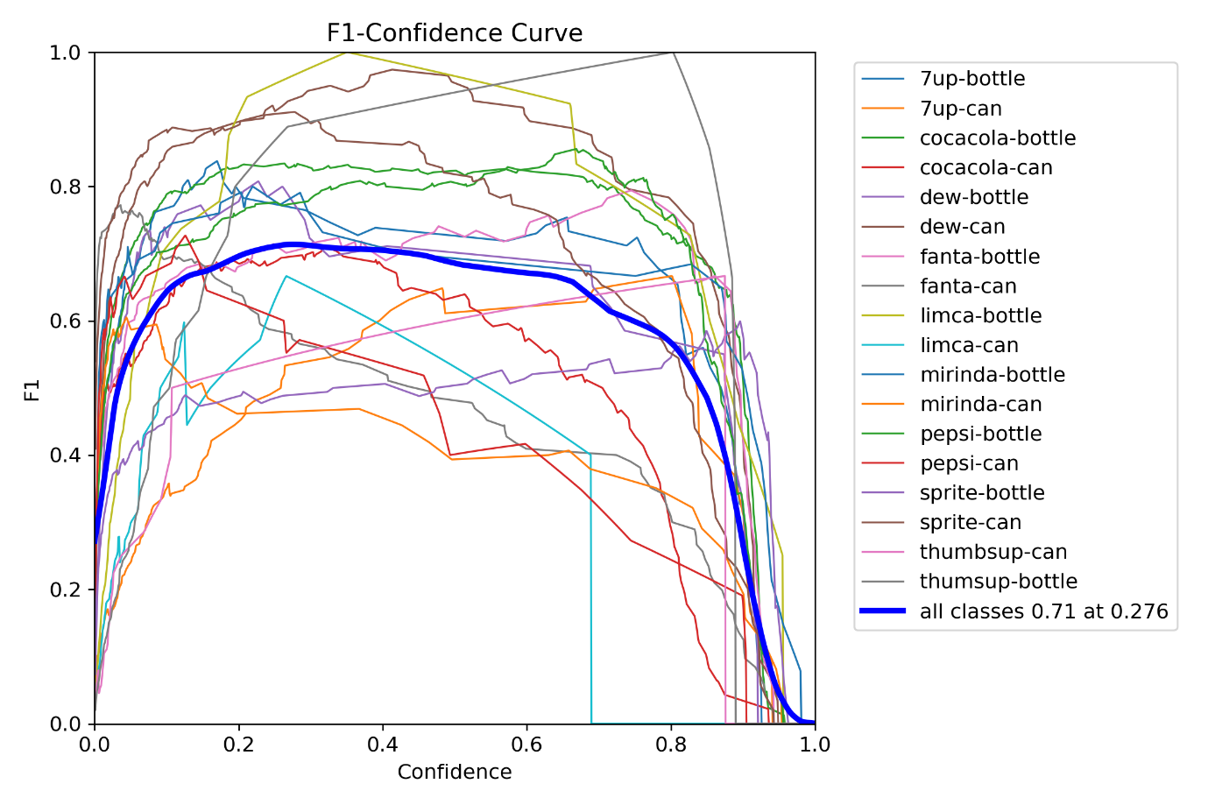
The F1 curve illustrates the harmonic mean of precision and recall across different threshold levels, offering an overall assessment of the model's balance between the two metrics. A higher F1 score indicates that the model is achieving both high precision and recall, reducing the trade-offs between false positives and false negatives. From the curve, we can observe that the model demonstrates strong F1 scores for well-represented classes like 'cocacola-bottle' and 'pepsi-can', but struggles slightly with more visually similar classes like '7up-can' and 'sprite-can'. This curve highlights the model's performance stability and suggests potential areas where threshold tuning could further optimize the balance between precision and recall.
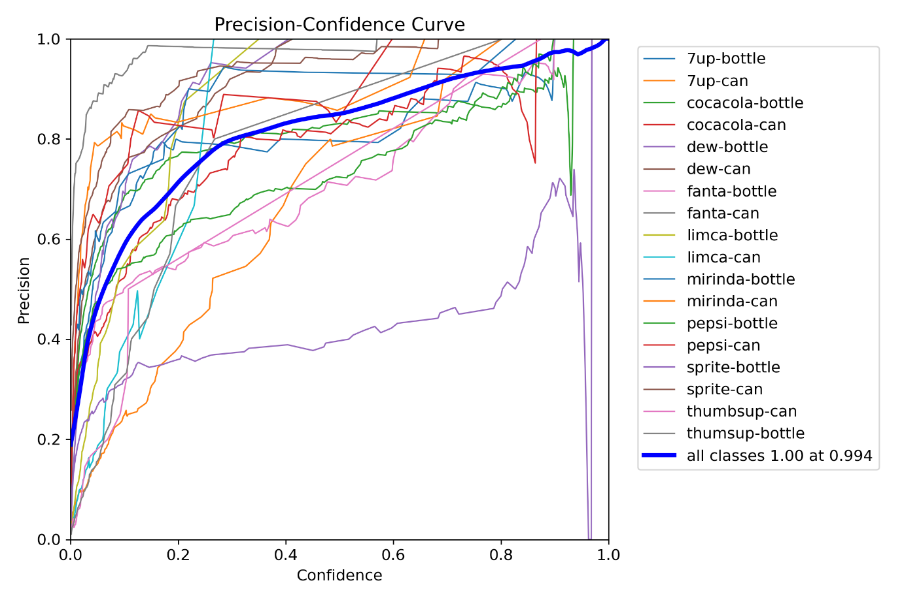
The precision curve shows how the model’s precision varies with different confidence thresholds. Higher precision indicates that when the model makes a positive prediction, it is more likely to be correct. The precision curve reveals that for classes like 'limca-bottle' and 'maaza-bottle', precision remains high even at lower confidence thresholds, while for classes like 'sprite-can' and 'fanta-can', precision begins to drop as the threshold decreases. This indicates that the model is highly reliable for certain object detections but might make more false positive predictions for others when the confidence threshold is lowered. The precision curve helps in identifying classes where the model is more confident and accurate.

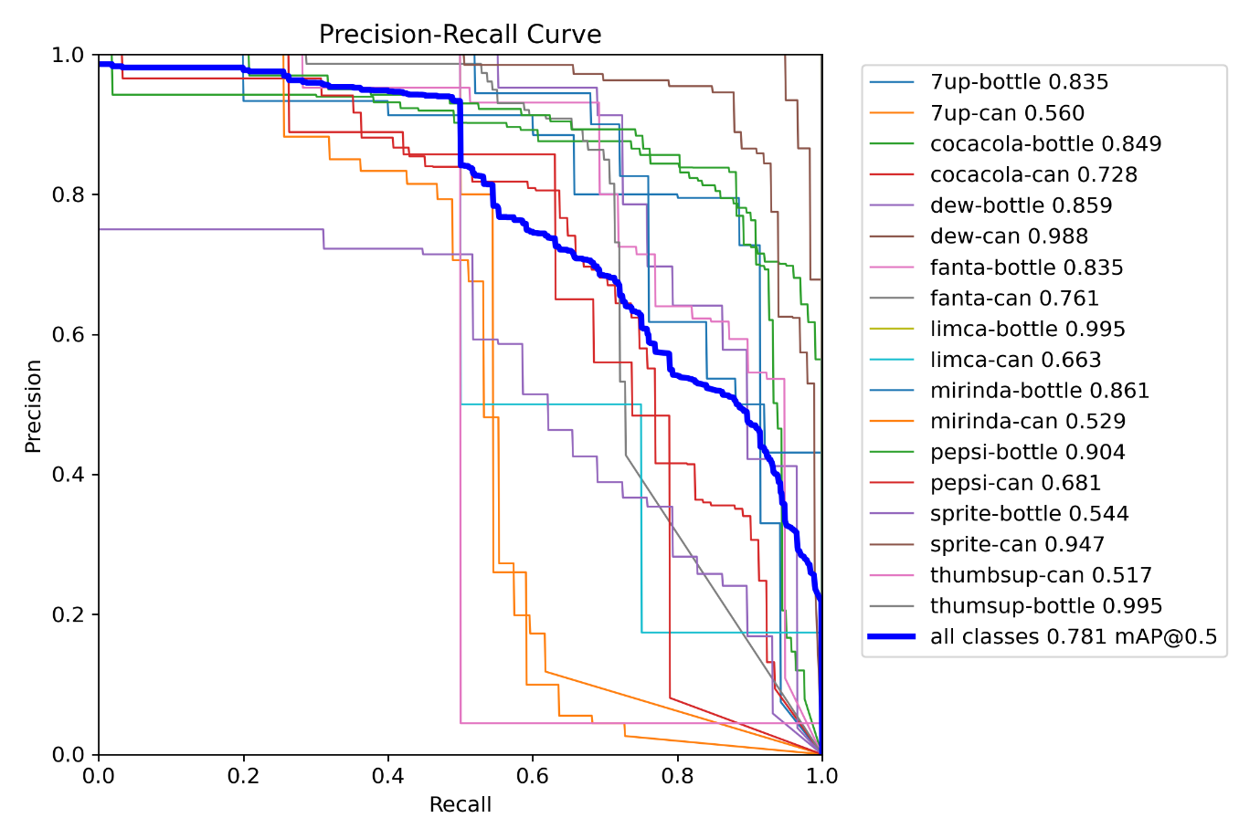
The Precision-Recall (PR) curve evaluates the relationship between precision and recall for different object classes. This curve is particularly useful for assessing the model's performance when dealing with imbalanced data. From the PR curve, we can observe that certain classes, such as 'cocacola-bottle' and 'pepsi-bottle', maintain high precision and recall across various confidence levels, indicating that the model is well-calibrated for these categories. On the other hand, there are some drops in precision for classes like '7up-can', which suggests that the model encounters difficulty when distinguishing between more similar object classes. The PR curve offers a comprehensive view of model behavior in scenarios where precision and recall must be considered together, especially in dealing with rare or similar categories.
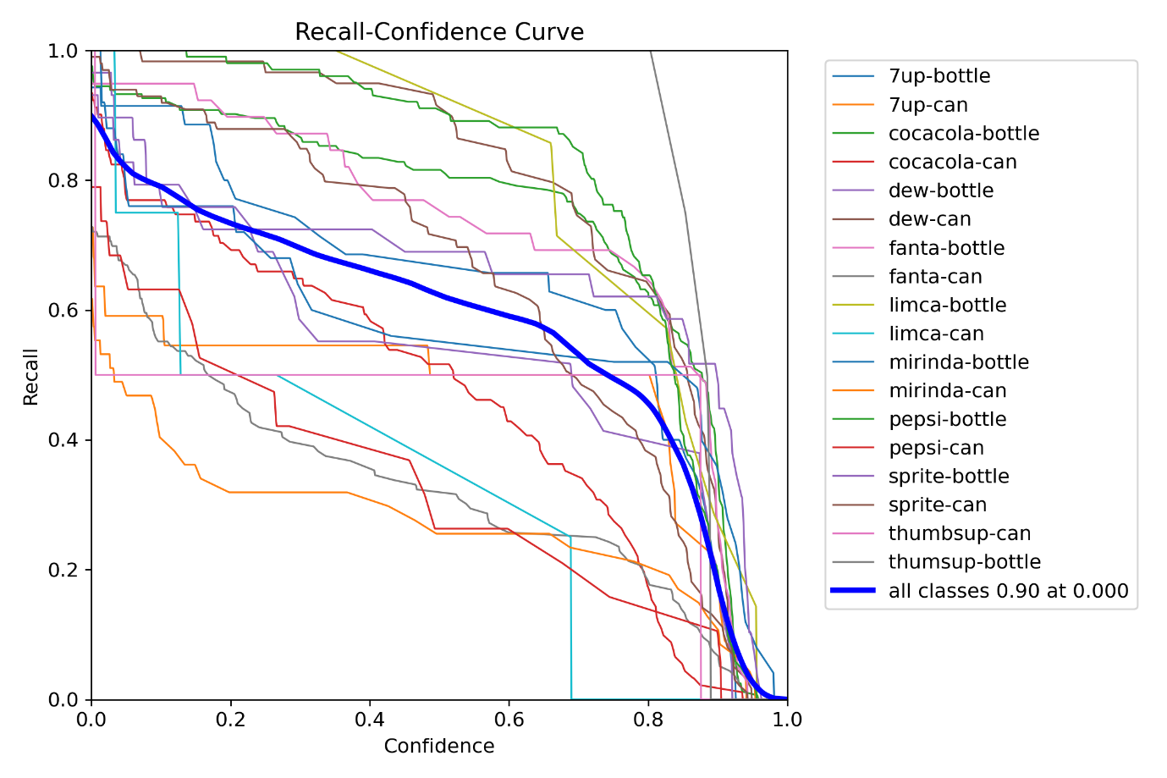

The recall curve demonstrates how well the model identifies true positives across different confidence thresholds. A higher recall value suggests that the model is able to correctly identify most instances of the object class. The recall curve in our analysis shows that the model performs exceptionally well in detecting 'frooti-bottle' and 'mirinda-bottle' with high recall values, but it shows some struggles with classes like '7up-can' and 'sprite-can', where some objects are missed (false negatives). This analysis of recall helps us identify where the model might miss detections and gives insight into potential improvements to increase true positive rates for underperforming categories.

My own words :
We created a YOLO model that can detect various products, such as '7up-bottle', '7up-can', 'cocacola-bottle', 'cocacola-can', 'dew-bottle', 'dew-can', 'fanta-bottle', 'fanta-can', 'frooti-bottle', 'limca-bottle', 'limca-can', 'maaza-bottle', 'mirinda-bottle', 'mirinda-can', 'pepsi-bottle', 'pepsi-can', 'sprite-bottle', 'sprite-can', 'thumbsup-can', and 'thumsup-bottle'.
This is achieved using the YOLOv8 model. We designed a website and hosted it using Flask on a local machine. Python is used as the backend. This code will detect objects using the model from the frontend (JavaScript) and process the detection.

The model was trained with a batch size of 16 for 60 epochs using google colab .
We used labelled dataset from roboflow.
The link for the dataset we used https://universe.roboflow.com/iimacapstone/inventory-display-tracking-in-retail-stores-using-computer-vision

Here python Is the backend , this code will detect model from the front end java script and process it and detect the object
Python :
import base64
import io
from flask import Flask, render_template, request, jsonify
from PIL import Image
from ultralytics import YOLO
import numpy as np

app = Flask(__name__)

# Load the YOLO model
model = YOLO(r'C:\Users\logesh A.J\Documents\projects\final_billing\yolov8\website\yolo_billing_model_last_try_2.pt ') # Use your trained YOLO model

# Price dictionary for each item
prices = {
'7up-bottle': 40,
'7up-can': 35,
'cocacola-bottle': 45,
'cocacola-can': 40,
'dew-bottle': 35,
'dew-can': 30,
'fanta-bottle': 45,
'fanta-can': 35,
'frooti-bottle': 25,
'limca-bottle': 35,
'limca-can': 30,
'maaza-bottle': 25,
'mirinda-bottle': 45,
'mirinda-can': 35,
'pepsi-bottle': 40,
'pepsi-can': 35,
'sprite-bottle': 40,
'sprite-can': 35,
'thumbsup-can': 35,
'thumsup-bottle': 40
}

@app.route('/')
def index():
return render_template('index.html')

@app.route('/predict', methods=['POST'])
def predict():
try:
# Get the base64 image from the frontend
data = request.json.get('image')

if not data:
return jsonify({'error': 'No image data received'}), 400

# Convert the base64 image to PIL Image
image_data = base64.b64decode(data.split(',')[1])
image = Image.open(io.BytesIO(image_data))

# Convert the image to RGB (ignores alpha channel if present)
image_rgb = image.convert('RGB')

# Convert the image to a numpy array (YOLO format)
image_np = np.array(image_rgb)

# Run the image through YOLO model
results = model(image_np)

# Check if any boxes (detections) were found
if len(results[0].boxes) > 0:
# Get the predicted class (label index) from the first detection
label_index = int(results[0].boxes[0].cls[0])

# Get the label name from the model's class names
label = results[0].names[label_index]

# Print the detected label for debugging
print(f"Detected label: {label}")

# Get the price from the dictionary
price = prices.get(label, 0.0)

# Return the prediction and price as JSON
return jsonify({'label': label, 'price': price})
else:
print("No item detected")
return jsonify({'label': 'No item detected', 'price': 0.0})

except Exception as e:
print(f"Error during prediction: {e}")
return jsonify({'error': str(e)}), 500

if __name__ == '__main__':
app.run(debug=True)

this also create the local machine .

the respected html ,css and java script codes are

HTML

<!DOCTYPE html>
<html lang="en">

<head>
<meta charset="UTF-8">
<meta name="viewport" content="width=device-width, initial-scale=1.0">
<title>YOLO Billing System</title>
<link rel="stylesheet" href="/static/css/styles.css">
</head>

<body>
<div class="camera-container">
<h1>YOLO Object Detection Billing System</h1>

<video id="video" autoplay playsinline></video>
<img id="captured-image" style="display: none;" />
<img id="camera-placeholder" src="/static/images/camera_placeholder.avif" style="display: none;" />

<button id="start-camera">Start Camera</button>
<button id="capture" disabled>Capture</button>
<button id="end-billing" disabled>End Billing</button>

<div id="price-list">
<h2>Billing Summary</h2>
<ul id="item-list"></ul>
<h3>Total: $<span id="total-price">0.00</span></h3>
</div>
</div>

<script src="/static/js/scripts.js"></script>
</body>

</html>

Css:
/* General styling */
body {
font-family: 'Arial', sans-serif;
background-image: url('/static/images/billing_cart_background.webp');
background-size: cover;
background-position: center;
background-color: rgba(0, 0, 0, 0.5);
color: #333;
margin: 0;
padding: 0;
display: flex;
justify-content: center;
align-items: center;
height: 100vh;
}

h1 {
text-align: center;
color: #4CAF50;
margin-bottom: 20px;
}

/* Container that holds both the camera and the price list */
.container {
display: flex;
justify-content: space-between;
align-items: flex-start;
width: 90%;
max-width: 1200px;
background-color: rgba(255, 255, 255, 0.8);
padding: 20px;
border-radius: 10px;
box-shadow: 0px 4px 8px rgba(0, 0, 0, 0.1);
}

/* Camera section (left) */
.camera-container {
display: flex;
flex-direction: column;
align-items: center;
padding: 20px;
border-radius: 10px;
box-shadow: 0px 4px 8px rgba(0, 0, 0, 0.1);
width: 60%;
position: relative;
}

video,
#captured-image,
#camera-placeholder {
border: 2px solid #4CAF50;
border-radius: 5px;
margin-bottom: 20px;
width: 100%;
max-width: 640px;
height: 480px;
display: block;
}

#camera-placeholder {
display: none;
}

button {
background-color: #4CAF50;
color: white;
padding: 10px 20px;
margin: 10px 0;
border: none;
border-radius: 5px;
cursor: pointer;
font-size: 16px;
transition: background-color 0.3s ease;
}

button:active {
transform: scale(0.95);
}

button:hover {
background-color: #45a049;
}

button:disabled {
background-color: #cccccc;
}

#capture:active {
animation: capture-flash 0.3s ease;
}

@keyframes capture-flash {
0% {
background-color: #4CAF50;
}

50% {
background-color: #76ff03;
}

100% {
background-color: #4CAF50;
}
}

#end-billing {
background-color: #f44336;
}

#end-billing:hover {
background-color: #e53935;
}

/* Price list section (right) */
#price-list {
margin-left: 20px;
background-color: #ffffff;
border: 2px solid #ddd;
border-radius: 10px;
padding: 20px;
width: 35%;
box-shadow: 0px 4px 8px rgba(0, 0, 0, 0.1);
}

#price-list h2 {
text-align: center;
color: #333;
margin-bottom: 10px;
}

#price-list ul {
list-style-type: none;
padding: 0;
}

#price-list ul li {
background-color: #f9f9f9;
border-bottom: 1px solid #ddd;
padding: 10px;
font-size: 16px;
}

#price-list ul li:last-child {
border-bottom: none;
}

#price-list h3 {
text-align: center;
margin-top: 20px;
font-size: 18px;
color: #4CAF50;
}

#total-price {
font-weight: bold;
}

/* Responsive Design */
@media (max-width: 768px) {
.container {
flex-direction: column;
align-items: center;
}

.camera-container,
#price-list {
width: 100%;
margin-top: 20px;
}

button {
width: 100%;
}
}

Java script ;
const video = document.getElementById('video');
const captureButton = document.getElementById('capture');
const startCameraButton = document.getElementById('start-camera');
const endBillingButton = document.getElementById('end-billing');
const capturedImage = document.getElementById('captured-image');
const cameraPlaceholder = document.getElementById('camera-placeholder');
const itemList = document.getElementById('item-list');
const totalPriceEl = document.getElementById('total-price');

let stream = null;

// Start Camera
startCameraButton.addEventListener('click', async () => {
try {
stream = await navigator.mediaDevices.getUserMedia({ video: true });
video.srcObject = stream;
captureButton.disabled = false;
endBillingButton.disabled = false;
cameraPlaceholder.style.display = 'none';
capturedImage.style.display = 'none';
video.style.display = 'block';

// Clear previous bill
itemList.innerHTML = '';
totalPriceEl.textContent = '₹0.00'; // Set initial total price with ₹ symbol
} catch (err) {
console.error('Error accessing camera:', err);
}
});

// Capture Image and Send to Backend
captureButton.addEventListener('click', () => {
const canvas = document.createElement('canvas');
canvas.width = video.videoWidth;
canvas.height = video.videoHeight;
const context = canvas.getContext('2d');
context.drawImage(video, 0, 0, canvas.width, canvas.height);

const imageData = canvas.toDataURL('image/png');

// Send image data to backend for prediction
fetch('/predict', {
method: 'POST',
headers: {
'Content-Type': 'application/json',
},
body: JSON.stringify({ image: imageData })
})
.then(response => response.json())
.then(data => {
if (data.label !== 'No item detected') {
addItemToBill(data.label, data.price); // Add item to bill with received label and price
} else {
console.log('No item detected');
}
})
.catch(error => {
console.error('Error:', error);
});

// Display captured image temporarily
capturedImage.src = imageData;
capturedImage.style.display = 'block';
video.style.display = 'none';

setTimeout(() => {
video.style.display = 'block';
capturedImage.style.display = 'none';
}, 2000);
});

// End Billing
endBillingButton.addEventListener('click', () => {
if (stream) {
const tracks = stream.getTracks();
tracks.forEach(track => track.stop());
stream = null;
}
video.style.display = 'none';
cameraPlaceholder.style.display = 'block';
captureButton.disabled = true;
endBillingButton.disabled = true;
});

// Add item to the bill and update total price
function addItemToBill(item, price) {
const li = document.createElement('li');
li.textContent = `${item}: ₹${price.toFixed(2)}`; // Use ₹ symbol for item price
itemList.appendChild(li);

const currentTotal = parseFloat(totalPriceEl.textContent.replace('₹', '')); // Remove ₹ symbol before parsing
totalPriceEl.textContent = `₹${(currentTotal + price).toFixed(2)}`; // Update total with ₹ symbol
}

