Model Training Report

1. Project Overview
This project involves training a deep learning object detection model on a hand gesture dataset. The dataset includes various classes representing different hand signs, annotated with bounding boxes. The objective was to accurately detect and classify these hand gestures in diverse backgrounds and conditions.

2. Dataset Details
The dataset consists of thousands of images depicting different hand gestures labeled into 6 classes. These include classes like 'Fist', 'Two Fingers', 'Open Palm', etc. The dataset shows variation in background, lighting, and angle, making the task challenging.

3. Training Samples
The following image shows a sample batch from the training dataset with bounding box annotations. A good model should learn to localize and classify these accurately.
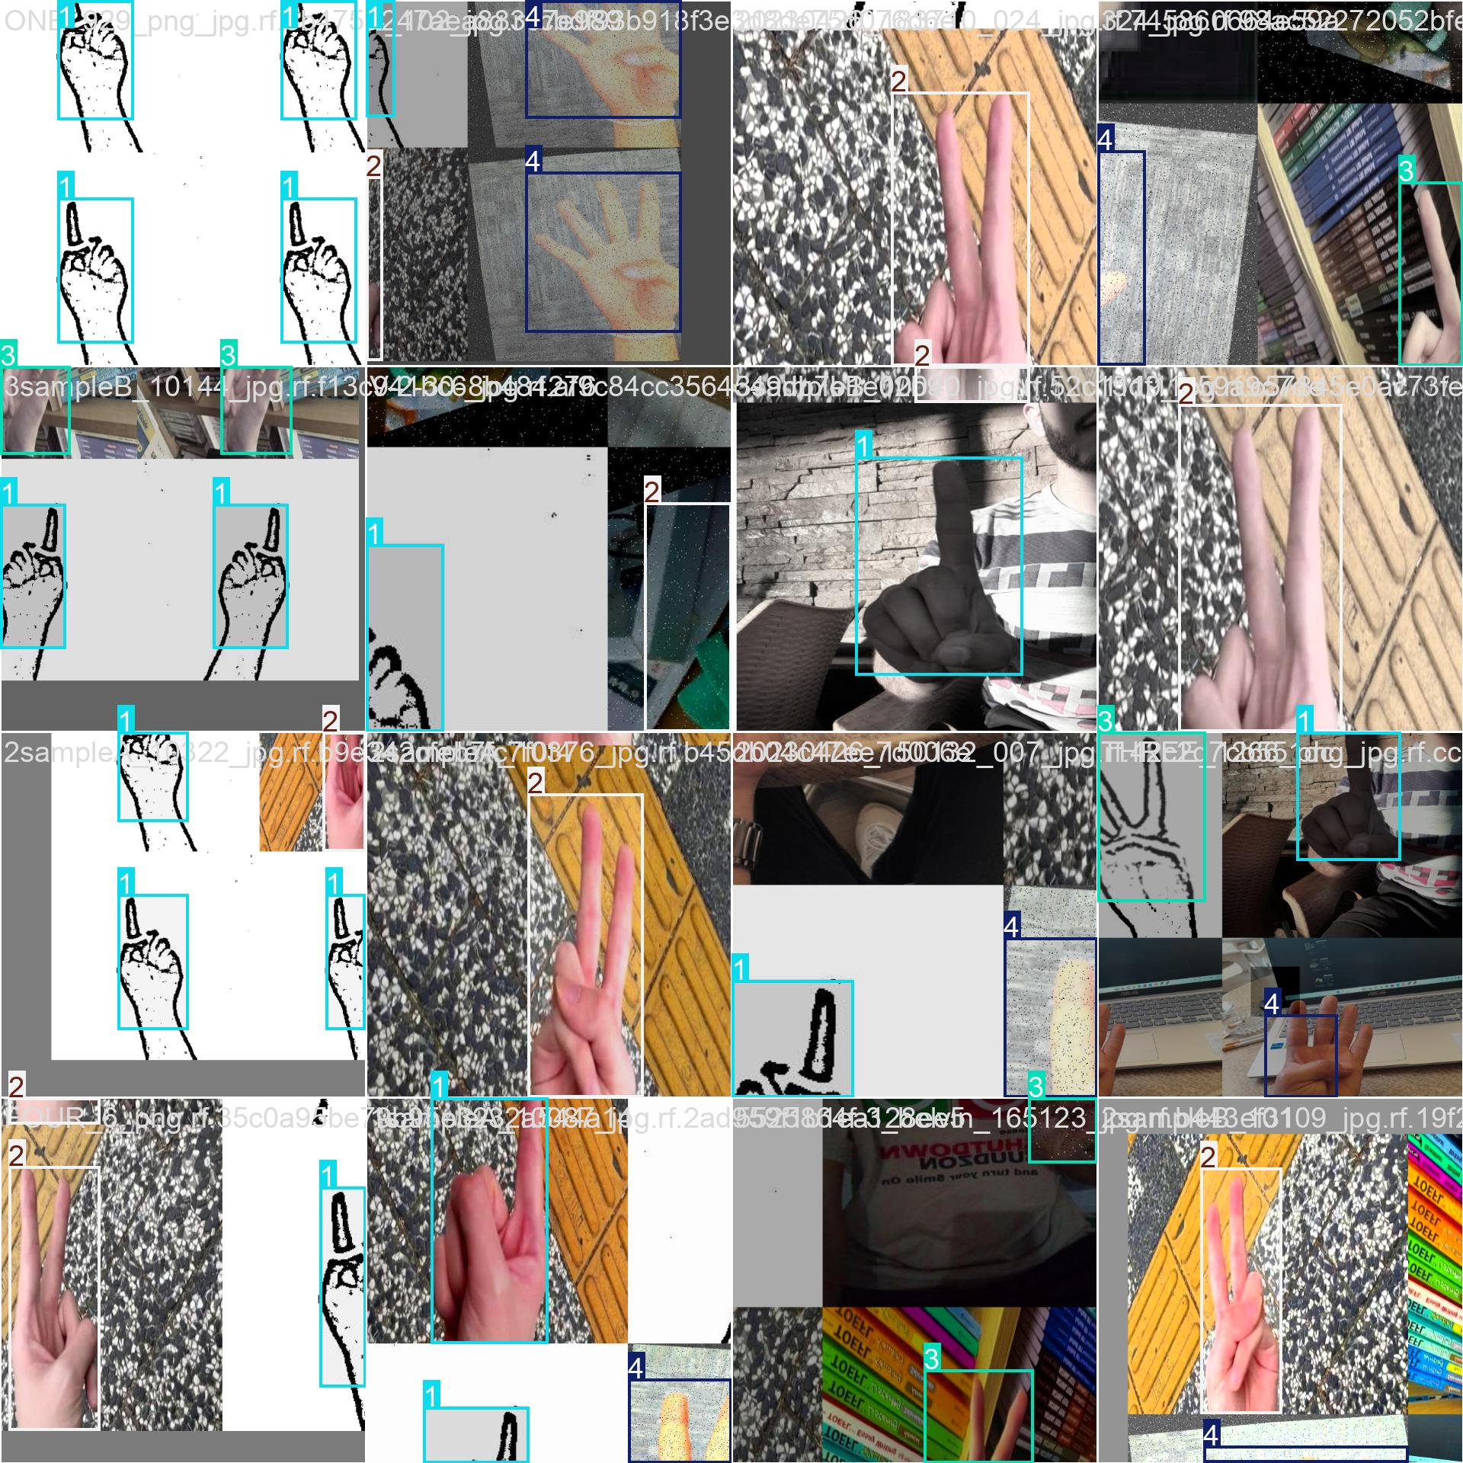

4. Validation Predictions
This image shows predicted bounding boxes on validation images. Ideally, predicted boxes should match the true object tightly with correct class labels. Some misclassifications or localization errors are still visible, indicating room for improvement.
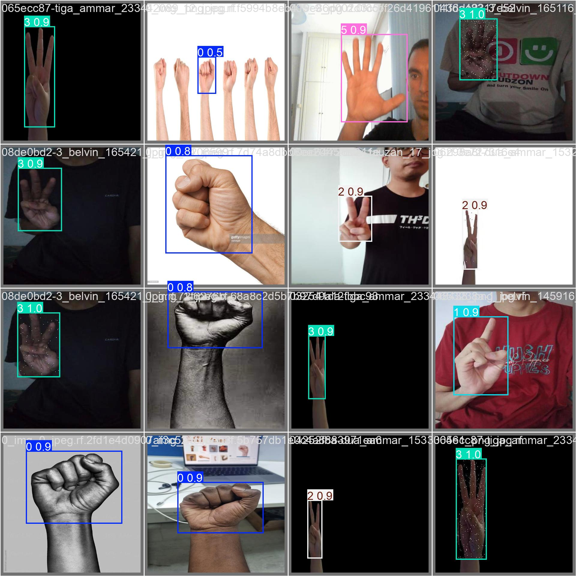

5. Confusion Matrix
The normalized confusion matrix shows per-class prediction accuracy. For a perfect model, all diagonal elements should be 1 (100%) and off-diagonal elements should be 0. In our case, diagonal values range from ~0.80 to ~0.92, indicating reasonably good but imperfect classification.
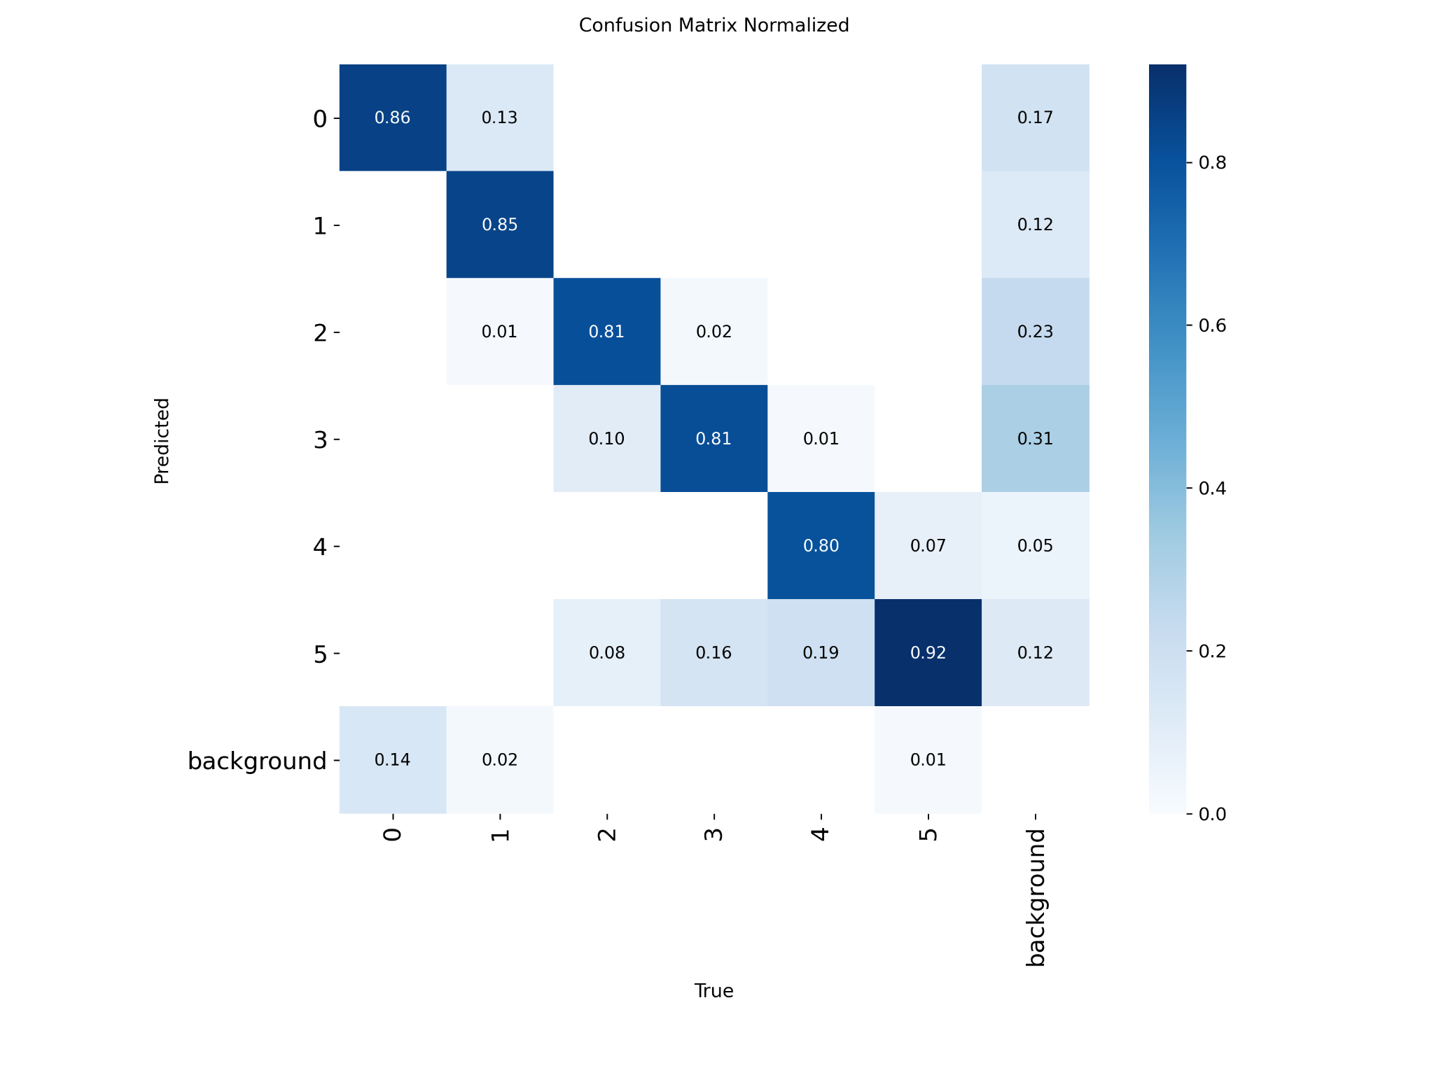

6. F1-Confidence Curve
This plot shows the F1 score against prediction confidence thresholds. A perfect model would exhibit a high F1 (~1.0) consistently across high confidence thresholds. Here, we observe peak mean F1 around 0.78, suggesting solid but not perfect detection consistency.
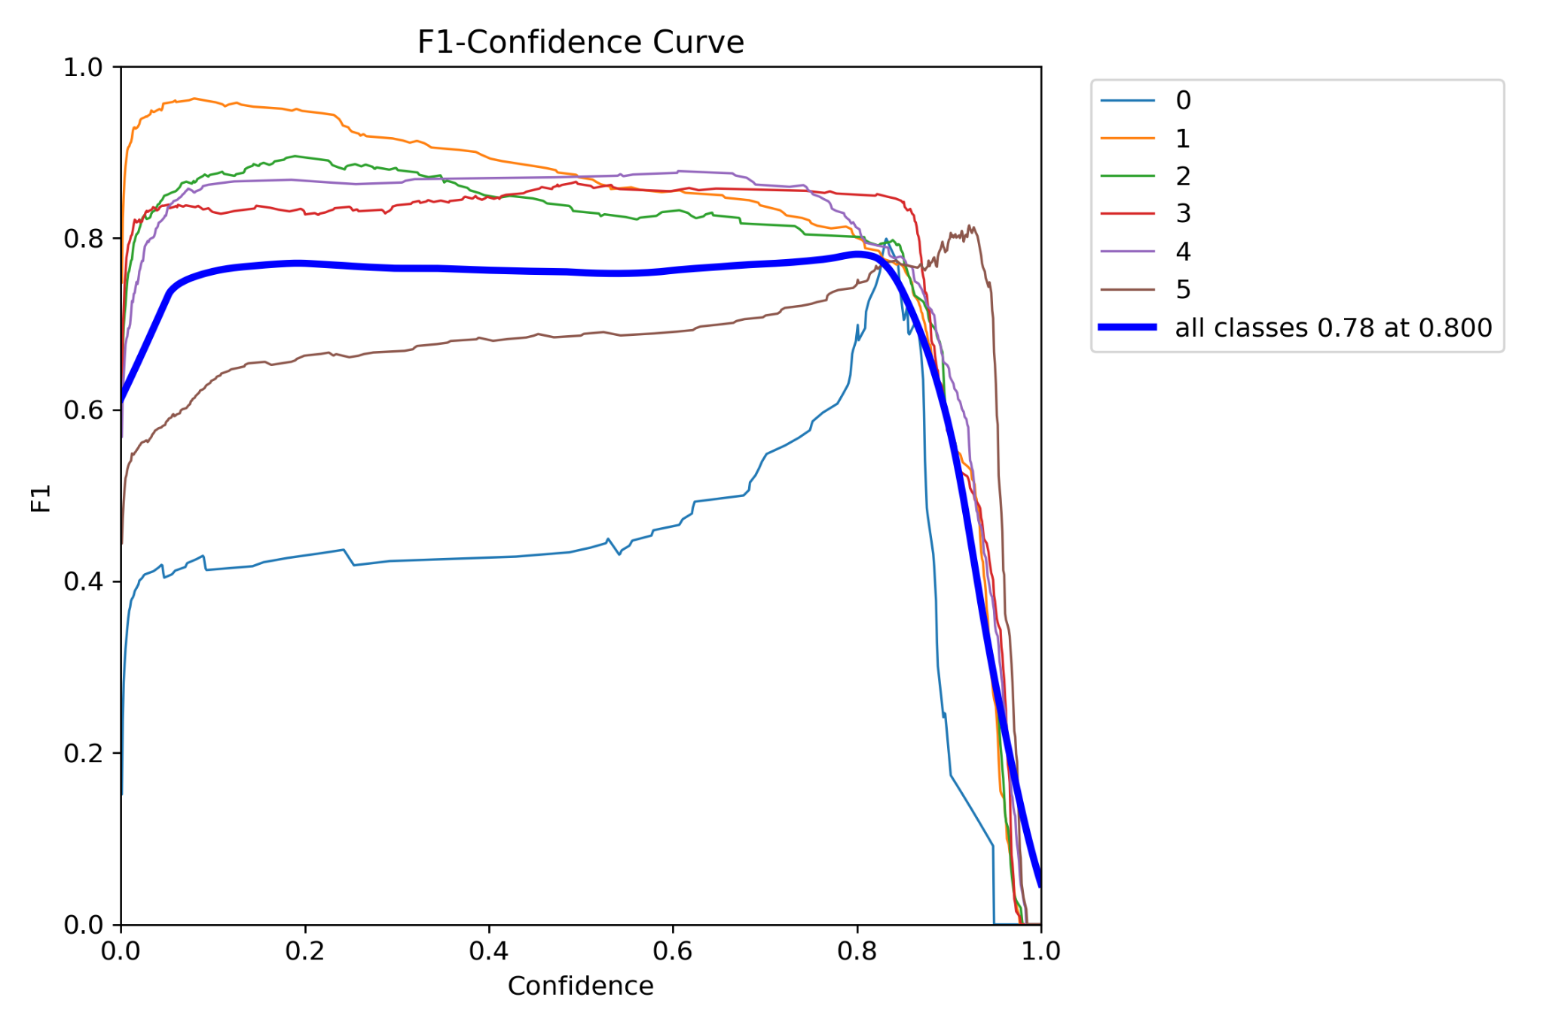

7. Label Statistics
This figure shows label distribution, bounding box locations, and size distributions. An even distribution and tight clustering of bounding box parameters indicates good data coverage. Our data is moderately balanced but one class has significantly fewer samples (wiper - 3).
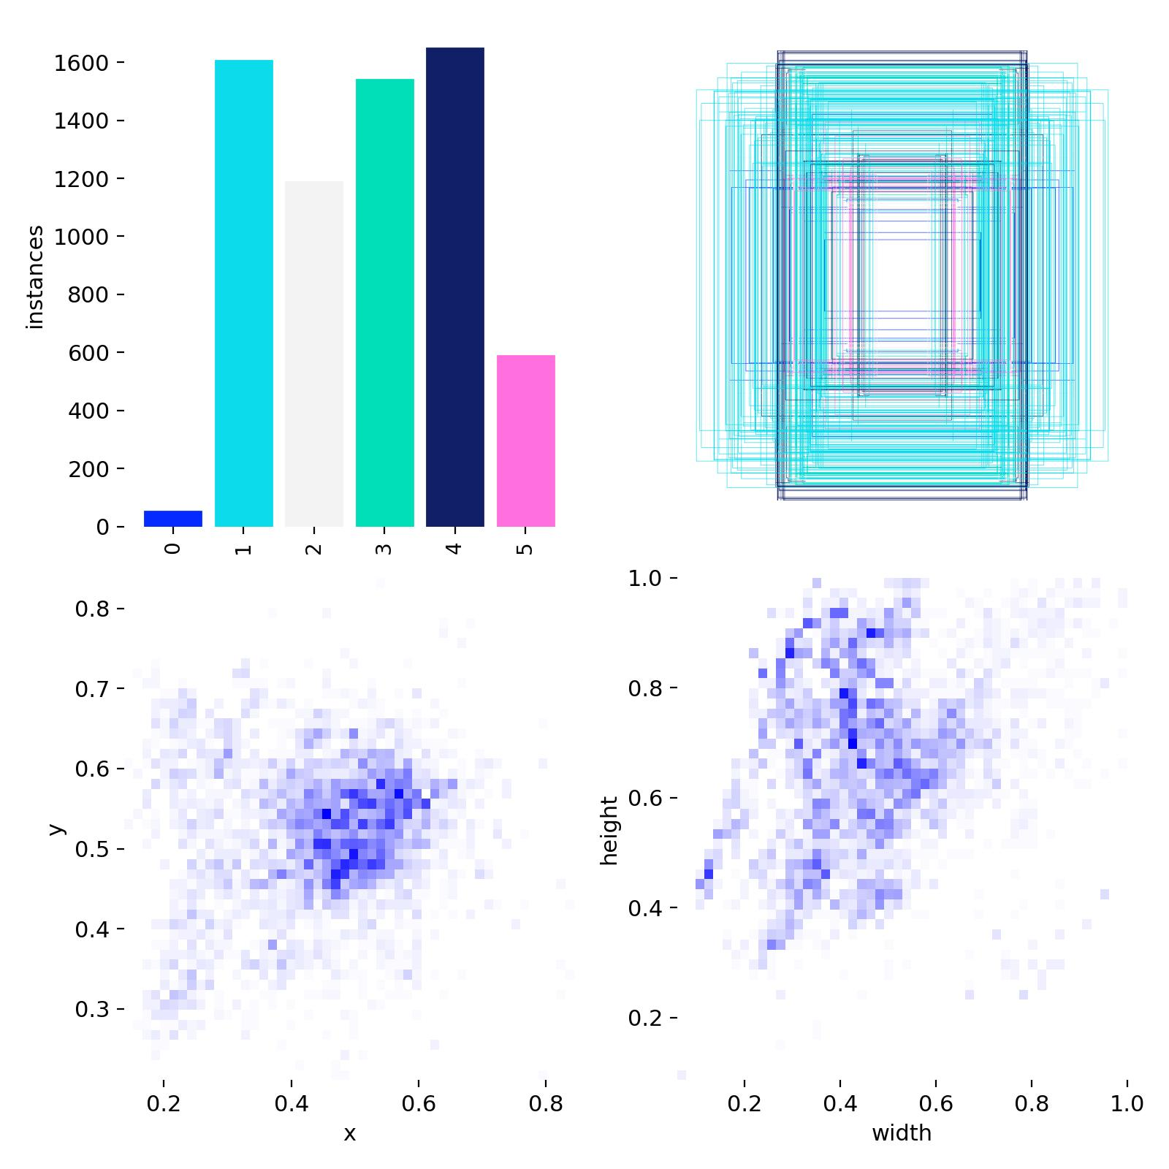

8. Labels Correlation
This correlogram visualizes statistical relationships between bounding box parameters (x, y, width, height). Tight clusters suggest consistent annotation practices. Some spread is normal in real-world data.
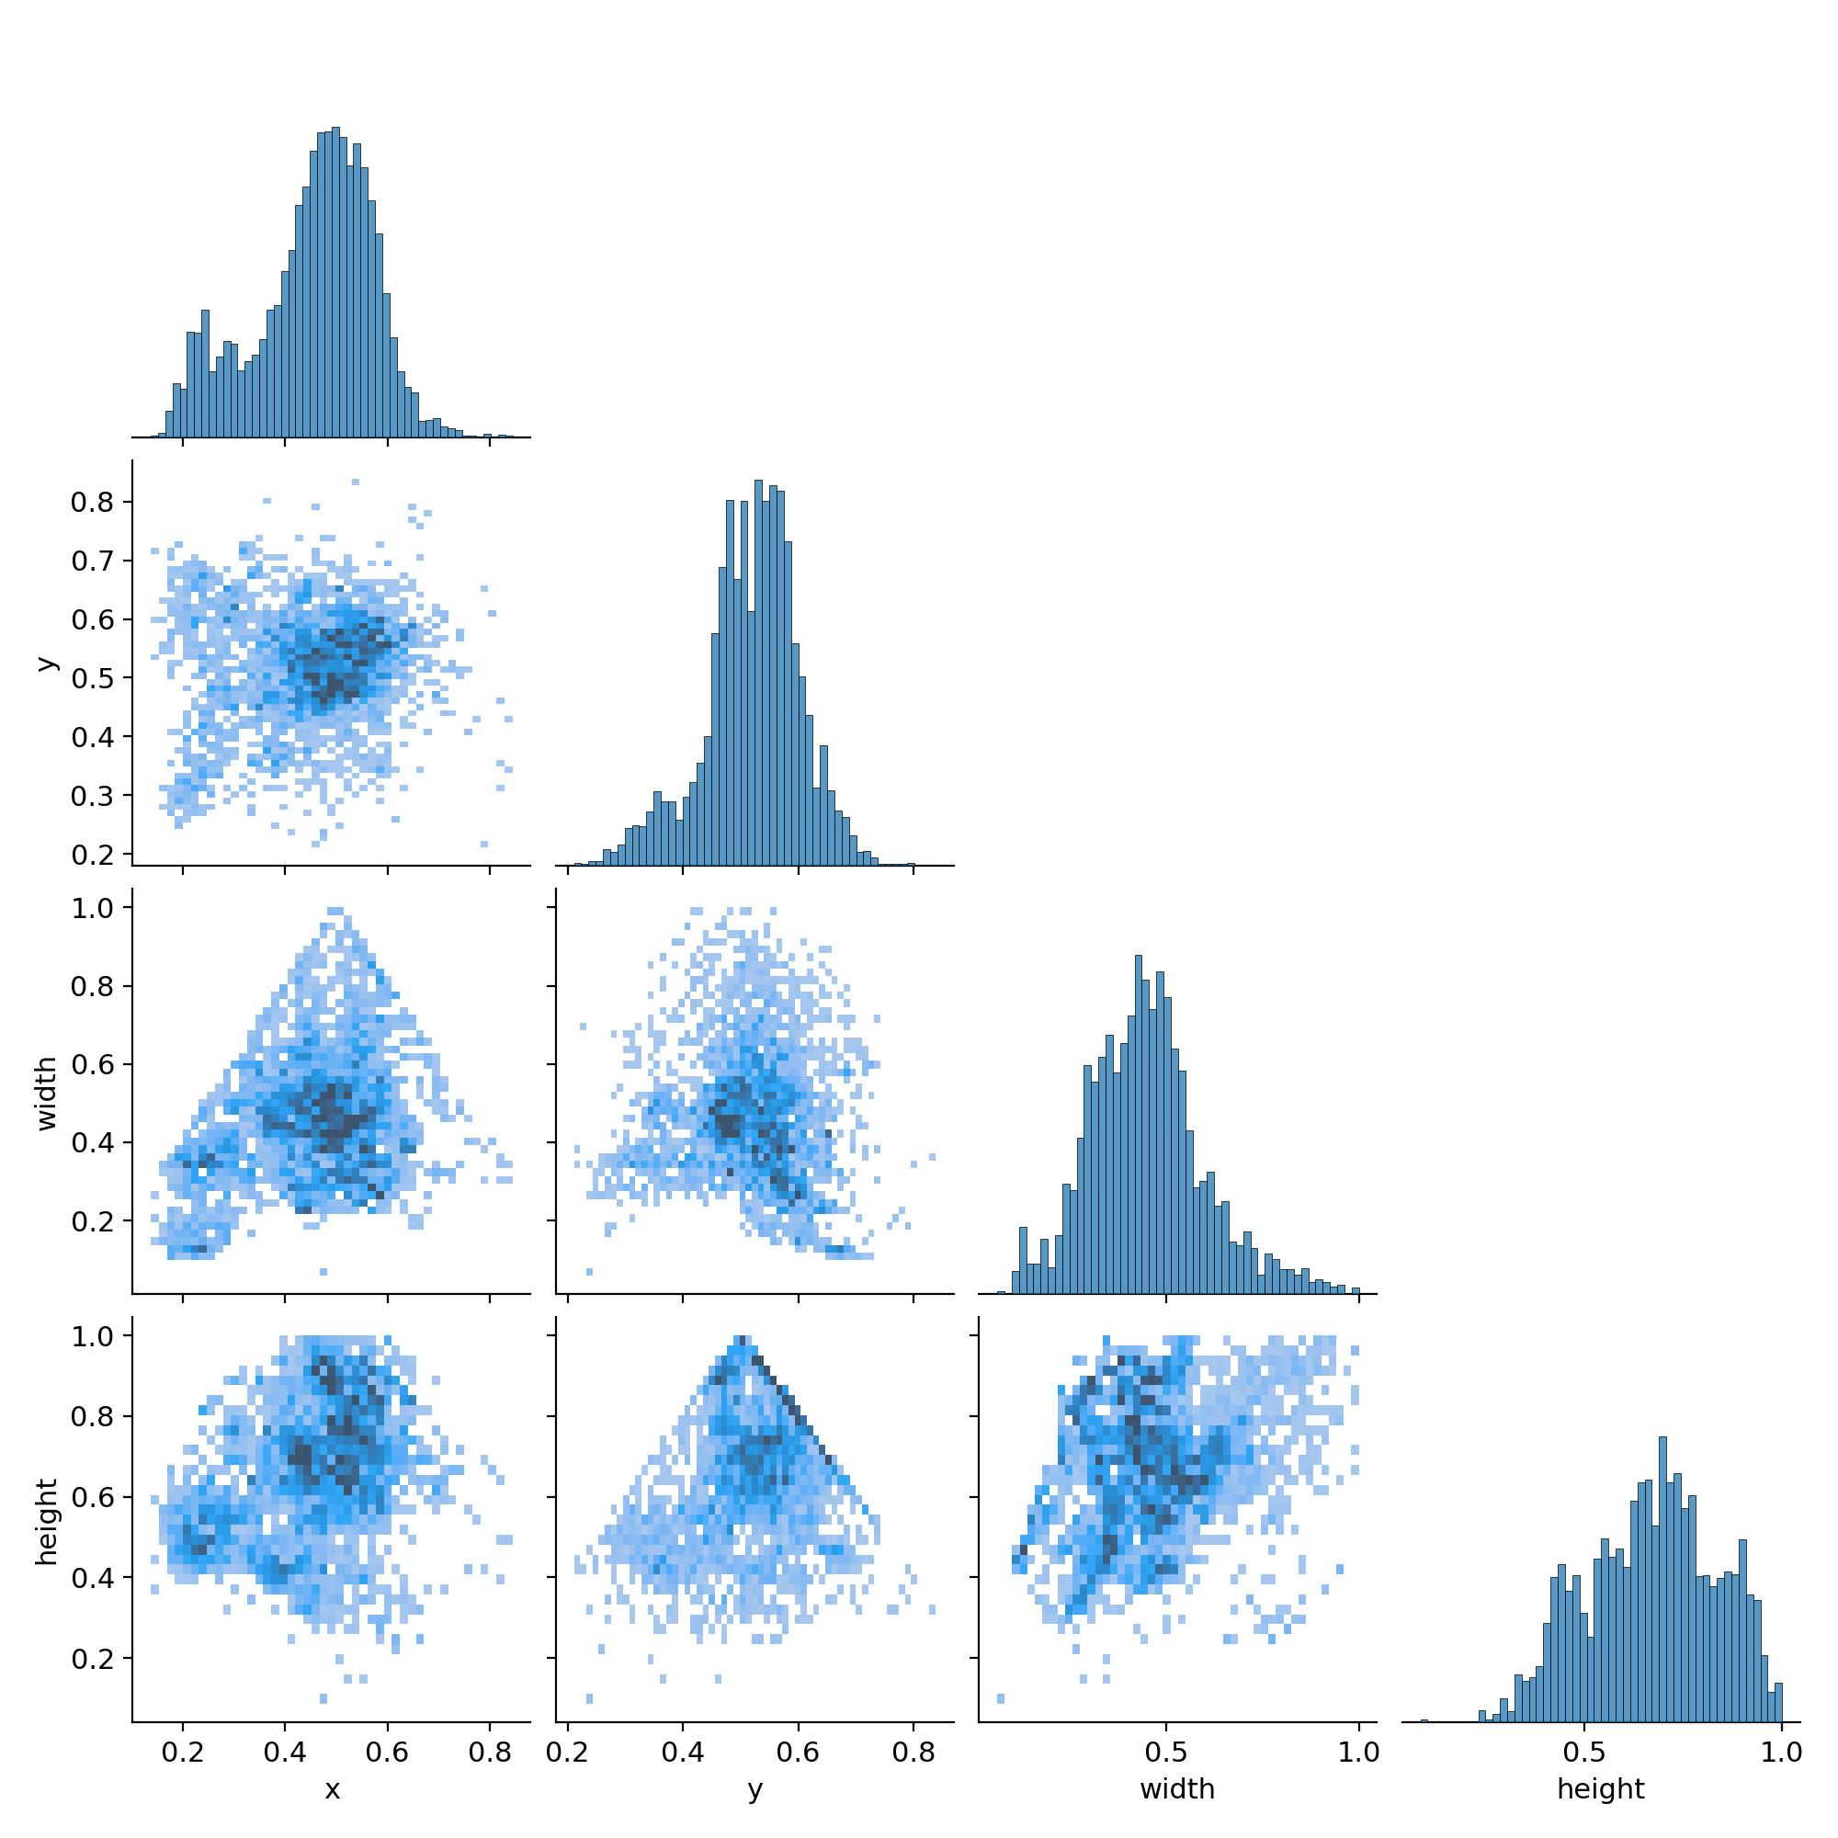

9. Precision-Confidence Curve
Precision ideally should be close to 1.0 at high confidence thresholds. Our curve shows precision peaks at ~1.0 around 0.99 confidence, which is a positive indicator.
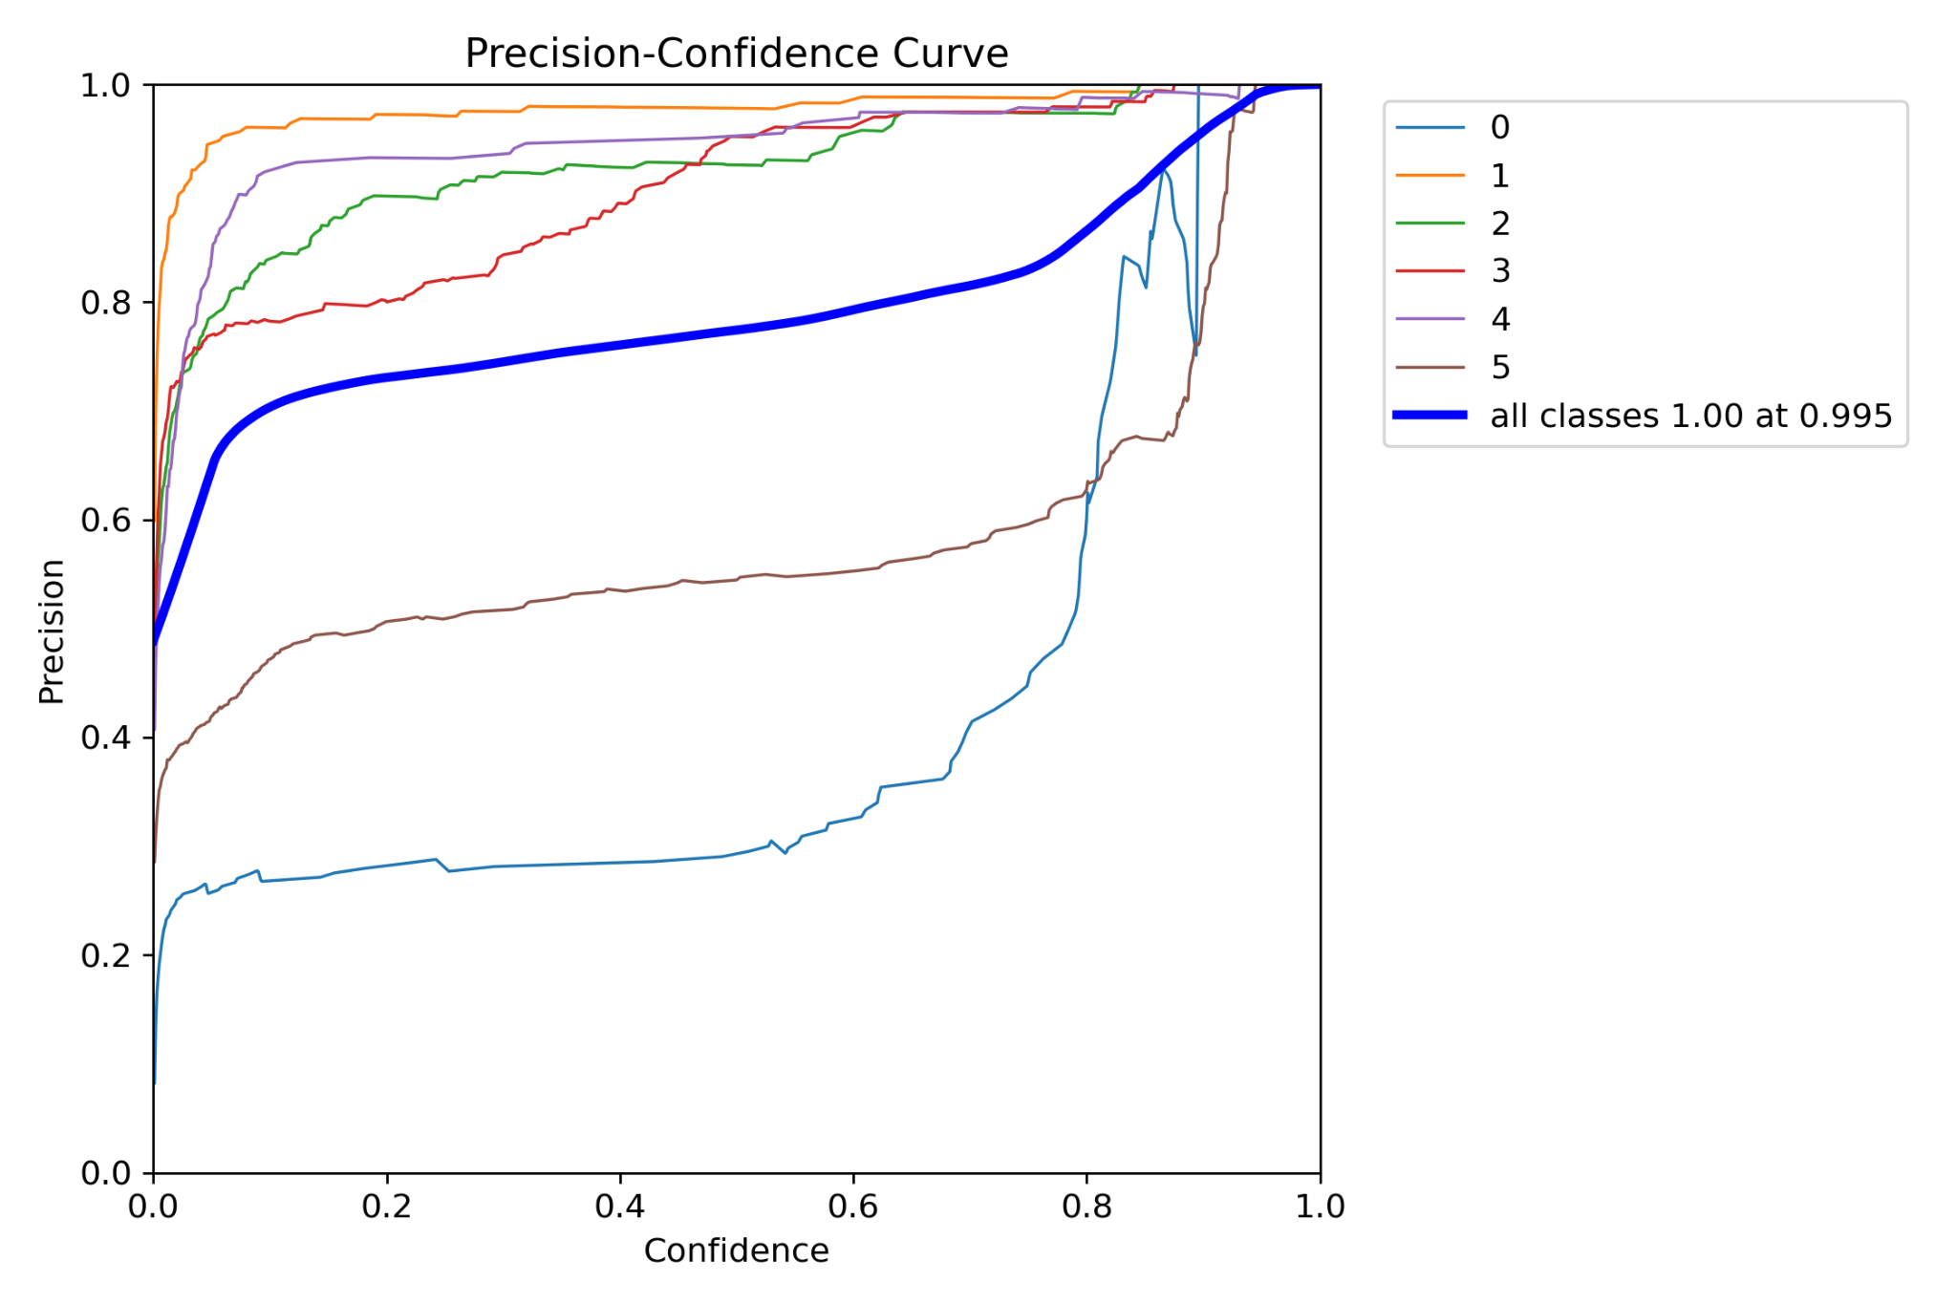

10. Precision-Recall Curve
A perfect model would have curves hugging the top-right corner, with high precision and recall simultaneously. We achieve a mean Average Precision (mAP) of 0.91 at IoU=0.5, which is strong but indicates slight trade-offs at lower recall levels.
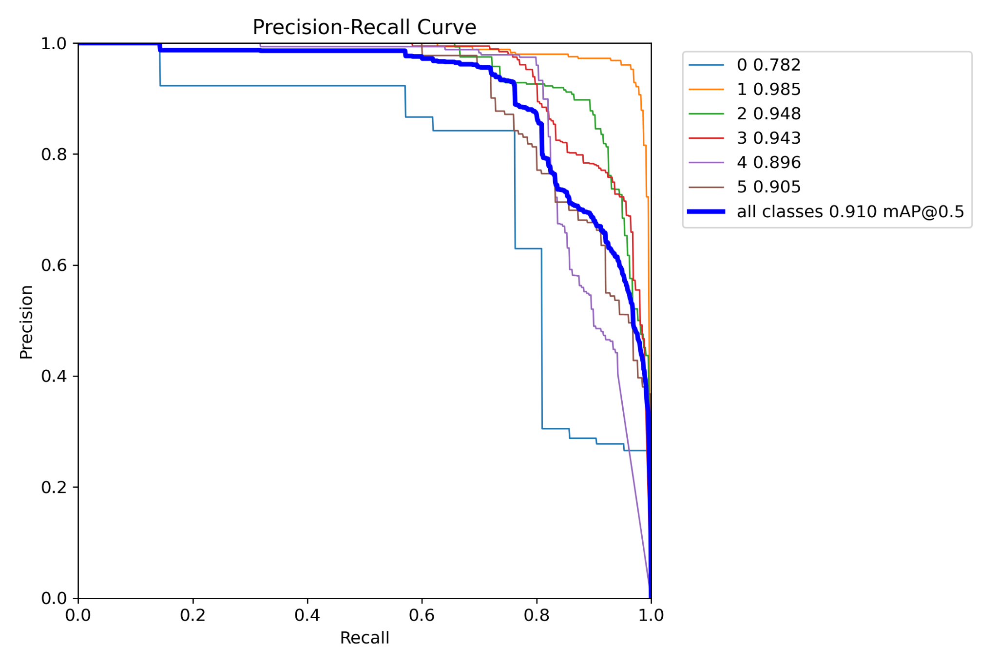

11. Recall-Confidence Curve
This shows recall versus confidence threshold. For a perfect model, recall would remain high (~1.0) up to high confidence levels. Here, recall gradually declines beyond 0.5 confidence, indicating some false negatives as confidence increases.
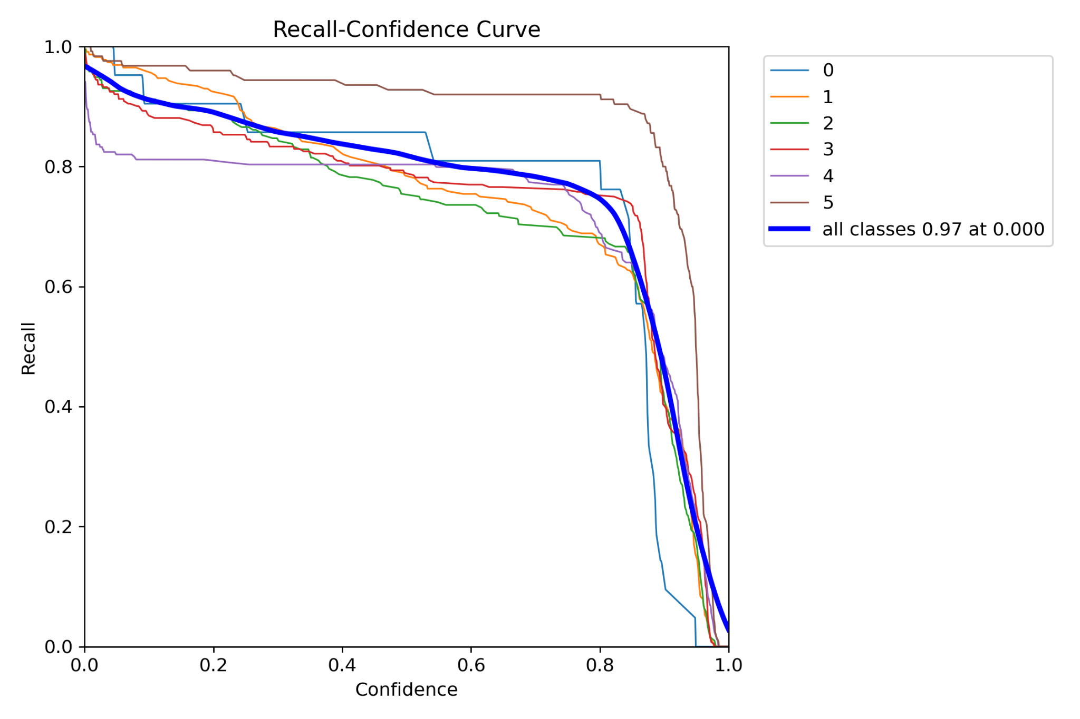

12. Training Metrics Over Epochs
The training plots show trends of loss, precision, recall, and mAP metrics. Ideally, training and validation losses should decrease smoothly while precision, recall, and mAP increase steadily. Our plots generally exhibit this trend, though some fluctuations remain, typical in real-world training.
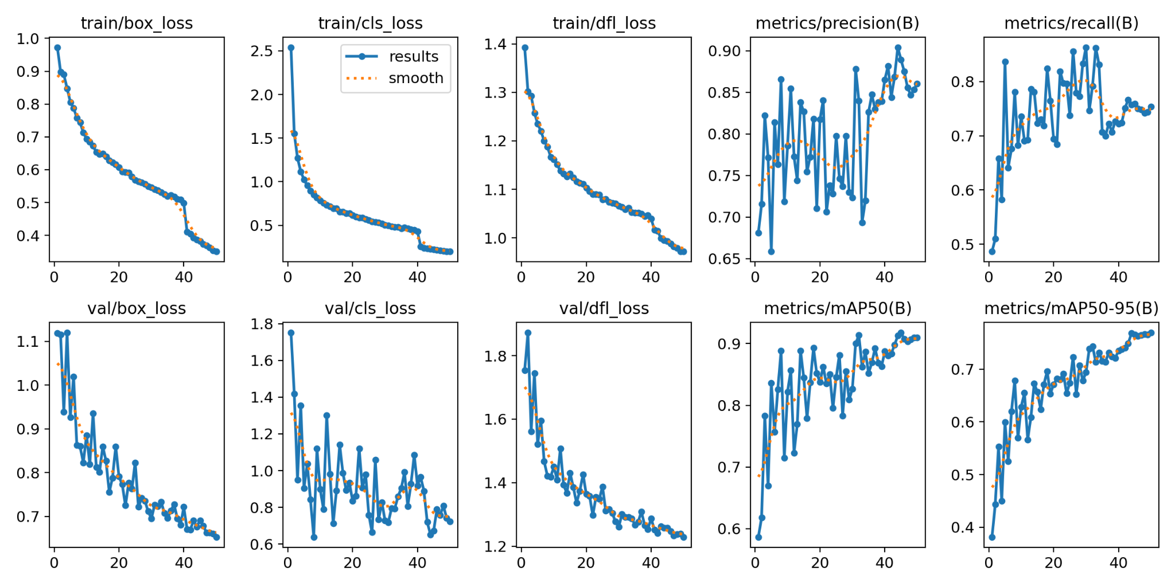

13. Conclusion
Overall, the model achieved strong performance with mAP@0.5 around 91%, and reasonably high precision and recall. While the model is not perfect (some class confusions and confidence-recall trade-offs remain), the results are promising for further fine-tuning or deployment in real-time applications.

