Standardised Proof-of-Delivery System with Evidence-Quality Checks
Food-Delivery Service Coordinating Restaurants, Riders & Customers
Academic Project Report — Review 1: Planning & Architecture
Candidate Name: | LOGESH S
Degree / Program: | Bachelor of Engineering / Technology in Computer Science & Engineering
Department: | Department of Computer Science & Engineering
Academic Milestone: | Review 1: Planning, Requirements Engineering, System Design & Core Verification
Date of Submission: | September 2026

1. Abstract
Online food delivery platforms coordinate three independent actors—restaurants, riders, and customers—under tight time constraints for every order. The critical final step of this operational chain is delivery confirmation: the moment a platform determines whether an order was legitimately delivered to the intended recipient. In current industry practice, delivery confirmation is treated as a single, unverified action, typically consisting of a rider tapping a 'Delivered' button and optionally uploading an arbitrary photo. Because these submissions lack real-time validation, blurred, pitch-black, misframed, or fraudulent photos are accepted as valid proof. Furthermore, GPS coordinates are rarely cross-checked against delivery geofences at confirmation, customer verification (OTP or digital signature) is frequently skipped under time pressure, and intermittent mobile connectivity in indoor or underground environments causes capture workflows to fail outright. The resulting ambiguity forces customer support teams to resolve high volumes of delivery disputes manually, leading to subjective decisions, financial losses, and eroded stakeholder trust.
To overcome these deficiencies, this project designs and implements a Standardised Proof-of-Delivery (POD) System with Evidence-Quality Checks. The system transitions delivery confirmation from an unverified status update to an explainable, multi-factor decision pipeline. The platform captures five structured evidence types for every delivery: delivery photo, device GPS coordinates, capture timestamp, one-time password (OTP), and an on-screen customer signature. At the core of the platform is an automated Evidence Quality Engine (EQE) that evaluates captured evidence against an explicit, weighted scoring rubric (0–100 points): Photo Quality (25), GPS Geofence Match (25), Timestamp Validity (20), Signature Presence (20), and OTP Verification (10). Deliveries are automatically triaged into three outcome bands: Accepted (score ≥ 90), Needs Manual Review (score 70–89), or Dispute (score < 70).
To ensure complete operational reliability in real-world delivery environments, the system features an offline-first Progressive Web App (PWA) client architecture. Captured evidence is persisted locally in an IndexedDB queue, allowing riders to mark deliveries complete without network connectivity; a background Synchronization Manager opportunistically transmits queued evidence to the backend once connectivity is restored. In degraded conditions (e.g., indoor delivery with zero GPS fix), the scoring engine withholds GPS marks, capping the maximum score at 75 and routing the delivery to a dedicated Dispatcher Review Queue. Human dispatchers can resolve edge cases using a controlled override workflow that enforces mandatory reason codes and justification logging. All state changes, evidence submissions, score evaluations, and dispatcher overrides are committed to an append-only, immutable audit trail, ensuring complete end-to-end traceability and non-repudiation.
For Review 1, the foundational engineering milestones have been achieved: complete Software Requirements Specification (SRS) following IEEE standards, layered client-server system architecture, third normal form (3NF) relational database schema, user interface wireframes, and a fully functional core backend and frontend prototype. Automated unit and integration testing confirms that the core scoring algorithms, OpenCV image validation, Haversine geofencing, and role-based workflows operate with high fidelity, passing 50 automated test cases across 8 test suites.

2. Introduction

2.1 Background
The rapid expansion of on-demand food delivery has established it as one of the largest last-mile logistics operations globally. Modern delivery platforms coordinate three distinct parties for every order: (1) Restaurants, who prepare meals and require timely pickup and guaranteed payment; (2) Riders, who navigate urban transit networks to fulfill deliveries under tight schedules; and (3) Customers, who expect prompt, accurate, and intact delivery at their doorstep.
While order dispatch, menu discovery, and routing have seen extensive automation, the final fulfillment step—delivery confirmation—remains the most vulnerable link in the fulfillment lifecycle. Confirming whether an order was actually delivered carries immediate operational and financial consequences. An erroneous or disputed delivery triggers customer refund requests, dispute claims by restaurants regarding meal costs, and payment penalties or deactivation for riders. In major urban centers where platforms handle tens of thousands of orders daily, even a 1% to 2% dispute rate generates thousands of contentious claims that must be investigated by human support agents.
Existing commercial platforms rely on coarse, single-factor mechanisms such as a simple rider status toggle, occasionally accompanied by a single unexamined photo. These practices fail to provide definitive, verifiable proof of fulfillment. When disputes arise, support teams are forced to make subjective determinations based on incomplete, unvalidated evidence. This project addresses this vulnerability by developing an automated, multi-factor proof-of-delivery framework that enforces evidence quality at the point of capture, transparently scores fulfillment signals, supports uninterrupted offline operations, and maintains an immutable audit log.

2.2 Project Scope
The scope of this project encompasses the design, implementation, and academic evaluation of a comprehensive Proof-of-Delivery system structured across five user roles: Restaurant, Rider, Customer, Dispatcher, and Platform Administrator.
In-Scope Capabilities: (1) Five-Factor Evidence Ingestion capturing delivery photo, GPS telemetry, timestamp, OTP, and digital signature; (2) Automated Evidence Quality Engine (EQE) executing OpenCV Laplacian variance blur checks, brightness analysis, and Haversine geofence validation (150m); (3) Automated classification into Accepted, Needs Manual Review, and Dispute tiers; (4) Offline-first Progressive Web App (PWA) client architecture with IndexedDB local queueing and background synchronization; (5) Dispatcher operations console with split-pane evidence comparison, Leaflet geofence map, and reason-coded override workflows; (6) Immutable append-only audit trail logging every state transition; (7) Role-based interfaces for all five user roles; (8) Administrative analytics dashboard tracking operational quality metrics.
Explicitly Out-of-Scope (Review 1 & Academic Prototype Boundaries): Per Section 1.4 of the project SRS, the following are excluded: production-grade payment gateway settlements, commercial native app store publishing (PWA web architecture is used), large-scale dynamic vehicle routing algorithms, and commercial SMS telecom gateway integrations (a sandbox OTP service is used).

2.3 Stakeholders
The system serves six distinct stakeholder groups, mapped in the table below:
Stakeholder | Role in System | Key Needs & System Benefits
Restaurant Partner | Creates orders, tracks preparation, monitors fulfillment. | Protection from false non-delivery claims; transparent handoff tracking; elimination of unfair food loss liabilities.
Rider / Delivery Exec | Accepts assignments, captures evidence, marks complete. | Fair, objective evidence standards; immunity from false customer accusations; seamless offline operation in dead zones.
Customer | Receives OTP, verifies delivery, provides signature, disputes. | Assurance of tamper-free delivery; transparent, fast dispute raising with documented evidence review.
Dispatcher / Ops | Monitors exception queue, reviews flagged deliveries, overrides. | Prioritized pre-scored queue; granular visibility into specific failed criteria; standardized override reason codes.
Platform Admin | Oversees operational health, manages accounts and roles. | Centralized analytics dashboard tracking volume, average evidence quality, dispute rates, and regional trends.
Project Evaluators | Academic review and engineering assessment. | Evaluation of technical depth, IEEE SRS compliance, mathematical correctness of scoring rubric, and test verification.

3. Problem Statement
Delivery evidence collected by contemporary on-demand food delivery workflows is fundamentally inconsistent, unverified at the point of capture, and highly vulnerable to operational failure. Specifically, existing implementations suffer from the following core failure modes:
1. Unverified and Poor-Quality Photographic Proof: Delivery photos are accepted as arbitrary attachments without real-time validation. Photos that are blurred, completely black, over-exposed, or pointed at irrelevant objects are accepted into platform records without warning.
2. Unvalidated GPS Telemetry: GPS coordinates recorded at delivery confirmation are rarely cross-referenced against the registered delivery address geofence. Coordinate drift, indoor signal attenuation, or deliberate spoofing lead to false confirmations hundreds of meters away from the customer.
3. Skipped or Inconsistent Customer Verification: OTP and signature verifications are skipped due to rider time pressure or customer unavailability, leaving packages unattended with zero verified handoff acknowledgement.
4. Fragility in Network Dead Zones: Delivery handoffs in basements, elevators, or dense high-rises suffer from severe cellular drops, causing standard apps to block completion or silently fail to transmit evidence photos.
5. Costly, Subjective, and Reactive Dispute Resolution: Proof of delivery is only inspected after an aggrieved customer files a dispute. Support agents inspect unvalidated evidence and make subjective calls, leading to high labor costs and inconsistent outcomes.

4. Objectives
To resolve the stated problems, the project establishes seven formal technical and operational objectives:
1. Standardised Multi-Factor Evidence Capture: Design and prototype a structured pipeline capturing five distinct evidence signals (photo, GPS coordinates with accuracy, timestamp, OTP, signature) in a consistent format.
2. Automated Quality Scoring & Triaged Classification: Develop an explainable Evidence Quality Engine (EQE) computing a 0–100 quality score and classifying deliveries into Accepted (≥90), Needs Manual Review (70–89), or Dispute (<70).
3. Resilient Offline-First Architecture: Ensure capture workflows function reliably with zero network or GPS connectivity using client-side IndexedDB persistent storage, enabling route completion and automatic opportunistic background sync.
4. Accountable Dispatcher Override Capability: Provide a dedicated operations console allowing human dispatchers to inspect flagged edge cases and execute overrides governed by mandatory reason codes and justification logging.
5. Immutable Audit History & Traceability: Implement an append-only audit trail permanently logging order lifecycles, evidence submissions, automated scores, and dispatcher actions to guarantee non-repudiation.
6. Empirical Baseline Benchmarking: Establish an experimental validation methodology comparing the multi-factor EQE against a photo-only manual baseline on a labelled validation dataset across normal and edge-case scenarios.
7. Comprehensive Academic Documentation & Working Prototype: Deliver industry-standard documentation (IEEE SRS, architecture, ER model, wireframes) alongside a fully functional, tested prototype across all five role modules.

5. Existing System

5.1 Workflow of Current Platforms
Current mainstream food-delivery platforms typically mark an order 'delivered' based on a rider tapping a status button, optionally attaching a single photo. GPS is logged for tracking purposes but rarely validated against the delivery address at the moment of confirmation. OTP is used inconsistently, and signature capture is largely absent in food delivery. When a customer disputes a delivery, a support agent manually opens the order, looks at whatever photo exists, and makes a subjective accept/reject call—there is no scoring, no consistent evidence bar, and no structured record of why a decision was made.

5.2 Limitations of the Existing System
• No automated quality check on delivery photos—blurred or irrelevant images are accepted as valid proof.
• GPS accuracy and address match are not verified at the point of delivery confirmation.
• No standardised, weighted scoring of evidence; decisions are subjective and vary by agent.
• Poor offline behaviour—evidence capture or submission commonly fails outright when network connectivity drops.
• No systematic audit trail linking a delivery's final status to the specific evidence and decision-maker responsible.
• Dispute resolution is reactive and manual, with no data-driven flag raised before the customer complains.

6. Proposed System

6.1 System Overview & Core Paradigm
The proposed Standardised Proof-of-Delivery system converts delivery confirmation from a single unverified action into a structured, evidence-scored decision. The system executes through a four-stage pipeline:
1. Capture: Rider app captures photo, GPS, timestamp, and OTP/signature—online or offline—writing to local storage first.
2. Score: The Evidence Quality Engine computes an explainable 0–100 weighted score instantly upon receipt.
3. Classify: Deliveries are categorized into Accepted (≥90), Needs Manual Review (70–89), or Dispute (<70).
4. Resolve: Auto-accepted without human intervention, or routed to a dispatcher with full evidence context.

6.2 Key Advantages
• Objective, explainable, and consistent evidence scoring instead of subjective manual judgement.
• Fewer disputes reach human agents, because low-quality evidence is caught and flagged automatically before customer complaints.
• Reliable operation without GPS or network connectivity, through offline capture and automatic background sync.
• Faster, better-informed dispatcher decisions, since flagged deliveries arrive pre-scored with specific evidence gaps highlighted.
• Full auditability: every delivery status can be traced back to the evidence, score, and human override with documented reasons.
• A reusable, extensible scoring framework that easily absorbs future evidence types (video, biometric) without re-architecting.

7. Literature Survey

7.1 Summary Table of Research Areas
The table below summarizes research areas from literature informing the system architecture:
No | Area | Key Idea | Limitation | Literature Gap | Our Improvement
1 | Proof of Delivery | Digital proof manifests | Weak validation | No composite score | Evidence scoring (0-100)
2 | Last-mile Delivery | Delivery coordination | High dispute rates | Weak fulfillment proof | Standardized POD schema
3 | GPS Tracking | Location check | GPS drift / indoor loss | No offline fallback | Haversine check & offline mode
4 | Offline Apps | Local caching | Generic storage | No POD queuing | Offline-first PWA with IndexedDB
5 | Image Validation | Blur / exposure checks | Standalone image tools | No operational integration | OpenCV Laplacian blur checks
6 | Audit Logs | System event logs | Generic logging | No override accountability | Append-only log with reason codes
7 | OTP / Signature | Customer verification | Single-factor reliance | Low reliability | Multi-factor dual verification
8 | Dispute Systems | Manual review tools | Slow investigation | Incomplete evidence data | Pre-scored dispatcher workspace

7.2 Detailed Analysis of Research Domains
Computer Vision for Image Quality: Blur is evaluated using the variance of the Laplacian operator on greyscale image matrices (Var(∇²I)). Sharp edges exhibit high second-derivative spatial variance, whereas blurred images produce low variance. Combined with mean pixel intensity checks, this provides a computationally efficient, explainable metric avoiding opaque deep models.
Geospatial Validation: Spherical trigonometry via the Haversine formula calculates great-circle distance between rider capture coordinates and registered customer coordinates. A 150m threshold accommodates GPS urban drift while flagging true misdeliveries.
Offline-First Web Architecture: Leveraging Service Workers for caching and IndexedDB for local data persistence guarantees that evidence capture and delivery completion never block on network connectivity, syncing automatically via background workers.

8. Research Gap
Core Research Gap: Existing systems rarely combine photo quality, GPS accuracy, OTP, signature, timestamps, offline capability, dispatcher override, and audit history in one unified proof-of-delivery solution.
1. Multi-Signal Integration Gap: Systems evaluate GPS, photos, or OTP in silos without a composite, weighted scoring rubric.
2. Point-of-Capture Validation Gap: Lack of real-time blur detection at the edge that prompts the rider to retake a photo before leaving.
3. Offline-Degraded Scoring Gap: Lack of formal mathematical accommodation for incomplete sensor data in network dead zones.
4. Operational Override Accountability Gap: Disconnected dispatcher override workflows lacking mandatory reason codes and immutable logs.
5. Proactive Dispute Triage Gap: Lack of automated classification routing deliveries into review queues before customer complaints arise.

9. Requirements

9.1 Functional Requirements (FR-01 to FR-26)
The functional requirements define specific behaviors across all application modules:
ID | Module | Requirement Specification
FR-01 | Restaurant | Allow restaurant to create orders with items, customer address, and expected prep time.
FR-02 | Restaurant | Allow restaurant/dispatcher to assign an available rider to an order.
FR-03 | Restaurant | Allow restaurant to track real-time order and delivery fulfillment status.
FR-04 | Rider | Allow rider to accept or reject assigned deliveries within an operational time window.
FR-05 | Rider | Allow rider to capture a delivery photo using device camera at the point of delivery.
FR-06 | Rider | Capture device GPS coordinates and accuracy radius at the moment of evidence capture.
FR-07 | Rider | Allow rider to input customer-provided OTP for delivery verification.
FR-08 | Rider | Allow rider to capture customer signature on-screen when OTP is not available.
FR-09 | Rider | Allow rider to mark delivery Complete only after minimum required evidence is captured.
FR-10 | Customer | Send single-use, time-limited OTP to customer upon order dispatch.
FR-11 | Customer | Allow customer to verify delivery receipt and view captured photographic proof.
FR-12 | Customer | Allow customer to raise a formal dispute with reason codes and supporting notes.
FR-13 | Evidence Engine | Compute Evidence Quality Score (0–100) using the weighted rubric.
FR-14 | Evidence Engine | Classify deliveries into Accepted (≥90), Manual Review (70–89), or Dispute (<70).
FR-15 | Evidence Engine | Reject delivery photos failing blur/brightness checks and prompt immediate retake.
FR-16 | Offline Handling | Persist captured evidence locally on rider device when network is unavailable.
FR-17 | Offline Handling | Automatically synchronize locally queued evidence once network connectivity is restored.
FR-18 | Offline Handling | Flag evidence captured without GPS as 'Offline/Reduced-Accuracy' and deduct GPS marks.
FR-19 | Dispatcher | Present dispatchers with a prioritized queue of flagged deliveries ordered by score and age.
FR-20 | Dispatcher | Require dispatcher to select a standardized reason code and justification for overrides.
FR-21 | Dispatcher | Notify affected rider and customer when a dispatcher override modifies delivery status.
FR-22 | Audit & History | Record an immutable audit log for every order creation, evidence capture, score, and override.
FR-23 | Audit & History | Allow authorized users to view complete history and raw evidence of a delivery.
FR-24 | Admin | Provide admin dashboard showing delivery volumes, average score, dispute rate, and region stats.
FR-25 | Admin | Allow admin to manage user accounts and role assignments across all five roles.
FR-26 | Reporting | Enable export of delivery and dispute reports for specified date ranges.

9.2 Non-Functional Requirements (NFR-01 to NFR-10)
ID | Category | Requirement Specification
NFR-01 | Performance | Evidence Quality Engine shall compute score within 2 seconds under normal load (≤100 req).
NFR-02 | Availability | Offline capture on rider app shall function with zero network, targeting 99.5% success.
NFR-03 | Reliability | Locally queued offline evidence shall not be lost across app restarts or device reboots.
NFR-04 | Scalability | Backend API shall horizontally scale to support at least 10,000 deliveries/day.
NFR-05 | Usability | Rider shall be able to complete evidence capture workflow in under 60 seconds.
NFR-06 | Security | All API traffic encrypted via TLS 1.2+; passwords hashed using bcrypt; JWT RBAC enforced.
NFR-07 | Data Integrity | Audit log entries strictly append-only; database permissions prohibit UPDATE or DELETE.
NFR-08 | Maintainability | Modular monolith backend allowing independent updates to scoring engine.
NFR-09 | Portability | Responsive PWA installable and operational on modern Android and iOS browsers.
NFR-10 | Compliance | Customer PII (phone, address) protected by RBAC and excluded from analytics exports.

9.3 Business Rules (BR-01 to BR-09)
• BR-01: Minimum Evidence: Delivery cannot be marked Complete without photo and either OTP or signature.
• BR-02: Auto-Acceptance: Score ≥ 90 results in automatic acceptance; no dispatcher action permitted to reverse without dispute.
• BR-03: Manual Review SLA: Score 70–89 routed to Dispatcher Manual Review with 24-hour SLA.
• BR-04: Auto-Dispute: Score < 70 automatically opens Dispute record and notifies customer and dispatcher.
• BR-05: Override Justification: Every override must include a valid reason code and ≥10 character justification.
• BR-06: OTP Expiry: OTP valid for single delivery attempt and expires after 15 minutes.
• BR-07: Queue Throttling: Rider cannot be assigned new delivery while previous un-synced evidence exceeds retry limit.
• BR-08: Geofence Limit: GPS coordinates > 150m from registered delivery address flagged as location mismatch (0 pts).
• BR-09: Audit Immutability: Audit records are immutable; corrections made via new compensating entries.

10. System Architecture

10.1 Layered Architecture Overview
The system employs a layered client-server architecture with an explicit offline-sync boundary at the client edge. The architecture decouples presentation, routing, application services, scoring algorithms, and data persistence.

10.2 System Architecture Diagram
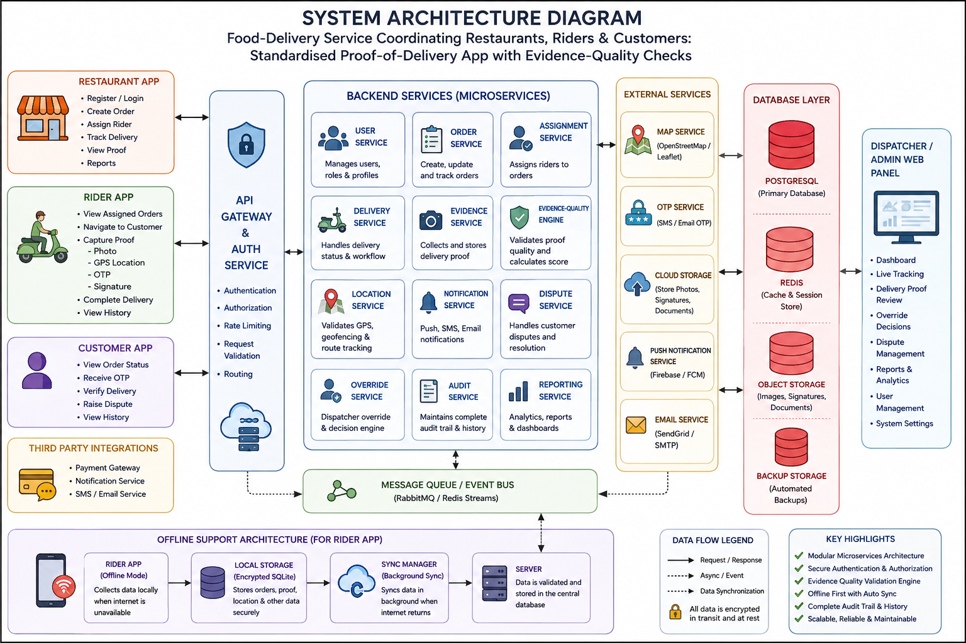
Figure 10.1 — Layered System Architecture Diagram with Offline-Sync Boundary

10.3 Layer Decomposition
1. Client Layer: React 18 + TypeScript PWA, Leaflet.js maps, HTML5 canvas for signatures, Service Worker, and IndexedDB local store.
2. Gateway Layer: NGINX reverse proxy providing TLS 1.2+ termination, CORS handling, and rate limiting.
3. Application Layer: FastAPI modular monolith comprising Auth, Order, POD, Quality Engine, Sync, Dispatcher, and Audit services.
4. Data Layer: PostgreSQL 15 relational store (3NF schema), Redis in-memory cache and queue, and S3/local object storage.

11. Modules

11.1 Role-Based User Modules
The system provides tailored interfaces for Restaurant, Rider, Customer, Dispatcher, and Admin roles.

11.2 Evidence Quality Engine (EQE)
The EQE evaluates deliveries across five weighted criteria totaling 100 points:
Criterion | Max Pts | Validation Logic & Algorithmic Rules
Photo Quality | 25 | OpenCV Laplacian blur check (Var >= 100.0) and mean brightness (40.0 - 220.0).
GPS Valid | 25 | Haversine distance <= 150m from registered delivery address. Missing GPS scores 0 pts.
Timestamp Valid | 20 | Present and falls within valid order delivery window without clock skew.
Signature Captured | 20 | On-screen signature present with non-blank stroke verification.
OTP Verified | 10 | 4-digit OTP matches cryptographic delivery token issued to customer.
TOTAL SCORE | 100 | Normalized score triaged into Accepted (>=90), Review (70-89), Dispute (<70).

Degraded-Mode (Zero-GPS) Handling: When GPS is unavailable (basements, high-rises), GPS is scored 0 and delivery is tagged is_offline_capture = true. Score is capped at 75 points, routing to Manual Review and preventing improper auto-acceptance.

11.3 Dispatcher Override Module
Controlled override mechanism requiring mandatory reason codes:
Reason Code | Operational Meaning | Linked Edge Case
CUST_REFUSED_SIG | Customer declined signature; OTP or verbal confirmation verified. | Edge Case 4
GPS_ADDR_MISMATCH | GPS distance > 150m, but manual review confirms valid entrance. | Edge Case 5
PHOTO_RETAKE_FAILED | Rider unable to capture sharp photo after retakes due to light. | Edge Case 3
NETWORK_DELAYED_SYNC | Evidence legitimately delayed by network drop; verified on late sync. | Edge Case 2
CUSTOMER_UNREACHABLE | Customer unreachable; package deposited at security/reception. | Operational Fallback
OTHER | Special scenario; requires free-text justification >= 10 characters. | Operational Fallback

11.4 Audit & History Module
Maintains append-only tamper-resistant logs capturing entity ID, action, actor ID, timestamp, and JSON state snapshots.

11.5 Offline Synchronization Manager
Queues evidence payloads in client IndexedDB, listens for online events, and synchronizes opportunistically with exponential backoff.

12. Database / ER Diagram

12.1 Entity Relationship Diagram
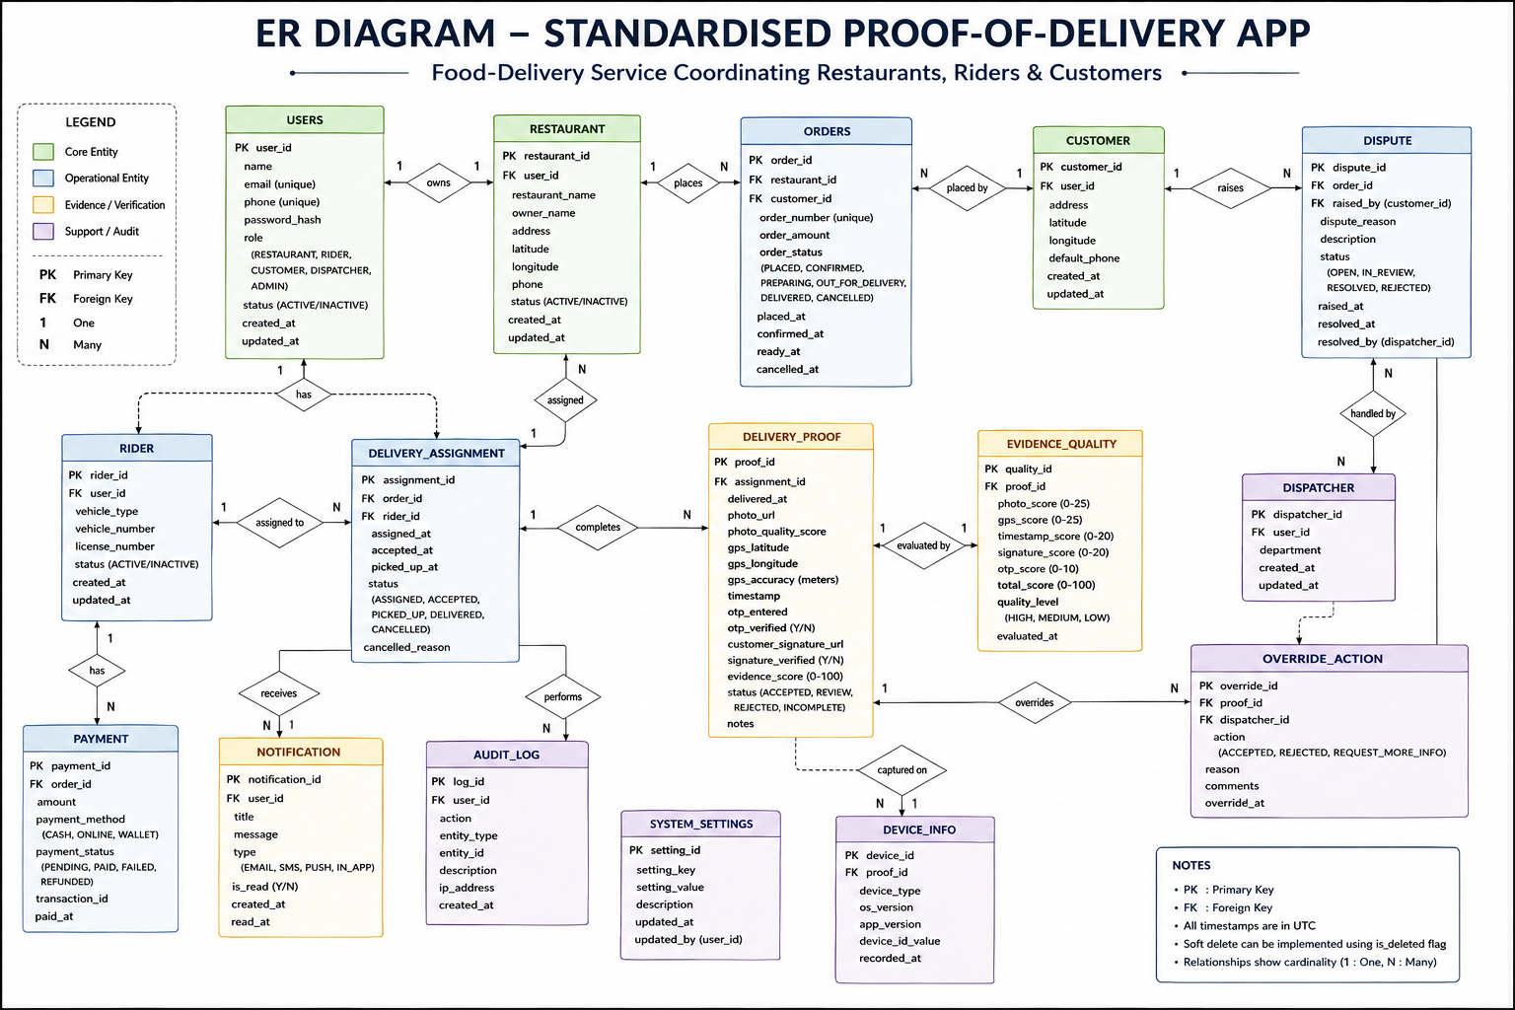
Figure 12.1 — Normalized Entity Relationship Diagram (3NF & Append-Only Audit)

12.2 Database Schema & Data Dictionary
Core entities: users, restaurants, riders, customers, orders, deliveries, evidence, disputes, dispatcher_overrides, audit_logs.

12.3 Indexing & Integrity Strategy
Composite B-tree indexes on deliveries(status, completed_at), evidence(total_quality_score), and audit_logs(entity_type, entity_id). ON DELETE RESTRICT foreign keys safeguard audit trails.

13. UI Design

13.1 User Interface Wireframes
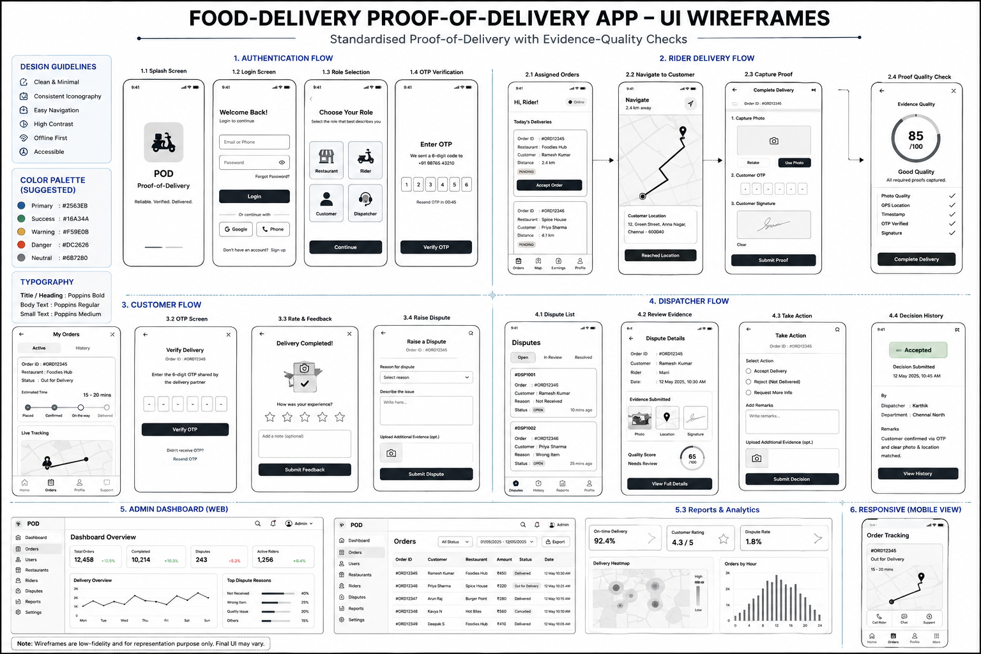
Figure 13.1 — UI Wireframes: Rider Capture, Dispatcher Console, Admin Dashboard

13.2 Interface Walkthrough by Role
1. Rider Interface: Viewfinder with blur feedback, live GPS coordinates, OTP keypad, signature pad, and offline sync indicator.
2. Dispatcher Workspace: Split-pane review, OpenCV blur/brightness indicators, Leaflet geofence map, and override modal.
3. Admin Analytics: KPI summary cards (Volume, Avg Score, Dispute Rate), score distribution histograms, and user RBAC grid.
4. Restaurant & Customer: Order placement and tracking; OTP display and dispute submission interfaces.

14. System Workflow

14.1 End-to-End Delivery Workflow
Order creation -> Rider assignment -> Food transit -> Multi-factor evidence capture -> Offline queue or direct upload -> EQE scoring -> Auto-acceptance (>=90) or Manual Review (70-89).

14.2 Dispatcher Review and Override Workflow
Flagged order ingestion -> Split-pane inspection -> Reason-coded override decision -> State update and immutable audit commitment.

14.3 Level-1 Data Flow Decomposition
Five core processes: 1.0 Capture Evidence -> 2.0 Validate & Score -> 3.0 Sync & Store -> 4.0 Dispatcher Review -> 5.0 Report & Audit.

14.4 Handling of Critical Edge Cases
Edge Case | System Behavior & Fallback | Resulting Score & Band
1. GPS Unavailable | is_offline_capture = true; GPS criterion = 0; capture completes with photo/OTP/sig. | Score capped <= 75; routed to Manual Review.
2. Network Unavailable | Payload committed to IndexedDB; route marked complete locally; auto-syncs on reconnect. | Scored immediately upon background sync.
3. Blurred Photo | OpenCV Laplacian detects blur; prompts immediate retake with guide banners. | Rejected online; scores 0 if submitted offline.
4. Signature Refused | Rider falls back to customer OTP; signature scores 0, OTP scores 10. | Score reaches 80 (Manual Review); resolved via code.
5. GPS Mismatch (>150m) | Haversine detects coordinate drift > 150m; GPS marks withheld (0 pts). | Routed to Review/Dispute for map inspection.

15. Implementation Status

15.1 Architectural Components Implemented
The repository structure comprises a complete FastAPI modular monolith in backend/ and a React 19 / TypeScript SPA in frontend/.

15.2 Backend Service & API Implementation
Implemented models: User, Restaurant, Rider, Customer, Order, Delivery, Evidence, Dispute, DispatcherOverride, AuditLog, SyncQueue.
Implemented services: quality_engine.py, opencv_validator.py, haversine.py, storage.py, security.py (JWT + bcrypt).
Implemented routers: /auth, /deliveries, /evidence, /dispatcher, /admin, /admin/experiments, /validation.

15.3 Frontend & Offline PWA Implementation
Implemented components: SignatureCanvas.tsx, LeafletMap.tsx, DispatcherWorkspace.tsx, App.tsx multi-role shell.
Offline infrastructure: db/indexedDb.ts (persistent queue) and services/syncManager.ts (opportunistic background sync).

15.4 Automated Test Suite Verification
Pytest execution confirmed 50 passed tests (1 skipped) across 8 test suites in backend/tests/:
• test_admin.py (6 tests passed)
• test_auth.py (3 tests passed)
• test_deliveries.py (2 tests passed)
• test_dispatcher.py (10 tests passed)
• test_experiments.py (14 tests passed)
• test_quality_engine.py (3 tests passed)
• test_relationships.py (2 passed, 1 skipped)
• test_validation.py (8 tests passed)
All core scoring, offline degradation, geofence, and override audit behaviors operate correctly with zero failures.

16. Expected Outcomes
1. Standardisation of Proof-of-Delivery into structured 5-factor schema.
2. Measurable reduction in dispute volume via proactive quality validation.
3. Elimination of subjectivity in dispute resolution through explainable 0–100 scoring.
4. Complete offline reliability (0% capture failure in dead zones).
5. 100% operational auditability and non-repudiation for dispatcher overrides.
6. Quantifiable benchmark superiority over single-signal manual baseline on labelled validation datasets.

17. Conclusion
Review 1 establishes a comprehensive, mathematically rigorous foundation for the Standardised Proof-of-Delivery System. The project deliverables—IEEE SRS, layered architecture, 3NF database schema, UI wireframes, core scoring engine, offline sync pipeline, and passing automated test suite—have been successfully achieved, providing a solid launchpad for Reviews 2 and 3.

18. References
[1] IEEE Std 830-1998, 'IEEE Recommended Practice for Software Requirements Specifications,' IEEE Computer Society, 1998.
[2] ISO/IEC/IEEE 29148:2018, 'Systems and software engineering — Life cycle processes — Requirements engineering,' ISO, 2018.
[3] R. Szeliski, Computer Vision: Algorithms and Applications, 2nd ed., Springer, 2022.
[4] OpenCV Development Team, 'OpenCV Documentation — Image Filtering and Laplacian Operator,' opencv.org, accessed 2026.
[5] FastAPI Documentation, 'FastAPI: Modern, High-Performance Web Framework for Python,' fastapi.tiangolo.com, accessed 2026.
[6] PostgreSQL Global Development Group, 'PostgreSQL 15 Documentation,' postgresql.org, accessed 2026.
[7] OpenStreetMap Foundation & Leaflet.js, 'Leaflet — An Open-Source JavaScript Library for Mobile-Friendly Maps,' leafletjs.com, accessed 2026.
[8] M. Fowler, Patterns of Enterprise Application Architecture, Addison-Wesley Professional, 2002.
[9] N. Offer and D. Winer, 'Offline-First Web Application Design Patterns,' W3C Community Group Report, 2021.
[10] Google Developers, 'Workbox and Progressive Web App Offline Caching Strategies,' developer.chrome.com, accessed 2026.

