Software Requirements Specification

Project Title:
Food-Delivery Service Coordinating Restaurants, Riders & Customers: Standardised Proof-of-Delivery App with Evidence-Quality Checks

1. Introduction

1.1 Background
Online food delivery has become one of the largest last-mile logistics operations in the world, coordinating three independent parties — restaurants, riders, and customers — for every single order. The final and most contested step of this chain is delivery confirmation: the moment a platform must decide, often automatically, whether an order was actually delivered. This decision has direct financial consequences (refunds, rider payouts, restaurant liability) and directly affects customer trust.
Most consumer-facing delivery platforms treat proof of delivery as an afterthought: a single photo attached to an order record, with no structured validation of whether that photo, the GPS location, or the OTP/signature actually demonstrate that a valid delivery occurred. As delivery volumes scale into thousands of orders per city per day, even a small percentage of ambiguous or low-quality evidence translates into a large absolute number of disputes that must be resolved manually by support teams.

1.2 Problem Statement
Delivery evidence collected by current food-delivery workflows is inconsistent and unverified at the point of capture. Photos may be blurred, out of frame, or of the wrong location; GPS coordinates may be inaccurate, spoofed, or entirely unavailable in indoor or high-rise environments; OTP or customer signature capture is frequently skipped due to rider time pressure or customer unavailability; and mobile network interruptions during the last mile cause evidence to be lost or never submitted. Because this evidence is accepted without a validation layer, customers and riders both raise disputes that the operations team can only resolve by manually inspecting whatever evidence happens to exist — a slow, inconsistent, and costly process that scales poorly with order volume.

1.3 Objectives
The project has the following objectives:
- Design and prototype a Standardised Proof-of-Delivery (POD) system that captures five evidence types (photo, GPS, timestamp, OTP, signature) for every delivery in a consistent, structured format.
- Implement an Evidence Quality Engine that automatically scores captured evidence using explicit, explainable weighted criteria, and classifies each delivery as Accepted, Needs Manual Review, or Dispute.
- Ensure the evidence-capture workflow degrades gracefully and remains fully functional when GPS is unavailable, when the network is unavailable, or when sensor data is incomplete, by persisting evidence locally and syncing automatically on reconnect.
- Provide a Dispatcher Override capability so a human operator can resolve edge cases with a mandatory, logged reason, without bypassing the audit trail.
- Maintain a complete, immutable audit history of every delivery, evidence submission, quality score, and override decision.
- Benchmark the system against a manual/baseline delivery-confirmation approach on a labelled validation dataset covering normal and edge-case scenarios, and report measurable accuracy, dispute-reduction, and performance metrics.
- Produce industry-standard project documentation — SRS, architecture, ER model, wireframes — and a working, demonstrable prototype with an admin analytics dashboard.

1.4 Scope
The prototype covers five role-based modules — Restaurant, Rider, Customer, Dispatcher, and Admin — built as a web application (React/TypeScript frontend, FastAPI/Python backend, PostgreSQL database). It includes order creation and rider assignment, evidence capture (photo, GPS, OTP, signature) with offline queuing and background sync, an automated Evidence Quality Engine using OpenCV-based image checks, a dispatcher override workflow, an audit history, and an admin dashboard with delivery analytics.
The following are explicitly out of scope for this academic prototype: production-grade payment processing and settlement, a live rider-facing native mobile app (a responsive/offline-capable web app is used as a stand-in and clearly documented as such), large-scale multi-city routing/dispatch optimisation, and integration with a real third-party SMS gateway (a mock/sandbox OTP provider is used). These are noted as Future Scope in Section 22.

1.5 Stakeholders
Stakeholder | Interest / Role
Restaurant Partner | Creates orders, tracks fulfilment status, is protected from unfair delivery-failure liability.
Rider / Delivery Executive | Captures delivery evidence; benefits from fair, defensible evidence standards and offline reliability.
Customer | Receives OTP, verifies delivery, raises disputes when a delivery is not received or is incorrect.
Dispatcher / Operations Team | Reviews flagged deliveries, resolves disputes, issues overrides with documented reasons.
Platform Admin / Management | Monitors delivery quality analytics, dispute volume, and rider/region performance via the dashboard.
Project Guide / Evaluators | Assess technical depth, correctness, and completeness of the prototype against academic and industry benchmarks.

1.6 Existing System
Current mainstream food-delivery platforms typically mark an order “delivered” based on a rider tapping a status button, optionally attaching a single photo. GPS is logged for tracking purposes but rarely validated against the delivery address at the moment of confirmation. OTP is used inconsistently, and signature capture is largely absent in food delivery (more common in parcel/courier systems). When a customer disputes a delivery, a support agent manually opens the order, looks at whatever photo exists, and makes a subjective accept/reject call — there is no scoring, no consistent evidence bar, and no structured record of why a particular decision was made.

1.7 Limitations of the Existing System
- No automated quality check on delivery photos — blurred or irrelevant images are accepted as valid proof.
- GPS accuracy and address match are not verified at the point of delivery confirmation.
- No standardised, weighted scoring of evidence; decisions are subjective and vary by agent.
- Poor offline behaviour — evidence capture or submission commonly fails outright when network connectivity drops.
- No systematic audit trail linking a delivery's final status to the specific evidence and decision-maker responsible.
- Dispute resolution is reactive and manual, with no data-driven flag raised before the customer complains.

1.8 Proposed System
The proposed Standardised Proof-of-Delivery system converts delivery confirmation from a single unverified action into a structured, evidence-scored decision. At the moment of delivery, the rider app captures all five evidence types in a fixed schema; the Evidence Quality Engine immediately computes a 0–100 score using explicit weighted rules (Section 15) and classifies the delivery as Accepted, Needs Manual Review, or Dispute — before the customer or restaurant ever has to raise a complaint for many cases. The entire capture pipeline is offline-first: evidence is written to local storage first and synced to the backend opportunistically, so riders in low-connectivity areas are never blocked from completing a delivery. Every automated decision and every dispatcher override is written to an append-only audit log, giving operations a defensible record for every delivery.

1.9 Advantages of the Proposed System
- Objective, explainable, and consistent evidence scoring instead of subjective manual judgement.
- Fewer disputes reach human agents, because low-quality evidence is caught and flagged automatically, often before the customer notices.
- Reliable operation without GPS or network connectivity, through offline capture and automatic background sync.
- Faster, better-informed dispatcher decisions, since flagged deliveries arrive pre-scored with the specific evidence gap already identified.
- Full auditability: every delivery status can be traced back to the evidence, the score, and (if applicable) the human override and reason.
- A reusable, extensible scoring framework that can absorb new evidence types (e.g. video, biometric) without re-architecting the system.

2. Functional Requirements
Functional requirements define the specific behaviours the system must exhibit. Each requirement is uniquely identified (FR-xx), grouped by module, and independently testable; corresponding test cases are provided in Section 24.
ID | Module | Requirement
FR-01 | Restaurant Module | The system shall allow a restaurant to create a new order with items, customer address, and expected pickup time.
FR-02 | Restaurant Module | The system shall allow a restaurant/dispatcher to assign an available rider to an order.
FR-03 | Restaurant Module | The system shall allow a restaurant to track real-time order and delivery status.
FR-04 | Rider Module | The system shall allow a rider to accept or reject an assigned delivery within a configurable time window.
FR-05 | Rider Module | The system shall allow a rider to capture a delivery photo using the device camera at the point of delivery.
FR-06 | Rider Module | The system shall capture device GPS coordinates and accuracy radius at the moment of evidence capture.
FR-07 | Rider Module | The system shall allow a rider to input a customer-provided OTP for delivery verification.
FR-08 | Rider Module | The system shall allow a rider to capture a customer signature on-screen when OTP is not available.
FR-09 | Rider Module | The system shall allow a rider to mark a delivery as Complete only after minimum required evidence is captured or an offline override reason is recorded.
FR-10 | Customer Module | The system shall send a one-time password (OTP) to the customer prior to delivery.
FR-11 | Customer Module | The system shall allow a customer to verify/confirm delivery receipt through the customer app.
FR-12 | Customer Module | The system shall allow a customer to raise a dispute against a delivery, with a reason and optional supporting note.
FR-13 | Evidence Engine | The system shall compute an Evidence Quality Score (0–100) for every delivery using the weighted rules defined in Section 15.
FR-14 | Evidence Engine | The system shall automatically classify a delivery as Accepted (≥90), Needs Manual Review (70–89), or Dispute (<70) based on the computed score.
FR-15 | Evidence Engine | The system shall reject a delivery photo that fails a blur/quality check and prompt the rider to retake it before allowing submission (when online).
FR-16 | Offline Handling | The system shall persist captured evidence locally on the rider device when network connectivity is unavailable.
FR-17 | Offline Handling | The system shall automatically synchronise locally stored evidence to the backend once connectivity is restored, without rider intervention.
FR-18 | Offline Handling | The system shall flag any evidence captured without GPS as “Offline/Reduced-Accuracy” and apply the corresponding score reduction.
FR-19 | Dispatcher Module | The system shall present dispatchers with a queue of deliveries flagged for Manual Review or Dispute, ordered by score and age.
FR-20 | Dispatcher Module | The system shall require a dispatcher to select/enter a reason code when overriding an automated delivery decision.
FR-21 | Dispatcher Module | The system shall notify the affected rider and/or customer when a dispatcher override changes a delivery's status.
FR-22 | Audit & History | The system shall record an immutable audit-log entry for every order creation, evidence submission, score computation, status change, and override.
FR-23 | Audit & History | The system shall allow authorised users to view the complete history of a delivery, including all evidence versions and decisions.
FR-24 | Admin Module | The system shall provide an admin dashboard showing delivery volume, average evidence score, dispute rate, and rider/region performance.
FR-25 | Admin Module | The system shall allow the admin to manage user accounts and role assignments (Restaurant, Rider, Customer, Dispatcher, Admin).
FR-26 | Reporting | The system shall allow export of delivery and dispute reports for a selected date range.

3. Non-Functional Requirements
ID | Category | Requirement
NFR-01 | Performance | Evidence Quality Engine shall compute a score within 2 seconds of receiving complete evidence, under normal load (≤100 concurrent requests).
NFR-02 | Availability | The evidence-capture path on the rider app shall function with zero network connectivity (offline-first), targeting 99.5% capture success regardless of connectivity.
NFR-03 | Reliability | Locally queued offline evidence shall not be lost across an app restart or device reboot prior to successful sync.
NFR-04 | Scalability | The backend API shall be designed to horizontally scale to support at least 10,000 deliveries/day in a simulated load test.
NFR-05 | Usability | A rider with no prior training shall be able to complete the evidence-capture flow for a delivery in under 60 seconds under normal conditions.
NFR-06 | Security | All API traffic shall be encrypted in transit (TLS 1.2+); passwords shall be stored using a salted hash (bcrypt/argon2).
NFR-07 | Data Integrity | Audit-log entries shall be append-only; no API endpoint shall permit update or delete of a historical audit record.
NFR-08 | Maintainability | Backend services shall follow a modular, layered architecture (Section 17) to allow independent modification of the Evidence Quality Engine without affecting Order or Auth services.
NFR-09 | Portability | The rider web app shall be installable as a Progressive Web App (PWA) and function on both Android and iOS mobile browsers.
NFR-10 | Compliance | Personally identifiable customer data (address, phone) shall be access-controlled by role (RBAC) and excluded from public analytics exports.

4. Business Rules
- BR-01: A delivery cannot be marked Complete without at least a photo and either an OTP or a signature, unless captured under a system-recognised offline/degraded-evidence path.
- BR-02: An Evidence Quality Score ≥90 results in automatic acceptance; no dispatcher action is required or permitted to reverse an auto-acceptance without opening a formal dispute.
- BR-03: A score between 70 and 89 is routed to the Dispatcher Manual Review queue and may not be left unresolved for more than 24 hours (SLA).
- BR-04: A score below 70 automatically opens a Dispute record and notifies the customer and dispatcher.
- BR-05: Every dispatcher override must include a reason code selected from a controlled list (Section 19) or a free-text justification of at least 10 characters.
- BR-06: OTP is valid for a single delivery attempt and expires after 15 minutes or upon successful verification, whichever occurs first.
- BR-07: A rider may not be assigned a new delivery while a previous delivery's evidence sync is still pending beyond a configurable retry limit, to prevent evidence loss.
- BR-08: GPS coordinates captured more than 150 metres from the registered delivery address are automatically flagged as a location mismatch for review.
- BR-09: Audit records, once written, are immutable; corrections are made via new compensating entries, never by editing history.

5. User Stories
ID | Actor | User Story | Linked FR
US-01 | Rider | As a rider, I want to capture delivery evidence even without internet, so that I am not blocked from completing my route. | FR-16, FR-17
US-02 | Rider | As a rider, I want to know immediately if my delivery photo is too blurred, so that I can retake it before leaving the location. | FR-15
US-03 | Customer | As a customer, I want to confirm my delivery with an OTP, so that no one else can falsely claim my order was delivered. | FR-10, FR-11
US-04 | Customer | As a customer, I want to raise a dispute easily if I did not receive my order, so that I get a fair resolution. | FR-12
US-05 | Dispatcher | As a dispatcher, I want a prioritised queue of flagged deliveries with the exact evidence gap shown, so that I can resolve issues quickly. | FR-19
US-06 | Dispatcher | As a dispatcher, I want to be required to give a reason for every override, so that my decisions are accountable and auditable. | FR-20, BR-05
US-07 | Restaurant | As a restaurant owner, I want to see delivery status and evidence quality trends, so that I can identify problem riders or routes. | FR-03, FR-24
US-08 | Admin | As an admin, I want a dashboard of dispute rates and average evidence scores by region, so that I can monitor operational health. | FR-24

6. Use Cases
The complete actor/use-case map is shown in the Use Case Diagram (Section 8). Two representative use cases central to the system's value proposition are detailed below in full flow form; the remaining use cases (Create Order, Assign Rider, Verify Delivery, Raise Dispute, View Dashboard, Sync Offline Data) follow the same template and are documented in the project's supplementary use-case catalogue.

UC-05 — Capture and Submit Delivery Evidence
Field | Description
Actor | Rider
Preconditions | Rider has an accepted delivery assigned; rider has arrived at the delivery location.
Main Flow | 1. Rider opens the active delivery in the Rider App. 2. Rider captures a delivery photo via the in-app camera. 3. App attempts to read device GPS; if available, coordinates and accuracy are captured. 4. Rider enters the OTP provided by the customer, or captures a signature if OTP is unavailable. 5. Rider taps “Complete Delivery.” 6. If online, evidence is submitted immediately to the POD Service and scored by the Evidence Quality Engine. 7. If offline, evidence is queued in local storage and marked Pending Sync.
Postconditions | Delivery evidence is recorded (locally or on the server) and, once synced, scored and classified.
Alternate / Exception Flows | 3a. GPS unavailable: system proceeds with photo/OTP/signature only and flags the record Offline/Reduced-Accuracy (Section 20). 4a. Photo fails blur check (online only): rider is prompted to retake before submission is accepted.

UC-11 — Dispatcher Override of Delivery Decision
Field | Description
Actor | Dispatcher
Preconditions | A delivery has been auto-flagged for Manual Review or Dispute.
Main Flow | 1. Dispatcher opens the Manual Review / Dispute queue. 2. Dispatcher selects a flagged delivery and reviews the captured evidence and computed score. 3. Dispatcher selects a decision (Accept, Reject, Request Re-delivery) and a mandatory reason code. 4. System records the override against the delivery and writes an audit-log entry. 5. System notifies the affected rider and/or customer of the updated status.
Postconditions | The delivery's final status reflects the dispatcher's decision, and the override is permanently linked to the original evidence and score.
Alternate / Exception Flows | 3a. Dispatcher chooses “Other” reason: system requires a free-text justification of at least 10 characters before allowing submission.

7. Use Case Diagram
The diagram below maps each actor to the use cases they participate in, consistent with the module breakdown in the project scope.
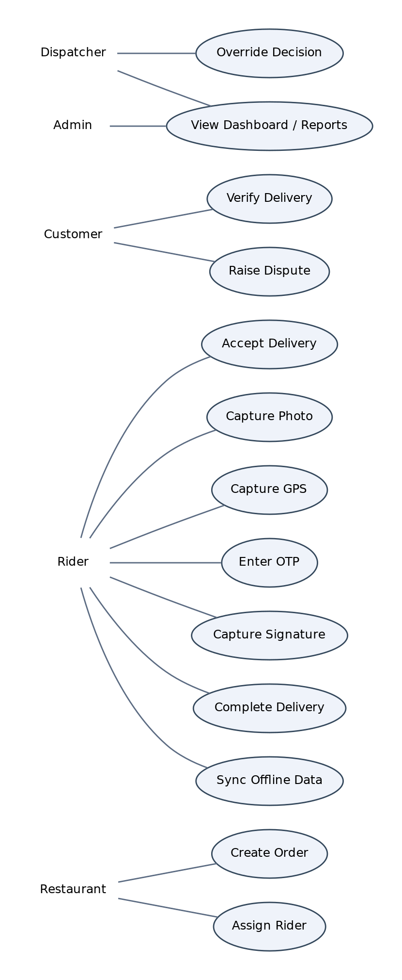
Figure 7.1 — Use Case Diagram: Restaurant, Rider, Customer, Dispatcher, and Admin actors

8. Activity Diagram
The activity diagram traces a single delivery from arrival at the location through evidence capture, automated scoring, and either auto-acceptance or dispatcher resolution — including the offline branch.
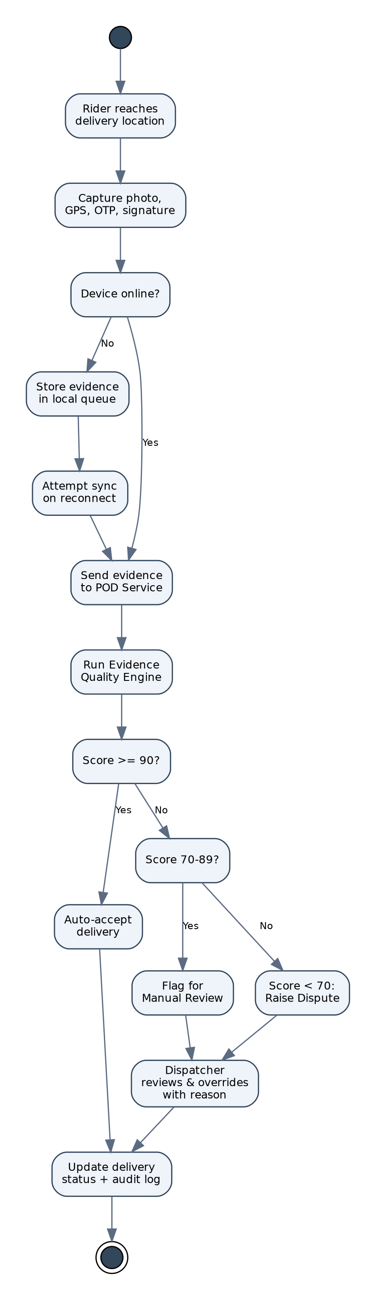
Figure 8.1 — Activity Diagram: Evidence Capture and Quality Scoring Flow

9. Sequence Diagram
The sequence diagram illustrates the interaction between the Rider App, local offline storage, the POD Service, the Evidence Quality Engine, the database, and the notification service during evidence capture and sync.
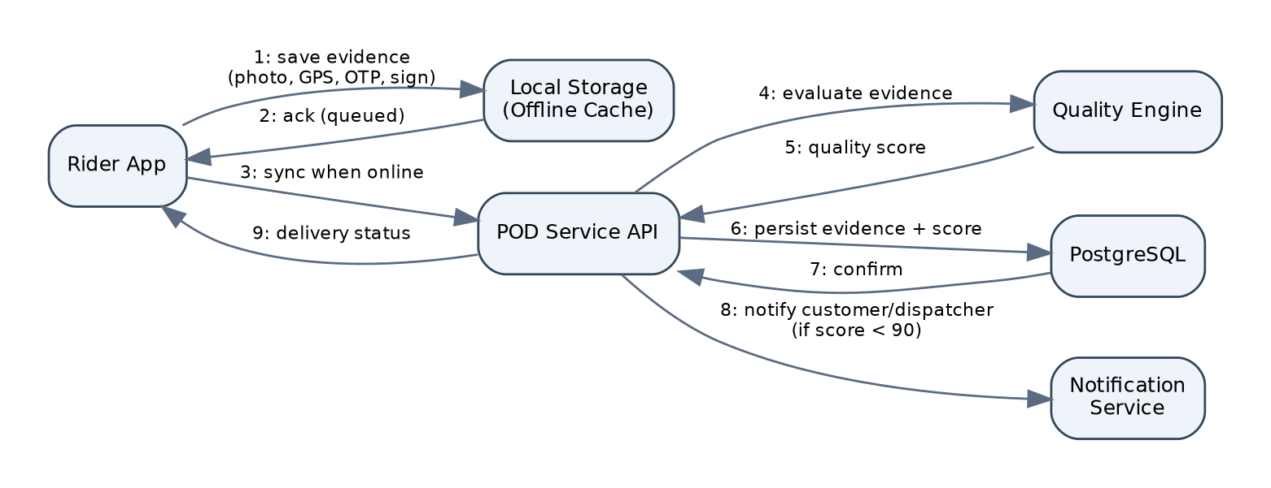
Figure 9.1 — Sequence Diagram: Evidence Capture, Sync, and Scoring

10. Data Flow Diagram (Level 1)
The Level-1 DFD decomposes the system into five core processes — Capture Evidence, Validate Quality, Sync & Store, Dispatcher Review, and Generate Reports — and their interaction with external entities and data stores.
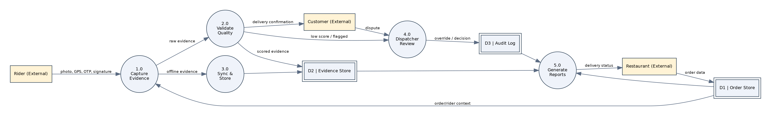
Figure 10.1 — Level 1 Data Flow Diagram

11. ER Diagram
The entity-relationship model below reflects the database design detailed in Section 18. Core entities are User (with role-specific extensions Rider, Customer, and Restaurant-owner), Order, Delivery, Evidence, Dispute, DispatcherOverride, and AuditLog.
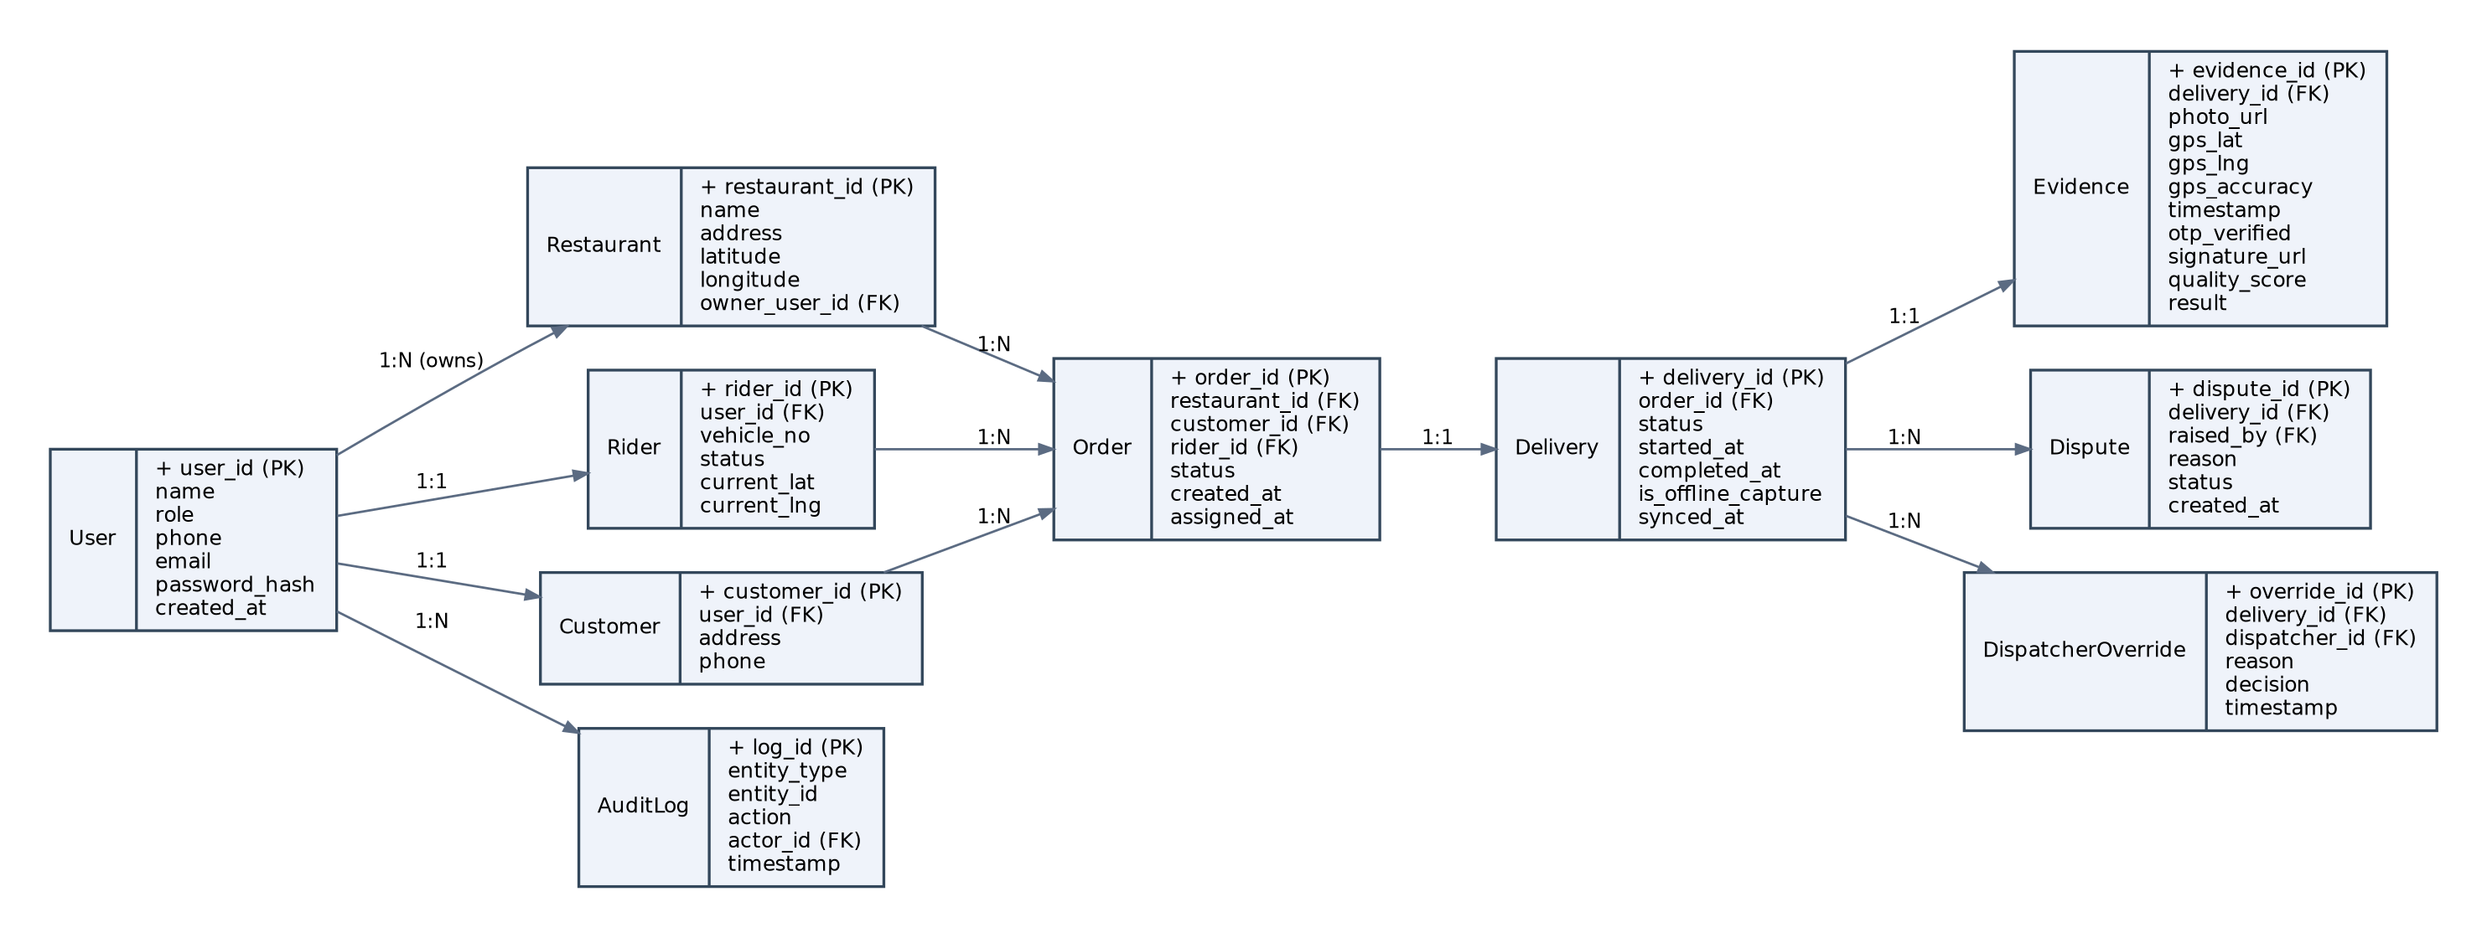
Figure 11.1 — Entity Relationship Diagram

12. System Architecture
The system follows a layered client–server architecture with an explicit offline-sync boundary at the client edge. The Client Layer hosts four role-based single-page applications sharing common components. Requests pass through an API Gateway (NGINX) providing TLS termination and rate limiting, into a FastAPI Application Layer composed of independently deployable services: Auth, Order, POD (evidence capture), Evidence Quality Engine, Offline Sync, Dispatcher/Dispute, and Notification. The Data Layer separates structured relational data (PostgreSQL), binary evidence (Object Storage for photos/signatures), and ephemeral session/queue state (Redis).
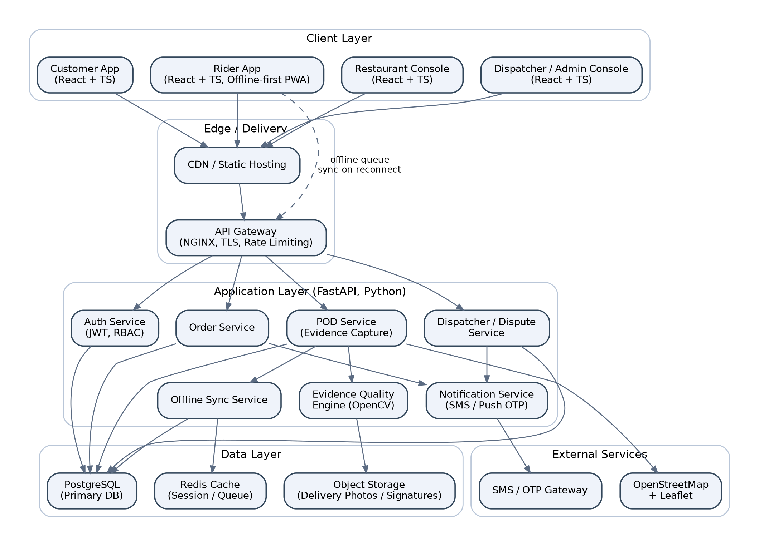
Figure 12.1 — System Architecture Diagram

12.1 Architectural Style
The backend is organised as a modular monolith exposing internally decoupled service modules behind a single FastAPI application — a deliberate choice for a Semester 5 prototype, since it keeps deployment simple while preserving clean module boundaries (Auth, Order, POD, Quality Engine, Sync, Dispatch, Notification) that could be extracted into independent microservices in a production evolution without redesigning the domain model.

12.2 Offline-First Design
The Rider App is built as an offline-first Progressive Web App. All evidence-capture writes go to a local IndexedDB-backed queue first; a background Sync Manager retries submission to the POD Service using exponential backoff whenever connectivity is detected, and reconciles server-assigned IDs back into local state. This ensures the rider's workflow is never blocked by network state, directly satisfying the college requirement that the system work without GPS, without internet, and with incomplete sensor data.

13. Technology Stack
Layer | Technology / Tooling
Frontend | React 18 + TypeScript, Vite build tooling, Tailwind CSS for styling, PWA (service workers + IndexedDB) for offline support
Backend | Python 3.11, FastAPI, Pydantic for schema validation, Uvicorn/Gunicorn ASGI server
Database | PostgreSQL 15 (primary relational store), Redis (cache / offline-sync queue)
Object Storage | S3-compatible storage (e.g. MinIO for local dev) for delivery photos and signature images
Maps & Geolocation | OpenStreetMap tile data with Leaflet.js for map rendering and distance/geofence checks
Image Validation | OpenCV (Python) — Laplacian-variance blur detection, brightness/contrast checks, basic content sanity checks
Authentication | JWT-based auth with role-based access control (RBAC) for the five user roles
Dashboard / Analytics | Chart.js (embedded in the Admin console) with optional Power BI export for extended reporting
Testing | Pytest (backend unit/integration), React Testing Library + Vitest (frontend), Postman/Newman (API contract tests)
DevOps | Docker & Docker Compose for local orchestration, GitHub Actions for CI (lint, test, build)

14. Database Design
The schema is normalised to Third Normal Form (3NF) for transactional tables; the append-only audit_logs table is intentionally denormalised (storing a JSON payload snapshot) to preserve historical accuracy even if referenced entities later change. Referential integrity is enforced via foreign keys with ON DELETE RESTRICT on evidence and audit-related tables to guarantee no delivery record can silently lose its evidence trail.
Table | Key Columns
users | user_id (PK), name, email, phone, password_hash, role, created_at
restaurants | restaurant_id (PK), name, address, latitude, longitude, owner_user_id (FK→users)
riders | rider_id (PK), user_id (FK→users), vehicle_no, status, current_lat, current_lng
customers | customer_id (PK), user_id (FK→users), address, phone
orders | order_id (PK), restaurant_id (FK), customer_id (FK), rider_id (FK, nullable), status, created_at, assigned_at
deliveries | delivery_id (PK), order_id (FK, unique), status, started_at, completed_at, is_offline_capture, synced_at
evidence | evidence_id (PK), delivery_id (FK, unique), photo_url, gps_lat, gps_lng, gps_accuracy, captured_at, otp_verified (bool), signature_url, quality_score, result_enum
disputes | dispute_id (PK), delivery_id (FK), raised_by (FK→users), reason, status, created_at, resolved_at
dispatcher_overrides | override_id (PK), delivery_id (FK), dispatcher_id (FK→users), reason_code, justification_text, decision, timestamp
audit_logs | log_id (PK), entity_type, entity_id, action, actor_id (FK→users), payload_json, timestamp

14.1 Indexing Strategy
- Composite index on deliveries(status, completed_at) to accelerate the dispatcher review queue.
- Index on evidence(quality_score) to support score-based filtering and analytics.
- Index on audit_logs(entity_type, entity_id) for fast history lookups per delivery/order.
- Geospatial index (PostGIS or lat/lng composite) on evidence(gps_lat, gps_lng) to support mismatch-distance queries (BR-08).

15. API Design
The backend exposes a versioned RESTful API (/api/v1) using JSON payloads validated against Pydantic schemas. All endpoints (other than login) require a Bearer JWT and are protected by role-based access control. Error responses follow a consistent envelope: {"error_code": string, "message": string, "details": object}. Idempotency keys are required on evidence-submission endpoints so that offline-sync retries cannot create duplicate evidence records.
Method | Endpoint | Description | Access
POST | /api/v1/auth/login | Authenticate a user and issue a JWT. | Public
POST | /api/v1/orders | Create a new order (restaurant). | Restaurant
PATCH | /api/v1/orders/{id}/assign | Assign a rider to an order. | Restaurant, Dispatcher
GET | /api/v1/orders/{id} | Retrieve order and delivery status. | Restaurant, Customer, Dispatcher, Admin
POST | /api/v1/deliveries/{id}/evidence | Submit captured evidence (photo, GPS, OTP/signature); triggers scoring. | Rider
POST | /api/v1/deliveries/{id}/evidence/sync | Bulk-sync locally queued offline evidence records. | Rider
GET | /api/v1/deliveries/{id}/score | Retrieve the computed Evidence Quality Score and classification. | Rider, Dispatcher, Admin
POST | /api/v1/customers/{id}/verify-otp | Verify a customer-entered OTP against the delivery record. | Customer
POST | /api/v1/disputes | Raise a delivery dispute. | Customer
GET | /api/v1/dispatcher/queue | Retrieve the prioritised Manual Review / Dispute queue. | Dispatcher
POST | /api/v1/dispatcher/overrides | Submit a dispatcher override decision with a reason code. | Dispatcher
GET | /api/v1/deliveries/{id}/history | Retrieve the full audit history of a delivery. | Dispatcher, Admin
GET | /api/v1/admin/analytics | Retrieve aggregate dashboard metrics (volume, avg. score, dispute rate). | Admin

16. Security Requirements
- All client–server communication shall use TLS 1.2 or higher; no evidence (photo, GPS, OTP, signature) shall ever be transmitted unencrypted.
- Authentication shall use short-lived JWT access tokens with refresh tokens; passwords are stored using bcrypt with a per-user salt.
- Role-Based Access Control (RBAC) shall restrict every endpoint to the roles listed in Section 15's API table; the backend re-validates role on every request (never trusts the client).
- OTPs shall be single-use, expire after 15 minutes, and be rate-limited to prevent brute-force guessing (BR-06).
- Evidence photos and signatures shall be stored in access-controlled object storage with signed, time-limited URLs — never public buckets.
- Audit-log entries shall be write-once (append-only) at the database-permission level, not just the application level, so a compromised application role cannot rewrite history.
- Personally identifiable information (customer address, phone) shall be excluded from analytics/export endpoints available to the Admin dashboard's aggregate views.
- Input validation (Pydantic schemas) and parameterised queries (ORM) shall be used throughout to prevent injection attacks; file uploads are type- and size-validated before processing by the Evidence Quality Engine.

17. Offline Strategy
Offline capability is a core, non-negotiable design requirement rather than an add-on, because riders routinely operate in basements, elevators, indoor malls, and network dead zones.

17.1 Local-First Capture
The Rider App writes every captured evidence item (photo blob, GPS reading if available, OTP entry, signature stroke data) to an IndexedDB-backed local queue immediately, before any network call is attempted. The UI never blocks on network availability — “Complete Delivery” succeeds locally even at zero connectivity.

17.2 Background Sync
A Sync Manager listens for connectivity changes (the browser's online event and periodic polling as a fallback) and drains the local queue against the /evidence/sync endpoint using exponential backoff with jitter, capped retries, and idempotency keys to prevent duplicate submissions on retry.

17.3 Degraded-Mode Scoring
Evidence captured without GPS, or synced significantly later than capture time, is tagged is_offline_capture = true. The Evidence Quality Engine (Section 18) applies the documented reduced-score treatment for missing GPS rather than rejecting the delivery outright, ensuring riders are never penalised for infrastructure outside their control while still surfacing the reduced confidence to dispatchers.

17.4 Conflict Handling
Because evidence is 1:1 with a delivery, sync conflicts are limited to duplicate-submission scenarios, resolved by idempotency key; no merge logic is required. Local records are only purged after a signed server acknowledgement is received and stored.

18. Evidence Quality Engine
The Evidence Quality Engine (EQE) is the core innovation of the project: instead of accepting a photo as unexamined “proof,” it computes a transparent, rule-based 0–100 score from the five evidence signals, so every delivery decision is explainable and reproducible.

18.1 Scoring Rubric
Criterion | Max Marks | Validation Logic
Photo Available & Passes Quality Check | 25 | Photo present, resolution above threshold, Laplacian-variance blur score above threshold, brightness within acceptable range.
GPS Valid | 25 | GPS reading present, accuracy radius within tolerance, and distance to registered delivery address within the geofence threshold (BR-08).
Timestamp Valid | 20 | Capture timestamp present and falls within the expected delivery window (not clock-skewed or backdated).
Signature Captured | 20 | A customer signature was captured and passes a minimal stroke-count / non-blank check.
OTP Verified | 10 | The OTP entered by the rider matches the OTP issued to the customer for this delivery.

18.2 Classification Thresholds
Score Range | Outcome
90 – 100 | Delivery Accepted automatically; no human action required.
70 – 89 | Routed to Dispatcher Manual Review queue (BR-03, 24-hour SLA).
Below 70 | Automatically flagged as a Dispute and routed to the dispatcher and customer (BR-04).

18.3 Photo Quality Validation (OpenCV)
Blur is detected using the variance of the Laplacian of the greyscale image; a variance below an empirically tuned threshold is classified as blurred and, when the rider is online, triggers an immediate retake prompt rather than accepting a low-quality photo into the score (FR-15). Brightness is checked via mean pixel intensity to reject severely under/over-exposed images. These are deliberately simple, explainable classical computer-vision checks rather than a opaque deep-learning classifier, so that a dispatcher (or evaluator) can understand exactly why a photo failed.

18.4 GPS Validation
The captured coordinates are compared against the registered delivery address using the Haversine distance formula; a distance beyond 150 metres (BR-08) is flagged as a location mismatch and the GPS criterion's marks are withheld even if a GPS reading was technically present, since a wrong-location reading is worse than no reading in terms of evidentiary value.

18.5 Degraded / Offline Evidence
When GPS is unavailable, the GPS criterion (25 marks) is scored as zero and the delivery is tagged Offline/Reduced-Accuracy; this alone caps the maximum achievable score at 75, which correctly routes such deliveries into the Manual Review band rather than silently auto-accepting an under-verified delivery — directly implementing Edge Case 1.

19. Dispatcher Override
Not every delivery fits the automated rubric — a customer may legitimately refuse a signature, or GPS may be technically “valid” but wrong due to a building's address mapping. The Dispatcher Override module gives a trained human the final word, without weakening accountability.

19.1 Override Workflow
- A flagged delivery appears in the Dispatcher queue with its score, the specific criteria that failed, and the raw evidence for review.
- The dispatcher selects a decision: Accept Delivery, Reject / Confirm Dispute, or Request Re-delivery.
- The dispatcher must select a reason code (see table below) or provide a free-text justification of at least 10 characters (BR-05).
- The override is written to the delivery record and to the immutable audit log, and the rider/customer are notified.

19.2 Standard Reason Codes
Code | Meaning
CUST_REFUSED_SIG | Customer declined to sign; OTP or verbal confirmation used instead (Edge Case 4).
GPS_ADDR_MISMATCH | GPS flagged a mismatch but manual review confirms correct delivery location (Edge Case 5).
PHOTO_RETAKE_FAILED | Rider unable to capture an acceptable photo after retries (e.g. low light).
NETWORK_DELAYED_SYNC | Evidence legitimately delayed by connectivity; verified valid on late sync.
CUSTOMER_UNREACHABLE | Customer did not respond to OTP or app verification within the delivery window.
OTHER | Free-text justification required (minimum 10 characters).

20. Audit History
Every state-changing action in the system — order creation, rider assignment, evidence submission (including each offline-then-synced version), score computation, automatic classification, dispatcher override, and dispute resolution — is written as an immutable, timestamped entry to the audit_logs table (Section 14), keyed to the relevant entity and the acting user.
The audit trail directly satisfies the college requirement to “maintain complete history” and gives the Dispatcher/Admin modules a single reconstructable timeline per delivery: what evidence existed at what time, what score it produced, and who (human or system) made the final call and why. Because entries are append-only, the audit history also protects the platform and riders in downstream legal or payment disputes, since it cannot be retroactively altered.

21. Validation Dataset
To evaluate the Evidence Quality Engine objectively, the project constructs a labelled validation dataset of simulated delivery-evidence records spanning both normal and edge-case conditions, each independently labelled by the project team with an expected ground-truth outcome (Accept / Manual Review / Dispute).
Category | Description | Approx. Sample Size
Normal / Complete Evidence | All five evidence types present and valid. | 40 records
GPS Unavailable (Edge Case 1) | Photo, OTP/signature present; GPS missing. | 20 records
Network Unavailable (Edge Case 2) | Evidence captured offline and synced later. | 15 records
Blurred Image (Edge Case 3) | Deliberately blurred/low-quality photos. | 15 records
Signature Refused (Edge Case 4) | No signature; OTP-only verification. | 15 records
GPS Mismatch (Edge Case 5) | GPS present but >150 m from delivery address. | 15 records
The dataset is used in Section 22–23 to measure the EQE's classification accuracy against the human-labelled ground truth and against a naive manual baseline (a reviewer given only the photo, as in the existing system).

22. Testing Strategy
Testing is organised into four layers, each targeting a different class of defect, and is designed to produce the measurable experiments required by the college evaluation.

22.1 Unit Testing
Pytest covers the Evidence Quality Engine's scoring functions (blur detection, GPS distance, timestamp validity) in isolation with synthetic inputs, and the frontend's evidence-capture components are covered with React Testing Library / Vitest.

22.2 Integration Testing
API contract tests (Postman/Newman) validate each endpoint in Section 15 against expected request/response schemas, authentication, and RBAC enforcement, including negative cases (wrong role, missing fields, expired OTP).

22.3 Edge-Case / Scenario Testing
Each of the five required edge cases (Section 23) is executed as an explicit scenario test against the validation dataset (Section 21), and the system's automated classification is compared to the labelled ground truth to compute precision, recall, and F1 per class (Accept / Manual Review / Dispute).

22.4 Baseline Comparison Experiment
As required by the college evaluation, the EQE's classification is benchmarked against an existing-system baseline: a human reviewer given only the delivery photo (simulating current-industry practice, Section 1.6) makes an accept/reject call on the same validation dataset. The comparison measures (a) agreement rate with ground truth, (b) average decision time, and (c) the percentage of cases where the baseline reviewer's photo-only judgement would have wrongly accepted evidence that the EQE correctly flagged (e.g. GPS-mismatched deliveries), demonstrating the measurable value of multi-signal, weighted scoring over single-signal manual review.

22.5 Performance Testing
Locust or k6 is used to simulate concurrent evidence-submission load against NFR-01 and NFR-04, measuring p95 scoring latency and throughput up to the target of 10,000 simulated daily deliveries.

23. Test Cases
The following representative test cases map directly to the five required edge cases and to the core functional and non-functional requirements; the full test suite is maintained alongside the codebase.
ID | Scenario | Input | Expected Result | Ref.
TC-01 | Complete valid evidence submitted online | Photo (sharp), GPS (accurate, on-address), timestamp (current), OTP (correct) | Score ≥ 90; status = Accepted | FR-13, FR-14
TC-02 | GPS unavailable at capture | Photo (sharp), GPS = null, OTP (correct) | GPS criterion scored 0; total score capped ≤ 75; status = Needs Manual Review; is_offline_capture = true | FR-18, Edge Case 1
TC-03 | Network unavailable during capture | Full evidence captured with device offline | Evidence stored in local queue; status Pending Sync; auto-submitted and scored once connectivity restored | FR-16, FR-17, Edge Case 2
TC-04 | Blurred delivery photo submitted online | Photo with Laplacian variance below threshold | System rejects photo and prompts retake before allowing submission | FR-15, Edge Case 3
TC-05 | Customer refuses signature | No signature; OTP entered and verified | Signature criterion scored 0; OTP criterion scored 10; delivery routed per resulting score; dispatcher notified | FR-08, FR-21, Edge Case 4
TC-06 | GPS present but 300 m from delivery address | GPS reading valid but outside 150 m geofence | GPS criterion scored 0 (mismatch flag); delivery flagged for evidence review | BR-08, Edge Case 5
TC-07 | Dispatcher override without reason code | Override submitted with empty reason field | API rejects request with 422 validation error | BR-05, FR-20
TC-08 | Duplicate offline-sync submission (retry) | Same evidence record submitted twice with identical idempotency key | Second submission is a no-op; no duplicate evidence row created | FR-17, NFR-03
TC-09 | OTP expiry | OTP entered 20 minutes after issue | System rejects OTP as expired; rider prompted to resend | BR-06
TC-10 | Unauthorised role access | Customer JWT used to call /dispatcher/overrides | API returns 403 Forbidden | NFR-06, Security
TC-11 | Audit log immutability | Attempt to PATCH/DELETE an existing audit_logs row via API/DB role | Operation rejected at both application and database-permission level | FR-22, BR-09
TC-12 | Concurrent load | 500 simultaneous evidence submissions | p95 scoring latency ≤ 2s (NFR-01); zero dropped or corrupted records | NFR-01, NFR-04

24. Risk Analysis
ID | Risk | Likelihood | Impact | Mitigation
R-01 | GPS spoofing by riders to falsify delivery location | Medium | High | Cross-check GPS against cell-tower/Wi-Fi-assisted location where available; flag statistically improbable GPS jumps for review.
R-02 | OpenCV blur/brightness thresholds miscalibrated, causing false retake prompts | Medium | Medium | Tune thresholds against the labelled validation dataset before deployment; allow dispatcher override to accept a flagged photo.
R-03 | Offline queue grows unbounded on a rider device with prolonged connectivity loss | Low | Medium | Cap local queue size with user-visible warning; prioritise oldest records for sync first; local storage quota monitoring.
R-04 | Scope creep toward a full commercial delivery platform (payments, live routing) | High | Medium | Explicit Out-of-Scope statement (Section 1.4) reviewed and reaffirmed at each review milestone.
R-05 | Team member unavailability near deadlines | Medium | Medium | Modular task ownership per service (Section 12.1) so components can be independently completed and integrated.
R-06 | Database performance degradation under simulated load | Low | Medium | Indexing strategy (Section 14.1) validated via the performance test (Section 22.5) ahead of Review 3.
R-07 | Ambiguity in edge-case scoring rules discovered late | Medium | High | Finalise and freeze the EQE rubric (Section 18) at Review 2 after stakeholder/guide sign-off; changes after that require a documented rationale.

25. Project Timeline
Period | Milestone | Activities
Week 1–2 | Review 1 | Requirements gathering, literature survey, SRS drafting, architecture & ER design, wireframes.
Week 3–4 | Development | Database setup, Auth & Order services, base React app shells for all five roles.
Week 5–6 | Development | Rider evidence-capture flow (photo/GPS/OTP/signature), offline queue and sync manager.
Week 7–8 | Development | Evidence Quality Engine (OpenCV integration, scoring rubric), Dispatcher queue and override workflow.
Week 9 | Review 2 | Demo of core capture-to-scoring pipeline; guide feedback incorporated.
Week 10–11 | Development | Audit history, Admin dashboard & analytics, notification service, validation dataset construction.
Week 12–13 | Testing | Unit, integration, edge-case, baseline-comparison, and performance testing (Section 22).
Week 14 | Documentation | Final report, test report, presentation preparation.
Week 15 | Review 3 | Final testing sign-off and live demo.

26. Future Scope
- Replace classical OpenCV heuristics with a lightweight trained image-quality/content classifier once sufficient labelled real-world data is available.
- Add liveness-checked biometric or video evidence as an optional sixth evidence type for high-value orders.
- Integrate a real SMS/OTP gateway and a production push-notification service in place of the sandbox provider.
- Extend the Evidence Quality Engine with a configurable, per-region rubric (e.g. different GPS tolerance in dense urban vs. rural delivery zones).
- Build a native rider mobile app (iOS/Android) to access richer offline storage and background-sync APIs than a PWA allows.
- Introduce ML-based anomaly detection over the audit history to proactively flag riders or regions with statistically unusual dispute patterns.
- Scale the modular monolith (Section 12.1) into independently deployed microservices behind a message queue for very high delivery volumes.

27. References
[1] IEEE Std 830-1998, “IEEE Recommended Practice for Software Requirements Specifications,” IEEE, 1998.
[2] ISO/IEC/IEEE 29148:2018, “Systems and software engineering — Life cycle processes — Requirements engineering,” ISO, 2018.
[3] R. Szeliski, Computer Vision: Algorithms and Applications, 2nd ed., Springer, 2022.
[4] OpenCV Development Team, “OpenCV Documentation — Image Filtering and Laplacian Operator,” opencv.org, accessed 2026.
[5] FastAPI Documentation, “FastAPI: A Modern, Fast Web Framework for Building APIs with Python,” fastapi.tiangolo.com, accessed 2026.
[6] PostgreSQL Global Development Group, “PostgreSQL 15 Documentation,” postgresql.org, accessed 2026.
[7] OpenStreetMap Foundation, “OpenStreetMap Wiki and Leaflet.js Documentation,” leafletjs.com, accessed 2026.
[8] M. Fowler, Patterns of Enterprise Application Architecture, Addison-Wesley, 2002.
[9] N. Offer and D. Winer, “Offline-First Web Application Design Patterns,” W3C Community Group Report, 2021.
[10] Google Developers, “Workbox and Service Worker Offline Caching Strategies,” developer.chrome.com, accessed 2026.

