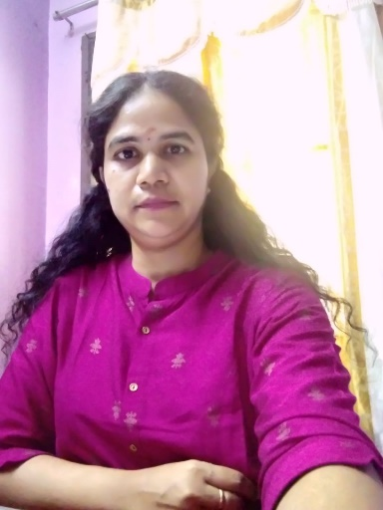

**Founder & Principal Consultant**

Swarna Kumari is the Founder & Principal Consultant of TalentTap Management Consultants.

Swarna heads the Operations for TalentTap India & Overseas and is mandated with establishment and expansion of its business in India & Overseas.

She has over 15 years of recruiting experience from various Industrial sector like Automotive Manufacturing Engineering, having served as Head of Talent Acquisition and Head of HR during her stint at PSS-Ray & Berndtson, Renault Nissan Automotive India Pvt Ltd, Murugappa Group, Eltech Appliances and Spirax Sarco Engineering.

She has a strong experience of working in Engineering, Manufacturing, Automotive, Renewable, Green Hydrogen, Energy Storage, Electric Vehicle, Infra/EPC, Digital/Industrial Automation, Chemicals, Oil & Gas Industry, Transportation space. Swarna has passion for Business Development, New Client Acquisition, Key Account Development, Head-Hunting for CEO CFO Profit-Centre Head, Mid-Senior level Technical/Non-Technical Recruitment's, Client Management, Customer Relationship, Team Management, Business Intelligence and Analysis, Market/Business Research.

She was successful in leading and developing large teams and delivering growth and profitability.

Swarna has over the years gained experience in designing and delivering large RPO engagements.

Swarna has done fulltime B.Com from Ethiraj College from Women, Masters in Business Administration from University of Madras and Diploma in Labour Law from Tamilnadu Institute of Labour Studies.

**Financial Controller**

P. Durairaj is the Financial Controller of TalentTap Management Consultants besides being a Lenovo Distributor

Durairaj heads the Financial operations, IT and Legal aspects of the Company that includes the upkeep of Books of Accounts, filing of GST, Auditing

He has over 15 years of corporate experience, having served as Regional Sales Head for Microsoft and Quick Heal Technologies

Durairaj holds a fulltime BBA from Gobi Arts & Science and Masters in Business Administration from University of Madras.