HCLTech 60-Day Training
Selenium Automation – XPath Assignment
Assignment V • 08.10.2026
━━━━━━━━━━━━━━━━━━━━━━━━━━━━━━━━
Name | Logesh.N.A
Register No. | 212223240078
Application Under Test | Vinoth QA Academy – Registration Form

Objective
To practice Selenium XPath techniques by locating form elements, interacting with the registration form, and verifying submission.
Github : https://github.com/Logesh051/Testing/tree/main/08_10_2026

1. Assignment Overview
This assignment focused on XPath-based element identification in Selenium WebDriver. The registration page was automated using Python and Selenium, covering attribute-based XPath, text matching, dynamic matching, XPath axes, logical operators, indexing, and multiple-element retrieval.

Tools & Technologies
- Python 3.14
- Selenium WebDriver
- Google Chrome
- XPath
- Selenium Select class for dropdown handling

Test Scenario
Online student registration form automation: open the registration page, locate and fill form fields, select required controls, submit the form, and verify successful submission.

2. Test Cases Covered
Test Case | Description | Technique
TC01 | Open student registration page | get()
TC02 | Locate username | Attribute XPath
TC03 | Enter password | Attribute XPath
TC04 | Locate Registration Form | text()
TC05 | Locate textbox dynamically | contains()
TC06 | Locate element with prefix | starts-with()
TC07 | Find input using two attributes | and
TC08 | Find element using alternatives | or
TC09 | Find parent element | parent
TC10 | Find form from input | ancestor
TC11 | Find child inputs | child
TC12 | Find next element | following
TC13 | Find checkbox | Attribute + XPath
TC14 | Find radio button | Attribute + XPath
TC15 | Select country | XPath + Select
TC16 | Find second textbox | XPath index
TC18 | Find all input fields | find_elements()
TC19 | Find dynamic element | contains()
TC20 | Complete registration automation | Multiple XPath concepts
TC17 | Verify successful submission | text()

3. XPath Techniques Practiced
Attribute XPath
//input[@name='vfb-5']
text()
//h3[text()='Registration Form']
contains()
//input[contains(@name,'vfb-13[address]')]
starts-with()
//input[starts-with(@name,'vfb-14')]
AND operator
//input[@name='vfb-13[city]' and @type='text']
OR operator
//input[@name='vfb-13[city]' or @type='text']
parent axis
//input[@id='vfb-13-zip']/parent::*
ancestor axis
//input[@id='vfb-13-zip']/ancestor::form
child axis
//form/child::input
following axis
//input[@id='vfb-13-city']/following::input[1]
Indexing
(//input[@type='text'])[2]
Multiple elements
driver.find_elements(By.XPATH, '//input')

4. Execution Evidence
The following screenshots document the main stages of the Selenium automation run.

Figure 1 – Registration page opened
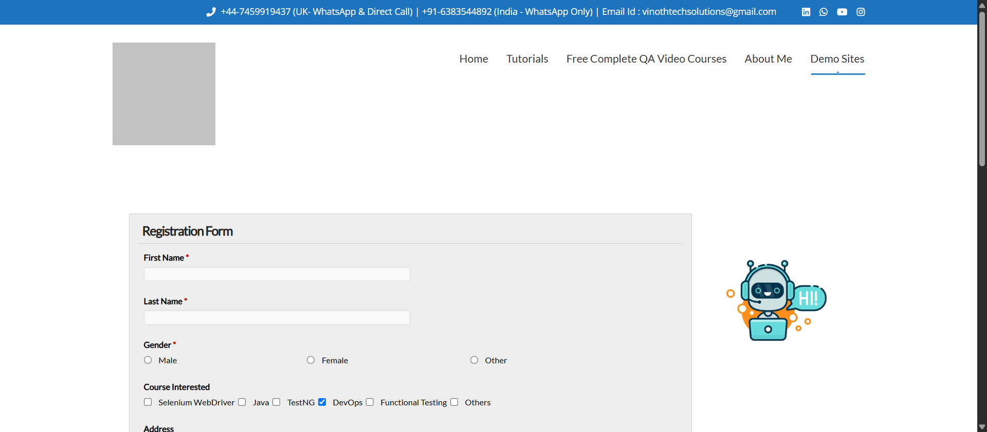
Figure 2 – Registration form interaction / filled state
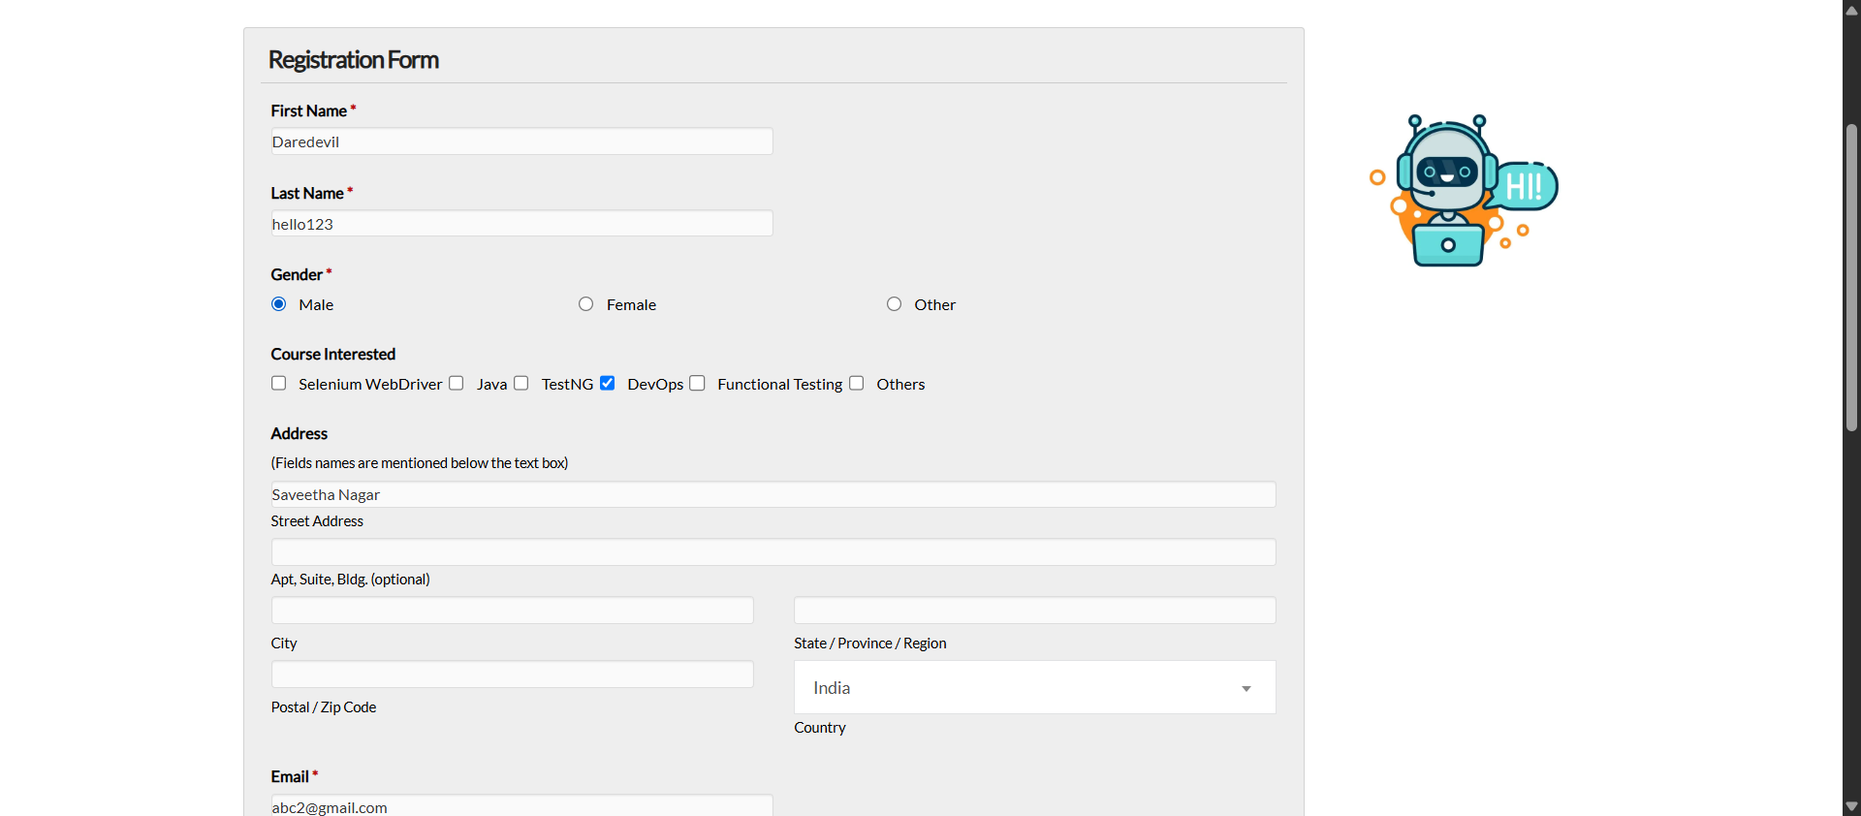
Figure 3 – 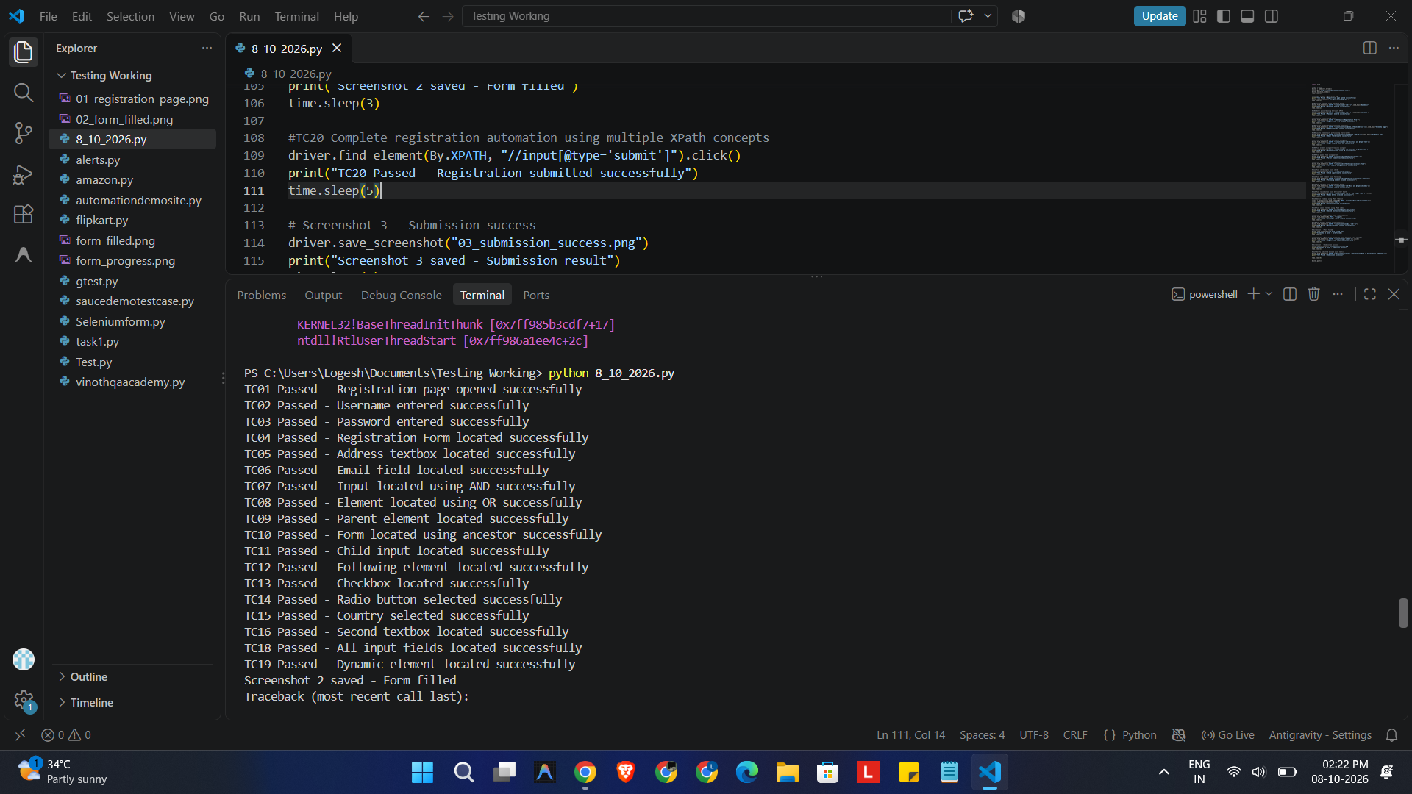

5. Execution Result
Status: Successful execution of the XPath test cases through TC16, TC18, and TC19 was observed during the run. The final workflow included form submission and post-submission verification.

Key Learning Outcomes
- Understood how XPath can locate elements when direct locators are not used.
- Practiced dynamic XPath using contains() and starts-with().
- Learned how and/or operators can combine alternative conditions.
- Practiced XPath axes such as parent, ancestor, child, and following.
- Used XPath indexing for locating a specific matching element.
- Used find_elements() to retrieve multiple elements.
- Combined XPath with Selenium Select for dropdown handling.
- Applied XPath concepts in an end-to-end registration workflow.

6. Conclusion
The assignment provided practical experience with XPath locators and Selenium WebDriver. The registration form scenario helped demonstrate how different XPath strategies can be applied to locate and interact with web elements during automation testing.

