Software Engineering Lab

1. **Design an activity diagram for an automated online banking system which shows the flow of withdrawal, deposit and balance enquiry.**

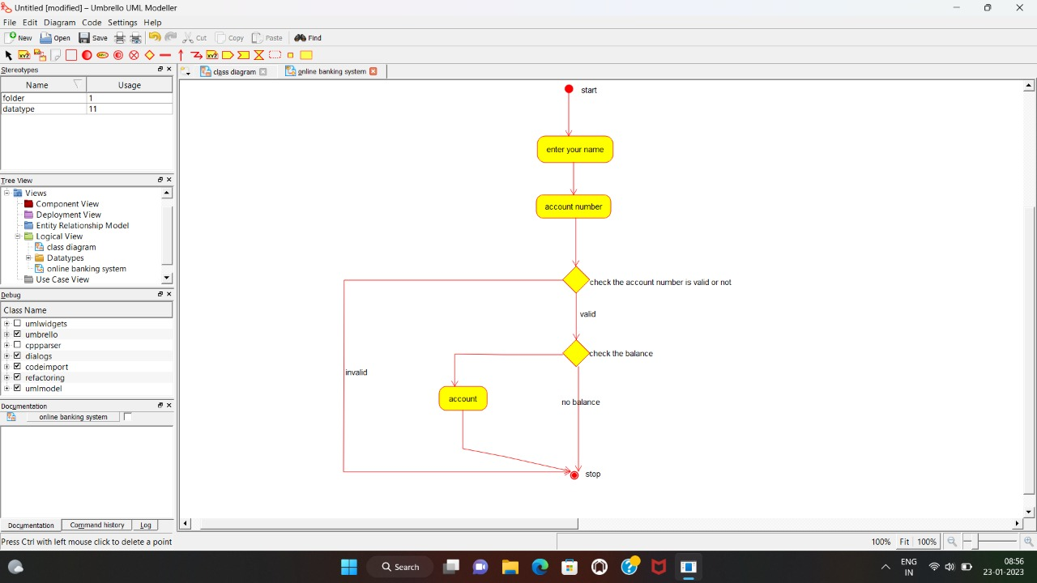

1. **Develop an activity diagram for an e-library online public access catalogue. The activities of the system are listed below. Patrons of a library can search library catalogue online to locate various resources - books, periodicals, audio and visual materials, or other items under the control of the library. Patrons may reserve or renew items, provide feedback, and manage their account.**

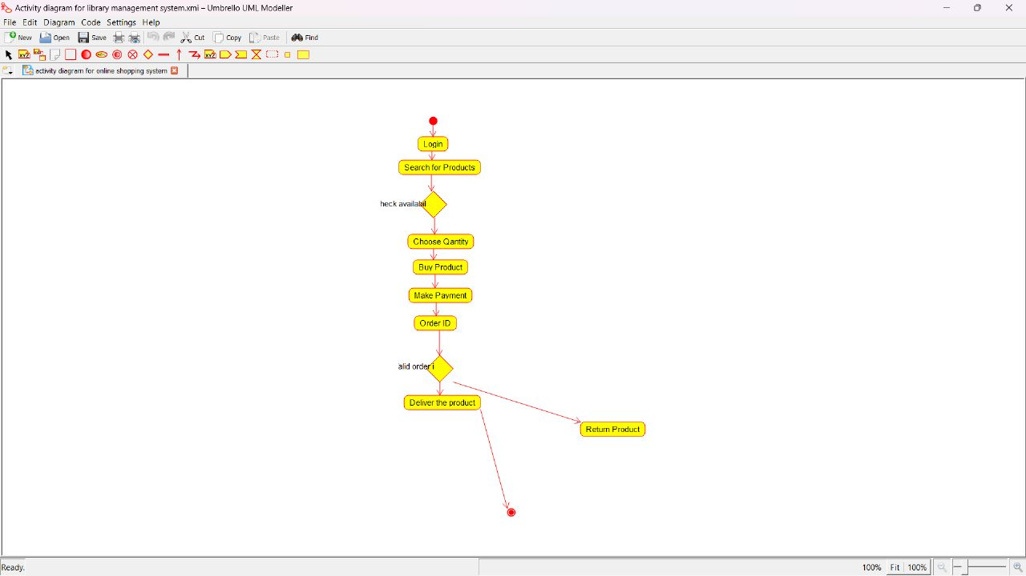

1. **Draw a Class diagram for an e-library online public access catalogue. The activities of the system are listed below. Patrons of a library can search library catalogue online to locate various resources - books, periodicals, audio and visual materials, or other items under the control of the library. Patrons may reserve or renew items, provide feedback, and manage their account.**

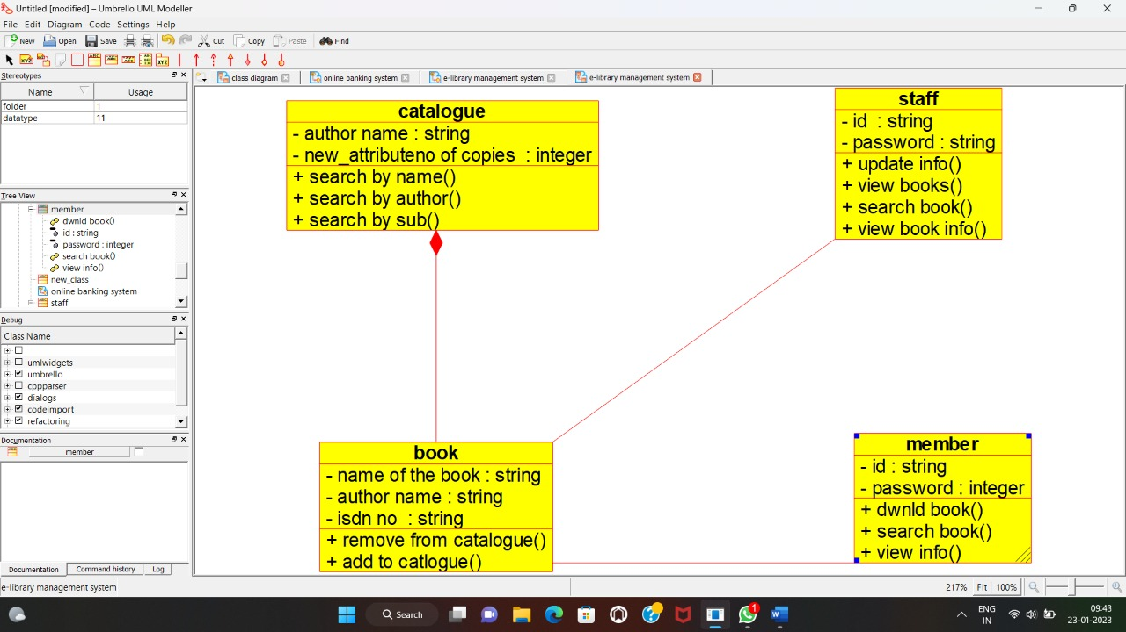

1. **Draw a Use Case diagram for a Restaurant Systems. The activities of the Restaurant system are listed below. Receive the Customer food orders, Produce the customer ordered food, Serve the customer with their ordered food, Collect payment from Customers, Store customer payment details, Order Raw Materials for food products, Pay for Raw Materials and Pay for Labour.**

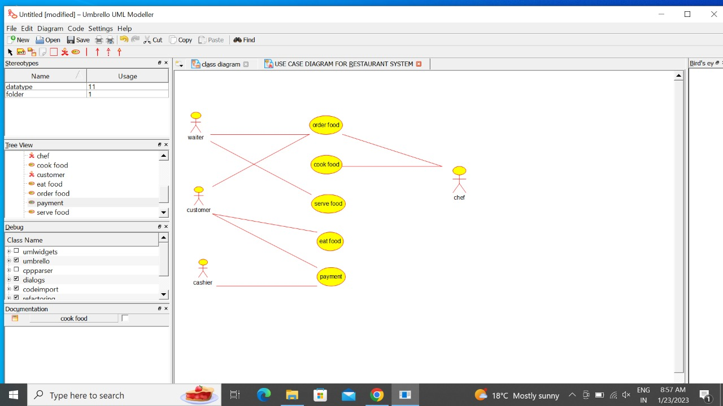

1. **Draw a Class diagram for a Restaurant Systems. The activities of the Restaurant system are listed below. Receive the Customer food orders, Produce the customer ordered foods, Serve the customer with their ordered foods, Collect payment from Customers, Store customer payment details, Order Raw Materials for food products, Pay for Raw Materials and Pay for Labour.**

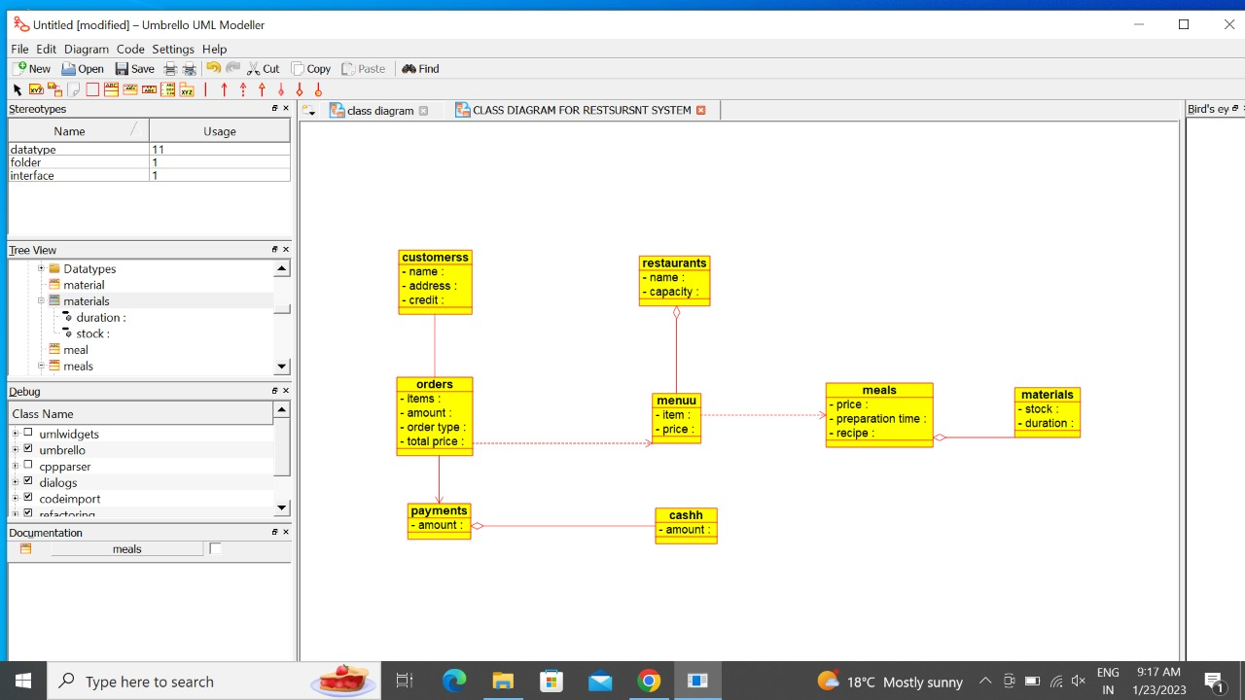

1. **Make a class diagram to model for a quiz system. A user can request a quiz for the system. The system picks a set of questions from its database, and composes them together to make a quiz. It rates the user’s answers and gives hints if the user requests it. In addition to users, we also have helpers who provide questions and hints. And also administrators who must certify questions to make sure they are not too trivial, and that they are correct.**

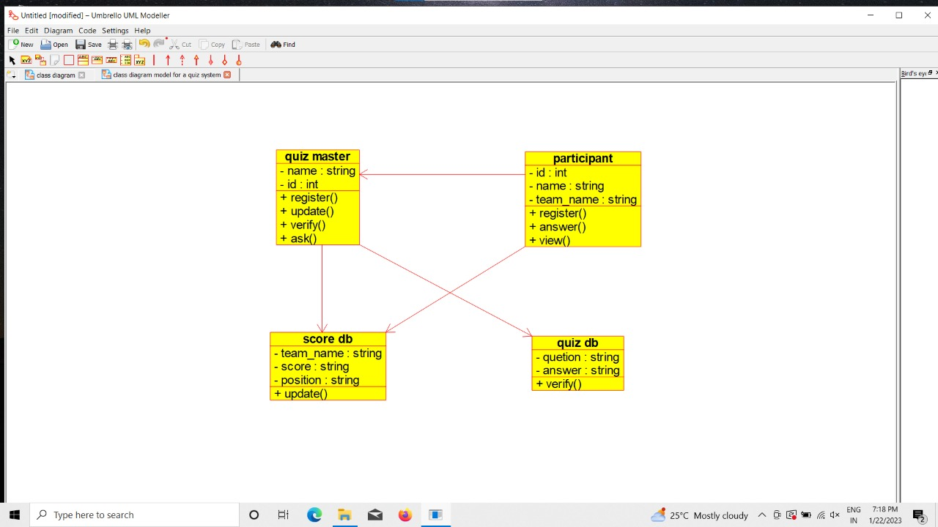

1. **Draw a Use case diagram to model for a quiz system. A user can request a quiz for the system. The system picks a set of questions from its database, and composes them together to make a quiz. It rates the user’s answers and gives hints if the user requests it. In addition to users, we also have helpers who provide questions and hints. And also administrators who must certify questions to make sure they are not too trivial, and that they are correct**

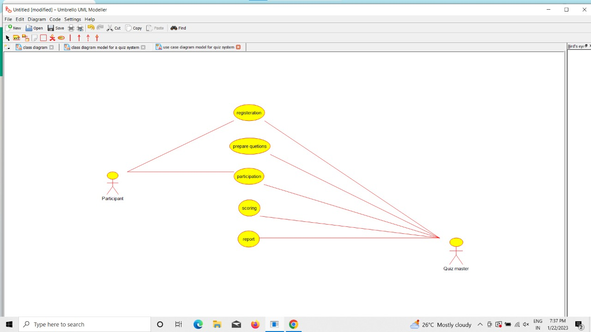

1. **Using Raptor- Draw and validate the flowchart to calculate Factorial of a number.**

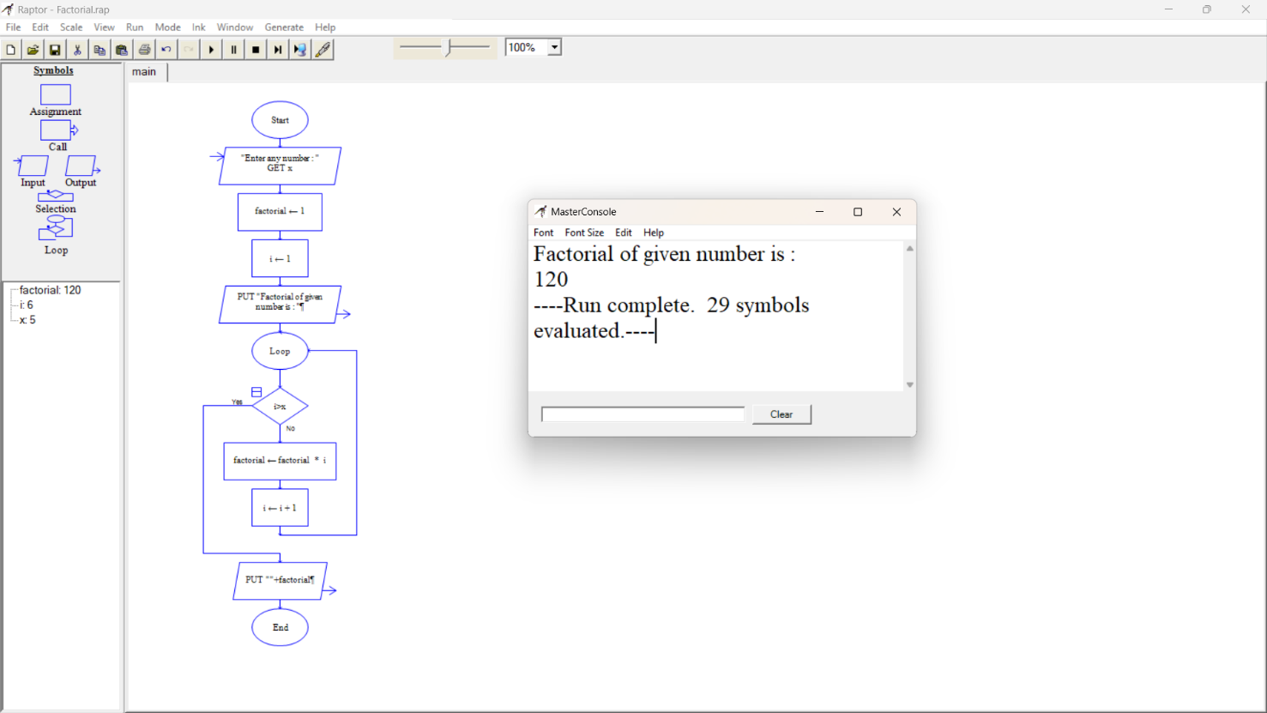

1. **Using Raptor – Draw and validate the flowchart to find odd series of the given number.**

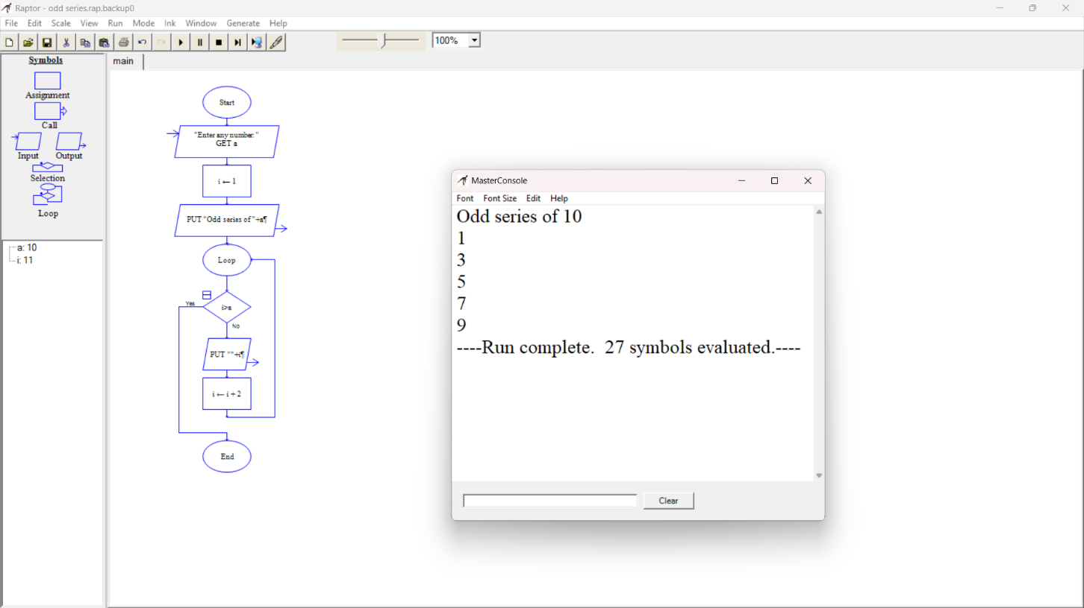

1. **Using Raptor – Draw and validate the flowchart to find even series of the given number.**

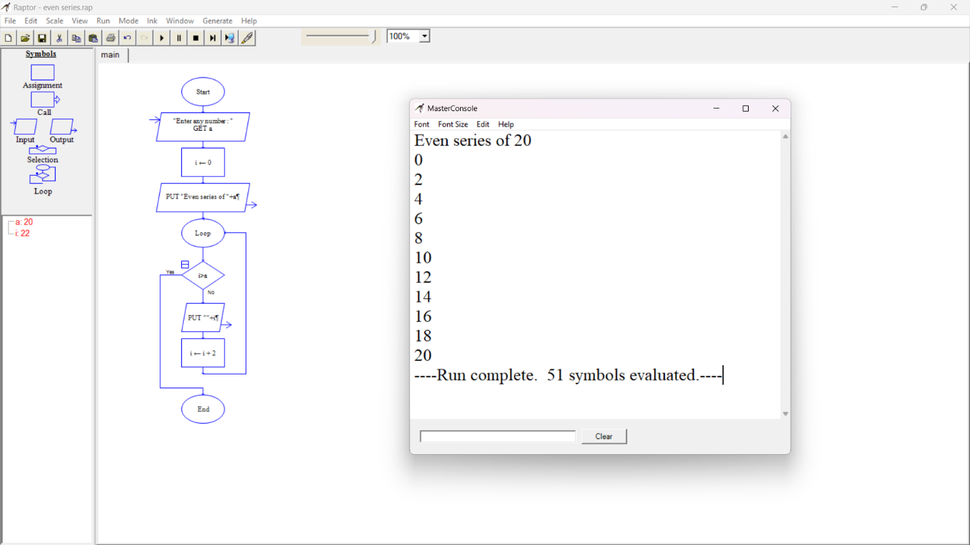

1. **Using Raptor – Draw the flowchart to display the reverse of the string.**

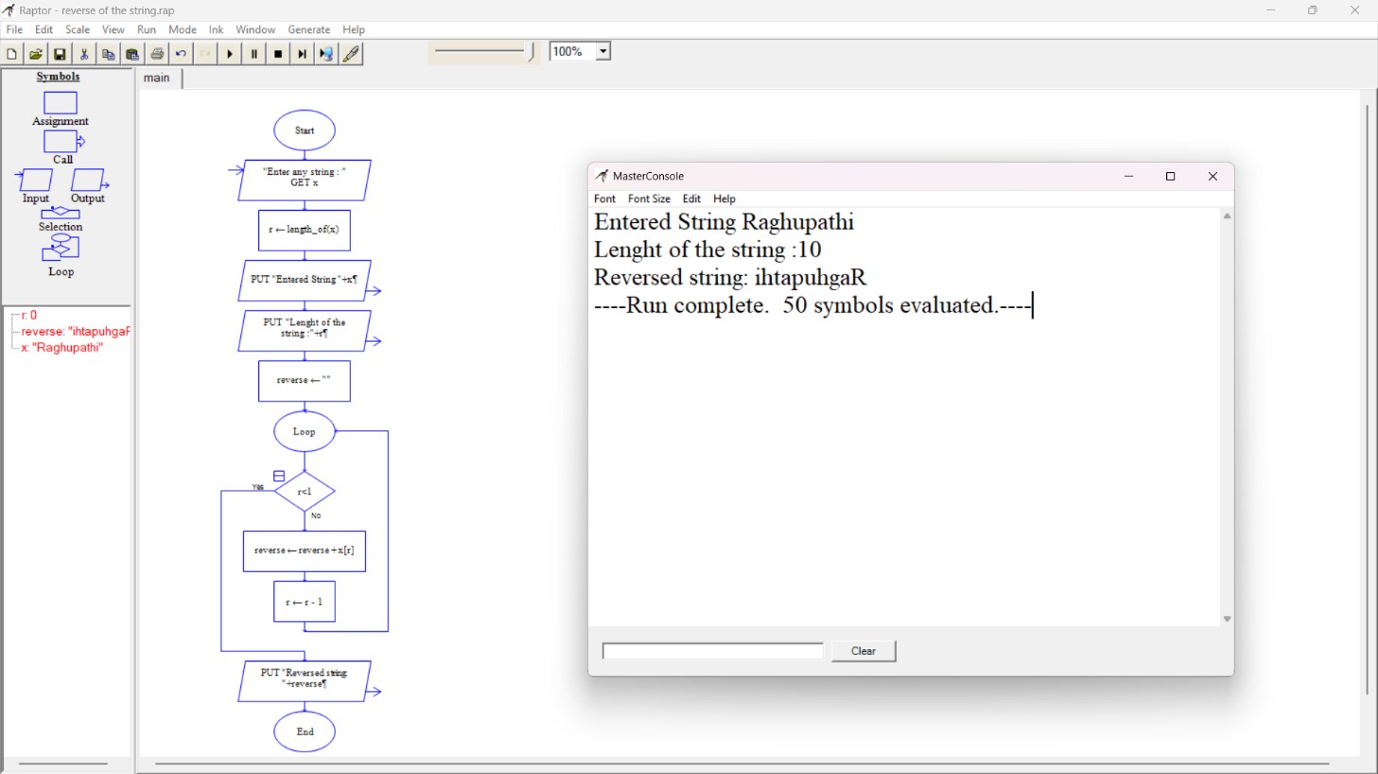

1. **Using Raptor – Draw the flowchart to find sum of n numbers.**

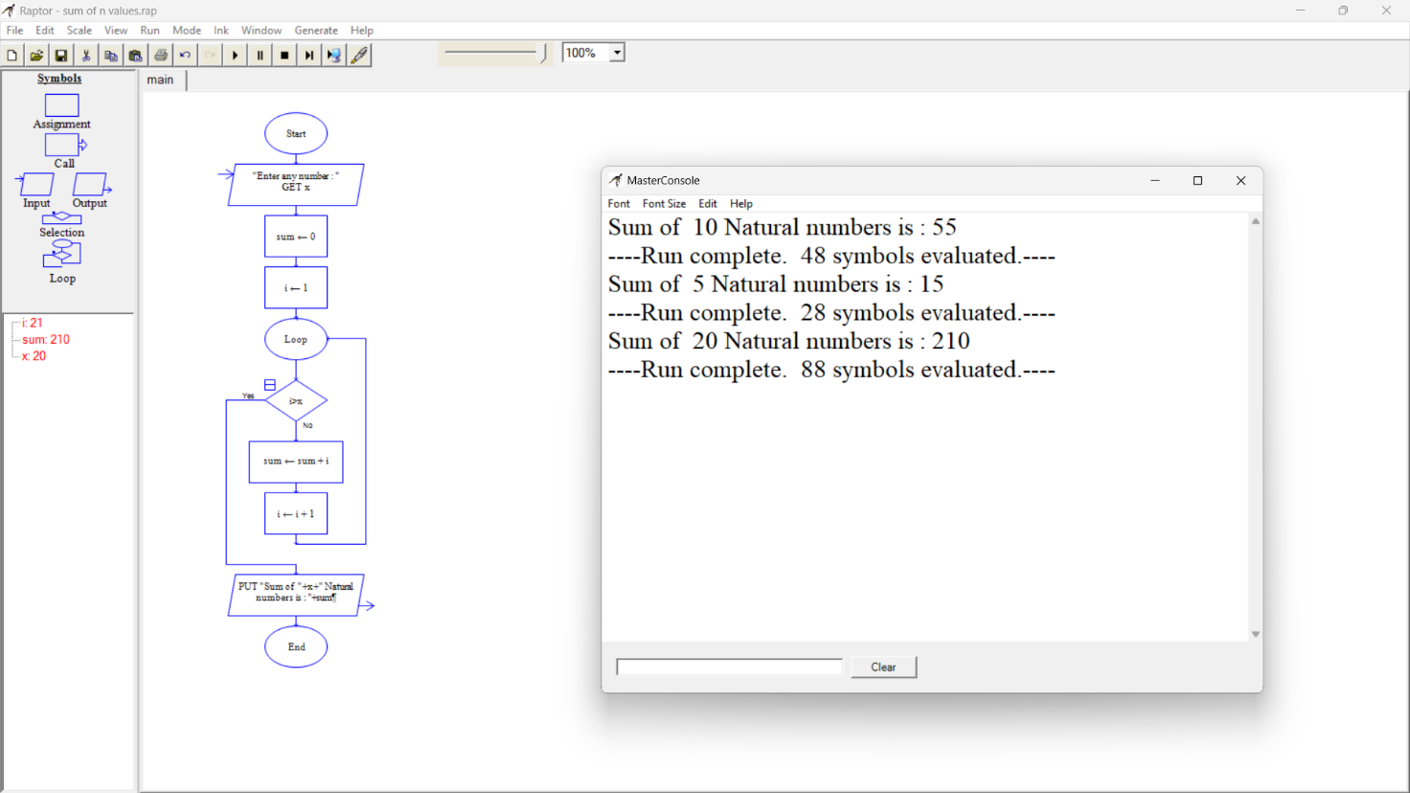

1. **Using Raptor – Draw the flowchart to find largest of n numbers.**

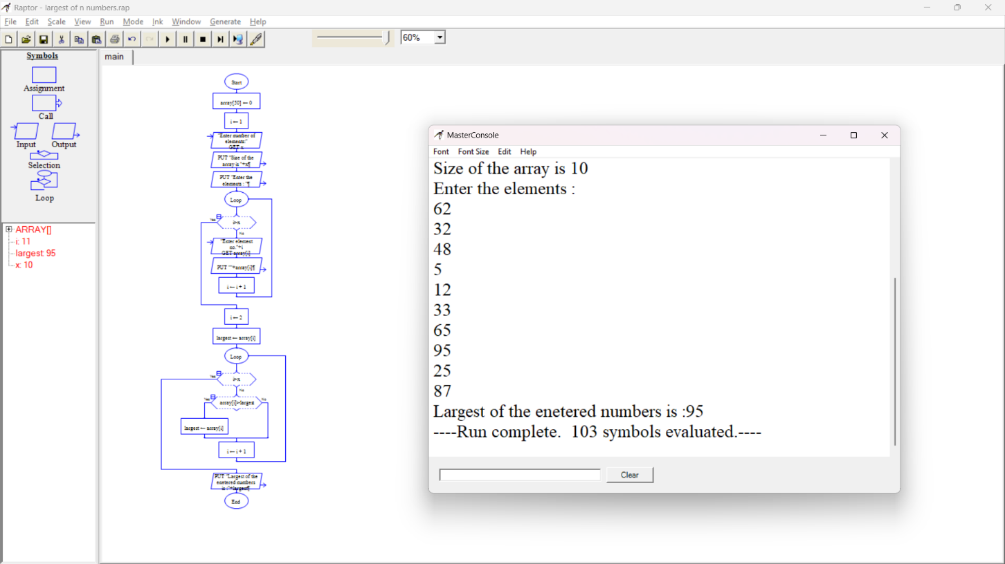

1. **Using Raptor – Draw the flowchart to find smallest of n numbers**

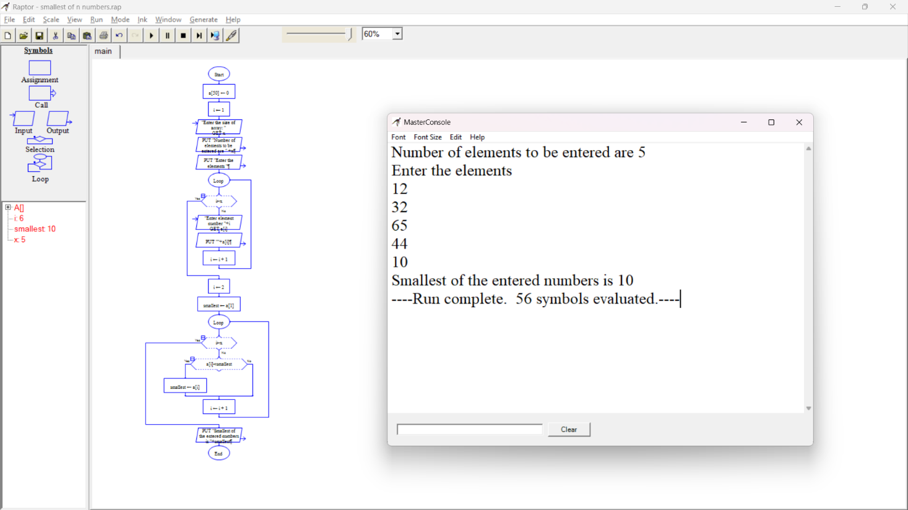

1. **Find Cyclomatic Complexity for a graph having number of edges as 20, number of nodes as 15 and number of predicate nodes in the flow graph as 4.**

