Cloud Computing Lab 2

Name: Logesh N

Register Number: 2147120

Class: 5 MCA A

1. Describe IaaS

Infrastructure as a service (IaaS) is a type of cloud computing service that offers essential computing, storage, and networking resources on demand, on a pay-as-you-go basis. IaaS is one of the four types of cloud services, along with software as a service ([SaaS](https://azure.microsoft.com/en-us/resources/cloud-computing-dictionary/what-is-saas/)), platform as a service ([PaaS](https://azure.microsoft.com/en-us/resources/cloud-computing-dictionary/what-is-paas/)), and [serverless](https://azure.microsoft.com/en-us/resources/cloud-computing-dictionary/what-is-serverless-computing/).

1. List the Compute Services available in AWS and GCP.

3) Create an AWS EC2 Instance (Instance Name: Regno_EC2) and install the necessary

packages to execute a program of your choice in it.

Steps to create EC2 instance

1. create a new instance and add a name to it, generate a key-value pair download it. Check all the checkboxes, then download the pem file.
2. Now open the cmd prompt to the pem file’s location.
3. 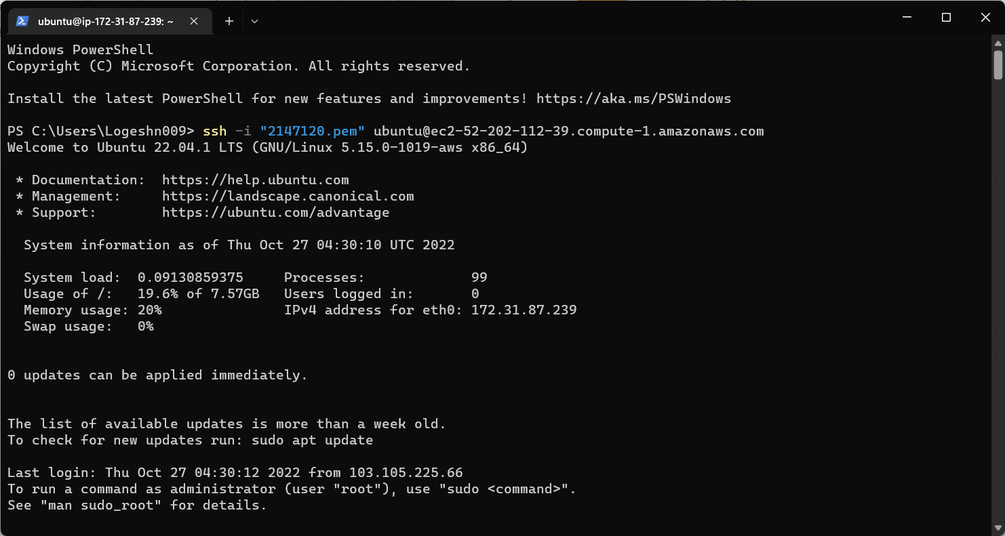Run the ssh in the cmd prompt that you got on the aws page.

Update existing packages using these cmds:

**sudo apt-get update**

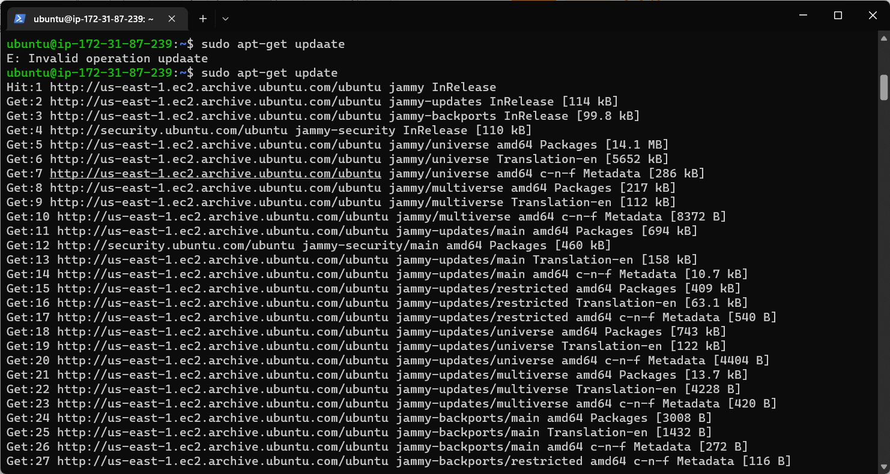

**sudo apt-get upgrade**

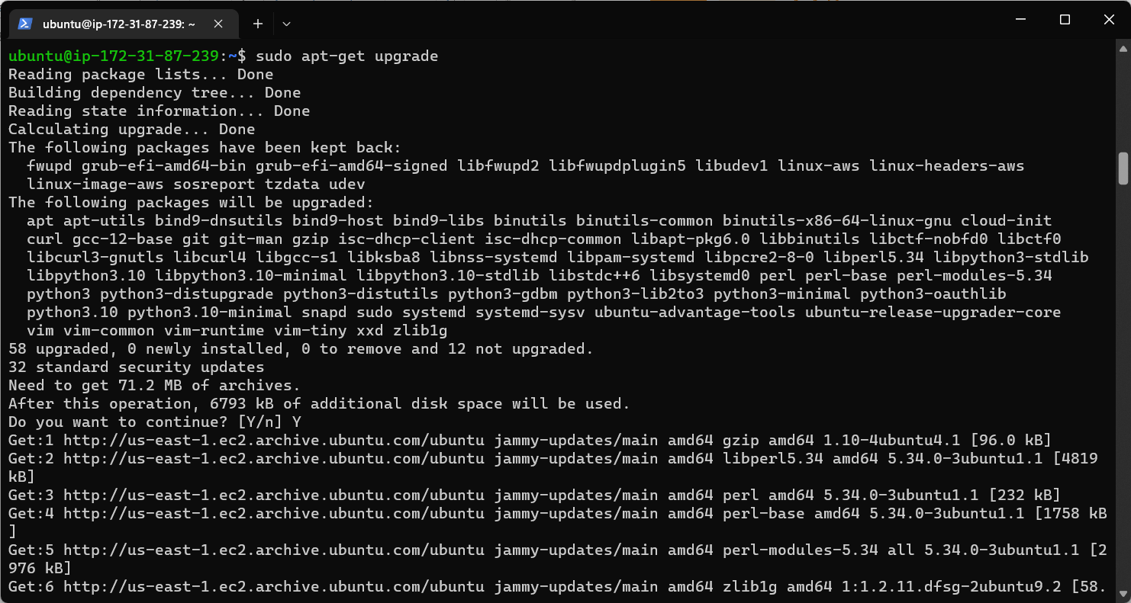

Create a new directory using the cmd:

**sudo mkdir python-aws**

**cd python-aws**

Check for the latest python version using this cmd:

**python3 –version**

Now install the Python environment into the current directory by entering:

Sudo apt-get install python3 virtualenv

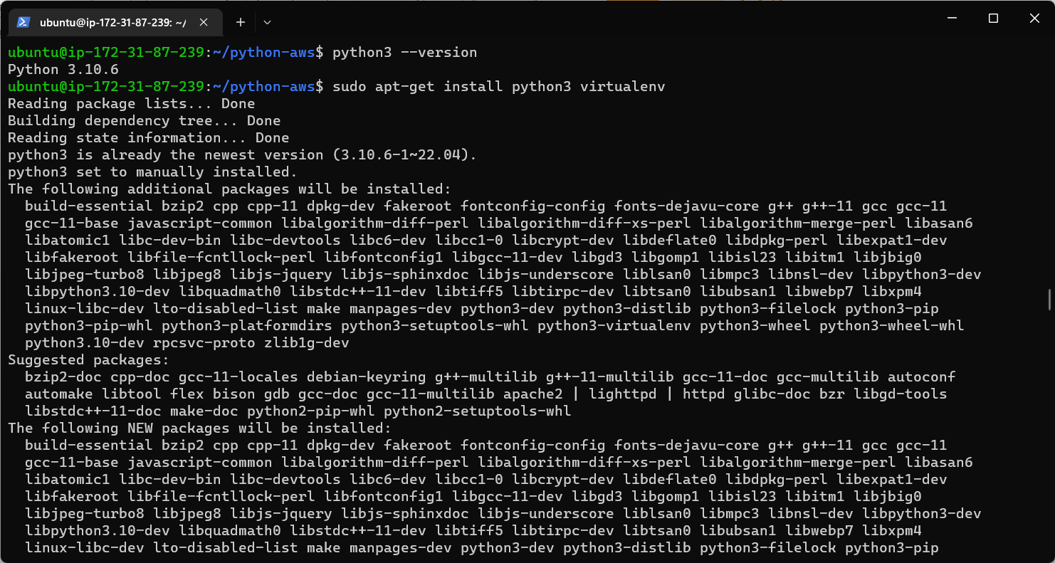

Create a python project within your directory using this cmd:

sudo python3 -m virtualenv <project-name>

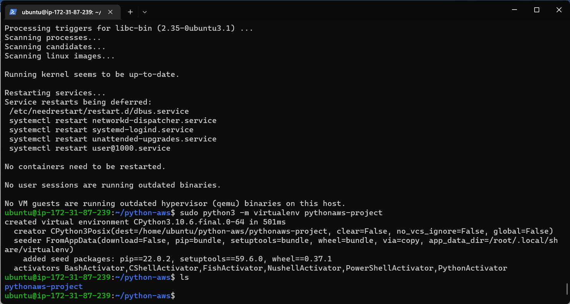

Now we have to activate the environment and then change our directory to the project directory. Use this cmd: source <project-name>/bin/activate

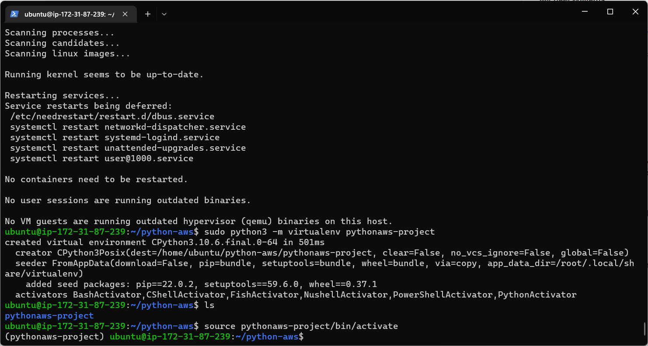

Use Vim to write the python program using the cmd

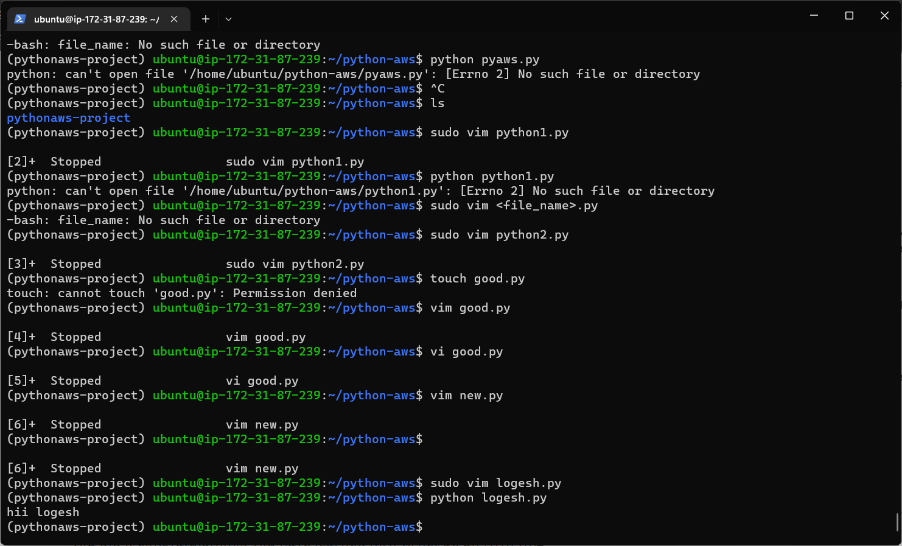sudo vim pyaws.py

4. Create a Webserver on that EC2 Instance and host your organization’s website (Static

Website)