**Cloud Computing Lab 3**

Name: Logesh N

Reg Number: 2147120

Class: 5 MCA A

1. **Describe Load Balancing and its significance in Cloud Environment**

Cloud load balancing is defined as the method of splitting workloads and computing properties in a cloud computing. It enables enterprises to manage workload demands or application demands by distributing resources among numerous computers, networks or servers.

There are several ways you can load balance on Google Cloud. In google cloud we will setup:

* Network Load Balancer
* HTTP(s) Load Balancer

Thousands of users have accessed a website at a particular time. It is challenging for applications to manage the load that comes from all these requests at a time. Sometimes, it may result in a breakdown of your entire system.

Load balancing in cloud computing is the process in which workloads and computing resources are distributed across more than one servers. The workload is divided among two or more servers, network interfaces, hard drives and other computing resources which result in better utilization and system response time.

High traffic web site requires highly efficient load balancing for a smooth operation of their business. Load balancing helps in maintaining system firmness, performance and protection against system failures.

**Importance of Load Balancing**

1. Better Performance

* Load balancing techniques are less expensive and easy to implement as compared to its counterparts. Organizations can work on their client's applications much more faster and deliver better performance at relatively lower costs.

2. Maintain Website Traffic

* Cloud Balancing provides scalability to control website traffic. With the help of effective load balancers, you can easily manage high-end user traffic with the presence of servers and network devices.
* Cloud balancing plays a crucial role for e-commerce websites like Amazon and Flipkart, who are dealing with millions of visitors every single second. Load balancers help them distribute and manage workloads at the time of promotional and sale offers.
* Handle Sudden Traffic Burst
* Load balancers have this ability to handle any sudden traffic received at a particular time. For example, a College or University website can shut down during result declaration due to too many requests arrivals at the same time.
* If they are using load balancers they do not have to worry about any amount of traffic burst. No matter how big is the traffic, load balancers equally divide entire website load into different servers for maximum results in a minimum response time.

3. Flexibility

* The main objective of using a load balancer is to protect the website from a sudden mishap. When the workload is distributed among a number of network units or servers, even if one node fails, the load could be shifted to another node. This shows scalability, flexibility and the handling ability of traffic.

**2. List the Load Balancing Service available in AWS, Azure and GCP.**

In AWS, Elastic Load Balancing supports the following load balancers: Application Load Balancers, Network Load Balancers, Gateway Load Balancers, and Classic Load Balancers. In GCP there are external load balancers and internal load balancers. Azure Front Door, Traffic Manager, Application Gateway, Azure Load Balancer are the azure load balancers.

**3. Create 2 Identical AWS EC2 / GCP VM Instances (Instance Name:**

**Regno_EC2_VM1, Regno_EC2_VM2) and install a web server of your choice in each**

**of the instances to host the website of your organization globally.**

***IN GCP>>>>>***

Step1: start the lab

Step2: Activate cloud shell

Cloud Shell is a virtual machine that is loaded with development tools. It offers a persistent 5GB home directory and runs on the Google Cloud. Cloud Shell provides command-line access to your Google Cloud resources. gcloud is the command-line tool for Google Cloud. It comes pre-installed on Cloud Shell and supports tab-completion.

You can list the active account name with this command:

gcloud auth list

Click Authorize.

Step3: Set the default region and zone for all resources

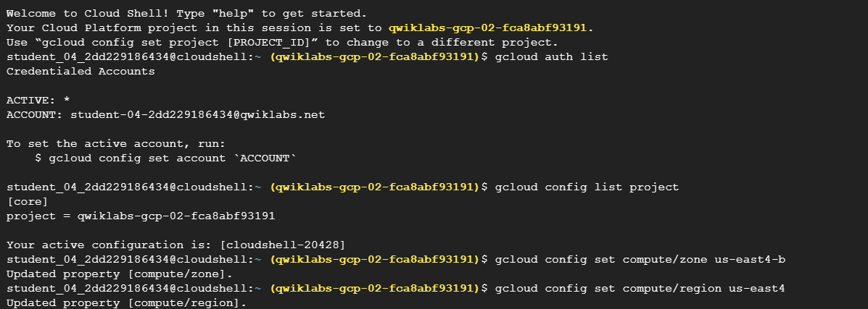

Step4: Create multiple server instances and Create a firewall rule to allow external traffic to the VM instances

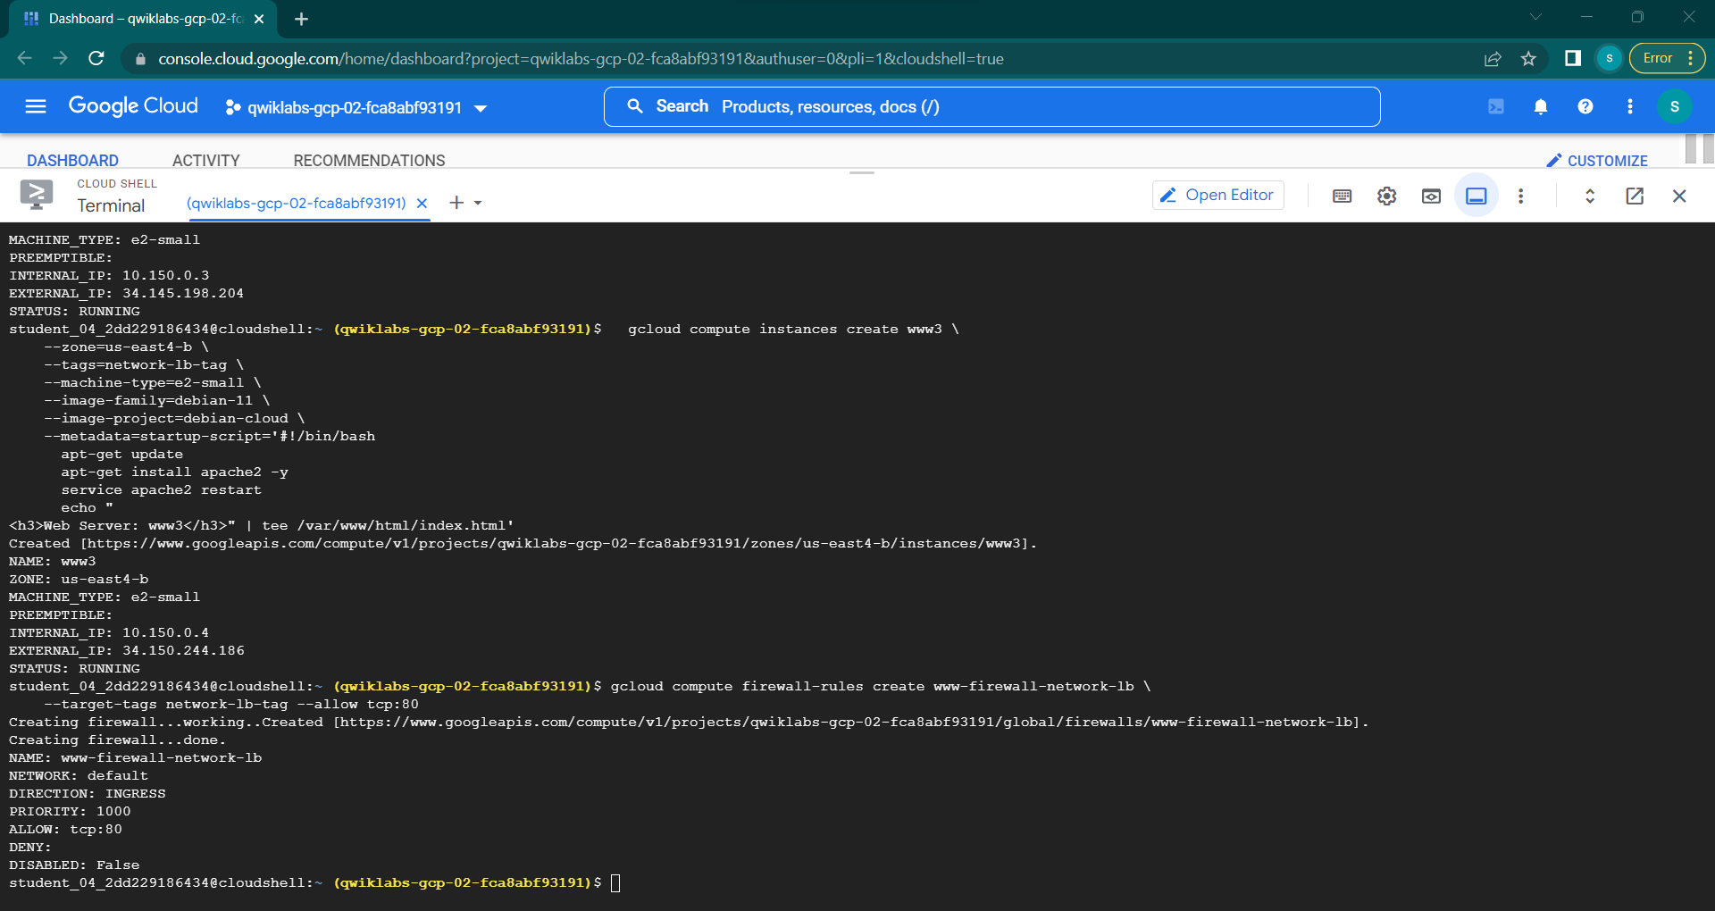

Run the following to list your instances. You'll see their IP addresses in the EXTERNAL_IP column:

Cmd >>>>> gcloud compute instances list

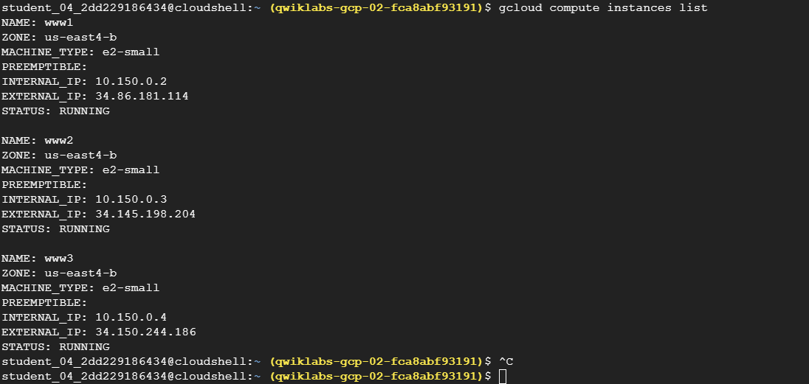

Step 5: Configure the load balancing service

When you configure the load balancing service, your virtual machine instances will receive packets that are destined for the static external IP address you configure. Instances made with a Compute Engine image are automatically configured to handle this IP address.

**4. Create a Load Balancer to ensure the fare allocation of tasks among the web servers deployed on the Virtual machine instances.**

Testing traffic sent to your instances

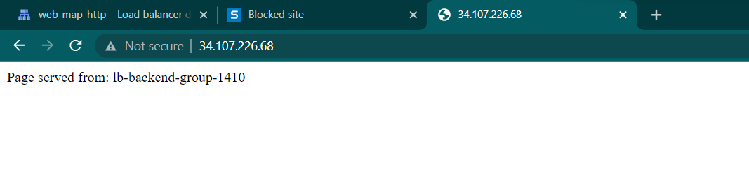

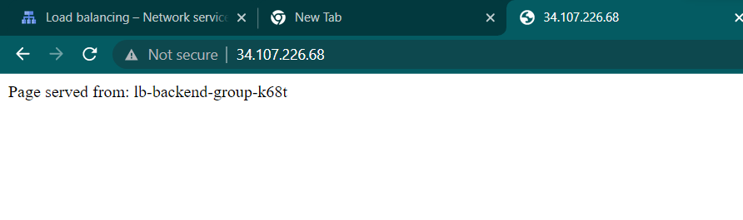

**Same ip address different webpages 1410 and k68t**

**IN AWS**

Creating two instances on amazon ec2 – named it as 2147120_ec2_vm1 and 21417120_ec2_vm2.

**Step1:** run the ssh client cmd of both the instances on cmd

**Step2:** now update and upgrade using the cmd **sudo apt-get-update** and **sudo apt-get-upgrade** respectively.

**Step3: sudo apt install apache2** cmd to install apache2 package

**Step4:** After the Apache installation process, the web server service should be started automatically, you can check if it is up and running with the following command >> **sudo systemctl status apache2**

**Step5:** Now cd to /var/www/html using the cmd “cd /var/www/html”

**Step6:** now do sudo nano logesh.html, then paste the html code and save using ctrl+o and ctrl+x to exit. Now refresh the web server page for two instances go to /logesh.html refresh and see the html page. Do for both the instances.

**Step7:** Now create a load balancer (follow this tutorial >> <https://docs.aws.amazon.com/elasticloadbalancing/latest/classic/elb-getting-started.html>)

Output of the load balancing:

