**Question 3**

Step 1: Create a feature branch. **Ans:** git branch new_branch

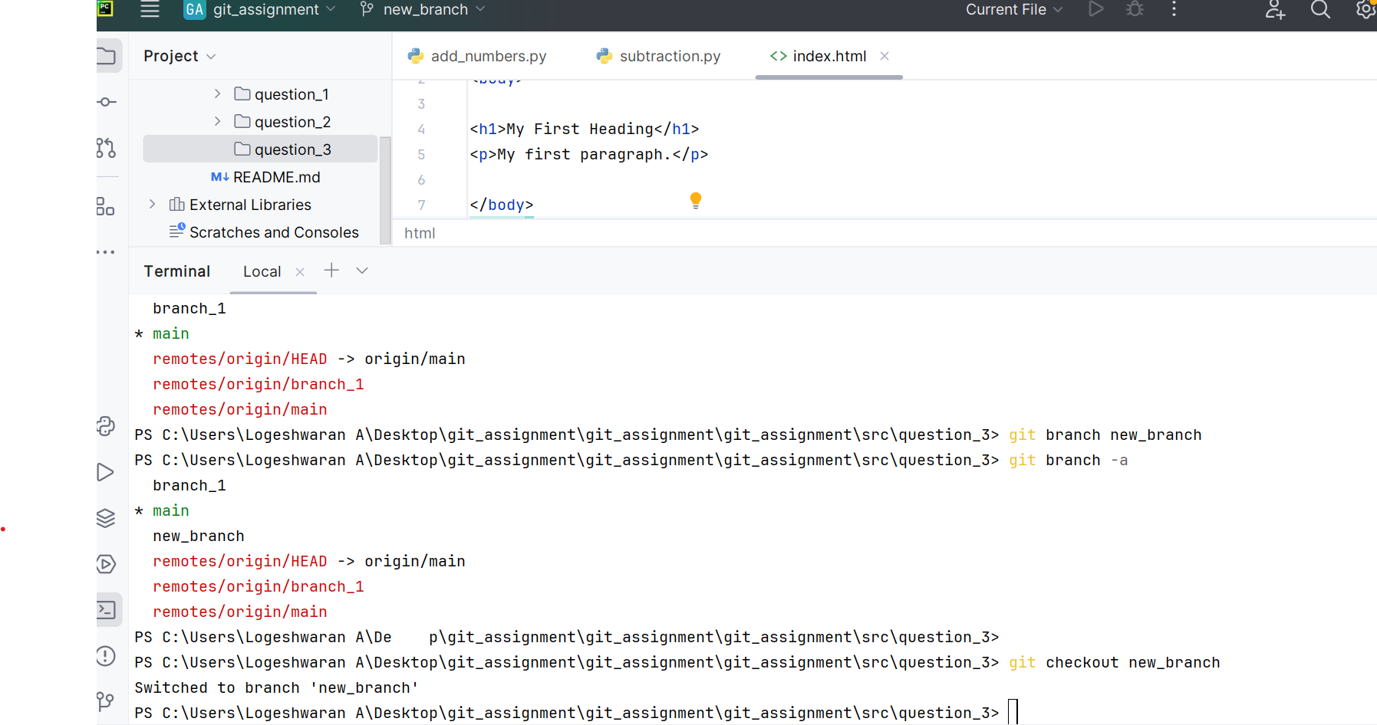

Step 2: Switch to the new branch.

git checkout new_branch

Step 3: open the file and make some changes to it.

Create new file and add changes

Step 4: Add and commit the changes to the new branch.

commit changes using - git add ., git commit -m “commit_message”

Step 5: Push the changes to the new feature branch.

git push origin “new_branch”

Step 6: Create a pull request.

Step 6: As another user in the master branch make some changes to the same file.

Make any changes in the master branch with the same file. And commit changes

Step 7: Add and commit the changes to the master branch.

git add ., git commit -m “commit_message”

Step 8: Push the changes to the master branch. **Ans:** push the changes using merge

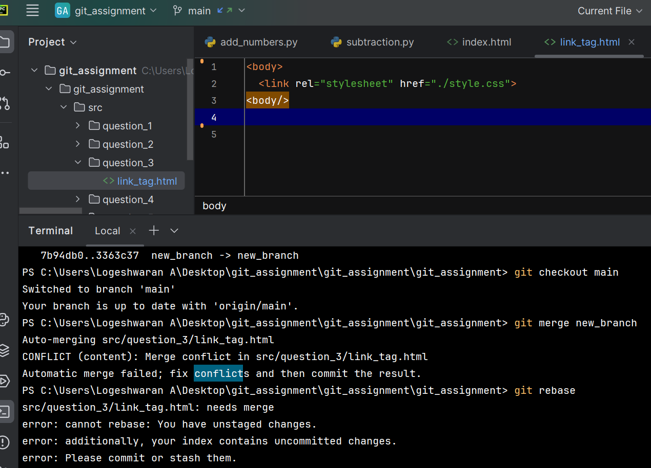

Note: There will be a conflict in the pull request, how do we resolve it??

If there is any changes in the same file and if we try to merge the branches it will show conflict. To resolve conflict we used to change the modification in the file and try to merge the conflict changes using rebase,

Hint: git rebase

