**ANOVA-Two Way Classification**

One-Way ANOVA Results

* F-Statistic: 0.672
* P-Value: 0.511

Conclusion

There is no statistically significant difference among the group means (p > 0.05), indicating that the groups are comparable.

**ANOVA-Two Way Classification**

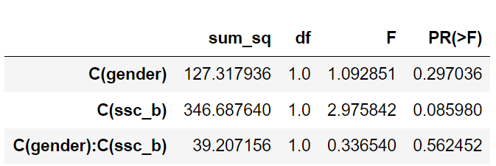

**C(gender)**:

* **P-Value = 0.297**: Not statistically significant. Gender does not significantly affect SSC percentage.

**C(ssc_b)**:

* **P-Value = 0.08598**: Close to significance but not quite there at 0.05. The type of school board may have an effect, but further research is needed.

**C(gender)(ssc_b)** (Interaction):

* **P-Value = 0.562452**: Not statistically significant. The effect of gender on SSC percentage does not depend on the type of school board.