**Percentile:**

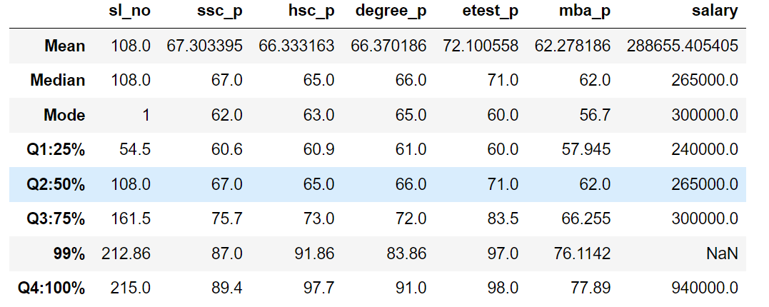

**SSC_P**

* The **SSC percentage (ssc_p)** for the **first quartile (Q1: 25%)** is **60.6%**, for the **second quartile (Q2: 50%)** is **67.0%**, for the **third quartile (Q3: 75%)** is **75.7%**, and for the **fourth quartile (Q4: 100%)** is **89.4%**.
* The **difference in performance** between **Q1 and Q2** shows a **7% increase**.
* The **difference in performance** between **Q2 and Q3** reflects an **8% increase**.
* The **performance increase** between **Q3 and Q4** is more significant, with a **14% improvement**.

**HSC_P**

* The **HSC percentage (hsc_p)** for the **first quartile (Q1: 25%)** is **60.9%**, for the **second quartile (Q2: 50%)** is **65.0%**, for the **third quartile (Q3: 75%)** is **73.0%**, and for the **fourth quartile (Q4: 100%)** is **97.7%**.
* The **difference in performance** between **Q1 and Q2** shows a **5% increase**.
* The **difference in performance** between **Q2 and Q3** reflects an **8% increase**.
* The **performance increase** between **Q3 and Q4** is more significant, with a **24% improvement**.

**Degree_P**

* The **Degree percentage (degree_p)** for the **first quartile (Q1: 25%)** is **61.0%**, for the **second quartile (Q2: 50%)** is **66.0%**, for the **third quartile (Q3: 75%)** is **72.0%**, and for the **fourth quartile (Q4: 100%)** is **91.0%**.
* The **difference in performance** between **Q1 and Q2** shows a **5% increase**.
* The **difference in performance** between **Q2 and Q3** reflects an **6% increase**.
* The **performance increase** between **Q3 and Q4** is more significant, with a **19% improvement**.

**etest_P**

* The **etest percentage (etest_p)** for the **first quartile (Q1: 25%)** is **60.0%**, for the **second quartile (Q2: 50%)** is **71.0%**, for the **third quartile (Q3: 75%)** is **83.5%**, and for the **fourth quartile (Q4: 100%)** is **98.0%**.
* The **difference in performance** between **Q1 and Q2** shows a **11% increase**.
* The **difference in performance** between **Q2 and Q3** reflects an **12% increase**.
* The **performance increase** between **Q3 and Q4** is more significant, with a **15% improvement**.

**mba_P**

* The **mba percentage (mba_p)** for the **first quartile (Q1: 25%)** is **57.9%**, for the **second quartile (Q2: 50%)** is **62.0%**, for the **third quartile (Q3: 75%)** is **66.2%**, and for the **fourth quartile (Q4: 100%)** is **77.8%**.
* The **difference in performance** between **Q1 and Q2** shows a **5% increase**.
* The **difference in performance** between **Q2 and Q3** reflects an **4% increase**.
* The **performance increase** between **Q3 and Q4** is more significant, with a **11% improvement**.

**Salary**

* The salary for **first quartile (Q1: 25%)** is 240000.0
* The salary for **second quartile (Q2: 50%)** is 265000.0
* The salary for **third quartile (Q3: 75%)** is 300000.0
* The salary for **fourth quartile (Q4: 100%)** is 940000.0