**Machine Learning Classification (Random Forest)**

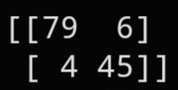**Confusion Matrix:**

True Purchased=79

False Purchased=6

False Not Purchased=4

True Not Purchased=45

**Evaluation Metrics using Confusion Metrics:**

1.Accuracy

2.Recall

3.Precision

4.F1 Score

5.Macro Average

6.Weighted Average

**Classification Report:**

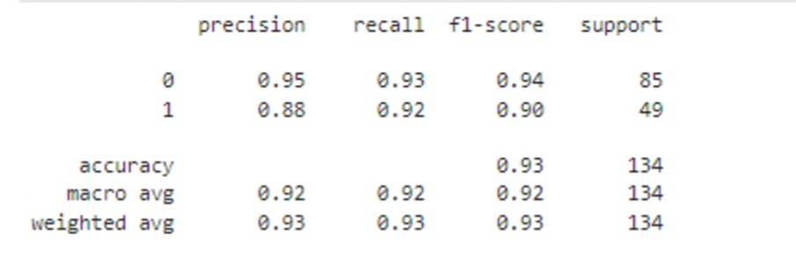

**Manual Calculation for Classification Report:**

**{Purchased=P, Not Purchased=NP} #Note**

**1.Accuracy**

Accuracy=T(p)+T(Np)/T(p)+T(NP)+F(P)+F(NP)

=79+45/79+45+6+4

=124/134

=0.925

**2.Recall**

T(P)/T(P)+F(P)=79/79+6

=79/85

=0.929

#Percentage of correct classification of (Purchased) to the total input of (Purchased) in the test set.

T(NP)/T(NP)+F(NP)=45/45+4

=45/49

=0.918

#Percentage of correct classification of (Not Purchased) to the total input of (Not Purchased) in the test set.

**3.Precision**

T(P)/T(P)+F(NP)=79/79+4

=79/83

=0.951

T(NP)/T(NP)+F(P)=45/45+6

=45/51

=0.88

**4.F1 Score**

**#**Overall Performance of Purchased

2*Recall*Precision/Recall+Precision

2*0.93*0.95/0.93+0.95

=0.939

**#**Overall Performance of Not Purchased

2*Recall*Precision/Recall+Precision

2*0.92*0.88/0.92+0.88

=0.899

**5.Macro Average**

**Precision**

**#**Average Performance of Precision

Precision(P)+Precision(NP)/2

0.95+0.88/2=0.915

**Recall**

**#**Average Performance of Recall

Recall(P)+ Recall (NP)/2

0.93+0.92/2=0.925

**F1 Score**

**#**Average Performance of F1 Score

F1 Score(P)+ F1 Score(NP)/2

0.94+0.90/2=0.92

**6.Weighted Average**

**Precision**

**#**Sum of product of proportion rate of each class

Precision(P)*85/134+Precision(NP)*49/134

0.95*85/134+0.88*85/134

=0.602+0.321=0.923

**Recall**

**#**Average Performance of Recall

Recall(P) *85/134+ Recall (NP)* 49/134

0.93*85/134+0.92*49/134

=0.925

**F1 Score**

**#**Average Performance of F1 Score

F1Score(P)*85/134+ F1 Score(NP)* 49/134

0.94*85/134+0.90*85/134

=0.925