**Problem Statement or Requirement:**

A requirement from the Hospital, Management asked us to create a predictive model which will predict the Chronic Kidney Disease (CKD) based on the several parameters. The Client has provided the dataset of the same.

**3 stages of problem Identification:**

1.Machine Learning

2.Supervised Learning

3.Classification

**Total No. of rows=**399 rows

**Total No. of Columns=** 25 columns

**Pre-processing method:**

* Converts categorical data into numerical data.
* Create binary columns and avoid redundancy.

**Decision Tree Classifier:**

**Classification report:**

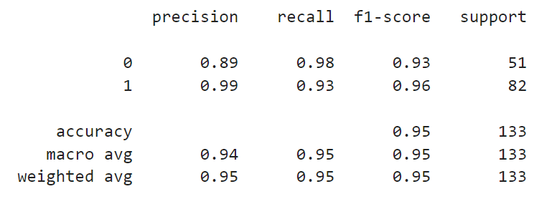

**Using Grid Search,**

The f1_macro value for best parameter {'criterion': 'log_loss', 'splitter': 'random'}: 0.9477705902916346

**roc_auc_score:**

0.9536107125777139

**Random Forest Classifier:**

**Classification Report:**

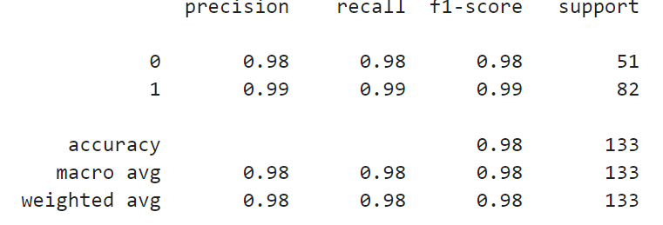

**Using Grid Search,**

The f1_macro value for best parameter {'criterion': 'entropy', 'n_estimators': 100}: 0.9849624060150376

**roc_auc_score:**

0.9997608799617408

**KNeighbour Classifier:**

**Classification Report:**

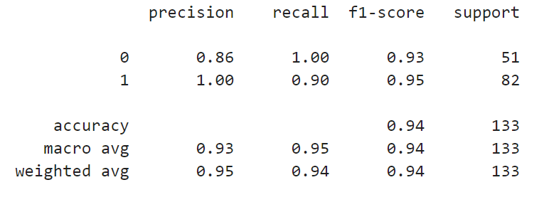

**Using Grid Search,**

The f1_macro value for best parameter {'algorithm': 'auto', 'weights': 'distance'}: 0.940494593126172

**roc_auc_score:**

1.0

**SVM Classifier:**

**Classification Report:**

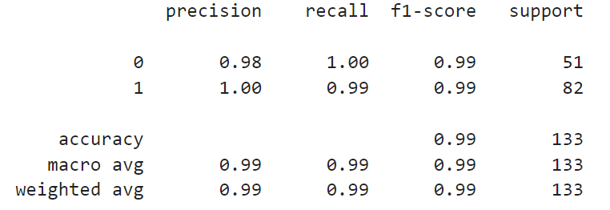

**Using Grid Search,**

The f1_macro value for best parameter {'C': 10, 'decision_function_shape': 'ovo', 'gamma': 'auto', 'kernel': 'sigmoid'}: 0.9924946382275899

**roc_auc_score:**

1.0

**Logistic Regression:**

**Classification Report:**



**Using Grid Search,**

The f1_macro value for best parameter {'penalty': 'l2', 'solver': 'newton-cg'}: 0.9924946382275899

**roc_auc_score:**

1.0

**Multinomial Naïve Bayes:**

**Classification Report:**

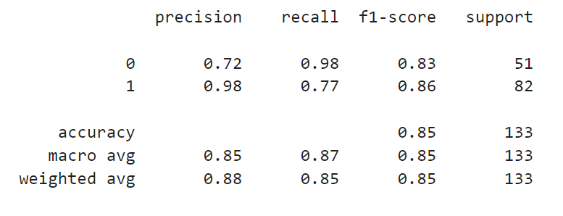

**Using Grid Search,**

The f1_macro value for best parameter {'alpha': 0.1}: 0.8516325059223402

**roc_auc_score:**

0.9356767097082734

**Gaussian Naïve Bayes:**

**Classification Report:**

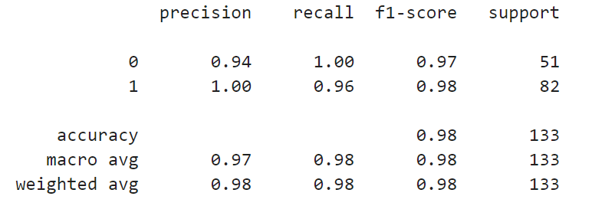

**Using Grid Search,**

The f1_macro value for best parameter {'var_smoothing': 1e-08}: 0.9775556904684072

**roc_auc_score:**

1.0

**Complement Naïve Bayes:**

**Classification Report:**

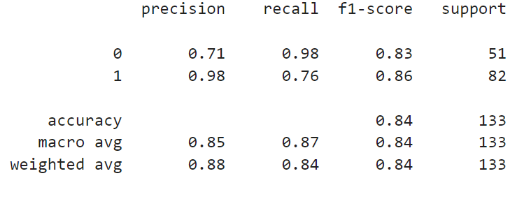

**Using Grid Search,**

The f1_macro value for best parameter {'alpha': 0.1}: 0.8441571297865639

**roc_auc_score:**

0.9356767097082734

**Bernoulli Naïve Bayes:**

**Classification Report:**

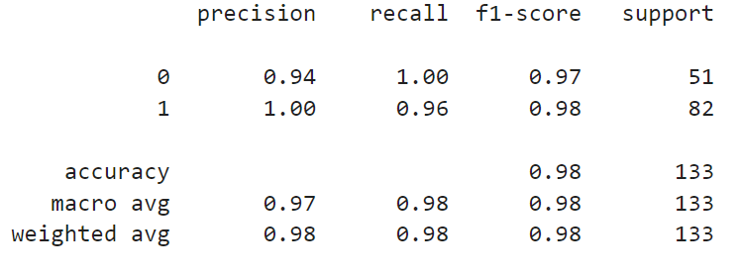

**Using Grid Search,**

The f1_macro value for best parameter {'alpha': 0.5, 'fit_prior': True}: 0.9775556904684072

**roc_auc_score:**

1.0

**Categorical Naïve Bayes:**

**Classification Report:**

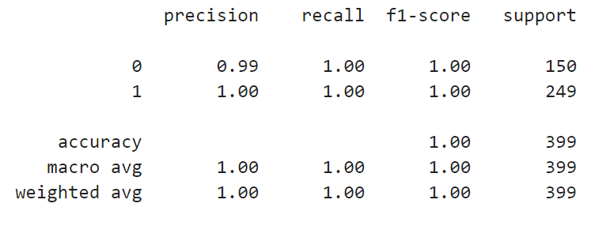

**Using Grid Search,**

The f1_macro value for best parameter {'alpha': 0.1}: 0.9874953761738116

**roc_auc_score:**

1.0