BANNARI AMMAN INSTITUTE OF TECHNOLOGY
TECHNOVA'26
Mentor–Mentee Interaction and Tracking Portal
Problem Statement

Team Name | TechTrio
Team Number | #Team013

1. Problem Description
Educational institutions rely heavily on manual, paper-based, or fragmented digital processes to manage mentor–mentee interactions, resulting in poor visibility into student progress, delayed communication, and inconsistent record-keeping. There is a need for a comprehensive, digitized portal that streamlines mentoring workflows across all institutional stakeholders.
The proposed system shall design and develop a comprehensive portal for mentor–mentee interaction and tracking that digitizes manual processes, provides role-based access for administrators, staff, and users, automates workflows, generates analytical reports, sends real-time notifications, and integrates securely with institutional systems — improving operational efficiency, transparency, collaboration, and overall user experience.

2. Objectives
- Digitize and centralize all mentor–mentee interaction records currently handled manually.
- Provide secure, role-based access for Administrators, Staff (Mentors), and Users (Mentees).
- Automate recurring workflows such as meeting scheduling, task assignment, and approvals.
- Generate analytical and performance reports for informed decision-making.
- Deliver real-time notifications for meetings, announcements, and requests.
- Enable secure integration with existing institutional systems (e.g., academic/ERP data).

3. Scope of the Solution
The portal will support three primary roles — Administrator, Staff/Mentor, and User/Mentee — each with a dedicated dashboard. Core capabilities include profile management, meeting and task tracking, academic progress monitoring, document handling, grievance redressal, feedback collection, analytics/reporting, and institution-wide announcements, all delivered through a secure, responsive web interface.

4. Requirements — Dashboard Widgets
▌ Mentee Dashboard
- Profile — Name, Register Number, Department, Year & Semester, Mentor Name, Contact Details, Parent Details
- Upcoming Meetings — Date, Time, Venue/Link, Status
- Academic Progress — CGPA, GPA, Attendance, Internal Marks, Backlogs
- Goals & Tasks, Notifications, Mentor Messages, Meeting History
- Documents, Skill Progress, Announcements, Raise Request
- Mentor Feedback, Attendance Summary, Placement Status, Calendar
▌ Mentor Dashboard
- Profile, Assigned Mentees, Today's Schedule, Meeting Management
- Student Progress, Task Management, Messages, Announcements
- Meeting History, Documents, Feedback, Reports, Analytics
- Student Requests, Calendar, Approvals
▌ HOD / Admin Dashboard
- Profile, Dashboard Overview, User Management, Department Analytics
- Meeting Monitoring, Reports, Announcements, Grievance Tracking
- Settings & Role Management, Academic Calendar
- Mentor Allocation — for absent, resigned, or newly joined mentors
- Overview of Mentors and their Mentees

5. Functional Requirements
▌ Authentication & Access Control
- The system shall provide secure login for Administrators, Mentors (Staff), and Mentees (Users) with role-based access control.
- The system shall allow password reset and account recovery via registered email/institutional credentials.
- The system shall restrict each role to only the dashboards, records, and actions permitted for that role.
▌ Profile & Records Management
- The system shall allow Mentees to view and update permitted profile fields (contact details, parent details, etc.).
- The system shall allow Mentors to view assigned mentees' profiles and academic records.
- The system shall allow Admins to create, update, and deactivate user accounts and mentor–mentee allocations.
▌ Meeting & Task Management
- The system shall allow Mentors to schedule, reschedule, and cancel meetings with Mentees.
- The system shall allow Mentors to assign tasks/goals to Mentees and track completion status.
- The system shall maintain a searchable meeting history for each mentor–mentee pair.
▌ Academic Progress & Reporting
- The system shall display academic progress indicators (CGPA, GPA, Attendance, Internal Marks, Backlogs) on the Mentee dashboard.
- The system shall generate analytical and performance reports for Mentors and Admins.
- The system shall allow Admins to view department-level analytics across all mentors and mentees.
▌ Communication & Notifications
- The system shall send real-time notifications for scheduled meetings, announcements, and pending requests.
- The system shall allow Mentors to send messages and feedback to their assigned Mentees.
- The system shall allow Mentees to raise requests/grievances that route to the appropriate Mentor or Admin.
▌ Documents & Administration
- The system shall support upload, storage, and retrieval of documents shared between Mentors and Mentees.
- The system shall allow Admins to reallocate mentors for absent, resigned, or newly joined staff.
- The system shall integrate securely with existing institutional systems (e.g., academic/ERP data).

6. Non-Functional Requirements
- Performance — The system shall load dashboard pages within 3 seconds under normal load and support at least 500 concurrent users.
- Security — The system shall encrypt sensitive data (credentials, academic records) in transit and at rest, and enforce role-based authorization on every request.
- Availability — The system shall maintain at least 99% uptime during the academic term, excluding scheduled maintenance.
- Scalability — The system shall support horizontal scaling to accommodate additional departments, mentors, and mentees without redesign.
- Usability — The system shall provide a responsive, intuitive interface usable on both desktop and mobile browsers with minimal training.
- Reliability — The system shall ensure no data loss during scheduling, task updates, or report generation, with automated backups.
- Maintainability — The system shall follow modular design principles so that features can be updated or extended independently.
- Compliance — The system shall comply with institutional data privacy policies governing student academic and personal information.

7. Tools & Technology Stack
Layer | Tool | Purpose
Frontend | React | Building interactive, role-based dashboard UIs
Backend | Node.js / Express.js | API layer, business logic, and authentication
Database | SQL | Structured storage of users, records, and activity data
Version Control | Git | Source code versioning and team collaboration
IDE | VS Code | Primary development environment for coding
Deployment | Vercel | Hosting and continuous deployment of the portal

8. Entity Relationship Diagram
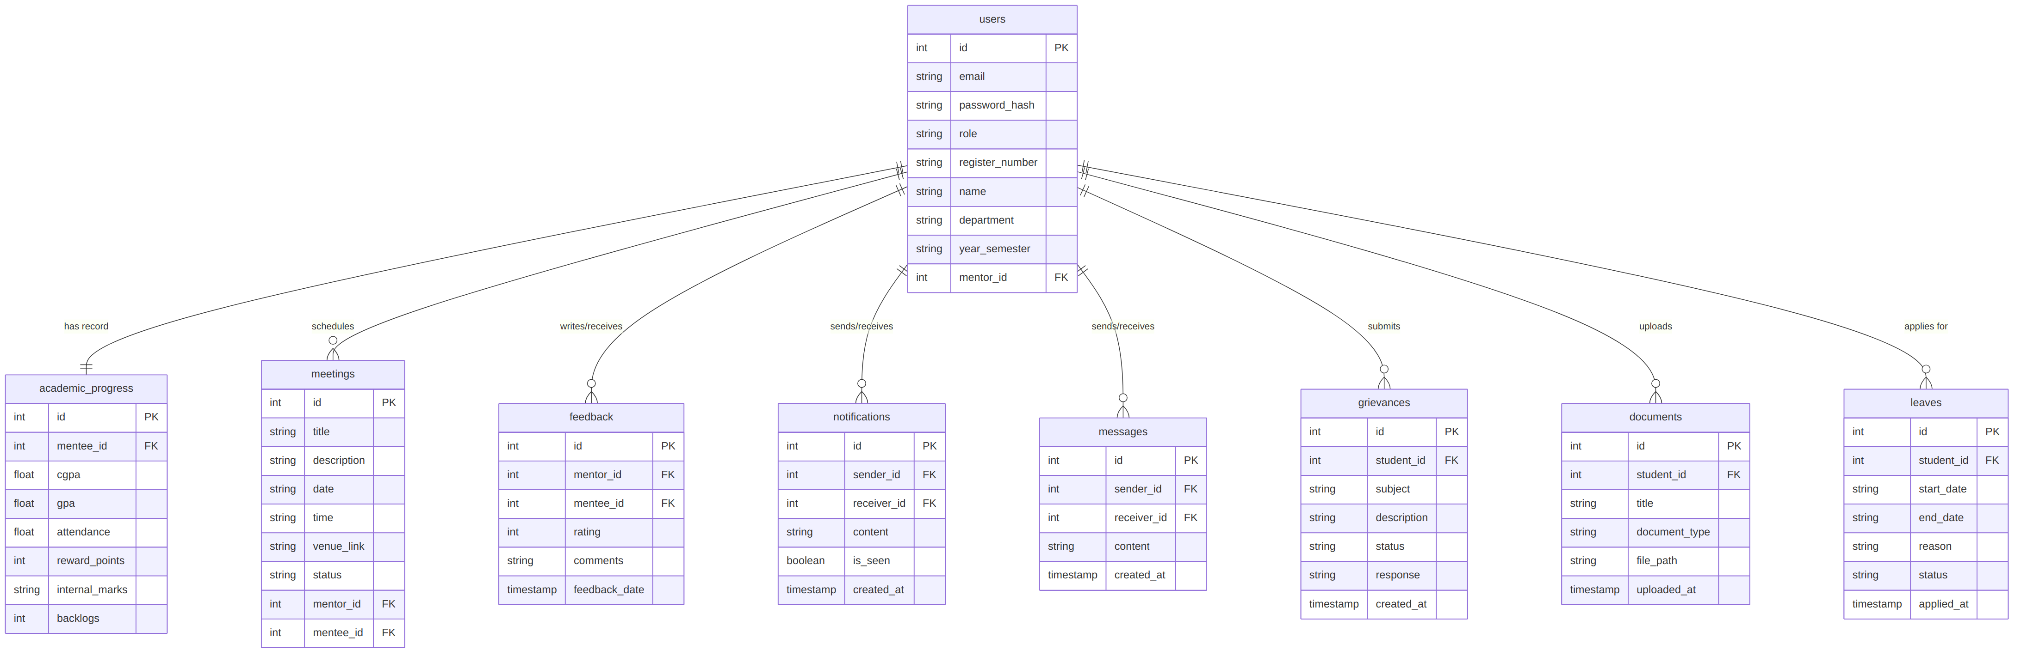
Database schema for the Mentor–Mentee Interaction and Tracking Portal, showing relationships between users, academic progress, meetings, feedback, notifications, messages, grievances, documents, and leaves.

Github link: https://github.com/Logeswaran-01/menticonnect
Vercel Deployment : https://menticonnect-five.vercel.app/

