Hi [Names],

The two incident dates now tell the story very clearly:
3 Aug: Orphan 92.53% ↑ while Forward Recon 45% ↓
2 Sep: Orphan 69.92% ↑ while Forward Recon 54.51% ↓
On the surrounding normal days, orphaning is approximately 0.01–0.12% and Forward Recon is approximately 100%.
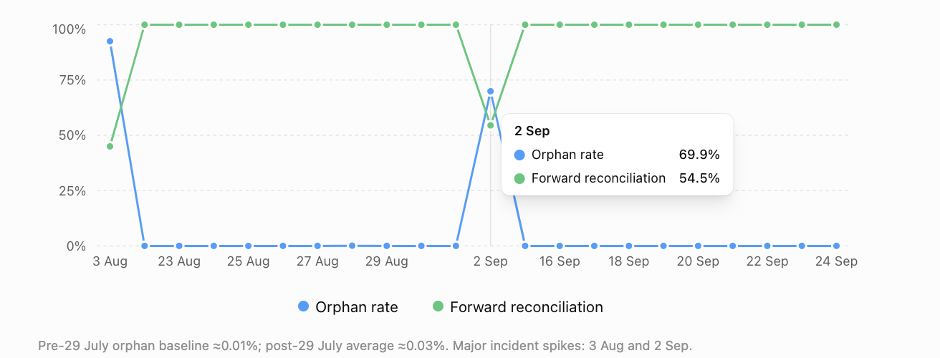
Following our discussion, I have looked at the BICoE production trend around the MQS orphan records, particularly before and after the 29 July MQS release, which was intended to reduce message loss/orphaning.
From the BICoE data, there are two observations worth highlighting.
1. Change in the underlying orphan trend
Prior to 29 July, the average orphan rate was approximately 0.01%. Since the 29 July release, this has increased to approximately 0.03%.
While the absolute percentages remain small on normal processing days, the trend is important because the expectation following the release was for orphaning to reduce rather than increase.
2. Significant spikes on 3 August and 2 September
There are two clear exceptions to the normal daily pattern:
- 3 August: approximately 1.02m out of 1.10m quotes (92.53%) were identified with an incomplete/orphaned message sequence. Forward Reconciliation also dropped to approximately 45%.
- 2 September: approximately 755k out of 1.08m quotes (69.92%) were identified with an incomplete/orphaned message sequence. Forward Reconciliation dropped to 54.51%.
On the surrounding normal processing days, the orphan rate is generally very low and Forward Reconciliation is close to 100%. Both indicators therefore show a significant deterioration on the same two incident dates.
There is an important distinction between the two measures. Forward Reconciliation is primarily based on the quote-request population from the Athena reconciliation file, whereas the orphan analysis identifies breaks across the wider sequence of MQS messages associated with a quote. The populations and matching logic are therefore different, and we should not interpret the orphan percentage as directly explaining the reconciliation percentage.
However, the trend is significant: on both 3 August and 2 September, the orphan population increased exceptionally at the same time that Forward Reconciliation deteriorated significantly. This indicates that both BICoE controls are independently showing disruption to the MQS message flow on the same incident dates.
The attached trend graph illustrates this behaviour, including the change in the underlying orphan rate following 29 July.
Regards,
[Name]

