PROJECT REPORT
CUSTOMER SUPPORT TICKET PRIORITY PREDICTION AND AUTOMATED ASSIGNMENT SYSTEM USING AGENTFORCE

1. Introduction
Brainstorming is a creative group activity used to generate many ideas for a problem without judging them at first. In this project, the team brainstormed ways to solve the problem of manual, slow and inconsistent support ticket prioritization. The ideas were then grouped and evaluated using an Impact versus Feasibility matrix, and the best solution was selected.

2. Problem Focus
How might we help support teams identify and handle critical tickets faster, with less manual effort, and with the right assignment every time?
Challenge | Description
High volume of tickets | Large numbers of tickets arrive daily from many channels
Manual prioritization | Time-consuming, inconsistent and error-prone
Incorrect assignment | Tickets reach the wrong agent or team and get reassigned
Delayed resolution | Critical issues take longer to resolve
Poor customer experience | Frustration due to slow response and no updates

3. Brainstorming Session
Every team member wrote ideas on sticky notes. No idea was rejected during this phase. The board below shows the ideas collected.
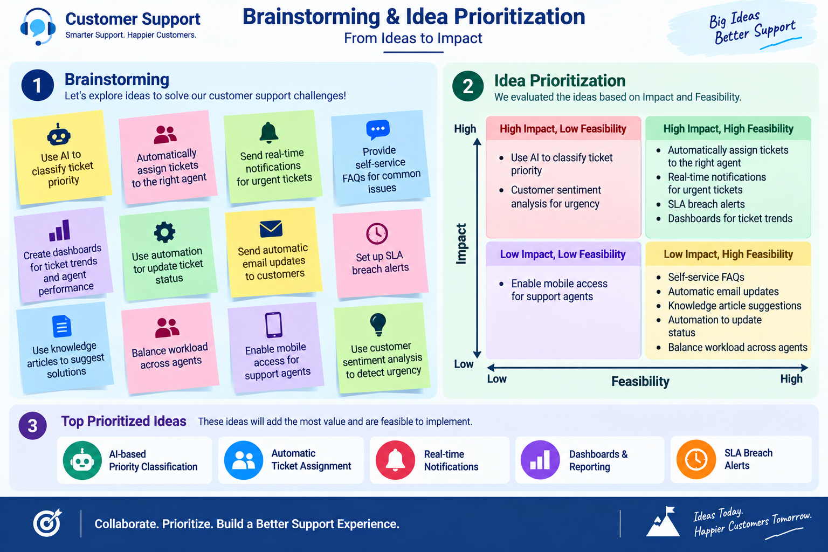
Figure 1: Brainstorming and idea prioritization board

3.1 Ideas Generated
No. | Idea | No. | Idea
1 | Use AI to classify ticket priority | 7 | Set up SLA breach alerts
2 | Automatically assign tickets to the right agent | 8 | Use knowledge articles to suggest solutions
3 | Send real-time notifications for urgent tickets | 9 | Balance workload across agents
4 | Provide self-service FAQs for common issues | 10 | Enable mobile access for support agents
5 | Create dashboards for ticket trends and agent performance | 11 | Use customer sentiment analysis to detect urgency
6 | Use automation to update ticket status | 12 | Send automatic email updates to customers

4. Idea Prioritization
Each idea was placed on a matrix using two criteria: Impact (how much value it adds) and Feasibility (how easy it is to build within the project time).
Quadrant | Ideas
High impact, high feasibility | Automatic ticket assignment, real-time notifications for urgent tickets, SLA breach alerts, dashboards for ticket trends
High impact, low feasibility | AI-based priority classification (advanced model), customer sentiment analysis for urgency
Low impact, high feasibility | Self-service FAQs, automatic email updates, knowledge article suggestions, status automation, workload balancing
Low impact, low feasibility | Mobile access for support agents

The top prioritized ideas were: AI-based priority classification, automatic ticket assignment, real-time notifications, dashboards and reporting, and SLA breach alerts. For the current scope, the team implemented priority classification, automatic assignment, urgent task creation and an optional SLA check, and kept notifications and dashboards as future scope.

5. Alternative Solutions Considered
Solution option | Advantages | Disadvantages
Manual ticket registers | Simple, no cost | Slow, error-prone, no automation
Spreadsheet-based tracking | Easy to start, familiar | No real-time updates, no AI, hard to scale
Standalone support portal | Customized interface | High development effort, separate maintenance
Salesforce CRM with Agentforce | Built-in automation, AI agent, secure data, scalable | Needs Salesforce knowledge and configuration

5.1 Evaluation Scoring
Each option was scored from 1 (poor) to 5 (excellent) against the criteria that matter most for this project. The highest total was selected.
Criteria | Manual register | Spreadsheet | Standalone portal | Salesforce + Agentforce
Automation capability | 1 | 2 | 4 | 5
AI-assisted analysis | 1 | 1 | 3 | 5
Speed of development | 5 | 4 | 2 | 4
Scalability | 1 | 2 | 3 | 5
Data security | 2 | 2 | 3 | 5
Maintenance effort (5 = low) | 3 | 3 | 2 | 4
Total (out of 30) | 13 | 14 | 17 | 28

5.2 Risks of the Selected Idea
Risk | Mitigation
Keyword rules may miss some urgency signals | Keep keyword list configurable in the Flow and extend it over time
Agent may give wrong output if instructions are unclear | Write precise subagent scope and step-by-step instructions, then test in Conversation Preview
Tickets may not be linked to an Account | Make the Customer lookup field mandatory during data entry

6. Final Selection
Salesforce CRM with Agentforce was selected as the final solution because it offers:
- Automation through Salesforce Flow without heavy coding.
- AI-assisted ticket analysis through Agentforce in a conversational form.
- Automatic priority classification (High, Medium, Low).
- Automatic urgent-task creation for critical tickets.
- Reduced manual support effort and easy scalability.

7. Outcome of Brainstorming
The brainstorming phase converted a broad problem into a clear, buildable plan: an Auto-Launched Flow containing the priority logic, a custom object for ticket data, and an Agentforce subagent as the user interface. The remaining ideas were recorded as the future scope of the project.

