PROJECT REPORT
CUSTOMER SUPPORT TICKET PRIORITY PREDICTION AND AUTOMATED ASSIGNMENT SYSTEM USING AGENTFORCE

1. Introduction
Customer support is one of the most important parts of any business. When a customer faces a problem with a product or service, the speed and quality of the response decides whether the customer stays loyal or leaves. Modern support teams receive tickets through portals, email, chat and phone, and the number of tickets grows every day.
In many organizations, a support agent or manager reads each ticket, decides how urgent it is, and then assigns it to someone. This manual process takes time, depends on the person reading the ticket, and can cause critical issues to wait behind simple ones. Artificial intelligence and workflow automation can solve this problem by reading the ticket, deciding the priority, and starting the right action immediately.
This project, the Customer Support Ticket Priority Prediction and Automated Assignment System using Agentforce, uses the Salesforce platform to do exactly that. It combines a custom data model, an Auto-Launched Flow and an Agentforce AI agent into one working solution.

2. Background
Salesforce is a leading cloud CRM platform used to manage customers, cases and business processes. It provides Flow for no-code automation and Agentforce for building AI agents that understand natural language and perform actions on Salesforce data. An Agentforce agent is organized into subagents (topics), where each subagent has a scope, instructions and actions. Actions can call Flows, Apex or prompt templates.
Instead of building a separate support tool, this project reuses the strengths of Salesforce: secure customer data, strong automation, and a built-in conversational AI layer. This makes the solution easy to extend and maintain.

3. Problem Statement
Support tickets are not always prioritized automatically. Manual prioritization is slow and inconsistent, urgent keywords can be missed, and assignment needs manual decisions. As a result, critical customer issues may wait behind lower-priority tickets, and older unresolved tickets may cross their SLA limits without anyone noticing.
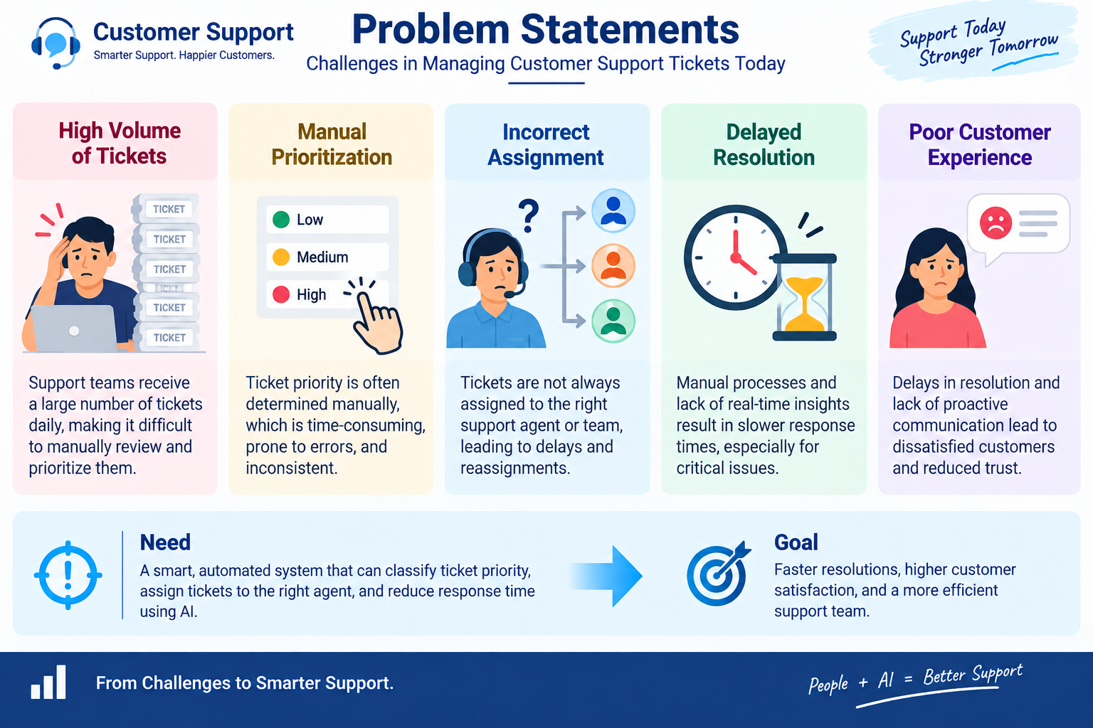
Figure 1: Challenges in managing customer support tickets today
Problem | Who is affected | Impact
Tickets are not prioritized automatically | Support Agent | Frustration, time wasted on sorting
Critical issues wait behind others | Customer | Concern, poor experience
Assignment needs manual decisions | Support Manager | Overwhelmed, inconsistent handling
Urgency keywords can be missed | Support Agent | Uncertainty about what to handle first
Old tickets may cross SLA | Support Manager | SLA risk and penalties

4. Objectives
- Automatically classify support tickets as High, Medium or Low priority.
- Retrieve the latest support ticket associated with a customer Account.
- Reduce manual prioritization and assignment effort.
- Create an urgent handling task for High-priority tickets.
- Assign High-priority tickets to a senior support agent.
- Use Agentforce to analyze ticket details and trigger backend automation.
- Improve ticket response and resolution efficiency.

5. Proposed System in Brief
The proposed system accepts an Account Name through the Agentforce conversation. The Support Ticket Priority Analysis subagent triggers an Auto-Launched Flow. The Flow finds the Account, retrieves its latest Support Ticket Intelligence record, and checks the description for urgency keywords:
Priority | Keywords in description | System response
High | urgent, not working, failure | Urgent task created, Senior Support Agent assigned
Medium | issue, slow, delay | Ticket marked medium, handled shortly
Low | No matching keyword | Ticket queued for processing

The Flow returns the Account Id, Ticket Id, Priority Level, Assigned Agent and an Action Message, and Agentforce shows them to the user in the conversation.

6. Scope of the Project

6.1 In Scope
- Creation and storage of support tickets in the Support Ticket Intelligence object.
- Keyword-based priority analysis of the ticket description.
- Automatic task creation and agent-level assignment for High-priority tickets.
- Optional SLA risk check for tickets older than two days.
- Conversational access through the Agentforce subagent.

6.2 Out of Scope
- Billing, subscription management and account updates (the subagent declines these).
- Sending emails or updating records directly from the agent (all actions go through the Flow).
- Advanced analytics dashboards and full SLA escalation (kept as future scope).

7. Significance of the Project
The project shows how low-code automation and generative AI can work together for a real business need. For support teams, it means urgent tickets are seen first. For customers, it means faster help for critical problems. For managers, it means consistent assignment and early awareness of SLA risk. For students and developers, it is a practical example of using Salesforce Flow and Agentforce together.
Stakeholder | Benefit
Support Agent | Focuses on critical tickets first; less manual sorting
Customer | Urgent issues are resolved quickly
Support Manager | Consistent assignment, reduced SLA risk
Organization | Better productivity and customer satisfaction

8. Overview of the Technologies

8.1 Salesforce Platform
Provides the cloud database, security model, objects, fields and relationships. The custom object Support_Ticket_Intelligence__c stores ticket data and is linked to Account, Contact and User records.

8.2 Salesforce Flow
A visual automation tool. The Auto-Launched Flow used here has no trigger of its own; it is called by Agentforce. It uses Get Records, Assignment, Decision and Create Records elements.

8.3 Agentforce
The AI agent framework of Salesforce. The Default agent is extended with the subagent Support Ticket Priority Analysis, which has a defined scope, step-by-step instructions and a Flow action.

9. Expected Outcomes
- Faster identification of critical tickets.
- Reduced manual effort for agents and managers.
- Improved response time and better team productivity.
- A working, extensible Salesforce solution that can be improved with more rules and analytics.

10. Organization of the Report
Section | Content
README | Overview, setup and usage
Introduction | Background, problem, objectives and scope (this report)
Empathy | Users, empathy map and journey map
Brainstorming | Idea generation and prioritization
Requirement Analysis | Functional and non-functional requirements, data flow, technology stack
Solution Analysis | Problem-solution fit, proposed solution and architecture
Project Planning | Agile plan, backlog, sprints and tracking
Development | Implementation of object, flow, agent, testing and results

