PROJECT REPORT
CUSTOMER SUPPORT TICKET PRIORITY PREDICTION AND AUTOMATED ASSIGNMENT SYSTEM USING AGENTFORCE

1. Introduction
Project planning describes how the work is organized, who does it, and in what order. This project follows the Agile methodology with short sprints. The work is broken down as Epics, then User Stories, then Story Points, and progress is tracked using sprint velocity and a burndown chart.

2. Planning Approach
- Agile methodology with sprint-based execution.
- Epics to Stories to Story Points for breaking down and estimating work.
- Velocity (story points completed per sprint) used for estimation.
- Six sprints of one week (6 working days) each.

3. Team Roles
Team member | Responsibility
Member 1 | Environment setup and Agentforce subagent configuration (Sprint 1 and 4)
Member 2 | Data modeling and task and assignment automation (Sprint 2 and 4)
Member 3 | Account and Contact relationships and SLA management (Sprint 2 and 5)
Member 4 | Flow logic, priority classification and conversational support (Sprint 3 and 6)

4. Product Backlog
Sprint | Epic | Story | User story / task | Pts | Priority | Owner
1 | Developer setup | USN-1 | As a system administrator, I want to configure the Salesforce environment for Support Ticket Intelligence so that the automation can be developed | 3 | High | Member 1
2 | Data modeling | USN-2 | As an admin, I want to create the Support Ticket Intelligence object with required fields and relationships so that ticket information is stored systematically | 5 | High | Member 2
2 | Data modeling | USN-3 | As a support user, I want tickets associated with Accounts and Contacts so that the latest customer ticket can be identified | 3 | High | Member 3
3 | Automation | USN-4 | As a support agent, I want an Auto-Launched Flow to retrieve the latest ticket and analyze its description so that priority is determined automatically | 5 | High | Member 4
3 | Automation | USN-5 | As a support agent, I want tickets classified as High, Medium or Low so that critical issues receive attention first | 5 | High | Member 4
4 | Agentforce and automation | USN-6 | As an AI agent, I want to analyze ticket details and trigger the backend Flow so that manual prioritization is reduced | 8 | High | Member 1
4 | Task and assignment | USN-7 | As a support manager, I want High tickets to create an urgent task and assign the support level so that critical tickets are handled quickly | 5 | High | Member 2
5 | SLA management | USN-8 | As a support manager, I want the system to check SLA breach risk for older unresolved tickets | 5 | Medium | Member 3
6 | Conversational support | USN-9 | As a support user, I want to give an Account Name to Agentforce and receive ticket Id, priority, assigned agent and action message | 5 | Medium | Member 4

5. Sprint Schedule and Estimation
Sprint | Duration | Planned timeline | Focus | Story points
Sprint 1 | 6 days | Week 1 | Developer org and environment setup | 3
Sprint 2 | 6 days | Week 2 | Custom object, fields, Account and Contact links | 8
Sprint 3 | 6 days | Week 3 | Auto-Launched Flow and priority classification | 10
Sprint 4 | 6 days | Week 4 | Agentforce subagent, Flow action, urgent task and assignment | 13
Sprint 5 | 6 days | Week 5 | SLA risk check | 5
Sprint 6 | 6 days | Week 6 | Conversational output, testing and documentation | 5
Total |  | 6 weeks |  | 44

6. Velocity Calculation
Total story points = 3 + 8 + 10 + 13 + 5 + 5 = 44. Number of sprints = 6. Average velocity = 44 / 6 = about 7.3 story points per sprint.
Using the average velocity, the remaining work after any sprint can be estimated. For example, if 8 points are completed in Sprint 2, the remaining 33 points need roughly 4 to 5 more sprints, which matches the plan.

7. Project Tracker and Burndown Chart
Sprint | Points planned | Points completed | Remaining after sprint
Sprint 1 | 3 | 3 | 41
Sprint 2 | 8 | 8 | 33
Sprint 3 | 10 | 10 | 23
Sprint 4 | 13 | 13 | 10
Sprint 5 | 5 | 5 | 5
Sprint 6 | 5 | 5 | 0

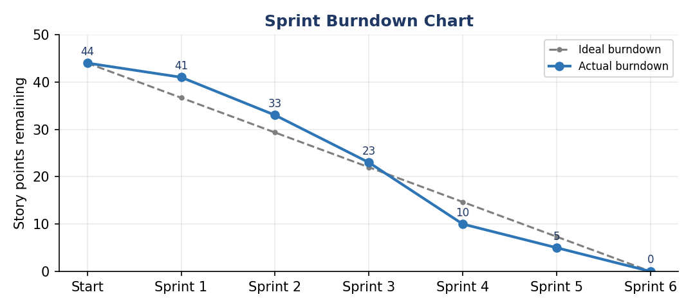
Figure 1: Sprint burndown chart

8. Milestones
Milestone | Description | Deliverable
M1 | Salesforce account created and activated | Developer org ready
M2 | Data management: custom object and fields | Support Ticket Intelligence object
M3 | Flow logic complete | Support_Ticket_Intellegence flow (active)
M4 | Agentforce configuration | Subagent and Flow action
M5 | Testing and documentation | Test results and project report

9. Risk Management
Risk | Impact | Response
Agentforce not enabled in the org | High | Enable through Salesforce Go in Sprint 1
Flow logic errors | Medium | Debug with test records before linking to the agent
Scope growth | Medium | Keep extra ideas in future scope; follow the backlog
Time shortage | Medium | Move Medium-priority stories to the next sprint

10. Testing Plan
- Unit testing of the Flow with sample tickets for High, Medium and Low descriptions.
- Integration testing of the Agentforce action with the Flow in Conversation Preview.
- Verification of task creation and assignment for High-priority tickets.

