PROJECT REPORT
CUSTOMER SUPPORT TICKET PRIORITY PREDICTION AND AUTOMATED ASSIGNMENT SYSTEM USING AGENTFORCE

1. Introduction
Requirement analysis defines exactly what the system must do and under which conditions. It translates the user needs found in the empathy and brainstorming phases into clear, testable requirements. This report covers the functional requirements, non-functional requirements, user stories, data requirements, data flow and technology stack of the system.

2. Functional Requirements
FR No. | Requirement | Description
FR-1 | Support ticket creation and management | Store tickets with issue type, description, status and dates
FR-2 | Account and Contact association | Link each ticket to an Account and a Contact
FR-3 | Ticket description analysis | Read the description and look for urgency keywords
FR-4 | Automatic priority classification | Set priority as High, Medium or Low
FR-5 | High-priority task creation | Create the task "Urgent Ticket Handling" for High tickets
FR-6 | Support agent assignment | Assign High tickets to a Senior Support Agent
FR-7 | SLA breach risk checking | Flag older unresolved tickets as SLA risk
FR-8 | Agentforce conversational analysis | Accept Account Name and return result in conversation

3. Non-Functional Requirements
NFR | Description
Usability | Clear Agentforce interaction and understandable priority messages
Reliability | Consistent priority classification based on configured conditions
Performance | Quick retrieval and analysis of the latest support ticket
Security | Controlled Salesforce access to customer and ticket information
Maintainability | Flow and Agentforce configuration can be updated easily
Scalability | Supports increasing ticket volumes through Salesforce automation

4. User Stories
ID | User story
US-1 | As a support agent, I want tickets classified automatically so that critical issues get attention first.
US-2 | As a support manager, I want High-priority tickets to create an urgent task and be assigned to a senior agent so that they are handled quickly.
US-3 | As a support user, I want to give an Account Name to Agentforce and receive the ticket Id, priority, assigned agent and action message.
US-4 | As a support manager, I want older unresolved tickets checked for SLA risk so that breaches can be avoided.
US-5 | As an administrator, I want to configure the Support Ticket Intelligence object and Flow so that the automation can be maintained.

5. Data Requirements
All ticket data is stored in the custom object Support Ticket Intelligence (API name: Support_Ticket_Intelligence__c).
Field label | API name | Data type | Purpose
Ticket Number | Ticket_Number__c | Auto Number | TKT-{0000}
Customer | Customer__c | Lookup (Account) | Related Account
Contact | Contact__c | Lookup (Contact) | Customer contact
Issue Type | Issue_Type__c | Picklist | Technical, Billing, General
Description | Description__c | Long Text Area | Issue details
Priority Level | Priority_Level__c | Picklist | Low, Medium, High
Status | Status__c | Picklist | New, In Progress, Resolved
Created Date | Created_Date__c | Date | Ticket date
Assigned To | Assigned_To__c | Lookup (User) | Support agent
SLA Breach Risk | SLA_Breach_Risk__c | Checkbox | Risk flag
Resolution Time (hrs) | Resolution_Time__c | Number | Time taken

6. Data Flow
The data flows from the user request through Agentforce and the Flow, and back to the user as a final response.
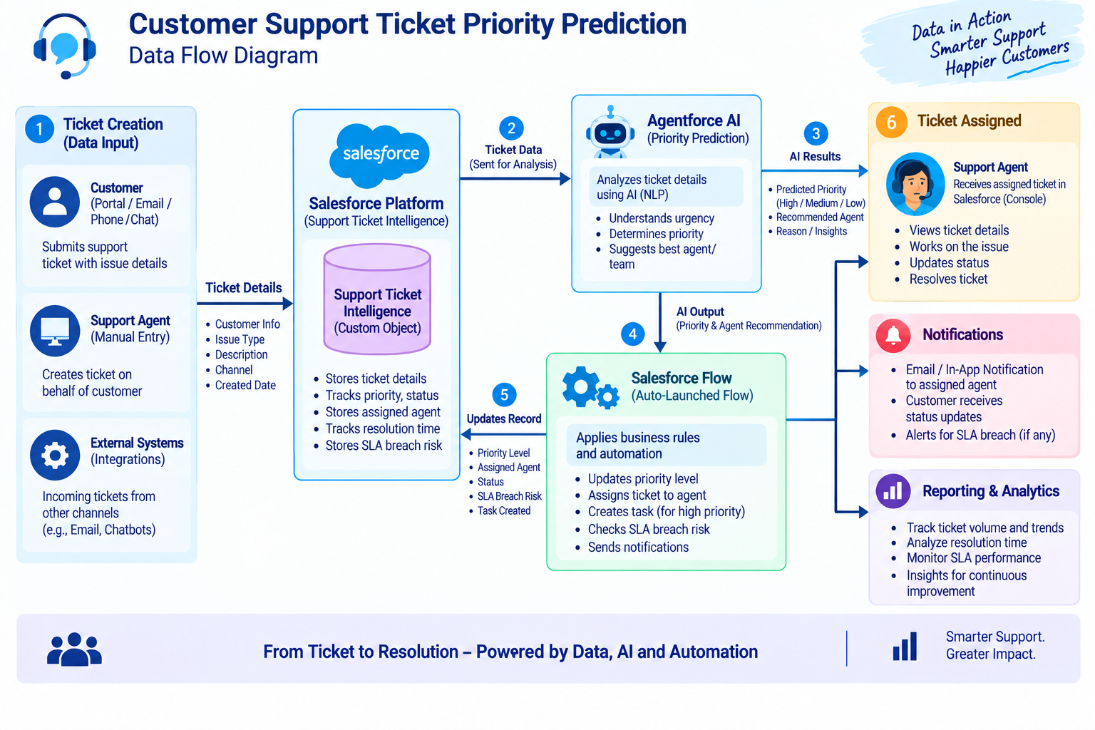
Figure 1: Data flow diagram
Flow: Customer / Support Request, Account, Latest Support Ticket, Ticket Description, Analyze Description, Priority Level, High/Medium/Low Decision, Agent Assignment, High-Priority Task (if applicable), Final Response.
Agentforce path: User provides Account Name, Agentforce Support Ticket Priority Analysis, Auto-Launched Flow, Ticket Analysis, Priority and Assignment Output, Response to User.

7. Flow Variables
Type | Label | API name | Data type
Input | Account Name | varAccountName | Text
Output | Account Id | varAccountId | Text
Output | Ticket Id | varTicketId | Text
Output | Priority Level | varPriorityLevel | Text
Output | Assigned Agent | varAssignedTo | Text
Output | Action Message | varActionMessage | Text

8. Technology Stack
Layer | Technology
Platform | Salesforce
Database | Support_Ticket_Intelligence__c with Account, Contact, User and Task records
Logic | Auto-Launched Flow
AI | Agentforce
Agent configuration | Support Ticket Priority Analysis subagent
Automation | Flow Decision, Assignment and Create Records
Output | Agentforce conversation response

9. Software and Hardware Requirements
- Software: Salesforce Developer Edition org with Agentforce enabled; a modern web browser (Chrome or Edge).
- Hardware: Any computer with internet access and at least 4 GB RAM.
- Users: Admin access to create objects, flows and agents; support user access to the Agentforce panel.

10. Assumptions and Constraints
- Every ticket is linked to an Account, and the Account Name given by the user is correct.
- Priority is based on configured keywords: urgent, not working, failure (High) and issue, slow, delay (Medium).
- The Agentforce subagent handles only ticket analysis and priority; billing and subscription requests are out of scope.
- The agent does not update records or send emails directly; all actions run through the Flow.

