PROJECT REPORT
CUSTOMER SUPPORT TICKET PRIORITY PREDICTION AND AUTOMATED ASSIGNMENT SYSTEM USING AGENTFORCE

1. Introduction
Solution analysis explains how the proposed system solves the identified problems, why the chosen approach is suitable, and how the system works internally. It covers problem-solution fit, the proposed solution, the priority decision logic, the architecture, feasibility and risks.

2. Problem-Solution Fit
Each problem found during the empathy and requirement phases is matched with a feature of the solution and the benefit it gives.
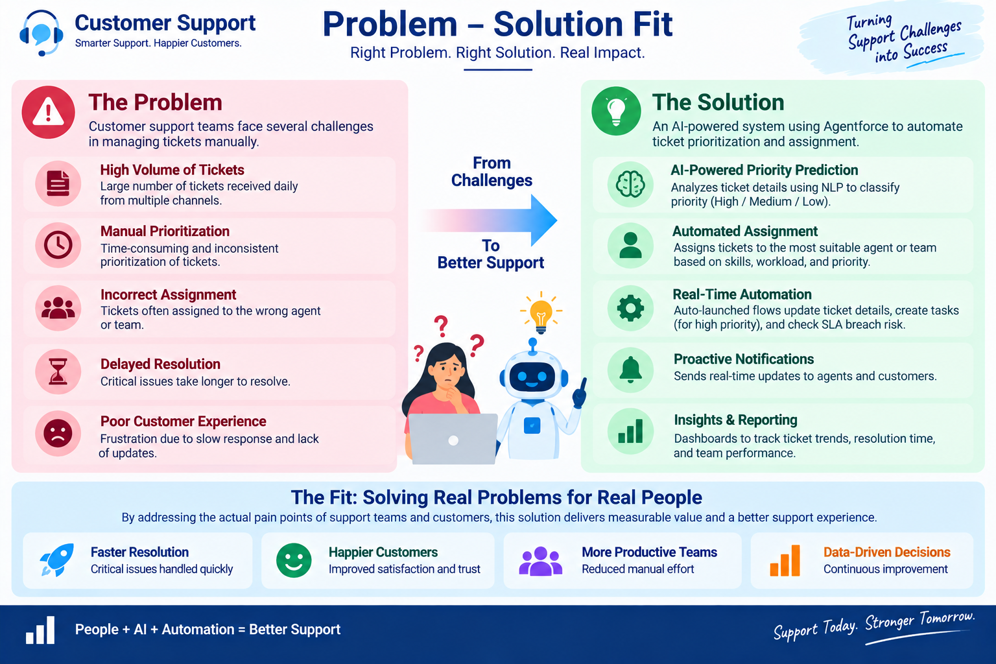
Figure 1: Problem-solution fit
Problem | Solution | Benefit
Manual ticket prioritization | Flow analyzes the description and sets priority | Faster identification of urgent cases
Urgent issues may be missed | High-priority keyword decision | Critical cases receive attention
Manual task creation | Flow creates a Task for High priority | Reduced manual effort
Manual support assignment | Flow sets the assigned support level | More consistent handling
SLA risk can be overlooked | Optional SLA risk decision | Better risk awareness
Need for conversational access | Agentforce subagent with AI-assisted interaction | Easy use for support users

3. Proposed Solution
Parameter | Description
Problem | Manual ticket prioritization and assignment causing delays in handling critical customer support issues
Solution | Salesforce-based Customer Support Ticket Priority Prediction and Automated Assignment System
Innovation | Agentforce AI plus Auto-Launched Flow for analyzing ticket descriptions, classifying priority, assigning support level and triggering urgent-task automation
Impact | Faster identification of critical tickets, reduced manual effort, improved response time and better team productivity
Business model | Customer support operations involving customers, support agents, support managers and AI-assisted ticket handling
Scalability | Supports increasing ticket volumes through Salesforce automation, with scope for more assignment rules, SLA monitoring and priority indicators

4. Solution Architecture
Users talk to Agentforce. The subagent Support Ticket Priority Analysis calls the Auto-Launched Flow, which works on Account and ticket data in Salesforce, analyzes the description, decides the priority, creates a task or assignment, and sends the final message back to the agent.
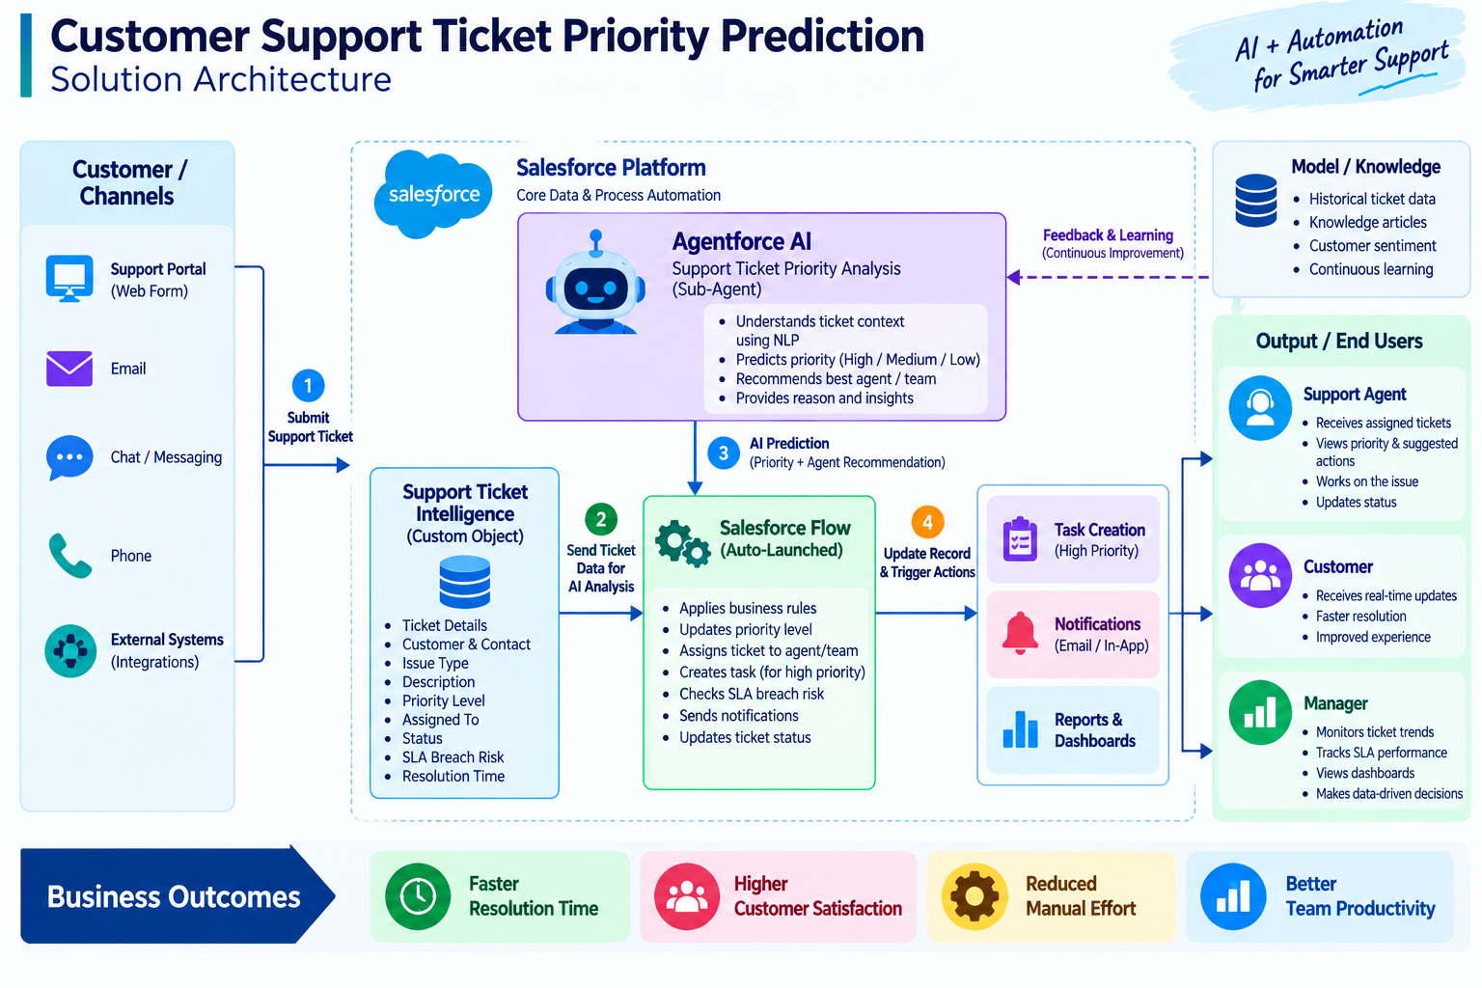
Figure 2: Solution architecture
Component chain: Users / Support Team, Agentforce, Support Ticket Priority Analysis, Auto-Launched Flow, Account and Ticket Data, Description Analysis, Priority Decision, Task / Assignment, Final Message, Agentforce Response.

5. Priority Prediction Logic
The Flow uses a Decision element called Analyze Description with CONTAINS conditions on the ticket description. The first matching outcome decides the priority; if nothing matches, the default outcome Low Priority is used.
Priority | Keywords checked | Variable set | Final message
High | urgent, not working, failure | varPriorityLevel = High | High priority ticket detected. Assigned to senior agent.
Medium | issue, slow, delay | varPriorityLevel = Medium | Ticket marked as medium priority. Will be handled shortly.
Low | Default (none of the above) | varPriorityLevel = Low | Tickets are low priority and queued for processing.

5.1 Assignment Rules
- High priority: a Task named Urgent Ticket Handling (Priority = High, Status = Not Started) is created and linked to the ticket; varAssignedTo is set to Senior Support Agent.
- Medium and Low priority: the ticket continues in the normal queue with a status message.
- Optional SLA check: if the ticket Created Date is older than 2 days, an internal flag or message is raised.

6. Working of the Solution (Step by Step)
- The user asks Agentforce to analyze a support ticket; the agent asks for the Account Name.
- The Flow gets the Account whose Name equals the input and stores the Account Id.
- The Flow gets the latest Support Ticket Intelligence record of that Account and stores the Ticket Id.
- The Decision element checks the description for keywords and the priority is set.
- If the priority is High, a Task is created and the Senior Support Agent is assigned.
- The Flow sets the Action Message and returns all outputs to Agentforce.
- Agentforce displays the Account Id, Ticket Id, Priority, Assigned Agent and message.

7. Feasibility Analysis
Type | Assessment
Technical | Feasible. Uses standard Salesforce features: custom objects, Flow and Agentforce. No external system is needed.
Economic | Feasible. A free Developer Edition org is enough for building and testing; no separate software cost.
Operational | Feasible. Support users only type an Account Name; the rest is automatic.
Schedule | Feasible. Can be completed in six one-week sprints.

8. Strengths and Limitations
Strengths | Limitations
Automatic prioritization and assignment | Keyword-based logic may miss other urgency signals
Conversational interface through Agentforce | Depends on correct Account, Contact and ticket data
Easy to modify in Flow without code | Agent behavior depends on proper subagent instructions
Scalable with Salesforce automation | SLA monitoring and analytics are basic in current scope

9. Risk Analysis
Risk | Likelihood | Mitigation
Wrong priority because of missing keywords | Medium | Review and extend keyword list regularly
Account name typed incorrectly | Medium | Agent asks again; use exact Account Name
Flow not activated or agent inactive | Low | Verify activation before testing and deployment
Duplicate tasks for the same ticket | Low | Add a check for an existing open task before creating a new one

10. Conclusion
The analysis shows that the proposed solution directly answers the identified problems, is technically and economically feasible, and can grow with future rules and analytics.

