Progress: Your Path to Success (Workout Website)

Erika McCluskey

Jacob Meyer

Favor Fasunwon

Software Engineering Management

December 8th, 2020

Table of Contents

**Abstract…………………………………………………………………………………………...3**

**Introduction………………………………………………………………………………………4**

**Discussion………………………………………………………………………………………...4**

Why, What, Who………………………………………………………………………………..4

Supporting Documents………………………………………………………………………….5

Code Breakdown………………………………………………………………………………..6

Future MVP ……………………………………………………………………………………..8

Reflection……………………………………………………………………………………….8

**Conclusion…………………………………………………………………………………...…...9**

List of Figures

Figure 1: Landing Page………………………………………………………………………… 6

Figure 2: Community Workouts Page…………………………………………………………...7

Figure 3: Workout Builder Page…………………………………………………………............7

Figure 4: Exercises Page………………………………………………………….......................8

**Abstract**

Group work is a revolutionary process where individuals from different backgrounds come together to accomplish a given task, such as creating a website. “Progress: your path to success”, is a workout website built by Erika, Jacob, and Favor to enable any individual to begin or continue their fitness journey. The specifications/features on this website allow users to dynamically explore various applications which are intended to guide their progress on meeting their personal fitness goal. This website was solely built on users’ experiences/stories of how individuals will balance exercising with their other daily activities. Features within this website such as the workout builder and the community workouts allow users to create and browse through workouts where they can choose various exercises that will benefit their health both physically and mentally.

**Introduction**

Exercising is a productive physical activity that engages the mind as well as the body to always perceive the world in positivity. The benefits of exercising are astronomical, for example, it prevents a range of diseases and other health issues. As a group, Erika, Jacob, and Favor, we decided to enlighten our passion for exercising as well as spread awareness of exercising to individuals. Thus, we came up with a website application which tackles this task; Progress: your path to success, is a web application that fulfills an individual’s wants and needs in terms of reaching their fitness goals to live a healthier lifestyle. Features within this website such as the workout builder, allows for individuals to create a workout, based on their preference, allowing them to target an area on their body they want to improve. Through this report, we will address the details and specifications of our web application and how it will enable individuals to begin or continue their fitness journey.

**Discussion**

The process of creating this web application goes as follows: diving into why we want to build this app, what this app will look like, and the audience that is being targeted to use this app. More so, we created some documents which laid out the specifics of our web application as well as illustrated how the web application would look like in terms of directing the user to different pages. In addition, the code breakdown of creating this web app will be discussed which includes how the user’s data is stored and passed throughout the website.

**Why, What, Who**

Any software created must pertain to a “why” it was created, “what” it is used for and “who” it is designed for. While brainstorming, our group had one thing in common, and that was being engaged with fitness. Given our common interest and passion for this topic, it was decided that a great idea for this project was a workout application. This idea got us thinking and made us ponder why we wanted to build this app and who it was intended for. The central idea to our “why” addresses the fact that individuals need to prioritize their health, especially currently during COVID-19 where it is easy for one to adopt unhealthy habits. Living a healthy lifestyle should be an important goal for all individuals as our bodies need to be taken care of on a regular basis.

This web app was created for all individuals who are willing to achieve this goal. With multiple simple features, an individual can easily go to our website and find themselves at ease in terms of beginning their fitness journey on a “path to success”. Our website is a minimum viable product (MVP) because our completed product allows a user to do everything that is required for a basic workout tracker. A user can: create a workout and specify each exercise and its reps, sets, and/or duration, browse through various exercises that include a photo demonstration and a list of targeted muscles to help the user understand and visualize what the exercise would achieve, and browse through a list of workouts, called community workouts, that other members have created. The community workouts allow users to explore other individual’s ideas of efficient and effective workouts. This segment of our website is intended to encourage users to branch out of their own regular exercise regime and experiment with newer and tougher exercises.

**Supporting Documents**

To begin our process of implementing this website, we started by instantiating some foundations by using specific documents which would help validate the process of creating this website. Our project scope statement document provides a clear rationale of what our MVP should include while the roles and responsibility document states what each member of the group is responsible for. Our architectural design documents such as the lo-fi (low fidelity) sketches, ERD (entity relationship diagram), and the data flow diagram presented a path to begin the implementation of the front and back end. The lo-fi sketches were used as the template for how the front end would look like and how the user’s data would be presented. The ERD and the data flow diagram were mostly used for the back-end development; they clearly show the relationships between entities within the website, as well as the passing of user’s data from one page to another. Following these documents really aligned our perspective with the goal we wanted to achieve within construction of this website. As the implementation process began and carried on, these documents were updated respectively as our MVP was reduced from a “fitness social” website that focused on community engagement to a “fitness tracker” that provides a single user the means to create and record the completion of custom workouts.

**Code Breakdown**

 Our website was created starting with the landing page, the first page the user sees, which incorporates a model that keeps the user’s data of completed workouts on a table. The table dynamically updates as the user marks a specific workout as completed. The three buttons displayed in Figure 1 are used to direct the user to explore other pages on the website. To make the coding process more efficient and effective, bootstrap was used to add fashionable attributes to the front end which overall made the coding process a bit easier.

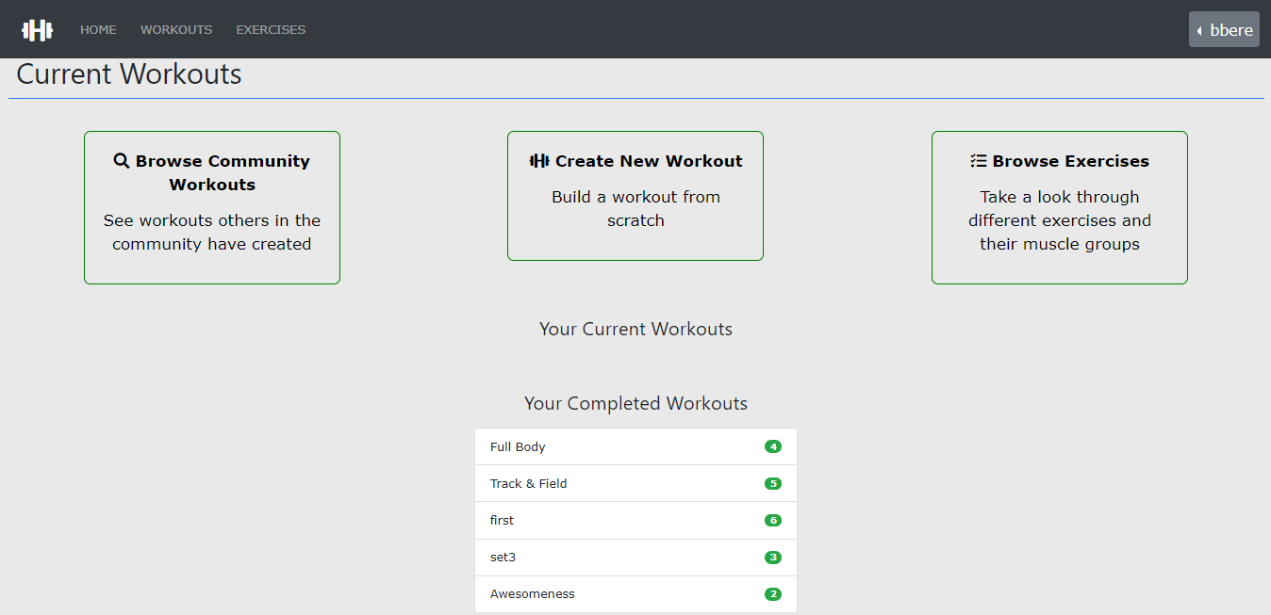

Figure 1: Landing page

As depicted in Figure 3 and 4, the user can view their created workouts as well as other users' created workouts. The model of this page includes storing the user’s data from creating a workout on the workout builder page, shown in Figure 4, and displaying it on the community workouts page.

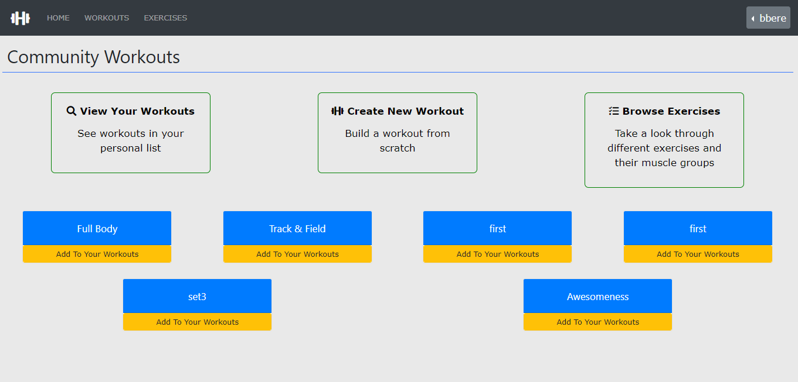

Figure 2: Community Workouts Page

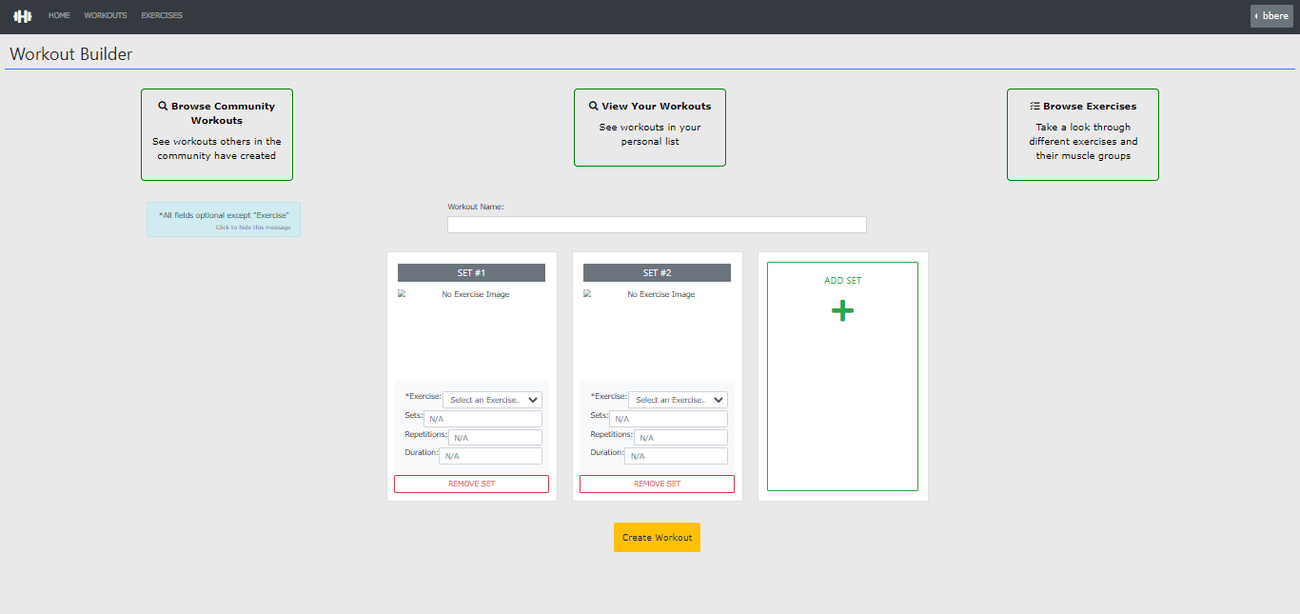

Figure 3: Workout Builder Page

The exercise page, shown in Figure 4, is a generic illustration of the different types of exercises that can be done. This page includes a model which has some exercises pre-stored in the database. The users can then view these exercises while performing their workouts to observe which muscle group or groups are being targeted.

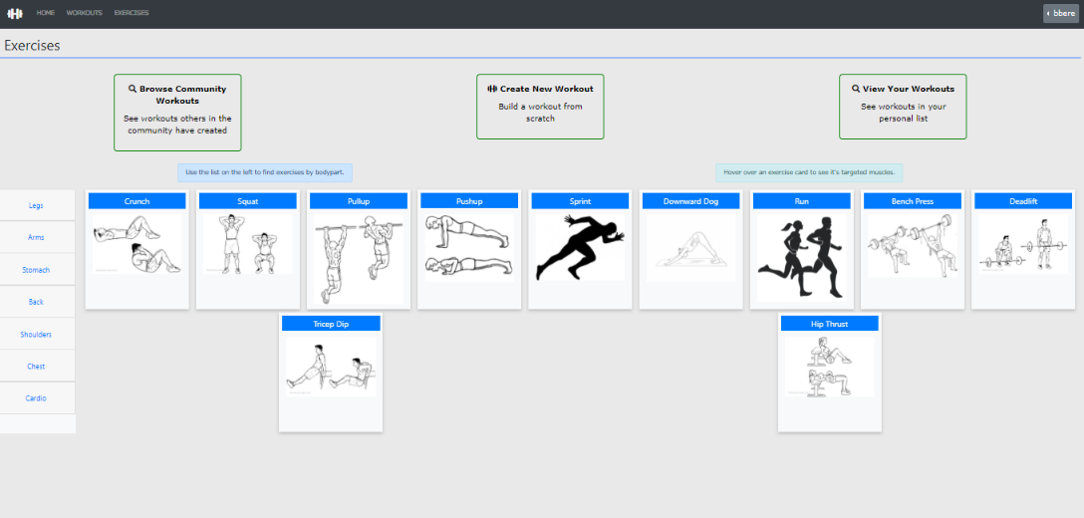

Figure 4: Exercises Page

**Future MVP**

The goal of this project was to implement a fully functional workout app with a unique feature of an open community forum where users could interact with each other providing tips on living healthy and recommending great exercises for specific parts of the body. However, this feature required more time to implement which, unfortunately, could not be possible as we were only assigned three weeks to complete a fully functional web app. It was then decided to narrow down our MVP for a single user who can create and view their current and completed workouts. The community forum along with other gamification features, such as goal definition and tracking, were reinstated as future MVPs; these features are merely additions to our website that make it more engaging for the users.

**Reflection**

This project was an interesting process as we got to learn more about each other as well as tactics to accomplish any given task as a group. We were successful in completing this project, however, throughout the process, we learnt that communication is key and without it, there is no chance a group can accomplish any assigned task. The concept of communication was emphasized on the weekend of November 20th, 2020 where, as a group, we had a miscommunication of which member was responsible for which part of the website. This miscommunication led to two members working on the same code and ended up with some code being of no use and having to be discarded. In such a short ‘sprint’ period, time is precious, and this error obviously led to some wasting of time.  Although this miscommunication was a step back for us, we believe it was a great way to get closer as a group. Following this error, our group had a meeting and discussed ways to prevent something like this from happening again. We agreed on adding better commit comments when pushing to GitHub and to properly name our files.

Throughout the project, we were able to recognize the strengths of each member and take initiative accordingly. Initially, our process to create this website was for each member to work on specific areas of the website (e.g., front-end, back-end, etc.). We quickly realized that given each member’s expertise, we often had to reach out for help. Our initial idea of having every member work on a singular part was shifted to a more collaborative coding environment in the sense that everyone ended up adding some form of code to the model, view, and controller of the website.

Feedback from our peers was quite generic, however, it did make us aware of scope creep in a sense that we should create a more realistic MVP which could be realized within the three-week ‘sprint’. Our professor Dr. Timothy Maciag’s feedback was the most impactful as it provided possible solutions to rationalize our website to become a viable MVP. In the end, this project was a success as we transformed an idea to a fully functional website and had fun implementing it in the process.

**Conclusion**

The completed project contains a fully functional workout builder, an engaging community workouts page, and an elaborate resource of exercises that includes a photo demonstration along with a list of targeted muscles. Our workout application is gratified as a useful tool for a user to continue or begin their fitness journey and to live a healthy lifestyle. The “why” behind this website still stays the same as we are trying to give back to the world and encourage individuals to take care of their mind and body and to feel confident and empowered. Overall, this project was an amazing experience as it gave us, Erika, Jacob, and Favor, insight to new software and coding techniques such as NodeJS and jQuery implementations. More so, this project highlights key components software engineers must possess to flourish out in industry, as well as software engineering management skills which are of great skill in making an individual a well-rounded software engineer.