Paper Title

Author(s) Name(s)
Author Affiliation(s)
E-mail

Abstract
The abstract is to be in fully-justified italicized text as it is here, below the author information. Use the word “Abstract” as the title, in 12-point Times New Roman, boldface type, centered relative to the column, initially capitalized. The abstract is to be in 11-point, single-spaced type, and may be up to 3 in. (18 picas or 7.62 cm) long. Leave two blank lines after the abstract, and then begin the main text. All manuscripts must be in English.

Keywords: We would like to encourage you to list your keywords in this section

1. Introduction
Congratulations! Your paper has been accepted for journal publication. Please follow the steps outlined below when submitting your final draft to the SERSC Press. These guidelines include complete descriptions of the fonts, spacing, and related information for producing your proceedings manuscripts. Please follow them and if you have any questions, direct them to the production editor in charge of your journal at the SERSC, sersc@sersc.org.

2. Formatting your Paper
All printed material, including text, illustrations, and charts, must be kept within the parameters of the 8 15/16-inch (53.75 picas) column length and 5 15/16-inch (36 picas) column width. Please do not write or print outside of the column parameters. Margins are 3.3cm on the left side, 3.65cm on the right, 2.03cm on the top, and 3.05cm on the bottom. Paper orientation in all pages should be in portrait style.

3. Main Title
The main title (on the first page) should begin 1 3/16 inches (7 picas) from the top edge of the page, centered, and in Times New Roman 14-point, boldface type. Capitalize the first letter of nouns, pronouns, verbs, adjectives, and adverbs; do not capitalize articles, coordinate conjunctions, or prepositions (unless the title begins with such a word) (e.g. A Comparative Study of Privacy Protection Methods for Smart Home Environments). Please initially capitalize only the first word in other titles, including section titles and first, second, and third-order headings (for example, “Titles and headings” — as in these guidelines). Leave two blank lines after the title.

4. Author Name(s) and Affiliation(s)
Author names and affiliations are to be centered beneath the title and printed in Times New Roman 12-point, non-boldface type. (See example below)

4.1. Affiliations
Affiliations are centered, italicized, not bold. Include e-mail addresses if possible.

For example:

Author¹, Author² and Author³
¹Affiliation
²Affiliation
³Affiliation
¹Email, ²Email, ³Email

4.2. Corresponding Author
Corresponding author should have an asterisk sign (*) if possible, after the corresponding author’s name. The Corresponding author (e.g., *Corresponding Author) label should be appeared at the footnote section of the first page of the paper, Times New Roman in style and 10 in font size.

5. Second and Following Pages
The second and following pages should begin 1.0 inch (2.54 cm) from the top edge. On all pages, the bottom margin should be 1-3/16 inches (2.86 cm) from the bottom edge of the page for 8.5 x 11-inch paper; for A4 paper, approximately 1-5/8 inches (4.13 cm) from the bottom edge of the page.

6. Type-style and Fonts
Wherever Times New Roman is specified, Times New Roman may be used. If not available in your word processor, please use a font closest to Times New Roman that you have access to. Please avoid using bit-mapped fonts if possible. True-Type 1 fonts are preferred.

7. Main Text
Type your main text in 11-point Times New Roman, single-spaced. Do not use double-spacing. All paragraphs should be indented 1 pica (approximately 1/6- or 0.17-inch or 0.43 cm). Be sure your text is fully justified, flush left and flush right. Please do not place any additional blank lines between paragraphs.

7.1. Tables
Place tables as close as possible to the text they refer to and aligned center. A table is labeled Table and given a number (e.g., Table 1. Sample Datasheet with Attributes in Linguistic Term) it should be numbered consecutively. The table label and caption or title appears 12pt space above the table, 6pt space after the text or paragraph if any; it should be uniforms fonts and font size, and use 11pt font size and Helvetica style, capitalized similar to paper title, aligned center and bold face. Sources and notes appear below the table, aligned left. All tables must be in portrait orientation.

For Example:
Table 1. Table Label

7.2. Figures
Place figures as close as possible to the text they refer to and aligned center. Photos, graphs, charts or diagram should be labeled Figure (do not abbreviate) and appear 6pt space below the figure, 12pt space before the next text or paragraph, and assigned a number consecutively. The label and title should be in line with the figure number (e.g., Figure 1. Location Error Rate of Three Schemes), it should be uniforms fonts and font size; use 11pt font size and Helvetica style, capitalized similar to paper title, aligned center and bold face. Source (if any) appear underneath, flush left. Figures should be at good enough quality. Minimum image dimensions are 6 cm (2.3622 in) wide by 6 cm (2.3622 in) high.

For Example:

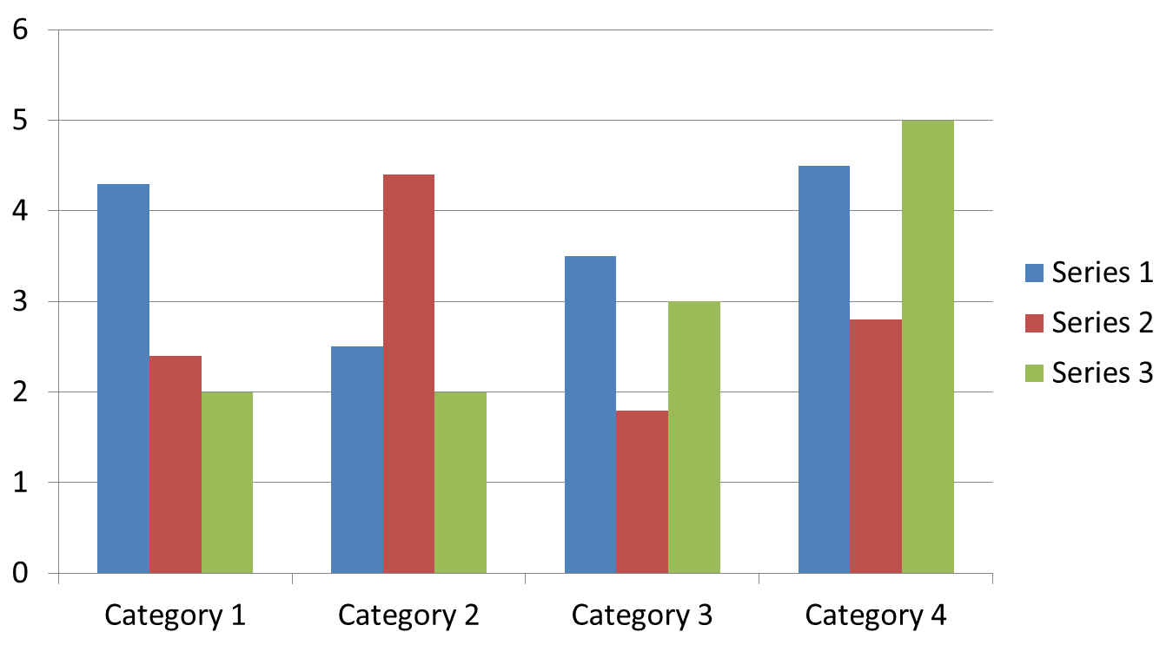

Figure 1. Figure Label
7.3. Equations
Including symbols and equations in the text, the variable name and style must be consistent with those in the equations. Equations should be indented at the left margin and numbered at the right margin, equation number is enclosed with open and close parenthesis () Time New Roman in style and 11pt font size. Deﬁne all symbols the ﬁrst time they are used. All equation symbols must be defined in a clear and understandable way.

For Example:

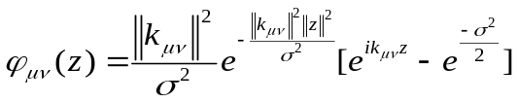 (1)

8. First-order Headings
For example, “1. Introduction”, should be Times New Roman 13-point boldface, initially capitalized, flush left, with one blank line before, and one blank line after.

8.1. Second-order Headings (Sub-heading)
As in this heading, they should be Times New Roman 11-point boldface, initially capitalized, flush left, with one blank line before, and one after.

8.1.1. Third-order Headings: Third-order headings, as in this paragraph, are discouraged. However, if you must use them, use 11-point Times New Roman, boldface, initially capitalized, flush left, and proceeded by one blank line, followed by a colon and your text on the same line.

9. Footnotes
Use footnotes sparingly (or not at all) and place them at the bottom of the column of the page on which they are referenced to. Use Times New Roman 9-point type, single-spaced. To help your readers, avoid using footnotes altogether and include necessary peripheral observations in the text (within parentheses, if you prefer, as in this sentence).

Appendix
An appendix, if needed, should appear before the acknowledgments.

Acknowledgments
These should be brief and placed at the end of the text before the references.

References
List and number all bibliographical references in 9-point Times New Roman, fully justified, single-spaced, at the end of your paper. When referenced in the text, enclose the citation number in square brackets, for example [1]. Do not abbreviate the months. Don’t forget to put period (.) at the end of each reference. (See examples below)

11.1. Journal Article
- C. D. Scott and R. E. Smalley, “Diagnostic Ultrasound: Principles and Instruments”, Journal of Nanosci. Nanotechnology., vol. 3, no. 2, (2003), pp. 75-80.

11.2. Book
- H. S. Nalwa, Editor, “Magnetic Nanostructures”, American Scientific Publishers, Los Angeles, (2003).

11.3. Chapter in a Book
- H. V. Jansen, N. R. Tas and J. W. Berenschot, “Encyclopedia of Nanoscience and Nanotechnology”, Edited H. S. Nalwa, American Scientific Publishers, Los Angeles, vol. 5, (2004), pp. 163-275.

11.4. Conference Proceedings
- J. Kimura and H. Shibasaki, “Recent Advances in Clinical Neurophysiology”, Proceedings of the 10th International Congress of EMG and Clinical Neurophysiology, Kyoto, Japan, (1995) October 15-19.

11.5. Patent
- C. E. Larsen, R. Trip and C. R. Johnson, “Methods for procedures related to the electrophysiology of the heart”, U.S. Patent 5,529,067, (1995) June 25.

Do not use the phrases "et al." and "ibid." in the reference section. Instead, the names of all authors in a reference must be listed.

12. Copyright Forms
You must include your fully-completed, signed SERSC copyright release form when you submit your paper. We must have this form before your paper can be published in the JOURNAL. The copyright form is available from journal home page. Authors should send their copyright forms to FAX. +82-70-7614-3027 or E-mail journal@sersc.org.

Authors

Author’s Name, Author’s profile.
Author’s picture
should be in grayscale.

Picture size should be absolute 3.18cm in height and absolute 2.65cm in width



