Project (Submission required)：

**Warning:** This is a long programming project designed for a study load for three weeks of estimated 3*8 = 24 hours. It is challenging at both conceptual level and implementation level. You must distribute the load in the given three weeks. You would not have enough time to complete it if you start the project only in the last week before the project is due.

**Description:** Consider that you are creating a simplified hotel block booking system that involves hotel retailers (agencies) and wholesalers (hotel chains). The system consists of multiple travel agencies (clients), e.g., hotels.com, hotwire.com, and priceline.com, where they can book blocks of hotel rooms, and multiple hotel chains (servers), e.g., Days Inn, Holiday Inn, and Hilton, that supply blocks of hotel rooms to the agencies. The required architecture and the major components of the system are shown in the diagram below.

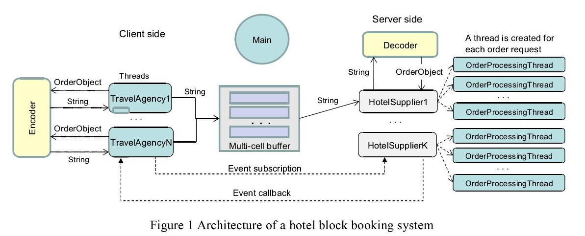

An **Operation Scenario** of the hotel block booking system is outlined below:

(1) The **HotelSupplier** uses a pricing model to calculate the room price. If the new price is lower than the previous price, it emits a (promotional推销) event and calls the event handlers in the travel agencies that have subscribed to the event.

(2) A **TravelAgency** evaluates the price, generates an OrderObject (consisting of multiple values), and sends the order to the Encoder to convert the order object into a plain string.

(3) The **Encoder** converts the object into a string.

1. The Encoder sends the encoded string back to the caller.
2. The TravelAgency sends the encoded string to one of the free cells in the **MultiCellBuffer**.
3. The **HotelSupplier** receives the encoded string from the MultiCellBuffer and sends the string to the Decoder for decoding.
4. The **Decoder** sends the OrderObject to the HotelSupplier. The decoded object must contain the same values generated by the TravelAgency.
5. The HotelSupplier creates a new thread to process the order;
6. The **OrderProcessingThread** processes the order, e.g., checks the credit card number and calculates the amount.
7. The OrderProcessingThread sends a confirmation to the travel agency and prints the order (on screen).

**Components** in the diagram are explained in details as follows, with their grades (points) allocation:

1. **HotelSupplier1**（程序中只创建一个供应商） are the objects of a class on the server side: Each object has method to be started as a thread by the Main method and will perform a number of functions. It uses a PricingModel to determine the room prices. It defines a price-cut event that can emit an event and call the event handlers in the TravelAgencys if there is a price-cut according to the PricingModel. It receives the orders (in a string) from the MultiCellBuffer. It calls the Decoder to convert the string into the order object. For each order, you can use the existing thread or start a new thread (resulting in multiple threads for processing multiple orders) from OrderProcessing class (or method) to process the order based on the current price. There is a counter p in the HotelSupplier. After p (e.g., p = 10) price cuts have been made, a HotelSupplier thread will terminate. [20 points]
2. **PricingModel**: It can be a class or a method in HotelSupplier class. It decides the price of rooms. It can increase price or decrease the price. You must define a mathematical model (random function is fine) to determine the price based on the order received within a given time period and the number of rooms available in the HotelSupplier in the same time period. You can use a hard-coded table of the price in each week day. However, you must make sure that your model will allow the price goes up some time and goes down some other time. [10 points]
3. **OrderProcessing** is a class or a method in a class on the supplier’s side. Whenever an order needs to be processed, a new thread is instantiated from this class (or method) to process the order. It will check the validity of the credit card number. you can define your credit card format, for example, the credit card number from the travel agencies must be a number registered to the HotelSupplier, or a number between two given numbers (e.g., between 5000 and 7000). Each OrderProcessing thread will calculate the total amount of charge, e.g., unitPrice*NoOf Rooms. [10 points]
4. **TravelAgency1** through **TravelAgencyN**, each travel agency is a thread instantiated from the same class (or the same method) in a class. The travel agency’s actions are event-driven. Each travel agency contains a call-back method (event handler) for the HotelSuppliers to call when a price-cut event occurs. The travel agency will calculate the number of rooms to order, for example, based on the need and the difference between the previous price and the current price. The thread will terminate after the HotelSupplier thread has terminated. Each order is an OrderClass object. The object is sent to the Encoder for encoding. The encoded string is sent back to the travel agency. Then, the travel agency will send the order in String format to the MultiCellBuffer. Before sending the order to the MultiCell Buffer, a time stamp must be saved. When the confirmation of order completion is received, the time of the order will be calculated and saved (or printed). You can set N = 5 in your implementation. [10 points]
5. **OrderClass** is a class that contains at least the following private data members:

* sender Id: the identity of the sender, you can use thread name or thread id;
* card No: an integer that represents a credit card number;
* amount: an integer that represents the number of room to order;

You must use public methods to set and get the private data members. You must decide if these methods need to be synchronized. The instances created from this class are of the OrderObject. [10 points]

1. **MultiCellBuffer** class is used for the communication between the travel agencies (clients) and the HotelSupplier (server): This class has 2 data cells. The number of cells available must be less than (<) the max number of travel agencies in your experiment. A setOneCell and getOneCell methods can be defined to write data into and to read data from one of the available cells. You must use a semaphore of value n to manage the cells and use a lock on each buffer cell. You cannot use a queue for the buffer, which is a different data structure. The semaphore will allow an agency to gain the right to write into one of the buffer cells. But the HotelSupplier can still read at the same time. Synchronization is also required. [10 points]
2. **Encoder** is a class or a method in a class: The Encoder class will convert an OrderObject into a string. You can choose any way to encode the values into a string, as long as you can decode the string to the original order object. You can use a class or a method to implement the Encoder. [10 points]
3. **Decoder** is a class or a method in a class: The Decoder will convert the encoded string back into the OrderObject. [10 points]
4. **Main:** The Main thread will perform necessary preparation, create the buffer classes, instantiate the objects, create threads, and start threads. [10 points]

**Notes:**

1. you can use a console application or a simple GUI application to implement the user interface to your program.

2. It is the purchase of this course to enforce the knowledge of C# (Visual Studio), as we have multiple courses in our program that use Java. We encourage you to use C#. However, we allow the use of Java (on Eclipse) in this assignment.

3. You must follow what is defined in the assignment/project document. You have flexibility to choose your implementation details if they are not specified in the document.

4. The program and each component of the program must be well commented.