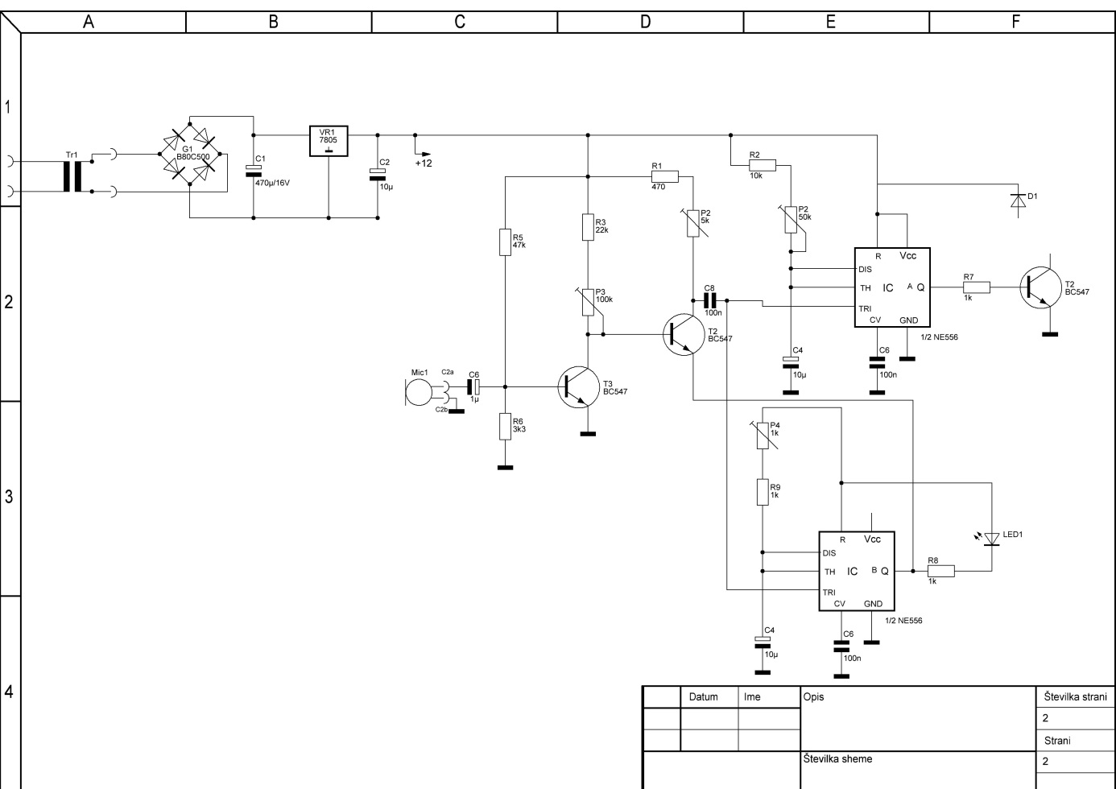

Component list

C1 = 1 x 470µ/16V

C6 = 1 x 1µ

C2,C4,C4 = 3 x 10µ

C6,C6,C8 = 3 x 100n

R1 = 1 x 470

R2 = 1 x 10k

R3 = 1 x 22k

R5 = 1 x 47k

R6 = 1 x 3k3

R7,R8,R9 = 3 x 1

P2 = 1 x 5k

P2 = 1 x 50k

P3 = 1 x 100k

P4 = 1 x 1k

T2,T2,T3 = 3 x BC547

IC,IC = 2 x 1/2 NE556

Tr1 = 1 x

G1 = 1 x B80C500

VR1 = 1 x 7805

Mic1 = 1 x Microphone

D1 = 1 x

LED1 = 1 x

