General Description
Resistor Temperature Detectors (RTD) are sensors used to measure temperature. The detector is based on material with accurate relationship between resistance and temperature as resistance is easy to measure.
This device is intended to serve as emulator of RTDs by allowing to set desired resistance or temperature on port. Such a device is very useful for testing systems that measure temperature using RTD, for instance heating systems. Programmable and possibly very high temperature slew rate of this device allows for automatic boundary-conditioning and fault testing, emulation of which is otherwise very cumbersome.

Functions and Benefits
- 1 channel isolated from power and RS-485 on mainboard
- Up to 18 isolated external channels using RTD expansion boards
- Direct resistance settings
- Emulate NTC using coefficients and temperature
- Platinum sensors are supported
- Programmable temperature slew rate
- 1 Digital output Modbus RTU with address switch
- Remote firmware update over Modbus
Parameter | Value
Parameter | Minimum | Typical | Maximum
Mounting | 35/7.5 (DIN 46277, EN 50022)
Size | 90 x 72 mm
Number of inputs | 1 RS-485 bus
Number of outputs | 1 RTD channel
Ambient temperature | -30 °C |  | 200 °C
Power supply voltage | 8 V | 12 V | 25 V
Power supply consumption @ 12 V | 16 mA | 18 mA | 25 mA
Nominal resistance of RTD port | 10 Ohm |  | 290000 Ohm
Resistance step (LSB) | 1.2 Ohm
Temperature accuracy (NTC 10k B3977) @ 25 °C | +- 0.1 °C
Accuracy vs ambient temperature | -0.5 °C @ 60 °C |  |  | +0.5 °C @ -20 °C
RTDx pins voltage to GND-ISO | 0 V |  |  | 3.5 V
Current through RTDx port | -350 mA |  |  | 350 mA
Modbus communication | 19200 baud/s, 8 data bits, Even parity, 1 stop bit
Modbus address | 32 + DIP value

Parameters

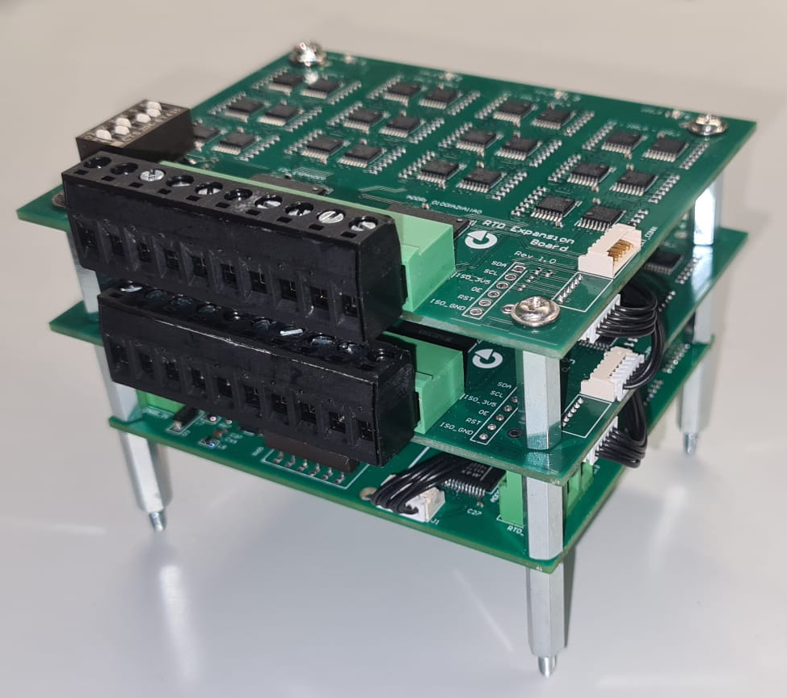
RTD Emulator

Pin Description – Main board

Pin Placing
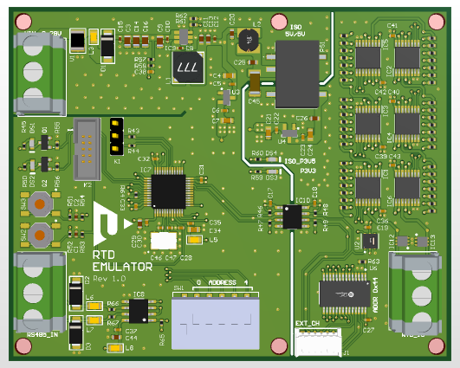
RTD connector
CH0

GND-ISO
RS-485 bus connector
RS485+ A
RS485- B
GND
.
Power connector
+12 V
GND
NC
Reset and factory reset push button

Connector for expansion board
ISO-3V5 | SCL | SDA | OE | RST
RS-485 bus address selection
.

Pinout Table
PIN | Type | Description
+12V | Power supply pin | Power supply pin for external power supply
GND | Power supply pin | Power pin for supply ground
NC | Not connected | Not internally connected
RS485+ A | RS-485 bus output | Positive RS-485 bus differential output
RS485- B | RS-485 bus output | Negative RS-485 bus differential output
RTD | Analog I/O | Port for RTD emulation. Both pins are interchangeable. Voltage at either pin must not exceed working range 0 – 3.5 V
GND-ISO | Ground of isolated RTDs | Ground of isolated part of RTD emulator. This ground must be tied to the ground of measuring device.
ADDRESS 0  –  ADDRESS 4 | Switch | Set Modbus RTU protocol address that will be added to base value 32. Individual address switches represent numerical values:  ADDRESS 0: 1  ADDRESS 1: 2  ADDRESS 2: 4  ADDRESS 3: 8  ADDRESS 4: 16  If given switch is turned on, related numerical value is effective. RS-485 Modbus protocol address is determined as sum of all numerical values enabled by switches. If all switches are ON, address is equal to 31 (1 + 2 + 4 + 8 + 16) + 32 = 63.

Pin Description – Expansion board
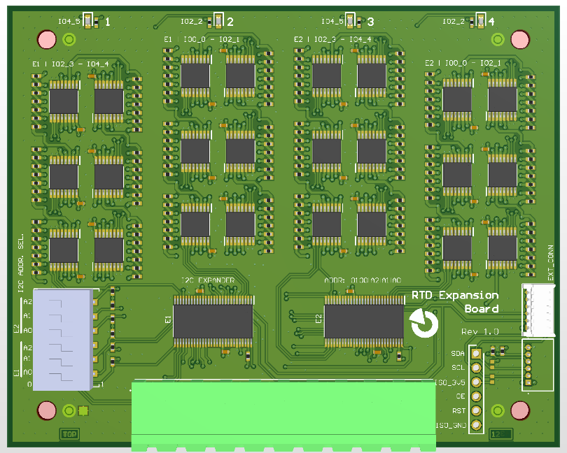
I2C expander address settings (E1, E2)
Expansion board connector
ISO-3V5
SCL
SDA
OE
RST

RTD connector CH1 CH2 CH3 CH4 GND-ISO

Pinout Table
PIN | Type | Description
RTD | Analog I/O | Port for RTD emulation. Pins are interchangeable. Voltage at pins must not exceed working range 0 – 3.5 V
GND-ISO | Ground of isolated RTDs | Ground of isolated part of RTD emulator. This ground must be tied to the ground of measuring device.
E1 | A2 – A0 | Switch | I²C expander address selection for Expander E1 (controls CH1 and CH2). The selected address must also be set in address selection registers.
E2 | A2 – A0 | Switch
  I²C expander address selection for Expander E2 (controls CH3 and CH4). The selected address must also be set in address selection registers.

Cable Connection Rule
When connecting two boards with the supplied cable, always connect the top-side connector of one board to the bottom-side connector of the other board.
Incorrect orientation may cause damage.

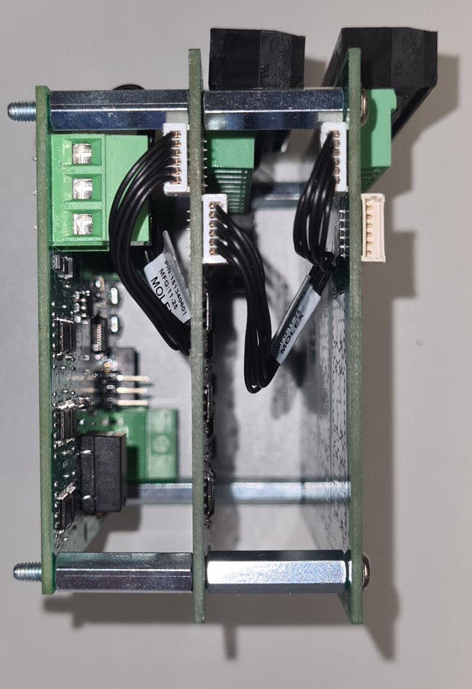
Correct connection

Modbus RTU Protocol
The device implements Modbus RTU slave supporting the following function codes 3, 4, 16.

Modbus Registers Mapping – Input Registers
Address | Name | Format | Description
0, 1 | Uptime | INT | Elapsed seconds from device startup  Unit: s.
2, 3 | Register map version | INT | Version of register map in format xxxyyy.  Xxx - major version of register map.  Yyy - minor version of register map.  Major version defines compatibility of different register maps. If major version of register map changes, the values previously stored in the flash memory are discarded and factory values are used  Minimum: 1001. Maximum: 5050.
4, 5 | Status register | BIN | Binary map of different status flags  Meaning of respective bits:  Bit 0 - Generic error - Error in the device.  Bit 1 - Testing mode - Testing mode is enabled.  Bit 2 - Calibrated successfully - Calibration data read successfully.  Bit 3 - Modbus timeout - No modbus communication for timeout period.  Bit 16 - Configuration flash error - Error when working with configuration memory.  Bit 17 - Reset by IWDG - Last reset was caused by Independent watchdog.
6 | Input signals | INT | Set of input signals.  Bits 0-4 - Modbus address offset  Bits 5-8 - Bootstrap  Bit 9 - Pushbutton  Minimum: 0. Maximum: 1023.
7, 8 | Serial number | INT | Serial number of product with common device ID in format xxyyzzzz.  Xx - year of production  Yy - month of production  zzzz - serial incremental number of the product
9, 10 | Product number | INT | Unique device ID  Minimum: 9153. Maximum: 9153.
11, 12 | Hardware version | INT | Hardware revision of the device defined as xxxyyy:  xxx - major revision (letter)  yyy - minor revision (number)  Minimum: 1001. Maximum: 5099.
13, 14 | Bootloader version | INT | Firmware revision of the bootloader as number xxxyyy:  xxx - major version of bootloader  yyy - minor version of bootloader  Minimum: 1001. Maximum: 5099.
15, 16 | Firmware revision | INT | Firmware revision of the current application image as an incremental number. See list of FW revision or release notes for respective features.  Minimum: 1. Maximum: 999.
17, 18 | Assembly date | INT | Assembly information of the current application in format xxxxyyzz:  xxxx - year of FW build  yy - month of FW build  zz - day of FW build  Minimum: 20231100. Maximum: 20250330.
19, 20 | Configuration writes | INT | Number of writes into internal configuration flash memory (size 4kB, entry 128 B, total endurance 10000 * 4096 / 128 = 320000)  Minimum: 0. Maximum: 1000000. Unit: writes.

Modbus Registers Mapping – Holding Registers
The table below contains a description of all Holding registers and its function description.
Address | Name | Format | Description
0, 1 | Command | INT | Following commands are supported:  Value 9901 - Reset  Value 8801 - Factory reset  Value 7701 - Testing mode  Value 66xx - Invoke error  Value 5501 - Invoke watchdog reset  Default: 0. Minimum: 0. Maximum: 9901.
2, 3 | Testing register | INT | Generic system testing register
4 | Modbus baud rate | ENUM | Modbus RTU serial port baud rate  Allowed values:  Value 0 - 9600 - 9600 baud/s.  Value 1 - 19200 - 19200 baud/s.  Value 2 - 38400 - 38400 baud/s.  Value 3 - 57600 - 57600 baud/s.  Value 4 - 115200 - 115200 baud/s.  Non-volatile, default: 1. Minimum: 0. Maximum: 4.
5 | Modbus parity | ENUM | Modbus RTU serial port parity  Allowed values:  Value 0 - NONE - NONE parity.  Value 1 - EVEN - EVEN parity.  Value 2 - ODD - ODD parity.  Non-volatile, default: 1. Minimum: 0. Maximum: 2.
6 | Modbus stop bits | ENUM | Modbus RTU serial port - number of stop bits  Allowed values:  Value 0 - 1 stop bit - 1 stop bit.  Value 1 - 2 stop bits - 2 stop bits.  Non-volatile, default: 0. Minimum: 0. Maximum: 1.
7 | Apply modbus parameters | INT | Apply new modbus communication parameters.  Value 1 - Apply new settings  Default: 0. Minimum: 0. Maximum: 1.
8 | Modbus timeout | INT | Longer silent period implies connection lost.  Zero value disables timeout indication.  Non-volatile, default: 10. Minimum: 0. Maximum: 7200. Unit: s.
100 | Emulation mode | ENUM | Mode of RTD emulation.  Allowed values:  Value 0 - Direct resistance - Set resistance is directly applied to RTD ports.  Value 1 - NTC thermistor - Set temperature is used for NTC resistance computation.  Value 2 - Platinum RTD - Set temperature is used for PT1000 resistance computation.  Default: 0. Minimum: 0. Maximum: 2.
101 | RTD channel selection | INT | RTD channel selection (0 = main board, 1-4 = 1. expansion board, 5-8 = 2. expansion board, )  Default: 0. Minimum: 0. Maximum: 8.
102 | 1. expansion board adress E1 | ENUM | Select E1 expansion board address A2|A1|A0  Allowed values:  Value 0 - ADDR1_000  Value 1 - ADDR1_001  Value 2 - ADDR1_010  Value 3 - ADDR1_011  Value 4 - ADDR1_100  Value 5 - ADDR1_101  Value 6 - ADDR1_110  Value 7 - ADDR1_111  Default: 0. Minimum: 0. Maximum: 7.
103 | 1. expansion board adress E2 | ENUM | Select E2 expansion board address A2|A1|A0  Allowed values:  Value 0 - ADDR2_000  Value 1 - ADDR2_001  Value 2 - ADDR2_010  Value 3 - ADDR2_011  Value 4 - ADDR2_100  Value 5 - ADDR2_101  Value 6 - ADDR2_110  Value 7 - ADDR2_111  Default: 1. Minimum: 0. Maximum: 7.
104 | 2. expansion board adress E1 | ENUM | Select E1 expansion board address A2|A1|A0  Allowed values:  Value 0 - ADDR1_000  Value 1 - ADDR1_001  Value 2 - ADDR1_010  Value 3 - ADDR1_011  Value 4 - ADDR1_100  Value 5 - ADDR1_101  Value 6 - ADDR1_110  Value 7 - ADDR1_111  Default: 2. Minimum: 0. Maximum: 7.
105 | 2. expansion board adress E2 | ENUM | Select E2 expansion board 2 address A2|A1|A0  Allowed values:  Value 0 - ADDR2_000  Value 1 - ADDR2_001  Value 2 - ADDR2_010  Value 3 - ADDR2_011  Value 4 - ADDR2_100  Value 5 - ADDR2_101  Value 6 - ADDR2_110  Value 7 - ADDR2_111  Default: 3. Minimum: 0. Maximum: 7.
106 | Expansion board adress init/reset | INT | Write 1 to Init/Reset exp. boards on addr change or new board  Default: 0. Minimum: 0. Maximum: 1.
107 | NTC beta | INT | NTC beta coefficient for computation  Default: 3977. Minimum: 3000. Maximum: 5500.
108 | NTC stock resistance | INT | NTC stock resistance at 25 C (10000 for common 10k NTC)  Default: 10000. Minimum: 1000. Maximum: 10000. Unit: Ohm.
109 | Platinum stock resistance | INT | Platinum stock resistance at 0 C  Value 100 - PT100  Value 500 - PT500  Value 1000 - PT1000  Default: 1000. Minimum: 100. Maximum: 1000. Unit: Ohm.
110, 111 | Set resistance | INT | Resistance that should be set at RTD port  Default: 10000. Minimum: 10. Maximum: 290000. Unit: Ohm.
112 | Temperature | FLOAT | Temperature that should be set at RTD port  Default: 25. Minimum: -30. Maximum: 200. Unit: C.
113 | Temp slew rate mode | ENUM | Temperature slew rate MODE  Allowed values:  Value 0 - Slew rate off - Temperature slew rate mode ON.  Value 1 - Slew rate on - Temperature slew rate mode OFF.  Default: 0. Minimum: 0. Maximum: 1.
114 | Temperature slew rate | FLOAT | Temperature slew rate in C/s  Default: 5. Minimum: 0. Maximum: 100. Unit: C/s.
115 | Max temperature in SR mode | INT | Set maximum of temperature range in SR mode  Default: 50. Minimum: -30. Maximum: 200. Unit: C.
116 | Min temperature in SR mode | INT | Set minimum of temperature range in SR mode  Default: 15. Minimum: -30. Maximum: 200. Unit: C.

RS-485 Communication Settings
RS-485 settings can be changed through Modbus Holding registers. The new settings are applied only after writing the “Apply modbus parameters” register. The default configuration is as follows.

Parameter | Value
Baud rate | 19200 Baud/s
Word length | 8 bits
Parity | Even
Stop bits | 1

Led Indication
For simple behavior indication, the device is equipped with Red and Green LED diode inside the housing next to the Termination DIP switch.

LED state | Meaning
Green – blinking | Operational state with active communication.
Red – solid | Malfunction, device is not operating.
Red – blinking | Warning State. Some internal error.
Red + Green concurrent blinking | Modbus communication timeout.
Red + Green alternate blinking | Bootloader is working. Either at power on or after remote firmware upgrade.

Channel LEDs on Expansion Modules
Each expansion module is equipped with a green LED per channel:
- The LED briefly blinks whenever a new value is written to the respective channel.
- In slew rate mode, the LED blinks continuously in sync with the value update rate.

Push Button
Push button can be used to restart device and to reset it to the factory default settings

Push time [s] | Action
Less than 0.5 s | Nothing (debouncing and false push prevention feature)
Between 0.5 s and 5 s | Device restart
More than 5 s | Reset to factory default settings. Device will restart as well.

Functional Description

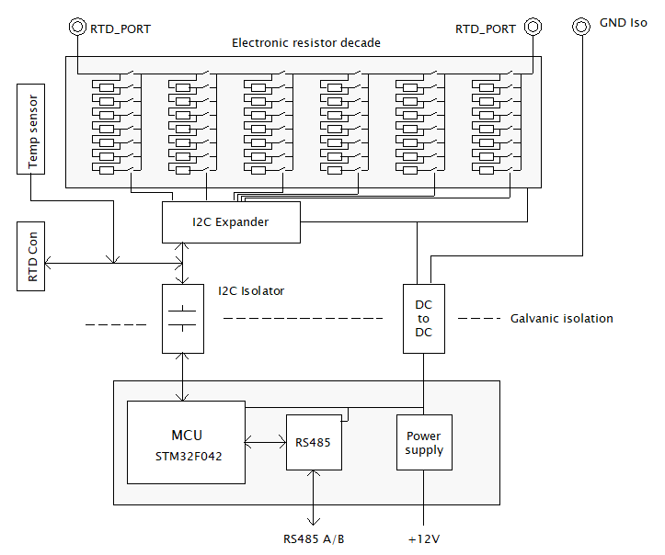
The RTD Emulator is composed of two galvanically isolated parts. The Controller part contains the RS485 transceiver, power supply stabilizer, and microcontroller. The RTD part is isolated by an I²C isolator and a DC-to-DC power supply. The RTD channel is galvanically referenced to the common isolated ground (GND-ISO). In most applications, this GND-ISO must be connected to the ground of the device that measures emulated resistance.
The RTD channel is implemented using a resistive decade that can be switched into the desired combination by analog switches. The resistor decade consists of six rows of fixed resistors, each row containing seven resistors and one direct connection.
Expansion modules operate on the same principle as the internal RTD part: each expansion channel uses its own isolated RTD section with resistive decade and switching network, referenced to the corresponding isolated ground.

Wiring and Power Up
Recommended powering-up sequence is as follows:
- Power up RTD emulator
- Connect RTD expansion boards if needed
- Connect RTD emulator to RS485 bus
- Connect GND-ISO to measuring device
- Connect to RTD port

NTC Emulation Use Case
- If an expansion board is connected, write its address to the corresponding register.
- Write the channel number into the RTD Channel Selection register:
- 0 = main board
- 1–4 = first expansion board
- 5–8 = second expansion board
- If no expansion boards are connected, set the value to 0.
- Write “Value 1 – NTC thermistor” to the Emulation mode register.
- (Optional) Configure slew rate:
- Set Minimum of slew rate range
- Set Maximum of slew rate range
- Set Temperature slew rate
- Write NTC stock resistance constant as expected by the measuring device.
- Write NTC beta constant as expected by the measuring device.
- Write the desired temperature to the Set temperature register for standard operation.
- To enable slew rate mode, write Value 1 (Slew rate on) to register – Temperature slew rate mode.

PT1000 Emulation Use Case
  - If an expansion board is connected, write its address to the corresponding register.
  - Write the channel number into the RTD Channel Selection register:
- 0 = main board
- 1–4 = first expansion board
- 5–8 = second expansion board
- If no expansion boards are connected, set the value to 0.
  - Write “Value 2 – Platinum RTD” to the Emulation mode register
  - (Optional) Configure slew rate:
- Set Minimum of slew rate range
- Set Maximum of slew rate range
- Set Temperature slew rate
5. Write value 1000 to the Platinum stock resistance register.
6. Write the desired temperature to the Set temperature register for standard operation.
7. To enable slew rate mode, write Value 1 (Slew rate on) to register 113 – Temperature slew rate mode.

Direct Resistance Emulation Use Case
  - If an expansion board is connected, write its address to the corresponding register.
  - Write the channel number into the RTD Channel Selection register:
- 0 = main board
- 1–4 = first expansion board
- 5–8 = second expansion board
If no expansion boards are connected, set the value to 0.
  - Write “Value 3 – Direct resistance” to the Emulation mode register.
  - (Optional) Configure slew rate:
- Set Minimum of slew rate range
- Set Maximum of slew rate range
- Set Temperature slew rate
  - Write the required resistance value (in ohms) to the Set resistance register for standard operation.
  - To enable slew rate mode, write Value 1 (Slew rate on) to register 113 – Temperature slew rate mode.

Note 1: To reset the slew rate, simply toggle the setting in register - Temp slew rate mode (set to 0 = off, then back to 1 = on).

Note 2: If more than two expansion boards are connected (up to a maximum of four), simply update the corresponding expansion board addresses in the configuration.

Device Limitations
GND-ISO
His ground should be connected to ground of measuring system that evaluates resistance of emulator.

RTD Ports Voltage
The voltage connected to the RTD port must not exceed 3.5V. Otherwise, the port may be destroyed.

Resistance Resolution
The resistance of the resistive decade has a step of 1.2 ohm.

Minimal Resistance Value
The minimum adjustable value of the RTD port is 10 ohms. This limit is given by the internal resistance of the analog switches in the decade.

Norm Compliance
This product was developed and manufactured with the compliance of following European norms (EN):

- EN 61000-4
- EN 55032
- EN 50581:2013

Document revisions
Revision number | Date | Remarks
Rev 1.2 | 8.2025 | adds detailed information about expansion modules
Rev 1.1 | 7.2024

