Kria Yocto Vitis Vision Library App
Getting Started Guide

Overview
This kria app utilizes the Vitis Vision Library ColorDetect HLS kernel based on the MIPI data received from Raspberry Pi Camera v2.
This system is running at Kria Yocto tool and in the background it uses 2025.2 Vitis acceleration flow for firmware development.
Architecture of the Kria App:
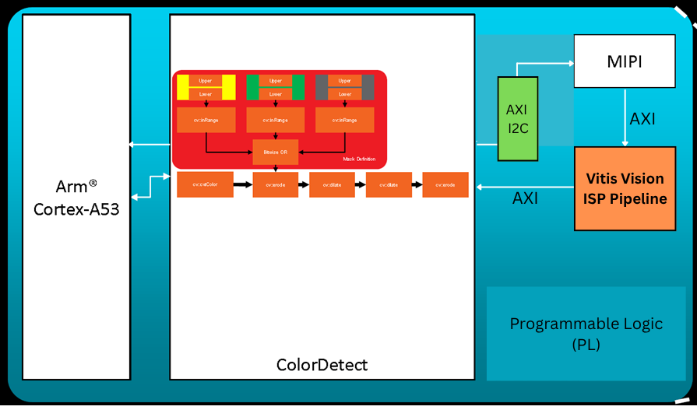

Preparing the KV260 and Raspberry Pi Camera v2 Setup
- Necessary Hardware -
  - KV260 Board , power adapter , 16+ GB of SD Card – Purchase Link from AMD
  - Raspberry Pi Camera v2 -

- Preparing the KV260 Board with Yocto EDF flow image
  - Download and burn this wic image with BalenaEtcher - AMD Download
  - Update the bootfrimware - 01.05 K24 Boot FW Update or later. Follow boot image recovery tool - https://xilinx-wiki.atlassian.net/wiki/spaces/A/pages/1641152513/Kria+SOMs+Starter+Kits#Boot-Image-Recovery-Tool
  - Now plug the SD card to KV260 , connect Power adapter, Raspberry Piv2 MIPI camera and boot the board.

- Connect the Pmod-UART and KV260 UART on the board with PC.
  - If you have two “USB-A to micro-B Cable” then connect one to J4 (JTAG/UART) port at KR260 and another to Digilent Pmod-UART.
    - The J4 (JTAG/UART) connection is primarily required to determine the IP address assigned to the KR260 once the boot process is complete. After obtaining the IP address, it can be used to access the KR260 via SSH.
    - [Optional] If you only have one USB-A to micro-B cable, first connect it to the J4 (JTAG/UART) port of the KR260. After identifying the KR260’s IP address, you can disconnect it from J4 and reconnect it to the Pmod-UART port.
  - You can use Mobaxterm/Teraterm in Windows or Gtkterm in Linux.
  - Connect the baudrate of 115200 for both of the UARTs

- KV260 and Raspbery Pi v2 sensors and connection:

- Now boot the KR260 board.
  - After booting , you will start getting boot log from Yocto EDF into your PC/computer.
  - After boot completes, you can enter the
    - Username: amd-edf
    - Password: Will be prompted to change on first login
  - [Optional] You can also identify and node down the KV260’s IP address by running the ifconfig command at the terminal of KV260. Once you have identified the IP address, you can disconnect the USB-A to micro-B cable from J4 and reconnect it to the Pmod-UART port.

Clone Github Repository
Clone this github repository at the KR260-Ubuntu image by running git clone command:
git clone https://github.com/LogicTronixInc/Kria-Yocto-Vitis-Vision-Library.git

Run the Application
Follow this Readme to run the application on KV260

Here are also the steps brief:
- You can connect the KR260 via SSH (for multi terminal access) as like here:

Compare the Accelerated ColorDetect and OpenCV ColorDetect at PS of MPSoC
Follow this Readme to run the application on KV260

Here are also the steps brief:
- You can connect the KR260 via SSH (for multi terminal access) as like here:

Congratulations for successful run and completion of this Kria-App.
For any queries, please raise the GitHub issue or mail us at info@logictronix.com.

Revision History
S.N | Revision Number | Date of Revision | Revision Details | Author
1. | v1.0 | June 21, 2026 | Initial Revision | Krishna Gaihre

