MicroBlaze-V-Zephyr-Kria-OpenAMP
Zephyr Device Tree Creation and Building Zephyr App

Creating Zephyr Device Tree
One can run the looper command to generate the Zephyr device tree:
LOPPER_DTC_FLAGS="-b 0 -@" west lopper-command -p microblaze_riscv_0 -s <path_of_device_tree>/zephyr/zephyr/system-top.dts -w .

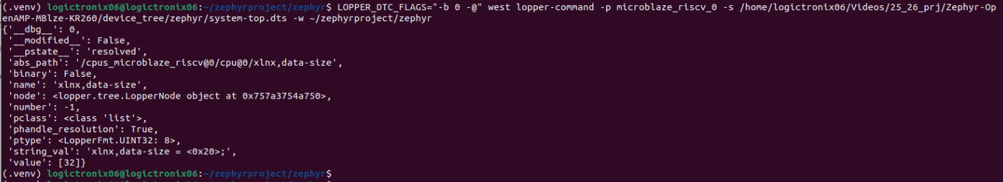

Building Zephyr Application
One can run following command to build the Zephyr application:

west build -p -b mbv32 tests/misc/test_build/

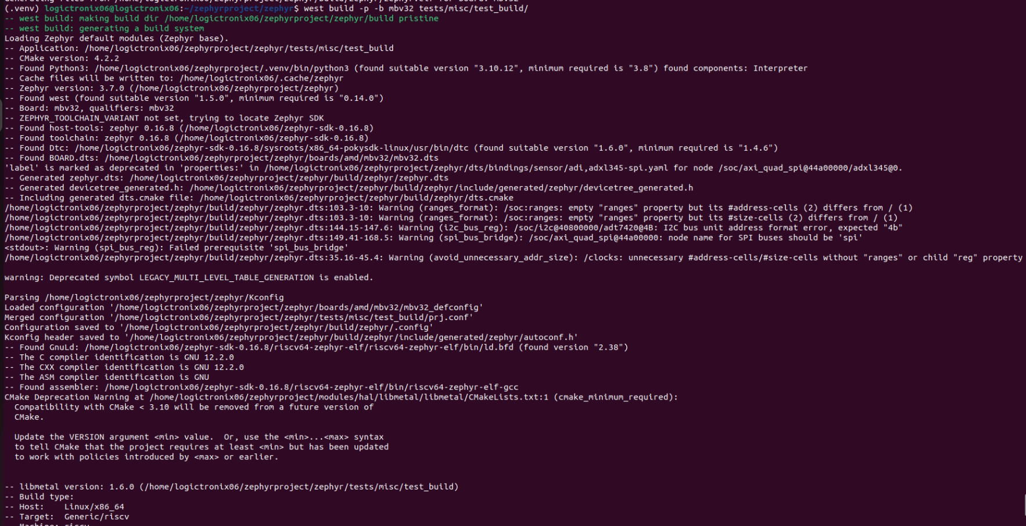
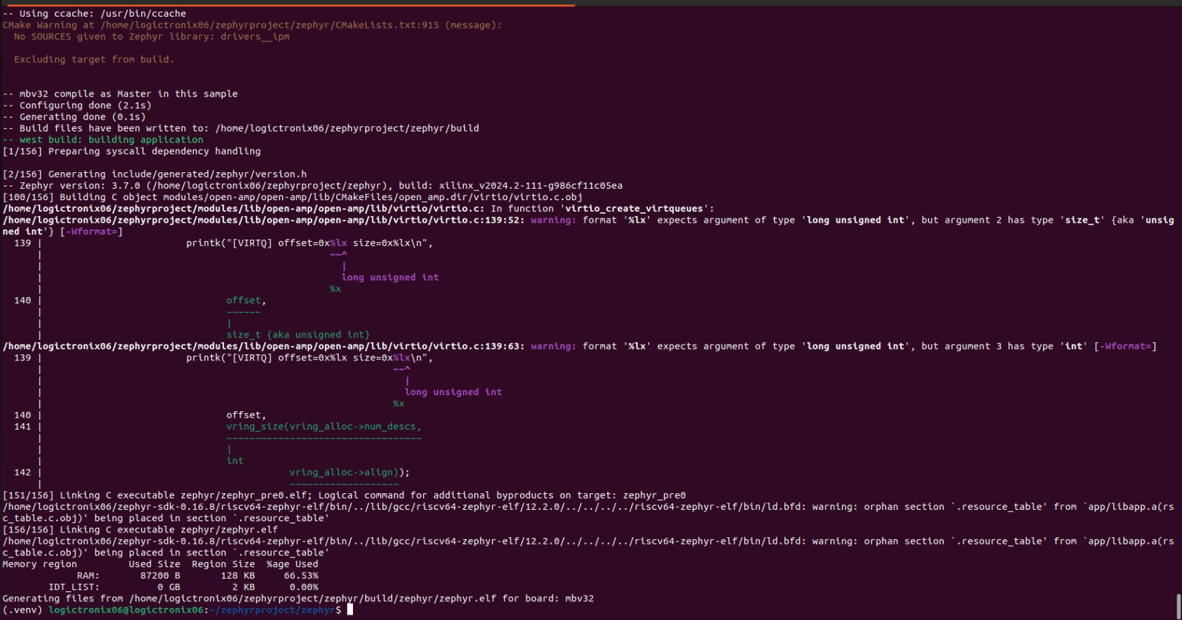

Revision History
S.N | Revision Number | Revision Details | Author
1. | v1.0 | Initial Revision | Krishna Gaihre and Sanam Shakya

