MicroBlaze-V-Zephyr-Kria-OpenAMP
Getting Started Guide, document revision v1.0

Preparing the KR260 and Sensor Setup
- Purchase the KR260 and Pmod Accessories
  - KR260 Board , power adapter , 16+ GB of SD Card – Purchase Link from AMD
  - Pmod Acl – Digilent Link
  - Pmod TMP2 – Digilent Link
  - Pmod GPIO 8 bit LED – Digilent Link
  - Pmod UART – Digilent Link
  - Few Male to female jumpers – Amazon or can be purchased from any electronics shop.

- Prepare the KR260 with power adapter , 16GB+ of SD card and burn the Kria-Ubuntu 22.04 LTS OS image on the SD card.
  - Download image
  - Burn using Balena etcher

- Connect the sensors
  - Pmod Acl - Accelerometer
    - Connect to Pmod1.
  - Pmod TMP2 – Temperature sensor
    - Connect to Pmod3.
  - Pmod GPIO – 8 bit LED
    - Connect to Pmod4.
  - Pmod UART and PL Reset
    - Connect to Pmod2.
    - You can follow following VIVADO Constraint section for connection.
# UARTlite
# UART_txd PMOD #2 pin 2 (connect rx of the uart device to pin 2)
set_property PACKAGE_PIN H11 [get_ports UART_txd]
set_property IOSTANDARD LVCMOS33 [get_ports UART_txd]

# UART_rxd PMOD #2 pin 4 (connect tx of the uart device to pin 4)
set_property PACKAGE_PIN G10 [get_ports UART_rxd]
set_property IOSTANDARD LVCMOS33 [get_ports UART_rxd]

# Reset button
# PMOD #2 pin 1
set_property PACKAGE_PIN J11 [get_ports ext_reset]
set_property IOSTANDARD LVCMOS33 [get_ports ext_reset]

- Connect the Pmod-UART and KR260 UART on the board with PC. You can use Mobazterm/Teraterm in Windows or Gtkterm in Linux.
  - Connect the baudrate of 115200 for both of the UARTs
- Connection now looks like:
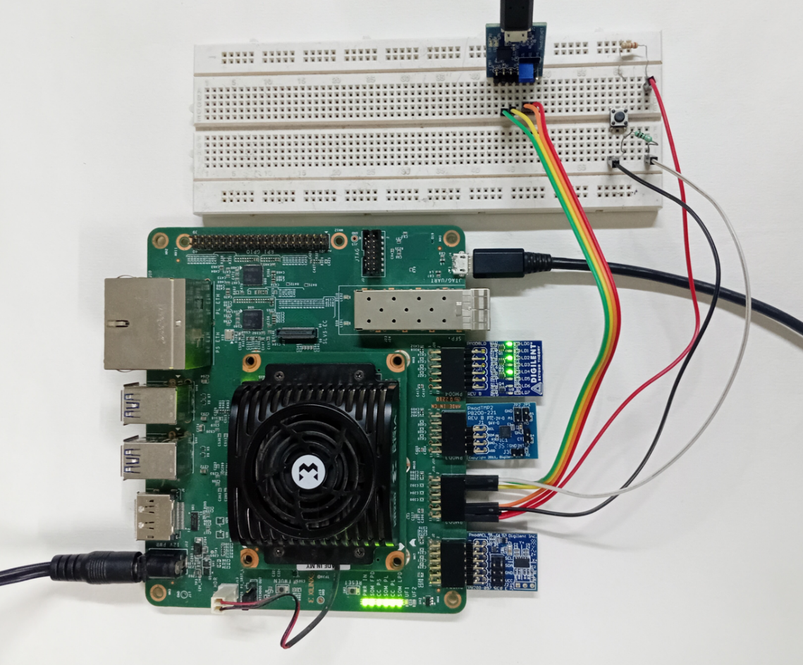
- Now boot the KR260 board.

Download and Update the Kernel
- Download the updated kernel from here using wget command at KR260 (or do the download at PC and SSH copy or USB disk based copy can be done).
- Now follow this command to update the kernel at Kria-Ubuntu
- Reboot the board

Download the Firmware and Host Code
- Download the firmware from here – Github link
  - Can also do the wget for the firmware file only or perform SSH copy or USB drive based copy

- Copy the firmware at the /lib/firmware/Xilinx
- Now load the firmware using xmutil command

Application run
- You can connect the KR260 via SSH (for multi terminal access) as like here:
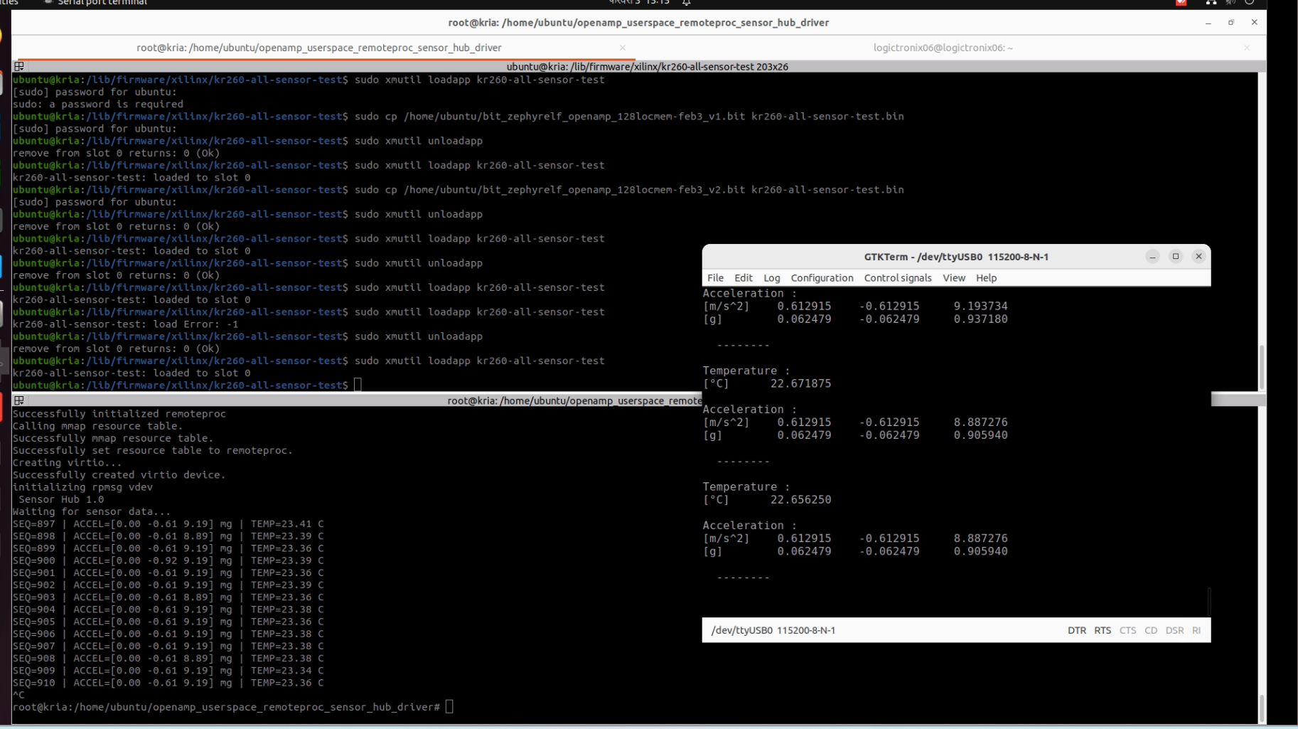

- Now, run the OpenAMP host app on the Kria-Ubuntu terminal.
- Now unload the kria app and re-load it.
- Now you must able to see the output as like in above picture.

Revision History
S.N | Revision Number | Revision Details | Author
1. | v1.0 | Initial Revision | Krishna Gaihre and Sanam Shakya

